**A Level Project**

***‘Conflux’***

**Daniel Baxter**

**The Trinity Catholic School**

Contents

Analysis

Background to/Identification of Problem 3

Description of the current system 5

Identification of the prospective user(s) 5

Identification of user needs and acceptable limitations 6

Data Source(s), Destinations and Volumes 6

Analysis data dictionary 9

Data flow diagrams(existing and proposed system) to Level 1 11

Objectives for the proposed system 13

Object analysis diagrams-Inheritance and Aggregation 15

Realistic appraisal of the feasibility of potential solutions 15

Justification of chosen solution 18

Design

Overall system design 19

Description of modular structure of system 27

Definition of data requirements (Design data dictionary) 43

Validation required 47

File Organisation and processing 47

Identification of storage media 48

Identification of suitable algorithms for data transformation 48

Class definitions and details object behaviours 50

User interface design rationale 51

Description of measures planned for system security 52

Overall test strategy 52

Testing

System testing 70

Testing evidence 91

System Maintenance

System overview 276

Sample of detailed algorithm design 277

Procedure and variable lists/descriptions for programs 280

User manual 289

Evaluation

Comparison of project performance against numbered general and specific objectives 295

Analysis of user feedback 298

Possible extensions to the system 299

Appendix 301

# Analysis

## Background to/Identification of Problem

The Confetti Institute of creative technologies is a specialist creative industries education centre providing several courses, including Games, Music and Film production technology. The particular area where my problem resides is in the the Game Development course, where the students cover a variety of topics crucial to game design and development, such as storyboards, concept art and 3d modelling. Speaking to my main contact, Robert Bednarski, a student currently studying the Games technology course, he told me that one of the projects that they have to complete is to design a multitude of debugging tests for a computer game of their choice. He has to find a video game that he can design these tests for and ideally he needs specific features that will give him the best grade possible for this unit on the course. He has asked me if i can produce a video game that he could use for this project as an alternative to finding his own, which he told me otherwise would most likely be the game ‘The binding of Isaac’.

Interview with main contact

1. What is the chosen current system that is used for your project?

*“For this unit, we have to pick a game ourselves and run debugging tests on it. At the moment, I have chosen the game ‘The binding of Isaac’.”*

1. What are the issues with the chosen current system?

*“The game is too long with all of the stages of it’s narrative, also having items/an inventory makes the project too complex with the multiple aspects of picking up and using items.”*

1. What features are required of a game used in this project?

*“I would like to have made a 2D top down shooter that has simple graphics with one player fighting AI characters, having obstacles and barriers to add some functionality. To make up for a lack of inventory and to keep some of the testing dynamic I would like more advanced shooting and movement mechanics that the ones in ‘The binding of Isaac’.”*

1. What features of ‘The binding of isaac’ do you want to keep for the new system?

*“I want to keep the style of rooms, the projectile mechanics of the player’s/enemy’s main attack and the immovable obstacles but I want the rooms to be linear”*

1. How many rooms do you want?

*“10, where the difficulty gets harder as they go.”*

1. How will it get more difficult?

*“There needs to be more enemies/enemies placed in harder positions in each successive room.”*

1. Does the player need to be able to move to previous rooms?

*“No, it’s not needed.”*

1. What kind of advanced mechanics?

*“I want the player character to be able to rotate to face the mouse so they can shoot at any direction, and have all movement based around the mouse so that pressing W moves towards the mouse, S moves away etc. ”*

1. Do you want any sideways player movement?

*“Yes, I would like the player to be able to strafe left and right with the A and D keys”*

1. What player inputs are required for the new system?

*“The player needs to able to rotate by moving the mouse, move using the WASD keys and shoot with a mouse click.”*

1. What kind of obstacles did you want?

*“Just some generic square barriers that the player can hide behind to avoid being shot by the enemies.”*

1. What operating system is used at your college?

*“Windows 7”*

1. Do you want to save any form of data in the game?

*“Yes, I would like to have the top high scores saved.”*

1. How many high scores do you want to be saved?

*“3”*

1. What do you want the player’s score to be?

*“The highest room reached by the player before they die.”*

1. Where do you want the scores to be displayed?

*“I would like some kind of high scores screen to view the scores from a button on the menu.”*

1. Do you want multiple difficulty levels for the game AI?

*“No, just one AI difficulty is fine.”*

1. Do you want any form of enemy movement?

*“No they should be fixed in one place.”*

1. Do you want any form of player of enemy health?

*“No it needs to be one shot, one kill for both.”*

1. Do you want any game menus?

*“Yes, there needs to be a main menu so I can get to the game, high scores screen and close the game. There should also be a menu at the end of every game where the player enters their name and can play again if wanted.”*

1. Do you want any pausing functionality?

*“Yes, I just need a pause menu where I can carry on, restart and go back to the main menu.”*

1. How do you want to move between the menus?

*“I would like some clickable buttons.”*

1. Are there any other features of the game that you would like included that we haven’t discussed ?

*“Yes I would like something that stops the player if they try to move to the next room and haven’t killed all of that room’s enemies, like a door or barrier.”*

Observation of current system

The current system in place that my contact would have chosen is ‘The binding of isaac’, so my observation consisted of me watching him conduct some of the more basically designed tests the he would have to do in the project. It included the various tests for buttons to travel between the various game states. With this he also further explained the information given in the interview such as what specifically wanted with the advanced shooting mechanics. Furthermore, I saw first hand the lacking features that are required in the new system, for example the need for dynamic movement and a more linear room design.

## Description of the current system

The system that he was planning on using was the game ‘The binding of Isaac’. This is a 2D top down game whereby the player moves between certain rooms, collecting useful items and fighting enemies along the way, eventually reaching a boss room to complete that stage in the overall game. The controls consist of the WASD keys to move up, down, left and right and the spacebar to shoot at numerous types of enemies that the player could encounter. The user interface consists of the game window, where the Player, enemies and barriers can be seen. Above this is a banner with a minimap on the left indicating where the player, items and boss levels are in the stage, on the left there is the player’s currently equipped item and their inventory.

‘The binding of Isaac’ is close to the ideal system for him but he wants something that has particular features so that he can get optimum marks for this project, such features will be mentioned later in this section. A problem that arises from testing this game is that he has seen it before, which is also not ideal as he has told me it is recommended by the college that they pick an unfamiliar game that will enhance the student’s skills the most. I plan on making the ideal game for him to test with the right amount of relevant content to be sufficient but not time consuming, in the style that he requires and in a suitable time frame to ensure practicality with his other college work.

## 

## Identification of the prospective user(s)

My user is Robert Bednarski, a 17 year old student at the Confetti Institute of Creative Technology in Nottingham who is currently studying the games development course. He will be using the game that I will develop for him as a means to design several different debugging tests for it to be used as part of one of his college assignments.

## 

## Identification of user needs and acceptable limitations

The game must:

* be playable on a PC
* have a main character that can move around in the map
* have hostile enemies that the user can attack/be attacked by
* have enemies of increasing difficulty
* have enemies that have randomly generated spawn locations
* display a Graphical user interface

These are the requirements that ‘The binding of Isaac’ meets, but the other requirements include:

* have 10 levels to the game
* have the player’s character rotate with the mouse

Game limitations:

* resolution of the screen
* processing speed of the PC
* memory capacity of the PC

## Data Source(s), Destinations and Volumes

The inputs for my system will be mainly from the keyboard and mouse for moving around and attacking enemies. Data inputs will be taken constantly in order to pick up the player when they want to perform an action in the game.

|  |  |  |  |  |  |  |
| --- | --- | --- | --- | --- | --- | --- |
| **Name** | **Description** | **Source/**  **Destination** | **Format** | **Data size**  **(per occurrence)** | **Frequency** | **Total size** |
| Player Name | The user entered name | **Source:**  User input from keyboard  **Destination:**  To player scores storage | Text | 10 Bytes | 1 per game played | 10 Bytes per game played |
| Player Rotation angle | The player movement where the player image’s direction changes | **Source:**  User input from mouse input  **Destination:**  Monitor | Float | 3 Bytes | Checked 60 times per second  (60fps) | 3 Bytes every time input is picked up |
| Forward movement | The user input to move the player image towards the mouse position | **Source:**  W key  **Destination:**  Monitor | integer | 5 Bytes | Checked 60 times per second  (60fps) | 3 Bytes every time input is picked up |
| Backward movement | The user input to move the player image away from the mouse position | **Source:**  S key  **Destination:**  Monitor | integer | 5 Bytes | Checked 60 times per second (60fps) | 3 Bytes every time input is picked up |
| Left movement | The user input to make the player strafe to the left at 90° left of the mouse position | **Source:**  A key  **Destination:**  Monitor | integer | 5 Bytes | Checked 60 times per second  (60fps) | 3 Bytes every time input is picked up |
| Right movement | The user input to make the player strafe to the right at 90° right of the mouse position | **Source:**  D key  **Destination:**  Monitor | integer | 5 Bytes | Checked 60 times per second  (60fps) | 3 Bytes every time input is picked up |
| Player attack | The input from the player to make the character attack | **Source:**  User input from mouse click -direction from Player rotation angle  **Destination:**  Monitor | (x,y) coordinate  (integer) | 3 Bytes | Checked 60 times per second  (60fps) | 3 Bytes every time input is picked up |
| Player score | used to rank players based on how many rooms they complete | **Source:**  User input from mouse click  **Destination:**To monitor and player scores storage | integer | 2 Bytes | 1 per game played | 2 Bytes per game played |
| Game over | screen that shows if the player dies | **Source:**  User inputs if the player gets shot by an enemy  **Destination:**Monitor | Object | 30 Bytes | 1 per game played  (unless game is won) | 30 Bytes per game played(unless game is won) |
| Won game | screen that shows if the player has won the game | **Source:**  User input if the user completes all of the levels  **Destination:**Monitor | Object | 30 Bytes | 1 per game played  (unless game is lost) | 30 Bytes per game played(unless game is lost) |
| Pause | screen that shows if the user clicks the pause button | **Source:**  User input from mouse click  **Destination:**Monitor | Object | 30 Bytes | Checked 60 times per second(60fps) | 30 Bytes every time input is picked up |
| User interface | The screen that is displayed when the user is playing the main game, that includes the map, the player image, the enemy images and barriers | **Source:**  User input to start playing the game  **Destination:**Monitor | Object | 30 Bytes | Displayed 60 times per second(60fps) | 30 Bytes every frame of the game |

## 

## 

## Analysis data dictionary

## 

|  |  |  |  |
| --- | --- | --- | --- |
| **Item** | **Description** | **Data Type** | **Character Length** |
| Main Menu | Where the user can start the game, view the high scores and exit the game. | Text | 20-40 |
| *Start Game* | This button will load the game and start to run the main game loop. | Text | 10 |
| *Display High Scores* | This button will take the user to a screen containing the high scores for the game(i.e. How many rooms the user completed). | Text | 20 |
| *Reset High Scores* | This button will overwrite the high scores with empty values | Test | 20 |
| *Return to main menu* | This button will return the user to the main menu.(from display high scores screen) | Text | 20 |
| *Quit* | This button will exit the program. | Text | 20-30 |
| Pause | This button will pause the game, stopping any movement/attacking by the player or enemies. | Text | 1-5 |
| *Continue* | This button will continue the game from the moment when the user paused. | Text | 8 |
| *Restart* | This button will restart the game from the beginning. | Text | 7 |
| *Exit* | This button will return the user to the main menu. | Text | 4 |
| Player | The user controlled character that can move through the map and attack enemies. | Object | - |
| Enemy | An AI character that can attack/kill the player. | Object | - |
| Barrier | Objects in the map that the player can take cover behind/hide from enemies. | Object | - |
| Bullet | The object that on impact will kill the player or any enemy. | Object | - |
| Room | The contained space in the background that the player can move around in. | Object | - |
| User interface | The environment where the menu’s, Player, Enemies, Barriers, Bullets and room are displayed to the user. After a game is won or lost, the user is brought back to the main menu. | Object | - |
| Win game | A brief message informing the user that they have won the game. | Text | 30-40 |
| Lose game | A brief message informing the user that they have died/lost the game. | Text | 30-40 |
| High scores | The screen that will show the user the current high scores stored, which are the highest room reached by a player. | Text | 40-50 |
| Player rotation | The player movement where the facing direction of the player image changes to face the mouse location | Object | - |
| Forward movement | The player movement where the player moves towards the mouse location. | Object | - |
| Backward movement | The player movement where the player moves away from the mouse location. | Object | - |
| Left movement | The player movement where the player strafes left at 90° to where the player image is facing. | Object | - |
| Right movement | The player movement where the player strafes right at 90° to where the player image is facing. | Object | - |

## 

## 

## Data flow diagrams(existing and proposed system) to Level 1

**Current System:**

The original system could be any game that a user would have previously chosen, but, due to what I have found from the information that my client gave me, a game that was a popular possible choice was a game called the Binding of Isaac. So, my proposed system will be based on this game, as it is the best option available.

Main menu

Game startup

Play

User input

Exit

View High scores

Game loop

Close game

High scores screen

High scores

Retrieve high scores

Main Menu

Game loop

Is Player Dead?

Save Player name and Score

Stats

Game over screen

End game option

Main Menu

Yes

Go to main menu

Replay

No

Player input

Can Player move in requested direction?

Move

Attack type

Attack

Move Player

Yes

No

Store item

Inventory

Get item

Attack with bomb

Shoot

Bomb

Projectile

Main menu

Start game

**Proposed system:**

Main menu

Game loop

Game startup

Play

User input

Exit

View High scores

Game loop

Close game

High scores screen

High scores

Retrieve high scores

Return to main menu

Is Player Dead?

Save Player name and room reached

High Scores

Yes

Player Input

Can player move in requested direction?

Move Player

No

Move

No

Yes

Attack

Attack

Main menu

Main menu

Start game

End game option

Exit

Replay

Pause menu

Continue/restart

Exit to main menu

## Objectives for the proposed system

Inputs, Processing and Outputs

1. The player must be able to move forward.
2. The player must be able to move backwards.
3. The player must be able to strafe left.
4. The player must be able to strafe right.
5. The player can shoot bullets by clicking the mouse.
6. The player will die if shot once by an enemy.
7. The player will kill an enemy by shooting them once.
8. The enemies will face towards the player when the player enters a room.
9. Will use the mouse to rotate/change the facing direction of the player character.
10. Will use the W to move forwards(ie towards the mouse location).
11. Will use the S to move backwards(ie away from the mouse location).
12. Will use the A to strafe left(perpendicular to the facing direction).
13. Will use the D to strafe right(perpendicular to the facing direction).
14. The player character must stop moving if they walk into a barrier.
15. The player character must stop moving if they walk into the map boundary.
16. The player will be able to select ‘Play Game’ from the main menu.
17. The player will be able to select ‘View High Scores’ from the main menu.
18. The player will be able to select ‘Exit Game’ from the main menu.
19. The player can pause the game from the game interface.
20. The player will be able to select ‘Continue’ from the pause menu.
21. The player will be able to select ‘Restart’ from the pause menu.
22. The player will be able to select ‘Exit to main menu’ from the pause menu.
23. The player score is the room number reached before the player died.

Volumetrics

1. The game must save the scores of players.
2. The game must correctly store the high scores of players.
3. The game must store 3 high scores.
4. The game must store 3 player names.

Performance Requirements

1. The system must run smoothly.
2. The system must not crash.
3. The game must load the program from clicking the game icon to displaying the main menu in under 10 seconds.
4. The pause menu must load in under 5 seconds.
5. The high scores must load in under 10 seconds.
6. The game must close in under 5 seconds after requested from the main menu.
7. The game will run on PC’s with the Windows 7 operating system.
8. The game will run at 60fps (frames per second).

## Object analysis diagrams-Inheritance and Aggregation

Player

Enemy

Room

**0..\***

**moves in**

**1..11**

Barrier

**0..\***

Door

**1..2**

Object

## Realistic appraisal of the feasibility of potential solutions

Off the shelf Software solutions

As my project is to provide students at Confetti with a game to test with certain properties that would be beneficial to them, there are several off the shelf solutions available. As none of these systems are to exactly the right needs of my client, I will list some of the best alternatives.

**The Binding of Isaac:**

This possible solution is an RPG game where the player will go between rooms of varying difficulty, also fighting bosses, finding collectables and picking up items to give the character certain abilities.

**Image Source - http://www.pastemagazine.com/articles/2011/10/the-binding-of-isaac-review-pcmac.html**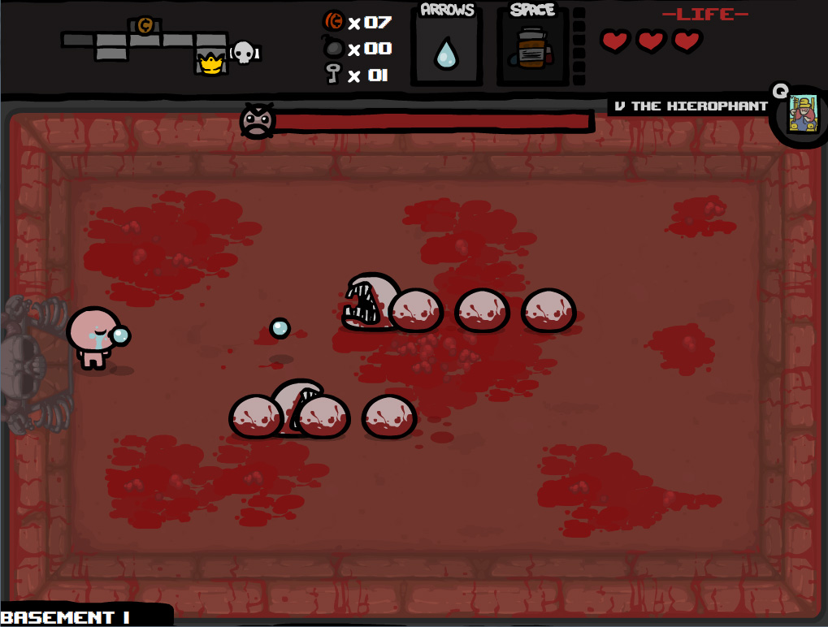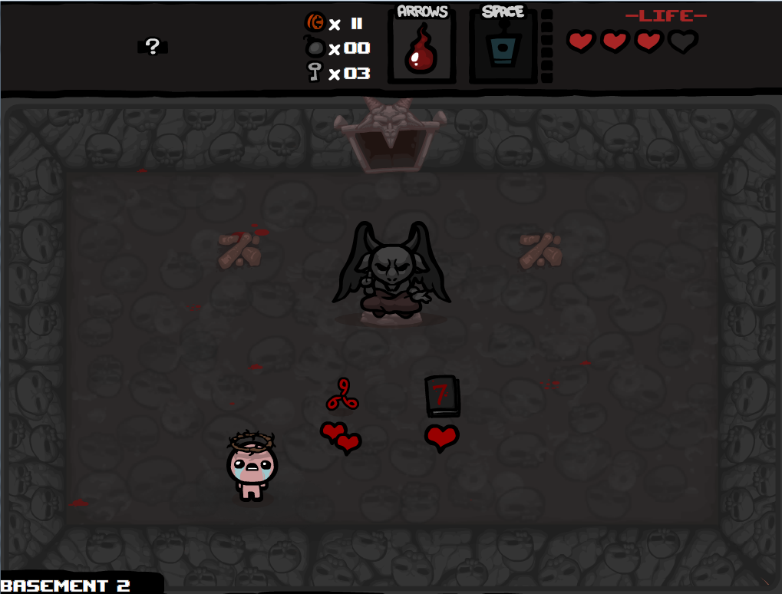

This solution is appropriate as it has qualities that my client has requested such as:

* It is a 2D top down game.
* It revolves around the player moving between rooms.
* It has rooms containing enemies of varying difficulty.
* The player can attack enemies with projectiles.

This solution is not appropriate as:

* It contains collectable items that is too detailed and contains too many variables to test.
* The game is too long to complete and the time taken to test everything in the way that they have to is time consuming.

**Towelfight 2:**

This is another 2D top down game, available on the Google play store, available to Google Android smartphone users. In the game the character has a variety of ‘jectiles’, a variety of unusual projectiles to shoot out of the monical of the protagonist at hostile enemies. As with the binding of isaac, the player will also encounter bosses and find a variety of collectibles.

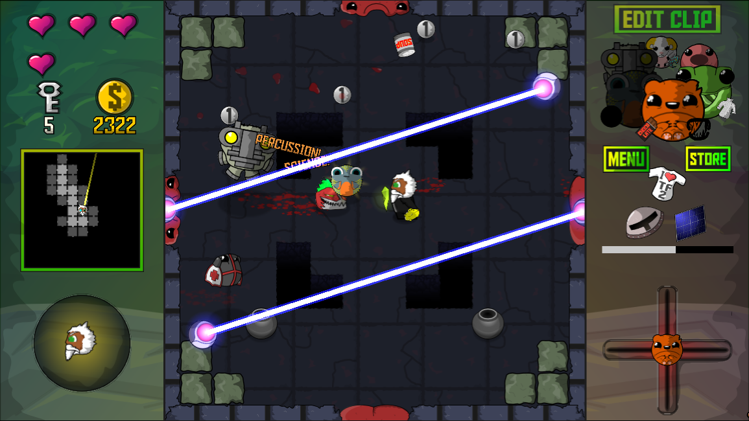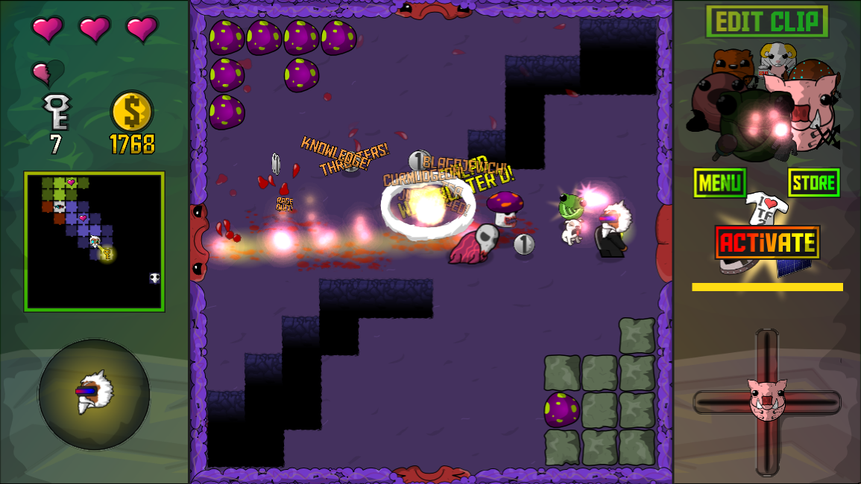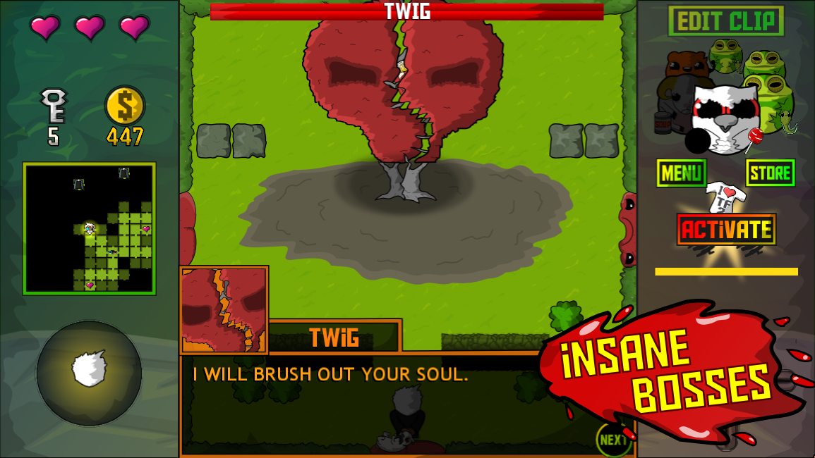

**Image Source**

**- https://play.google.com/store/apps/details?id=com.bscotch.towelfight2**

This solution is appropriate as it has qualities that my client has requested such as:

* It is a 2D top down game.
* The player moves between rooms containing of varying difficulty.
* The player has a ranged attack

This solution is not appropriate as:

* It is only available on smartphones with the Google Android operating system, not on PC, like my client has requested.
* The ‘jectiles’ mechanic would be excessively detailed as there are several combinations available to equip.

Bespoke software solutions

This option will be the best available to the clients as the system will be made exactly to their needs for the project that they have to do. This means that I can add any specific features that are required/desired to the game. Also, this means that my clients will save time with this part of the course. The particular features that he has requested that justify my project include:

* Not having an inventory/items as to reduce the complexity of working around such a versatile feature.
* Having a character that dynamically shoots towards the mouse location and faces/turns towards this location
* Having a shorter game to play with only basic graphics
* Having fixed enemies that track the player
* Being playable on a PC

## Justification of chosen solution

I have chosen the bespoke software solution for my client as this provides my client with the best suited game for the project that they have to do. I have rejected all other possible solutions due to multiple factors, including overly detailed games, more difficult devices to work with and the fact that no game currently available will be able to suit every one of my client’s needs.

This solution is the best possible one as any other software that closely resembles my client’s needs will be missing certain aspects, such as the the advanced shooting and movement mechanics, the shorter gameplay length, the fixed enemy positions and PC playability. Plus it will be a time consuming task just to find a game that is close to what he wants.

I will be writing the game in Python, with the module Pygame, using the programming environment Wing IDE. These tools are the most suitable as more complex game development options are not needed for a project of this size and difficulty.Plus, development in Python and Pygame is more straightforward with strong debugging features which will reduce overall development time. This will mean that the project can be completed in a suitable timeframe, which will be better as to ensure my user gets the final project when he needs it.

# Design

## 

## Overall system design

My system will be designed for a computer with certain minimum specifications needed to run the game. My system will run optimally on a PC with any computer with windows 7 installed housing an intel i series processor or AMD equivalent, with at least 2GB of RAM.

Move Player process

Move player

WASD Keys

Keyboard

Move player

Monitor

Shoot

Mouse

Monitor

Left click

Player shoots projectile

Player rotation process:

Rotate player

Mouse

Monitor

x/y coordinate

Player faces cursor

Player shoot process:

Shoot

Mouse

Monitor

Left click

Player shoots projectile

Enemy rotating process:

Rotate enemy

Hard drive

Monitor

Player’s x/y coordinates

Enemy faces player

Enemy shooting process:

Enemy shooting

Hard drive

Monitor

Enemy firing counter runs out

Enemy shoots projectile

Score save process:

Save Score

Mouse

Player exits the end game menu

Hard drive

Send score to high scores check

High Scores check process:

High score check

hard drive

high score from Save game

High Scores

Hard Drive

hard drive

Edit current high scores

(The check to see if a score is high enough to replace one of the high scores)

**Main menu selection processes**

Play game process:

Main menu:

Play game

Mouse

click on “Play game”

Monitor

Start main game loop

View high scores process:

Main menu:

View high scores

Mouse

Click on “View high scores”

High Scores

Hard Drive

Monitor

Display high scores

Exit game process:

Main menu:

Exit game

Mouse

click on “Exit game”

Monitor

close game window

**Pause processes**

Pause process:

Pause game

Mouse

click on “Pause”

Monitor

open the pause menu

Continue game process:

Pause menu:

Continue game

Mouse

click on “Continue”

Monitor

Continue game from location of pause

Restart game process:

Pause menu:

Restart game

Mouse

click on “Restart”

Monitor

Display the level 1 screen

Exit game process:

Pause menu:

Exit to main menu

Mouse

click on “Exit to main menu”

Monitor

Go to main menu

**End game menu processes**

Play again process:

End menu:

Play again

Mouse

click on “Play again”

Monitor

Display the level 1 screen

Exit to main menu process:

End menu:

Exit to main menu

Mouse

click on “Exit to main menu”

Monitor

Go to main menu

Player name collection process:

Player name collection

keyboard

User enters name

Monitor

Send to High scores check

Door state process:

Door state process

Hard drive

Door state

Monitor

Player can’t go through doors

Room counter process:

Room counter process

Monitor

Player completes a room

Hard drive

Add 1 to the room count

Enemy firing counter process:

Room counter process

hard drive

Game finishes a frame

Hard drive

Add 1 to the fire count

Game Over check process:

Game over check

Monitor

Player dies

Monitor

Display Game over screen

Load room process:

Load room

Mouse and keyboard

Player completes a room

Monitor

display next room with barriers and enemies

Collision detection process:

Collision detection

Mouse and keyboard

Is player in contact with any other object

Monitor

stop player from moving in direction of object

## 

## 

## 

## Description of modular structure of system

**Hierarchy charts**

Game loop

Play Game

load correct room

Check for room number

Move player

Load in correct enemies/ obstacles

Move player in direction requested

Get Object movement

Draw the U.I.

Get Object rotation

Get enemies rotation

Collision detection

Door room check

loops 60 times a second

Fire bullet

User interface

Start Menu

display message

create button

Pause Menu

Draw user interface

Display message

Create button

Continue option continues play game

Reset play game values

load map

load room user interface

load room specific objects(barriers and enemies)

End Game screen

Draw U.I

display message win/loss

create button

Start menu

User enters name

‘Get player name’

Player movement

Get Object Rotation

Get the rotation angle

Rotate the object image

Use Trigonometry to find the angle

(using Tan)

Get the vector between the two inputted objects

Calculate Object movement

Calculate unit vector

Calculate movement vector

Move player

import unit vector

Move player by unit vector

Move player y by unit vector

Move player x by unit vector

Detect key press

Fire bullet

Get bullet rotation

Move bullet

Draw bullet

Move bullet x and bullet y by unit vector

Detect mouse click

Saving data

Save Game

Get player score

Get player name

Save scores

save array to a file

place name and score into an array

Get player name

Input user name

load text box

validate player name

check for user input

update text box

Handling save data

Load high scores

read save file

Transfer high scores data into an array

View high scores

Draw user interface

Display high scores

create button

‘back to main menu’

load high scores

Update high scores

Get player score

check if score is a high score

change according score

Reset high scores

overwrite the data with initial save values

load the high scores data

Validation

Collision detection

Player- map boundary detection

Player- enemy detection

Player collision detection

Bullet collision detection

Player- barrier detection

Player- door detection

Bullet- player/ enemy detection

Bullet- barrier detection

Bullet-map boundary detection

Bullet-door detection

Door detection

Remove the door

Check if the player has killed all the enemies in a room

Remove the door boundary for collision detection

Stop drawing in the door to the screen

Exit game

Quit Game

Close Pygame

Close the window

Get user input for quit button

User interface mechanics

Create button

If user clicks the button, then do the requested action

Draw the button

message display

draw in the rectangle of required dimensions

message display

Display text to the screen

Input text from user

**Structure charts**

Game loop

Play Game

load correct room

Check for room number

Move player

Load in correct enemies/ obstacles

Move player in direction requested

Get Object movement

Draw the U.I.

Get Object rotation

Get enemies rotation

Collision detection

Door room check

loops 60 times a second

Key:

R = room number

L = loaded room

PR = new player rotation

U = movement unit vector

PP = new player position

EP = enemy position

BP =bullet position

D = door state

**R**

**L**

**PR**

**U**

**PP**

**PP**

**EP**

**BP**

**PP**

**EP**

**BP**

**R**

**D**

Fire bullet

**BP**

**BP**

User interface

Start Menu

display message

create button

Key:

B = button

M = button with message

**B**

**M**

load map

load room user interface

load room specific objects(barriers and enemies)

Key:

R = room number

U = room ui

O = room objects

**O**

**R**

**U**

Pause Menu

Draw user interface

Display message

Create button

Continue option continues play game

Restart game will reset play game values

Key:

B = button

M = button with message

C = player choice

**M**

**B**

**C**

**C**

End Game screen

Draw U.I

display message win/loss

create button

Main menu

User enters name

‘Get player name’

Key:

B = button

M = button with message

C = player choice

**M**

**N**

Player movement

Get Object Rotation

Get the rotation angle

Rotate the object image

Use Trigonometry to find the angle

(using Tan)

Get the vector between the two inputted objects

**V**

**A**

**A**

**PP**

**EP**

**MP**

Key:

MP = mouse position

PP = player position

EP = enemy position

V = object vector

A = rotation angle

N = new object

**N**

Move player

import unit vector

Move player by unit vector

Move player y by unit vector

Move player x by unit vector

Detect key press

KP

Key:

KP = key press

U = unit vector

OX = object old x

OY = object old y

NX = object new x

NY = object new y

U

NX

NY

OX

OY

Fire bullet

Get bullet rotation

Move bullet

Draw bullet

Move bullet x and bullet y by unit vector

Detect mouse click

MC

Key:

MC = mouse click

R = rotated bullet

B = new bullet position

D = drawn bullet

R

B

D

Calculate Object movement

Calculate unit vector

Calculate movement vector

Key:

A = rotation angle

M = movement vector

U = unit vector

A

M

U

Saving data

Save Game

Get player score

Get player name

Save scores

save array to a file

place name and score into an array

Key:

S = player score

N = player name

A = score array

F = saved file

**S**

**N**

**A**

**F**

Get player name

Input user name

load text box

validate player name

check for user input(key pressed)

update text box

Key:

T = text box

N = player name

V = validated player name

**T**

**N**

**V**

**N**

Handling save data

Load high scores

read save file

Transfer high scores data into an array

Key:

F = scores file

D = save data

S = high scores array

**D**

**F**

**S**

View high scores

Draw user interface

Display high scores

create button

‘back to main menu’

load high scores

Key:

S = high scores array

B = button

H = displayed high scores

**S**

**B**

**H**

Update high scores

Get player score

check if score is a high score

change according score

Key:

H = high scores

S = player score

SS = score state

H = high scores

**S**

**H**

**H**

**SS**

Reset high scores

overwrite the data with initial save values

load the high scores data

Key:

H = high scores

**H**

**H**

**Validation**

bullet - player- enemy detection

Collision detection

Player- map boundary detection

Player- enemy detection

Player collision detection

Bullet collision detection

Player- barrier detection

Player- door detection

Bullet- player/ enemy detection

Bullet- barrier detection

Bullet-map boundary detection

Bullet-door detection

Key:

PP = player position

PS = player state

BS = bullet state

D = door state

B = bullet state

**PP**

**PP**

**PS**

**PS**

**D**

**PP**

**BP**

**PP**

**B**

**B**

**B**

**B**

Exit game

Door detection

Remove the door

Check if the player has killed all the enemies in a room

Remove the door boundary for collision detection

Stop drawing in the door to the screen

Key:

E = enemy number

D = remove door

C = removed door detection

**E**

**D**

**C**

Quit Game

Close Pygame

Close the window

Get user input for quit button

Key:

U = user input

C = closed pygame

W = window closed

**U**

**C**

**W**

User interface mechanics

message display

Display text to the screen

Input text from user

Key:

T = inputted text

D = displayed text

**T**

**T**

Create button

If user clicks the button, then do the requested action

Draw the button

message display

draw in the rectangle of required dimensions

Key:

R = button rectangle

B = button with message

BC = button with detection

**R**

**B**

**B**

**BC**

## 

## 

## 

## 

## Definition of data requirements (Design data dictionary)

|  |  |  |  |
| --- | --- | --- | --- |
| **Name** | **Data type** | **Description** | **Range** |
| Player x | variable | The x coordinate of the player | 0-1000 |
| Player y | variable | The y coordinate of the player | 0-1000 |
| Player state | variable | A boolean variable defining whether or not the player is alive | True-False |
| Player speed | variable | The speed of the player | 5-10 |
| Enemy x | variable | The x coordinate of an enemy | 0-1000 |
| Enemy y | variable | The y coordinate of an enemy | 0-1000 |
| Enemy state | variable | A boolean variable defining whether or not an enemy is alive | True-False |
| Enemies list | list | The list of all enemy objects currently alive in a room | 0-5 |
| Bullet x | variable | The x coordinate of a bullet | 0-1000 |
| Bullet y | variable | The y coordinate of a bullet | 0-1000 |
| Bullet state | variable | A boolean variable defining whether or not a bullet should still be displayed to the screen | True-False |
| Bullet speed | variable | The speed of the bullet | 5-10 |
| Bullets list | list | The list of all bullet objects currently being displayed to the screen | 0-20 |
| Door state | variable | A boolean variable defining whether or not the door should be closed | True-False |
| Rotation angle | variable | The angle that specifies the facing angle of the player and any enemies | 0-360 |
| Mouse position | variable | The xy coordinate tuple that shows the mouse position at any one time | 0-1000 for x  0-1000 for y |
| Mouse click | variable | The boolean variable that defines if a mouse click has occurred | True-False |
| Player image | object | The image imported in that the player can move around and manipulate | - |
| Enemy image | object | The image imported in to be used for an enemy sprite that are hostile to the player | - |
| Bullet image | object | The image imported in to be used for a bullet sprite that both the player and enemy will fire | - |
| X change | variable | The value that specifies how much horizontal distance the player image can move in a particular frame | 0-5 |
| Y change | variable | The value that specifies how much vertical distance the player image can move in a particular frame | 0-5 |
| Unit vector x | variable | The calculated value that states the horizontal component of the unit vector that specifies X change | 0-1 |
| Unit vector y | variable | The calculated value that states the vertical component of the unit vector that specifies Y change | 0-1 |
| Pause | variable | The boolean variable that defines whether or not the game is paused | True-False |
| Room number | variable | The value that states what room the player is currently in | 1-10 |
| Score | variable | The player’s score after a game has finished | 1-10 |
| Player name | variable | The player’s entered name | 1-15 |
| FPS | variable | The number that defines the number of frames per second that are displayed to the screen | 60 |
| Play game | function | Runs the main game loop | - |
| Main menu | function | Displays the main menu and sends user to requested destination | - |
| View high scores | function | Displays the high scores screen and shows the top 3 scores | - |
| Pause menu | function | Displays a pause menu where the player can continue, restart or exit the game | - |
| Win screen | function | Displays a win game screen with a player name input text box | - |
| Lose screen | function | Displays a lose game screen with a player name input text box | - |
| Get rotation | function | Gets the angle of rotation and updates the player image | - |
| Get unit vector | function | Calculates the unit vector for player movement based off the facing angle | - |
| Load map | function | Will load in the map UI, enemies and barriers onto the screen | - |
| Boundary detection | function | Will stop the player from moving through the map boundaries | - |
| Boundary bullet detection | function | Will remove a bullet from the bullets list if they collide with the map boundaries | - |
| Barrier detection | function | Will stop the player from moving through a barrier | - |
| Barrier bullet detection | function | Will remove a bullet from the bullets list if they collide with a barrier | - |
| Door detection | function | Will stop the player from moving to the next room when they haven’t killed all enemies in that room | - |
| Door bullet detection | function | Will remove a bullet from the bullets list if they collide with a closed door | - |
| Player-enemy detection | function | Will kill the player if they collide with any enemy | - |
| Player-bullet detection | function | Will kill the player if an enemy bullet collides with them | - |
| Enemy-bullet detection | function | Will remove an enemy from the enemies list if they collide with a player bullet | - |
| Save game | function | Saves the players score (the highest room/level reached) into a file when they die or win the game | - |
| Load scores | function | Loads the high scores from the file that they are stored in | - |
| Quit game | function | Closes all necessary processes and the game window | - |
| Character | class | Parent class for Player and Enemy that includes the rotation function and all shared variables | - |
| Player | class | Class for the player | - |
| Enemy | class | Class for an individual enemy | - |
| Bullet | class | Class for an individual bullet including the bullet movement mechanics | - |
| Barrier | class | Class for an individual barrier that includes all collision detection associated with it | - |
| Door | class | Class for the door that includes all collision detection associated with it | - |

## 

## 

## 

## 

## 

## Validation required

|  |  |
| --- | --- |
| **Function** | **Description** |
| boundary_detection | This will check and stop the player from moving the player image outside the regions of the map if the user requests to do so. |
| bullet_collision_detection | This will check to see if a bullet fired from either the player or an enemy shot hits the player, an enemy, a barrier or the boundary of the map and will stop the bullet from moving further after a collision. |
| barrier_detection | This will check and stop the player from walking through a barrier if the user requests to do so. |
| door_detection | This will check if all enemies required have been killed in order to determine whether the player can progress to the next level. This will also change the collision detection between the door and the player accordingly(i.e. if all enemies have been shot, remove the barrier of the door to let the player pass through). |
| validate_player_name | This will check to see if the name that the player has entered is suitable in terms of length, and return a value that determines if the name is accepted or not. |
| name_prescence_check | This will prevent the user from entering a blank name in the ‘Insert name here’ text box. |

## File Organisation and processing

The system, the other data in stored files, the images, and the user/maintenance manuals will all be stored in the same directory. No backups of the data will need to be created as no sensitive or valuable data is going to be stored.

My file size estimations are that my system will have:

* 4 files at average of 5 kb(20 kb total)
* 10 arrays at 8kb each (80kb total)
* 100 variables at 20 bytes each (approx 1.95kb)

So estimated total size of system is 102kb

## Identification of storage media

The system itself, the high scores file, the user manual, plus the all of the images needed by the system (the player and enemy imported images) will all be stored in one directory. Also included in the directory will be all of the required resources needed for the game to run such as python and the added module pygame.

As my system does not require any form of database I do not have to consider the storage of one for my system.

## Identification of suitable algorithms for data transformation

Object rotation

This is the algorithm for rotating an object(changing the direction that is is facing), either a player/bullet towards the mouse or an enemy towards the player.

Function get_rotation(Object_x, Object_y)

get Mouse_pos

angle ← tan( (Mouse_pos_y - object_y)/ (Mouse_pos_x - object_x) )

new_object_image ← rotate(object_image) by angle

return new_object_image

EndFunction

High score sorting

This is the algorithm that will sort the scores into high scores after every game

Function is_high_score(high_scores)

add high_scores(Score)

high_scores[no_of_scores] name ← player_name

high_scores[no_of_scores] score ← room_number

for i ← first to no_of_scores

current_value ← high_scores[i].score

current_pointer ← i

while current_pointer > 0 and high_scores[current_pointer-1] score < current_value

high_scores[current_pointer], high_scores[current_pointer-1] ← high_scores[current_pointer-1], high_scores[current_pointer]

current_pointer ← current_pointer - 1

EndWhile

high_scores[current_pointer] score ← current_value

EndFor

remove high_scores(no_of_scores)

EndFunction

Bullet movement

This is the complete motion of an individual bullet shot by the player or an enemy. This code is repeated for every bullet currently on the screen.

Function bullet_movement(vector_angle)

if not bullet rotated

bullet_move_image, bullet_angle ← bullet_get_rotation(player_x, player_y)

bullet_rotated ← True

EndIf

bullet_x ← bullet_x + bullet_uvectx*bullet_speed

bullet_y ← bullet_y + bullet_uvecty*bullet_speed

kill_bullet ← False

bullet_remove_bullet ← bullet_boundary_detection(bullet_x, bullet_y, kill_bullet)

if bullet_remove_bullet ← True

remove bullets_list(bullet)

EndIf

EndFunction

## 

## 

## 

## 

## 

## 

## Class definitions and details object behaviours

## 

Player

name

add_name

Enemy

Room

room number

map layout

**0..\***

**moves in**

**1..11**

Barrier

barrier number

position of barrier

**0..\***

Door

open status

open_door

**1..2**

load_map

Object

position

alive/dead

object_move

object_attack

add_name

**User interface design rationale**



Game lost

Restart

Exit

Text box

Enter name

Room no.

Room no.

Pause

Continue

Restart

Exit

Room no.

Game won

Restart

Exit

Text box

Enter name

Game title

Play game

View high scores

Exit

Reset high scores

High Scores

High score 1

High score 2

High score 3

Return to menu

Justification

These user interface designs are simple but effective as the graphics of the game are not crucial for it’s purpose, to be used as a basis of game test designing.

## Description of measures planned for system security

As my project is a game, no methods for restricting access (such as any password protection) are needed, and thus I will not have to consider the security of my system or of the small amounts of data that I will be storing.

As my system does not require a database, I do not need to consider the security of stored data in one.

## 

## 

## Overall test strategy

Test series

|  |  |
| --- | --- |
| **Test series** | **Description** |
| 1 - Flow of Control | Testing the transitions between the separate game states |
| 2 - Validation | Testing all forms of validation throughout the system |
| 3 - User interface | Testing accessibility of aspects within the user interface |
| 4 - Calculations | Testing all calculation results |
| 5 - Object movement | Testing Player and enemy control throughout the system |
| 6 - Save data | Testing the handling of all save data |
| 7 - Objectives | Testing system against system objectives |

Detailed Test Plan

|  |  |  |  |  |
| --- | --- | --- | --- | --- |
| **Test no.** | **Purpose** | **Description** | **Test data** | **Expected result** |
| 1.1 | Main menu: ‘Play game button‘ | User must be taken to the game if button ‘Play game’ clicked in the main menu | **Normal:**  Click on ‘Play Game’ button | **Normal:**  The screen for level 1 will be displayed |
| 1.2 | Main menu: ‘View high scores‘ button | User must be taken to the high scores screen if button ‘View high scores’ clicked in the main menu | **Normal:**  Click on ‘View High Scores’ button | **Normal:**  The high scores screen will be displayed |
| 1.3 | Main menu: ‘Exit‘ button | User must be taken to the high scores screen if button ‘Exit’ clicked in the main menu | **Normal:**  Click on ‘Exit’ button | **Normal:**  The game window will close |
| 1.4 | Main menu: ‘Reset high scores‘ button | The high scores must be reset(to blank values) if button ‘Reset high scores’ is clicked in the main menu | **Normal:**  Click on ‘Reset high scores’ button | **Normal:**  The high scores will be reset |
| 1.5 | View high scores screen:  ‘Return to main menu’ button | User must be taken back to the main menu if button ‘Return to main menu’ is clicked in the View high scores screen | **Normal:**  Click on ‘Return to main menu’ button | **Normal:**  The main menu screen will be displayed |
| 1.6 | In game:  ‘Pause‘ button | User must be taken to the pause menu if button ‘Pause’ clicked mid game | **Normal:**  Click on ‘Pause’ button | **Normal:**  The pause menu will be displayed |
| 1.7 | Pause menu:  ‘Continue‘ button | User must be taken back to the game from where they left off if button ‘Continue’ clicked in the pause  menu | **Normal:**  Click on ‘Continue’ button | **Normal:**  The game will resume from where the player paused it |
| 1.8 | Pause menu:  ‘Restart‘ button | User must be taken back to the game from the beginning if button ‘Restart’ clicked in the pause menu | **Normal:**  Click on ‘Resume’ button | **Normal:**  The screen for level 1 will be displayed |
| 1.9 | Pause menu:  ‘Exit to main menu‘ button | User must be taken back to the main menu if button ‘Exit to main menu’ clicked in the pause menu | **Normal:**  Click on ‘Exit to main menu’ button | **Normal:**  The main menu screen will be displayed |
| 1.10 | End game menu:  ‘Play again’ button | User must be taken back to the game from the beginning if button ‘Play again’ clicked in the end game menu | **Normal:**  Click on ‘Play again’ button  **test name:**  ’john’  **Erroneous:**  Click on ‘Play again’ button when the player name is empty | **Normal:**  The screen for level 1 will be displayed  **Erroneous:**  Nothing should happen |
| 1.11 | End game menu:  ‘Exit to main menu‘ button | User must be taken back to the main menu if button ‘Exit to main menu’ clicked in the end game menu | **Normal:**  Click on ‘Exit to main menu’ button  **test name:**  ’john’  **Erroneous:**  Click on ‘Exit to main menu’ button when the player name is empty | **Normal:**  The main menu screen will be displayed  **Erroneous:**  Nothing should happen |
| 2.1 | Map player- border collision detection - top boundary | The player must be stopped if they try to move beyond the map top border | **Normal:** Player moves upwards towards up border  **Boundary:** Player is at the top border of the map and presses up | **Normal:**  Player is stopped at the bottom edge of the top border.  **Boundary:** Player is stopped at the bottom edge of the top border. |
| 2.2 | Map player- border collision detection - left boundary | The player must be stopped if they try to move beyond the map left border | **Normal:** Player moves leftwards towards left border.  **Boundary:** Player is at the left border of the map and presses left. | **Normal:**  Player is stopped at the right edge of the left border.  **Boundary:** Player is stopped at the right edge of the left border. |
| 2.3 | Map player- border collision detection - right boundary | The player must be stopped if they try to move beyond the map right border | **Normal:** Player moves rightwards towards right border.  **Boundary:** Player is at the right border of the map and presses right. | **Normal:**  Player is stopped at the left edge of the right border.  **Boundary:** Player is stopped at the left edge of the right border. |
| 2.4 | Map player- border collision detection - bottom boundary | The player must be stopped if they try to move beyond the map bottom border | **Normal:** Player moves downwards towards bottom border.  **Boundary:** Player is at the bottom border of the map and presses down. | **Normal:**  Player is stopped at the top edge of the bottom border.  **Boundary:** Player is stopped at the top edge of the bottom border. |
| 2.5 | Map player- entrance (left) collision detection | The player must be stopped if they try to move beyond the entrance of the map | **Normal:** Player move left towards left edge at the entrance.  **Boundary:** Player is at the left edge at the entrance and presses left. | **Normal:**  Player is stopped from moving off the screen.  **Boundary:** Player is at edge of screen and is stopped from moving of the screen. |
| 2.6 | Map player- exit (right) collision detection after door is open | The player must be stopped if they try to move beyond the exit of the map once the door has been opened | **Normal:**  All enemies have been killed and door is open. Player moves towards the right edge.  **Boundary:**  All enemies have been killed and door is open. Player is at the right edge and presses right. | **Normal:**  Player will move to the edge of the screen and the level will increase.  **Boundary:** Player will move to the edge of the screen and the level will increase. |
| 2.7 | Player-Enemy collision detection | The player must lose the game if they collide with an enemy | **Normal:** Move leftwards directly into an enemy  **Normal:**  Move upwards directly into an enemy  **Normal:**  Move rightwards directly into an enemy  **Normal:**  Move downwards directly into an enemy  **Boundary:** Move forwards  along the side of an enemy overlapping the enemy character  **Boundary:** Move backwards  along the side of an enemy overlapping the enemy character  **Boundary:** Strafe left  along the side of an enemy overlapping the enemy character  **Boundary:** Strafe right  along the side of an enemy overlapping the enemy character | **Normal:** Player will lose the game and be transferred to the endgame screen.  **Normal:**  Player will lose the game and be transferred to the endgame screen.  **Normal:**  Player will lose the game and be transferred to the endgame screen.  **Normal:**  Player will lose the game and be transferred to the endgame screen.  **Boundary:** Player will lose the game and be transferred to the endgame screen.  **Boundary:** Player will lose the game and be transferred to the endgame screen.  **Boundary:** Player will lose the game and be transferred to the endgame screen.  **Boundary:** Player will lose the game and be transferred to the endgame screen. |
| 2.8 | Player-Barrier collision detection | The player must be stopped if they try to move through a barrier | **Normal:**  Move left directly into a barrier  **Normal:**  Move right directly into a barrier  **Normal:**  Move upwards directly into a barrier  **Normal:**  Move downwards directly into a barrier  **Boundary:**  Move forwards  parallel to the side of a barrier    **Boundary:**  Move backwards  parallel to the side of a barrier  **Boundary:**  Strafe left  parallel to the side of a barrier  **Boundary:**  Strafe right  parallel to the side of a barrier | **Normal:**  Player will be stopped if they press forward  **Normal:**  Player will be stopped if they press forward  **Normal:**  Player will be stopped if they press forward  **Normal:**  Player will be stopped if they press forward  **Boundary:**  Player should not be stopped  **Boundary:**  Player should not be stopped  **Boundary:**  Player should not be stopped  **Boundary:**  Player should not be stopped |
| 2.9 | Player-Door collision detection | The player must be stopped if they try to move through a closed door(i.e. all enemies in a room haven’t been killed) | **Normal:**  All enemies have been killed and the door is open.  **Normal:**  At least one enemy is alive and the door is closed. | **Normal:**  Player can move forwards past open door to the next room  **Normal:**  The player cannot move through the closed door. |
| 2.10 | Bullet-Player collision detection | The player must lose the game if they get shot by an enemy and bullet must disappear | **Normal:** Player hit by bullet when player is stationary  **Boundary:** Player hit by bullet when player moves into bullet path  **Boundary:** Player not hit by bullet when player moves out of bullet path | **Normal:**  Player should be taken to the endgame screen and bullet disappears  **Boundary:** Player should be taken to the endgame screen and bullet disappears  **Boundary:** Bullet continues to move along it’s path. Player can keep moving. |
| 2.11 | Bullet-Enemy collision detection | An enemy must be killed when shot by the player and the bullet must disappear | **Normal:** Enemy hit by player bullet.  **Normal:** Player bullet misses enemy | **Normal:**  Enemy is killed and bullet disappears  **Normal:**  Bullet continues to move along it’s path. Enemy is not dead. |
| 2.12 | Bullet-Boundary collision detection | A bullet must be removed if it hits the boundary of the map | **Normal:**  Bullet collides with top boundary  **Normal:**  Bullet collides with left boundary:  **Normal:**  Bullet collides with bottom boundary:  **Normal:**  Bullet collides with right boundary  **Normal:**  Bullet collides with left edge of the map (entrance)  **Normal:**  Bullet collides door (right of map)  **Normal:**  Bullet collides with right edge of map (exit) | **Normal:**  Bullet disappears.  **Normal:**  Bullet disappears.  **Normal:**  Bullet disappears.  **Normal:**  Bullet disappears.  **Normal:**  Bullet disappears.  **Normal:**  Bullet disappears.  **Normal:**  Bullet disappears. |
| 2.13 | Bullet-Barrier collision detection | A bullet must be removed if it hits any barrier in the map | **Normal:**  Bullet collides with top of barrier.  **Normal:**  Bullet collides with left of barrier.  **Normal:**  Bullet collides with right of barrier.  **Normal:**  Bullet collides with bottom of barrier.  **Boundary:** Bullet misses barrier. | **Normal:**  Bullet disappears.  **Normal:**  Bullet disappears.  **Normal:**  Bullet disappears.  **Normal:**  Bullet disappears.  **Boundary:** Bullet continues to move along it’s path. |
| 2.14 | Player name length check | The entered player name must be under 15 characters | **Normal:** 10 characters (brian rowe)  **Boundary:** 15 characters (the rock 111111)  **Erroneous:** 22 characters (steven rogers the first) | **Normal:** Accepted  **Boundary:** Accepted  **Erroneous:** Rejected |
| 2.15 | Player name presence check | The entered player name must have some entered text | **Normal:** Entered text (john)  **Erroneous:** No text entered | **Normal:** Accepted  **Erroneous:** Rejected |
| 3.1 | Main menu: ‘Play game button‘ | The player must be able to click the button ‘Play game’ within 3 seconds | **Normal:**  User presses the button ‘Play game’ | **Normal:**  User will click the ‘Play game’ button within 3 seconds |
| 3.2 | Main menu: ‘View high scores‘ button | The player must be able to click the button ‘View high scores’ within 3 seconds | **Normal:**  User presses the button ‘View high scores’ | **Normal:**  User will click the ‘View high scores’ button within 3 seconds |
| 3.3 | Main menu: ‘Exit‘ button | The player must be able to click the button ‘Exit‘ within 3 seconds | **Normal:**  User presses the button ‘Exit‘ | **Normal:**  User will click the ‘Exit‘ button within 3 seconds |
| 3.4 | Main menu: ‘Reset high scores‘ button | The player must be able to click the button ‘Reset high scores’ within 3 seconds | **Normal:**  User presses the button ‘Reset high scores‘ | **Normal:**  User will click the ‘Reset high scores‘ button within 3 seconds |
| 3.5 | In game:  ‘Pause’ button | The player must be able to click the button ‘Pause’ within 5 seconds | **Normal:**  User presses the button ‘Pause‘ | **Normal:**  User will click the ‘Pause‘ button within 3 seconds |
| 3.6 | Pause menu:  ‘Continue’ button | The player must be able to click the button ‘Continue’ within 3 seconds | **Normal:**  User presses the button ‘Continue‘ | **Normal:**  User will click the ‘Continue‘ button within 3 seconds |
| 3.7 | Pause menu:  ‘Restart’ button | The player must be able to click the button ‘Restart’ within 3 seconds | **Normal:**  User presses the button ‘Restart‘ | **Normal:**  User will click the ‘Restart‘ button within 3 seconds |
| 3.8 | Pause menu:  ‘Exit to main menu’ button | The player must be able to click the button ‘Exit to main menu’ within 3 seconds | **Normal:**  User presses the button ‘Exit to main menu‘ | **Normal:**  User will click the ‘Exit to main menu‘ button within 3 seconds |
| 3.9 | View high scores screen:  ‘Return to main menu’ button | The player must be able to click the button ‘Return to main menu’ within 3 seconds | **Normal:**  User presses the button ‘Return to main menu’ | **Normal:**  User will click the ‘Return to main menu’ button within 3 seconds |
| 4.1 | Player rotation angle | The amount of rotation to get the player to face the mouse must be correct | **Normal:** Player moves the mouse to a new location  **Erroneous:**  Player moves the mouse to a location outside of the game window | **Normal:**  Player will rotate to face the mouse exactly  **Erroneous:**  Player doesn’t rotate towards the mouse |
| 4.2 | Enemy rotation angle | The amount of rotation to get each enemy to face the player must be correct | **Normal:** Player moves to a new location | **Normal:**  Every enemy will rotate to face the player |
| 4.3 | Player bullet rotation angle | The amount of rotation for a player bullet to face the mouse must be correct | **Normal:** Player clicks to shoot at the mouse location | **Normal:**  Bullet will face towards the mouse location |
| 4.4 | Enemy bullet rotation angle | The amount of rotation for an enemy bullet to face the player | **Normal:** Enemy shoots at the player | **Normal:**  Bullet will face towards the player location at the time of shooting |
| 5.1 | Player forwards movement | The player must move towards the mouse when the up key is pressed | **Normal:**  Player presses the up key | **Normal:**  Player will move towards the mouse |
| 5.2 | Player backwards movement | The player must move away from the mouse when the down key is pressed | **Normal:**  Player presses the down key | **Normal:**  Player will move away from the mouse |
| 5.3 | Player leftward strafing | The player must be able to strafe left | **Normal:**  Player presses the left key | **Normal:**  Player will strafe left from their facing direction |
| 5.4 | Player rightward strafing | The player must be able to strafe right | **Normal:**  Player presses the right key | **Normal:**  Player will strafe right from their facing direction |
| 6.1 | Save high scores | The high scores and names must be saved to a file | **Normal:**  The player enters their name and leaves the end menu  **test name:**  john | **Normal:**  The high scores list is saved to a file |
| 6.2 | Load high scores | The high scores and names are loaded from their save file whenever the main menu is displayed | **Normal:**  The main menu is loaded when the game is first loaded  **Normal:**  The main menu is loaded a game is won/lost | **Normal:**  The high scores list is loaded from the save file  **Normal:**  The high scores list is loaded from the save file |
| 6.3 | Reset high scores | The high scores in the file will all be reset to be 0 and all names to be empty | **Normal:**  Player presses the button ‘Reset high scores’ | **Normal:**  The high scores are reset |
| 6.4 | Sorting high scores | The high scores must be sorted when a new score is added before the scores are saved | **Normal:**  Player leaves the end menu | **Normal:**  The high scores are sorted from high to low |
| 7.1 | Player forwards movement | The player must be able to move forwards | **Normal:** Player presses up  **Boundary:**  Player presses up while against and facing towards a map border | **Normal:**  Player moves towards the mouse  **Boundary:**  Player doesn’t move towards the mouse |
| 7.2 | Player backwards movement | The player must be able to move backwards | **Normal:** Player presses down  **Boundary:**  Player presses down while against and facing away from a map border | **Normal:**  Player moves away from the mouse  **Boundary:**  Player doesn’t move away from the mouse |
| 7.3 | Player left strafing movement | The player must be able to strafe left | **Normal:** Player presses left  **Boundary:**  Player presses left while against and facing right of a map border | **Normal:**  Player strafes left from it’s facing direction  **Boundary:**  Player doesn’t strafe left from it’s facing direction |
| 7.4 | Player right strafing movement | The player must be able to strafe right | **Normal:** Player presses right  **Boundary:**  Player presses right while against and facing left of a map border | **Normal:**  Player strafes right from it’s facing direction  **Boundary:**  Player doesn’t strafe right from it’s facing direction |
| 7.5 | Player shooting | The player must be able to shoot bullets if the mouse button is clicked | **Normal:** Player clicks the left mouse button | **Normal:**  Player will shoot one bullet in the direction that it is facing |
| 7.6 | Player death | The player must die if shot by an enemy once | **Normal:**  One enemy bullet collides with the player | **Normal:**  The end game menu will be displayed |
| 7.7 | Enemy death | An enemy must die if it is shot by the player once | **Normal:**  One player bullet collides with an enemy | **Normal:**  Enemy will die and disappear |
| 7.8 | Enemy-Player tracking | All enemies present in the room must face towards the player at all times | **Normal:**  Player enters a room | **Normal:**  All enemies will face towards the player |
| 7.9 | Rotating the player | When the mouse is moved the player will face towards the mouse location | **Normal:**  Player moves the mouse to a new location | **Normal:**  Player will rotate towards the mouse |
| 7.10 | ‘W’ key movement | The player will press the ‘W’ key and move towards the mouse | **Normal:**  Player presses the ‘W’ key | **Normal:**  Player will move towards the mouse |
| 7.11 | ‘S’ key movement | The player will press the ‘S’ key and move away from the mouse | **Normal:**  Player presses the ‘S’ key | **Normal:**  Player will move away from the mouse |
| 7.12 | ‘A’ key movement | The player will press the ‘A’ key and strafe left from their facing location | **Normal:**  Player presses the ‘A’ key | **Normal:**  Player will strafe left from their facing direction |
| 7.13 | ‘D’ key movement | The player will press the ‘D’ key and strafe right from their facing direction | **Normal:**  Player presses the ‘D’ key | **Normal:**  Player will strafe right from their facing direction |
| 7.14 | Barrier detection | The player will be stopped from moving through a barrier | **Normal:**  Player requests to move through a barrier | **Normal:**  Player will stop moving |
| 7.15 | Map boundary detection | The player will be stopped from moving through a the map boundary | **Normal:**  Player requests to move through the map boundary | **Normal:**  Player will stop moving |
| 7.16 | Main menu:  ‘Play game’ button | The player must be able to select ‘Play Game’ from the main menu | **Normal:**  Player presses the button ‘Play game’ | **Normal:**  The screen for level 1 will be displayed |
| 7.17 | Main menu:  ‘View high scores’ button | The player must be able to select ‘View high scores’ from the main menu | **Normal:**  Player presses the button ‘View high scores’ | **Normal:**  The high scores screen will be displayed |
| 7.18 | Main menu:  ‘Exit’ button | The player must be able to select ‘Exit’ from the main menu | **Normal:**  Player presses the button ‘Exit’ | **Normal:**  The game window will close |
| 7.19 | In game:  ‘Pause’ button | The player must be able to select ‘Pause’ while playing the game | **Normal:**  Player presses the button ‘Pause’ | **Normal:**  The pause menu will be displayed |
| 7.20 | Pause menu:  ‘Continue’ button | The player must be able to select ‘Continue’ from the pause menu | **Normal:**  Player presses the button ‘Continue’ | **Normal:**  The game will resume from where the player paused it |
| 7.21 | Pause menu:  ‘Restart’ button | The player must be able to select ‘Restart’ from the pause menu | **Normal:**  Player presses the button ‘Restart’ | **Normal:**  The screen for level 1 will be displayed |
| 7.22 | Pause menu:  ‘Exit to main menu’ button | The player must be able to select ‘Exit to main menu’ from the pause menu | **Normal:**  Player presses the button ‘Exit to main menu’ | **Normal:**  The main menu will be displayed |
| 7.23 | High score values | The player score is the room number reached before the player died | **Normal:**  Player plays 1 game and presses the button ‘View high scores’  **test name:** daniel | **Normal:**  The room that the player died in will be the player score |
| 7.24 | Saving scores | The game must store the scores of players | **Normal:**  Player plays 1 game and presses the button ‘View high scores’  **test name:** john | **Normal:**  A high score will be displayed |
| 7.25 | High scores | The game must correctly store the high scores of players | **Normal:**  Player resets the high scores, plays 3 game with 3 unique names, presses the button ‘View high scores’.  Player plays a fourth with a high score and presses the button ‘View high scores’ again.  **test names:**  daniel  john  james  thomas | **Normal:**  Fourth score moves to the top and the others are moved down |
| 7.26 | High scores quantity | The game must store up to 3 high scores | **Normal:**  Player resets the high scores, plays 3 games with 3 unique names and presses the button ‘View high scores’  **test names:**  daniel  john  james | **Normal:**  3 high scores will be displayed |
| 7.27 | Player names quantity | The game must store 3 Player names with the high scores | **Normal:**  Player resets the high scores, plays 3 games and presses the button ‘View high scores’  **test names:**  daniel  john  james | **Normal:**  3 Player names will be displayed |
| 7.28 | System performance | The system must run smoothly | **Normal:**  Player plays continued games and gives feedback | **Normal:**  System will be stable |
| 7.29 | System stability | The system must not crash with continued use | **Normal:**  Player leaves game running for 5 minutes | **Normal:**  System will not crash |
| 7.30 | System loading time | The game must load from opening the program to loading the main menu within 10 seconds | **Normal:**  Player opens the game | **Normal:**  Game will load in under 10 seconds |
| 7.31 | Pause menu loading time | The pause menu must load from pressing the ‘Pause’ button in under 5 seconds | **Normal:**  Player presses the ‘Pause’ button | **Normal:**  Pause menu will load in under 5 seconds |
| 7.32 | High scores screen loading time | The high scores screen must load from pressing the ‘View high scores’ in under 10 seconds | **Normal:**  Player presses the ‘View high scores’ button | **Normal:**  High scores screen will load in under 10 seconds |
| 7.33 | System closing time | The game window must close from pressing the ‘Exit’ button in under 5 seconds | **Normal:**  Player presses the ‘Exit’ button | **Normal:**  Game window will close in under 5 seconds |
| 7.34 | Windows 7 compatibility | The system must run on pc’s with the Windows 7 operating system | **Normal:**  Player plays the game on a PC with windows 7 | **Normal:**  Game will run normally |
| 7.35 | Frame rate | The game must run at 60 frames per second | **Normal:**  Player plays a game | **Normal:**  Game is stable at 60 FPS |

# 

# 

# 

# Testing

## System testing

|  |  |  |  |  |  |  |
| --- | --- | --- | --- | --- | --- | --- |
| **Test no.** | **Purpose** | **Description** | **Test data** | **Expected result** | **Actual result** | **Pass?** |
| 1.1 | Main menu: ‘Play game button‘ | User must be taken to the game if button ‘Play game’ clicked in the main menu | **Normal:** Click on ‘Play Game’ button | **Normal:**  The screen for level 1 will be displayed | **Normal:**  The level 1 screen was displayed | yes |
| 1.2 | Main menu: ‘View high scores‘ button | User must be taken to the high scores screen if button ‘View high scores’ clicked in the main menu | **Normal:** Click on ‘View High Scores’ button | **Normal:**  The high scores screen will be displayed | **Normal:**  The high scores screen was displayed | yes |
| 1.3 | Main menu: ‘Exit‘ button | User must be taken to the high scores screen if button ‘Exit’ clicked in the main menu | **Normal:** Click on ‘Exit’ button | **Normal:**  The game window will close | **Normal:**  The game window closed | yes |
| 1.4 | Main menu: ‘Reset high scores‘ button | The high scores must be reset(to blank values) if button ‘Reset high scores’ is clicked in the main menu | **Normal:** Click on ‘Reset high scores’ button | **Normal:**  The high scores will be reset | **Normal:**  The current high scores were deleted | yes |
| 1.5 | View high scores screen:  ‘Return to main menu’ button | User must be taken back to the main menu if button ‘Return to main menu’ is clicked in the View high scores screen | **Normal:** Click on ‘Return to main menu’ button | **Normal:**  The main menu screen will be displayed | **Normal:**  The main menu was displayed | yes |
| 1.6 | In game:  ‘Pause‘ button | User must be taken to the pause menu if button ‘Pause’ clicked mid game | **Normal:** Click on ‘Pause’ button | **Normal:**  The pause menu will be displayed | **Normal:**  The pause menu was displayed | yes |
| 1.7 | Pause menu:  ‘Continue‘ button | User must be taken back to the game from where they left off if button ‘Continue’ clicked in the pause menu | **Normal:** Click on ‘Continue’ button | **Normal:**  The game will resume from where the player paused it | **Normal:**  The game resumed | yes |
| 1.8 | Pause menu:  ‘Restart‘ button | User must be taken back to the game from the beginning if button ‘Restart’ clicked in the pause menu | **Normal:**  Click on ‘Resume’ button | **Normal:**  The screen for The screen for level 1 will be displayed | **Normal:**  The level 1 screen was displayed | yes |
| 1.9 | Pause menu:  ‘Exit to main menu‘ button | User must be taken back to the main menu if button ‘Exit to main menu’ clicked in the pause menu | **Normal:** Click on ‘Exit to main menu’ button | **Normal:**  The main menu screen will be displayed | **Normal:**  The main menu was displayed | yes |
| 1.10 | End game menu:  ‘Play again’ button | User must be taken back to the game from the beginning if button ‘Play again’ clicked in the end game menu | **Normal:**  Click on ‘Play again’ button  **test name:**  ’john’  **Erroneous:**  Click on ‘Play again’ button when the player name is empty | **Normal:**  The screen for level 1 will be displayed  **Erroneous:**  Nothing should happen | **Normal:**  The level 1 screen was displayed  **test a**  **Erroneous:**  Nothing happened  **test b** | yes  yes |
| 1.11 | End game menu:  ‘Exit to main menu‘ button | User must be taken back to the main menu if button ‘Exit to main menu’ clicked in the end game menu | **Normal:**  Click on ‘Exit to main menu’ button  **test name:**  ’john’  **Erroneous:**  Click on ‘Exit to main menu’ button when the player name is empty | **Normal:**  The main menu screen will be displayed  **Erroneous:**  Nothing should happen | **Normal:**  The main menu was displayed  **test a**  **Erroneous:**  Nothing happened  **test b** | yes  yes |
| 2.1 | Map player- border collision detection - top boundary | The player must be stopped if they try to move beyond the map top border | **Normal:** Player moves upwards towards up border  **Boundary:** Player is at the top border of the map and presses up | **Normal:** Player is stopped at the bottom edge of the top border.  **Boundary:** Player is stopped at the bottom edge of the top border. | **Normal:**  Player was stopped  **test a**  **Boundary:**  Player didn’t move  **test b** | yes  yes |
| 2.2 | Map player- border collision detection - left boundary | The player must be stopped if they try to move beyond the map left border | **Normal:** Player moves leftwards towards left border.  **Boundary:** Player is at the left border of the map and presses left. | **Normal:** Player is stopped at the right edge of the left border.  **Boundary:** Player is stopped at the right edge of the left border. | **Normal:**  Player was stopped  **test a**  **Boundary:**  Player doesn’t move  **test b** | yes  yes |
| 2.3 | Map player- border collision detection - right boundary | The player must be stopped if they try to move beyond the map right border | **Normal:** Player moves rightwards towards right border.  **Boundary:** Player is at the right border of the map and presses right. | **Normal:** Player is stopped at the left edge of the right border.  **Boundary:** Player is stopped at the left edge of the right border. | **Normal:**  Player was stopped  **test a**  **Boundary:**  Player didn’t move  **test b** | yes  yes |
| 2.4 | Map player- border collision detection - bottom boundary | The player must be stopped if they try to move beyond the map bottom border | **Normal:** Player moves downwards towards bottom border.  **Boundary:** Player is at the bottom border of the map and presses down. | **Normal:** Player is stopped at the top edge of the bottom border.  **Boundary:** Player is stopped at the top edge of the bottom border. | **Normal:**  Player was stopped  **test a**  **Boundary:**  Player didn’t move  **test b** | yes  yes |
| 2.5 | Map player- entrance (left) collision detection | The player must be stopped if they try to move beyond the entrance of the map | **Normal:** Player move left towards left edge at the entrance.  **Boundary:** Player is at the left edge at the entrance and presses left. | **Normal:** Player is stopped from moving off the screen.  **Boundary:** Player stopped from moving off the screen. | **Normal:**  Player was stopped  **test a**  **Boundary:**  Player didn’t move  **test b** | yes  yes |
| 2.6 | Map player- exit (right) collision detection after door is open | The player must be stopped if they try to move beyond the exit of the map once the door has been opened | **Normal:**  All enemies have been killed and door is open. Player moves towards the right edge.  **Boundary:** All enemies have been killed and door is open. Player is at the right edge and presses right. | **Normal:** Player will move to the edge of the screen and the level will increase.  **Boundary:** Player will move to the edge of the screen and the level will increase. | **Normal:**  Next level screen was displayed  **test a**  **Boundary:**  Next level screen was displayed  **test b** | yes  yes |
| 2.7 | Player-  Enemy collision detection | The player must lose the game if they collide with an enemy | **Normal:** Move leftwards directly into an enemy  **Normal:** Move upwards directly into an enemy  **Normal:** Move rightwards directly into an enemy  **Normal:** Move downwards directly into an enemy  **Boundary:** Move forwards  along the side of an enemy overlapping the enemy character  **Boundary:** Move backwards  along the side of an enemy overlapping the enemy character  **Boundary:** Strafe left  along the side of an enemy overlapping the enemy character  **Boundary:** Strafe right  along the side of an enemy overlapping the enemy character | **Normal:** Player will lose the game and be transferred to the endgame screen.  **Normal:** Player will lose the game and be transferred to the endgame screen.  **Normal:** Player will lose the game and be transferred to the endgame screen.  **Normal:** Player will lose the game and be transferred to the endgame screen.  **Boundary:** Player will lose the game and be transferred to the endgame screen.  **Boundary:** Player will lose the game and be transferred to the endgame screen.  **Boundary:** Player will lose the game and be transferred to the endgame screen.  **Boundary:** Player will lose the game and be transferred to the endgame screen. | **Normal:**  The endgame screen was displayed  **test a**  **Normal:**  The endgame screen was displayed  **test b**  **Normal:**  The endgame screen was displayed  **test c**  **Normal:**  The endgame screen was displayed  **test d**  **Boundary:**  The endgame screen was displayed  **test e**  **Boundary:**  The endgame screen was displayed  **test f**  **Boundary:**  The endgame screen was displayed  **test g**  **Boundary:**  The endgame screen was displayed  **test h** | yes  yes  yes  yes  yes  yes  yes  yes |
| 2.8 | Player-  Barrier collision detection | The player must be stopped if they try to move through a barrier | **Normal:** Move left directly into a barrier  **Normal:** Move right directly into a barrier  **Normal:** Move upwards directly into a barrier  **Normal:** Move downwards directly into a barrier  **Boundary:**  Move forwards  parallel to the side of a barrier    **Boundary:**  Move backwards  parallel to the side of a barrier  **Boundary:**  Strafe left  parallel to the side of a barrier  **Boundary:**  Strafe right  parallel to the side of a barrier | **Normal:** Player will be stopped if they press forward  **Normal:** Player will be stopped if they press forward  **Normal:** Player will be stopped if they press forward  **Normal:** Player will be stopped if they press forward  **Boundary:**  Player should not be stopped  **Boundary:**  Player should not be stopped  **Boundary:**  Player should not be stopped  **Boundary:**  Player should not be stopped | **Normal:**  Player doesn’t move  **test a**  **Normal:**  Player doesn’t move  **test b**  **Normal:**  Player doesn’t move  **test c**  **Normal:**  Player doesn’t move  **test d**  **Boundary:**  Player moves normally  **test e**  **Boundary:**  Player moves normally  **test f**  **Boundary:**  Player moves normally  **test g**  **Boundary:**  Player moves normally  **test h** | yes  yes  yes  yes  yes  yes  yes  yes |
| 2.9 | Player-Door collision detection | The player must be stopped if they try to move through a closed door(i.e. all enemies in a room haven’t been killed) | **Normal:**  All enemies are dead and player presses right at the door boundary  **Normal:**  At least one enemy is alive and player presses right at the door boundary. | **Normal:** Player can move forwards past open door to the next room  **Normal:**  The player cannot move through the closed door. | **Normal:**  Player moves to the next room  **test a**  **Normal:**  The player doesn’t move  **test b** | yes  yes |
| 2.10 | Bullet-Player collision detection | The player must lose the game if they get shot by an enemy and bullet must disappear | **Normal:** Player hit by bullet when player is stationary  **Boundary:** Player hit by bullet when player moves into bullet path  **Boundary:** Player not hit by bullet when player moves out of bullet path | **Normal:** Player should be taken to the end game screen  **Boundary:** Player should be taken to the end game screen  **Boundary:** Bullet continues to move along it’s path. Player can keep moving. | **Normal:**  The end game screen was displayed  **test a**  **Boundary:**  The end game screen was displayed  **test b**  **Boundary:**  Bullet continued moving, nothing happened to the player  **test c** | yes  yes  yes |
| 2.11 | Bullet-  Enemy collision detection | An enemy must be killed when shot by the player and the bullet must disappear | **Normal:** Enemy hit by player bullet.  **Normal:** Player bullet misses enemy | **Normal:** Enemy is killed and bullet disappears  **Normal:** Bullet continues to move along it’s path. Enemy is not dead. | **Normal:**  Enemy and bullet disappeared  **test a**  **Normal:**  Bullet continued moving, nothing happened to the enemy  **test b** | yes  yes |
| 2.12 | Bullet-  Boundary collision detection | A bullet must be removed if it hits the boundary of the map | **Normal:** Bullet collides with top boundary  **Normal:** Bullet collides with left boundary:  **Normal:** Bullet collides with bottom boundary:  **Normal:** Bullet collides with right boundary  **Normal:** Bullet collides with left edge of the map (entrance)  **Normal:** Bullet collides door (right of map)  **Normal:** Bullet collides with right edge of map (exit) | **Normal:** Bullet disappears.  **Normal:** Bullet disappears.  **Normal:** Bullet disappears.  **Normal:** Bullet disappears.  **Normal:** Bullet disappears.  **Normal:** Bullet disappears.  **Normal:**  Bullet disappears. | **Normal:**  Bullet disappeared  **test a**  **Normal:**  Bullet disappeared  **test b**  **Normal:**  Bullet disappeared  **test c**  **Normal:**  Bullet disappeared  **test d**  **Normal:**  Bullet disappeared  **test e**  **Normal:**  Bullet disappeared  **test f**  **Normal:**  Bullet disappeared  **test g** | yes  yes  yes  yes  yes  yes  yes |
| 2.13 | Bullet-Barrier collision detection | A bullet must be removed if it hits any barrier in the map | **Normal:** Bullet collides with top of barrier.  **Normal:** Bullet collides with left of barrier.  **Normal:** Bullet collides with right of barrier.  **Normal:** Bullet collides with bottom of barrier.  **Boundary:** Bullet misses barrier. | **Normal:** Bullet disappears.  **Normal:** Bullet disappears.  **Normal:** Bullet disappears.  **Normal:** Bullet disappears.  **Boundary:** Bullet continues to move along it’s path. | **Normal:**  Bullet disappeared  **test a**  **Normal:**  Bullet disappeared  **test b**  **Normal:**  Bullet disappeared  **test c**  **Normal:**  Bullet disappeared  **test d**  **Boundary:**  Bullet continued moving  **test e** | yes  yes  yes  yes  yes |
| 2.14 | Player name length check | The entered player name must be under 15 characters | **Normal:** 10 characters (brian rowe)  **Boundary:** 15 characters (the rock 111111)  **Erroneous:** 22 characters (steven rogers the first) | **Normal:** Accepted  **Boundary:** Accepted  **Erroneous:** Rejected | **Normal:**  Name was accepted  **test a**  **Boundary:**  Name was accepted  **test b**  **Erroneous:**  Input was rejected after 15 characters  **test c** | yes  yes  yes |
| 2.15 | Player name presence check | The entered player name must have some entered text | **Normal:** Entered text (john)  **Erroneous:** No text entered | **Normal:** Accepted  **Erroneous:** Rejected | **Normal:**  Name was accepted  **test a**  **Erroneous:**  Input was rejected  **test b** | yes  yes |
| 3.1 | Main menu: ‘Play game button‘ | The player must be able to click the button ‘Play game’ within 3 seconds | **Normal:** User presses the button ‘Play game’ | **Normal:**  User will click the ‘Play game’ button within 3 seconds | **Normal:**  Button could be clicked within 3 seconds | yes |
| 3.2 | Main menu: ‘View high scores‘ button | The player must be able to click the button ‘View high scores’ within 3 seconds | **Normal:** User presses the button ‘View high scores’ | **Normal:**  User will click the ‘View high scores’ button within 3 seconds | **Normal:**  Button could be clicked within 3 seconds | yes |
| 3.3 | Main menu: ‘Exit‘ button | The player must be able to click the button ‘Exit‘ within 3 seconds | **Normal:** User presses the button ‘Exit‘ | **Normal:**  User will click the ‘Exit‘ button within 3 seconds | **Normal:**  Button could be clicked within 3 seconds | yes |
| 3.4 | Main menu: ‘Reset high scores‘ button | The player must be able to click the button ‘Reset high scores’ within 3 seconds | **Normal:** User presses the button ‘Reset high scores‘ | **Normal:**  User will click the ‘Reset high scores‘ button within 3 seconds | **Normal:**  Button could be clicked within 3 seconds | yes |
| 3.5 | In game:  ‘Pause’ button | The player must be able to click the button ‘Pause’ within 5 seconds | **Normal:** User presses the button ‘Pause‘ | **Normal:**  User will click the ‘Pause‘ button within 3 seconds | **Normal:**  Button could be clicked within 3 seconds | yes |
| 3.6 | Pause menu:  ‘Continue’ button | The player must be able to click the button ‘Continue’ within 3 seconds | **Normal:** User presses the button ‘Continue‘ | **Normal:**  User will click the ‘Continue‘ button within 3 seconds | **Normal:**  Button could be clicked within 3 seconds | yes |
| 3.7 | Pause menu:  ‘Restart’ button | The player must be able to click the button ‘Restart’ within 3 seconds | **Normal:** User presses the button ‘Restart‘ | **Normal:**  User will click the ‘Restart‘ button within 3 seconds | **Normal:**  Button could be clicked within 3 seconds | yes |
| 3.8 | Pause menu:  ‘Exit to main menu’ button | The player must be able to click the button ‘Exit to main menu’ within 3 seconds | **Normal:** User presses the button ‘Exit to main menu‘ | **Normal:**  User will click the ‘Exit to main menu‘ button within 3 seconds | **Normal:**  Button could be clicked within 3 seconds | yes |
| 3.9 | View high scores screen:  ‘Return to main menu’ button | The player must be able to click the button ‘Return to main menu’ within 3 seconds | **Normal:** User presses the button ‘Return to main menu’ | **Normal:**  User will click the ‘Return to main menu’ button within 3 seconds | **Normal:**  Button could be clicked within 3 seconds | yes |
| 4.1 | Player rotation angle | The amount of rotation to get the player to face the mouse must be correct | **Normal:** Player moves the mouse to a new location  **Erroneous:**  Player moves the mouse to a location outside of the game window | **Normal:**  Player will rotate to face the mouse exactly  **Erroneous:**  Player doesn’t rotate towards the mouse | **Normal:**  Player faced the mouse location  **test a**  **Erroneous:**  Player didn’t rotate  **test b** | yes  yes |
| 4.2 | Enemy rotation angle | The amount of rotation to get each enemy to face the player must be correct | **Normal:** Player moves to a new location | **Normal:**  Every enemy will rotate to face the player | **Normal:**  All enemies continuously faced the player | yes |
| 4.3 | Player bullet rotation angle | The amount of rotation for a player bullet to face the mouse must be correct | **Normal:** Player clicks to shoot at the mouse location | **Normal:** Bullet will face towards the mouse location | **Normal:**  Bullet faced  towards the mouse location | yes |
| 4.4 | Enemy bullet rotation angle | The amount of rotation for an enemy bullet to face the player | **Normal:** Enemy shoots at the player | **Normal:**  Bullet will face towards the player location at the time of shooting | **Normal:**  Bullet faced towards the player | yes |
| 5.1 | Player forwards movement | The player must move towards the mouse when the up key is pressed | **Normal:**  Player presses the up key | **Normal:**  Player will move towards the mouse | **Normal:**  Player moved towards the mouse | yes |
| 5.2 | Player backwards movement | The player must move away from the mouse when the down key is pressed | **Normal:**  Player presses the down key | **Normal:**  Player will move away from the mouse | **Normal:**  Player moved away from the mouse | yes |
| 5.3 | Player leftward strafing | The player must be able to strafe left | **Normal:**  Player presses the left key | **Normal:**  Player will strafe left from their facing direction | **Normal:**  Player strafed left | yes |
| 5.4 | Player rightward strafing | The player must be able to strafe right | **Normal:**  Player presses the right key | **Normal:**  Player will strafe right from their facing direction | **Normal:**  Player strafed right | yes |
| 6.1 | Save high scores | The high scores and names must be saved to a file | **Normal:**  The player enters their name and leaves the end menu  **test name:**  john | **Normal:**  The high scores list is saved to a file | **Normal:**  The high scores were saved to a file | yes |
| 6.2 | Load high scores | The high scores and names are loaded from their save file whenever the main menu is displayed | **Normal:**  The main menu is loaded when the game is first loaded  **Normal:**  The main menu is loaded a game is won/lost | **Normal:**  The high scores list is loaded from the save file  **Normal:**  The high scores list is loaded from the save file | **Normal:**  The high scores were loaded from the file  **test a**  **Normal:**  The high scores were loaded from the file  **test b** | yes  yes |
| 6.3 | Reset high scores | The high scores in the file will all be reset to be 0 and all names to be empty | **Normal:**  Player presses the button ‘Reset high scores’ | **Normal:**  The high scores are reset | **Normal:**  The high scores were reset | yes |
| 6.4 | Sorting high scores | The high scores must be sorted when a new score is added before the scores are saved | **Normal:**  Player leaves the end menu | **Normal:**  The high scores are sorted from high to low | **Normal:**  The high scores were sorted | yes |
| 7.1 | Player forwards movement | The player must be able to move forwards | **Normal:** Player presses up  **Boundary:**  Player presses up while against and facing towards a map border | **Normal:** Player moves towards the mouse  **Boundary:**  Player doesn’t move towards the mouse | **Normal:**  Player moved towards the mouse  **test a**  **Boundary:**  Player didn’t move towards the mouse  **test b** | yes  yes |
| 7.2 | Player backwards movement | The player must be able to move backwards | **Normal:** Player presses down  **Boundary:**  Player presses down while against and facing away from a map border | **Normal:** Player moves away from the mouse  **Boundary:**  Player doesn’t move away from the mouse | **Normal:**  Player moved away from the mouse  **test a**  **Boundary:**  Player didn’t move | yes  yes |
| 7.3 | Player left strafing movement | The player must be able to strafe left | **Normal:** Player presses left  **Boundary:**  Player presses left while against and facing right of a map border | **Normal:** Player strafes left from it’s facing direction  **Boundary:**  Player doesn’t strafe left from it’s facing direction | **Normal:**  Player strafed left  **test a**  **Boundary:**  Player didn’t move  **test b** | yes  yes |
| 7.4 | Player right strafing movement | The player must be able to strafe right | **Normal:** Player presses right  **Boundary:**  Player presses right while against and facing left of a map border | **Normal:** Player strafes right from it’s facing direction  **Boundary:**  Player doesn’t strafe right from it’s facing direction | **Normal:**  Player strafed right  **test a**  **Boundary:**  Player didn’t move  **test b** | yes  yes |
| 7.5 | Player shooting | The player must be able to shoot bullets if the mouse button is clicked | **Normal:** Player clicks the left mouse button | **Normal:** Player will shoot one bullet in the direction that it is facing | **Normal:**  Player shot a bullet in in it’s facing direction | yes |
| 7.6 | Player death | The player must die if shot by an enemy once | **Normal:**  One enemy bullet collides with the player | **Normal:**  The end game menu will be displayed | **Normal:**  The end game menu was displayed | yes |
| 7.7 | Enemy death | An enemy must die if it is shot by the player once | **Normal:**  One player bullet collides with an enemy | **Normal:** Enemy will die and disappear | **Normal:**  Enemy disappeared | yes |
| 7.8 | Enemy-  Player tracking | All enemies present in the room must face towards the player at all times | **Normal:**  Player enters a room | **Normal:**  All enemies will face towards the player | **Normal:**  All enemies faced towards the player | yes |
| 7.9 | Rotating the player | When the mouse is moved the player will face towards the mouse location | **Normal:**  Player moves the mouse to a new location | **Normal:** Player will rotate towards the mouse | **Normal:**  Player rotated towards the mouse | yes |
| 7.10 | ‘W’ key movement | The player will press the ‘W’ key and move towards the mouse | **Normal:**  Player presses the ‘W’ key | **Normal:** Player will move towards the mouse | **Normal:**  Player moved towards the mouse | yes |
| 7.11 | ‘S’ key movement | The player will press the ‘S’ key and move away from the mouse | **Normal:**  Player presses the ‘S’ key | **Normal:** Player will move away from the mouse | **Normal:**  Player moved away from the mouse | yes |
| 7.12 | ‘A’ key movement | The player will press the ‘A’ key and strafe left from their facing location | **Normal:**  Player presses the ‘A’ key | **Normal:** Player will strafe left from their facing direction | **Normal:**  Player strafed left | yes |
| 7.13 | ‘D’ key movement | The player will press the ‘D’ key and strafe right from their facing direction | **Normal:**  Player presses the ‘D’ key | **Normal:** Player will strafe right from their facing direction | **Normal:**  Player strafed right | yes |
| 7.14 | Barrier detection | The player will be stopped from moving through a barrier | **Normal:**  Player requests to move through a barrier | **Normal:** Player will stop moving | **Normal:**  Player stopped moving | yes |
| 7.15 | Map boundary detection | The player will be stopped from moving through a the map boundary | **Normal:**  Player requests to move through the map boundary | **Normal:** Player will stop moving | **Normal:**  Player stopped moving | yes |
| 7.16 | Main menu:  ‘Play game’ button | The player must be able to select ‘Play Game’ from the main menu | **Normal:**  Player presses the button ‘Play game’ | **Normal:**  The screen for level 1 will be displayed | **Normal:**  The level 1 screen was displayed | yes |
| 7.17 | Main menu:  ‘View high scores’ button | The player must be able to select ‘View high scores’ from the main menu | **Normal:**  Player presses the button ‘View high scores’ | **Normal:**  The high scores screen will be displayed | **Normal:**  The high scores screen was displayed | yes |
| 7.18 | Main menu:  ‘Exit’ button | The player must be able to select ‘Exit’ from the main menu | **Normal:**  Player presses the button ‘Exit’ | **Normal:**  The game window will close | **Normal:**  The game window closed | yes |
| 7.19 | In game:  ‘Pause’ button | The player must be able to select ‘Pause’ while playing the game | **Normal:**  Player presses the button ‘Pause’ | **Normal:**  The pause menu will be displayed | **Normal:**  The pause menu was displayed | yes |
| 7.20 | Pause menu:  ‘Continue’ button | The player must be able to select ‘Continue’ from the pause menu | **Normal:**  Player presses the button ‘Continue’ | **Normal:**  The game will resume from where the player paused it | **Normal:**  The game continued from the pause point | yes |
| 7.21 | Pause menu:  ‘Restart’ button | The player must be able to select ‘Restart’ from the pause menu | **Normal:**  Player presses the button ‘Restart’ | **Normal:**  The screen for level 1 will be displayed | **Normal:**  The level 1 screen was displayed | yes |
| 7.22 | Pause menu:  ‘Exit to main menu’ button | The player must be able to select ‘Exit to main menu’ from the pause menu | **Normal:**  Player presses the button ‘Exit to main menu’ | **Normal:**  The main menu will be displayed | **Normal:**  The main menu was displayed | yes |
| 7.23 | High score values | The player score is the room number reached before the player died | **Normal:**  Player plays 1 game and presses the button ‘View high scores’  **test name:** daniel | **Normal:**  The room that the player died in will be the player score | **Normal:**  The room of player death was the score | yes |
| 7.24 | Saving scores | The game must store the scores of players | **Normal:**  Player plays 1 game and presses the button ‘View high scores’  **test name:**john | **Normal:**  1 high score will be displayed | **Normal:**  1 high score was displayed | yes |
| 7.25 | High scores | The game must correctly store the high scores of players | **Normal:**  Player resets the high scores, plays 3 game with 3 unique names, presses the button ‘View high scores’.  Player plays a fourth game with a high score and presses the button ‘View high scores’ again.  **test names:**  daniel  john  james  thomas | **Normal:**  Fourth score moves to the top and the others are moved down | **Normal:**  Fourth game score was at the top and the others were shifted down | yes |
| 7.26 | High scores quantity | The game must store up to 3 high scores | **Normal:**  Player resets the high scores, plays 3 games with 3 unique names and presses the button ‘View high scores’  **test names:**  daniel  john  james | **Normal:**  3 high scores will be displayed | **Normal:**  3 scores were displayed | yes |
| 7.27 | Player names quantity | The game must store 3 Player names with the high scores | **Normal:**  Player resets the high scores, plays 3 games and presses the button ‘View high scores’  **test names:**  daniel  john  james | **Normal:**  3 Player names will be displayed | **Normal:**  3 names were displayed | yes |
| 7.28 | System performance | The system must run smoothly | **Normal:**  Player plays continued games and gives feedback | **Normal:** System will be stable | **Normal:**  (System stability given by user feedback) | yes |
| 7.29 | System stability | The system must not crash with continued use | **Normal:**  Player leaves game running for 5 minutes | **Normal:** System will not crash | **Normal:**  System did not crash | yes |
| 7.30 | System loading time | The game must load from opening the program to loading the main menu within 10 seconds | **Normal:**  Player opens the game | **Normal:** Game will load in under 10 seconds | **Normal:**  Main menu was displayed in under 10 seconds | yes |
| 7.31 | Pause menu loading time | The pause menu must load from pressing the ‘Pause’ button in under 5 seconds | **Normal:**  Player presses the ‘Pause’ button | **Normal:** Pause menu will load in under 5 seconds | **Normal:**  Pause menu was displayed in under 5 seconds | yes |
| 7.32 | High scores screen loading time | The high scores screen must load from pressing the ‘View high scores’ in under 10 seconds | **Normal:**  Player presses the ‘View high scores’ button | **Normal:** High scores screen will load in under 10 seconds | **Normal:**  High scores screen was displayed in under 10 seconds | yes |
| 7.33 | System closing time | The game window must close from pressing the ‘Exit’ button in under 5 seconds | **Normal:**  Player presses the ‘Exit’ button | **Normal:** Game window will close in under 5 seconds | **Normal:**  Game window closed in under 5 seconds | yes |
| 7.34 | Windows 7 compatibility | The system must run on pc’s with the Windows 7 operating system | **Normal:**  Player plays the game on a pc with windows 7 | **Normal:** Game will run normally | **Normal:**  Game ran normally | yes |
| 7.35 | Frame rate | The game must run at 60 frames per second | **Normal:**  Player plays a game | **Normal:**  Game is stable at 60 FPS | **Normal:**  Game was stable at 60 FPS | yes |

## 

## Testing evidence

1.1

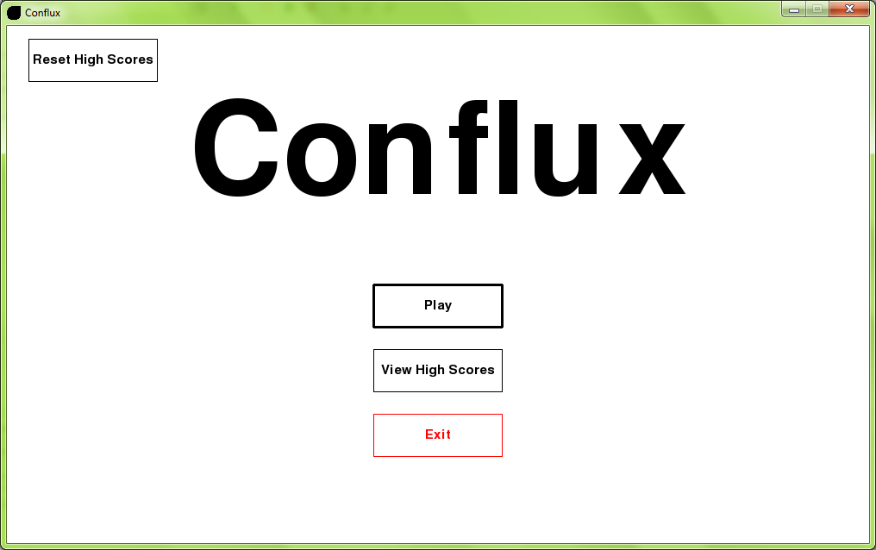

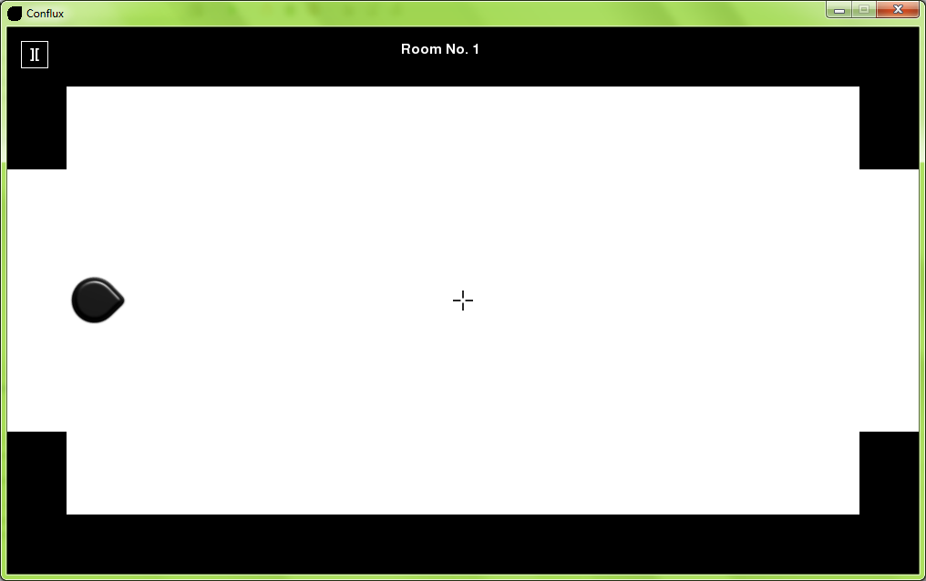

1.2

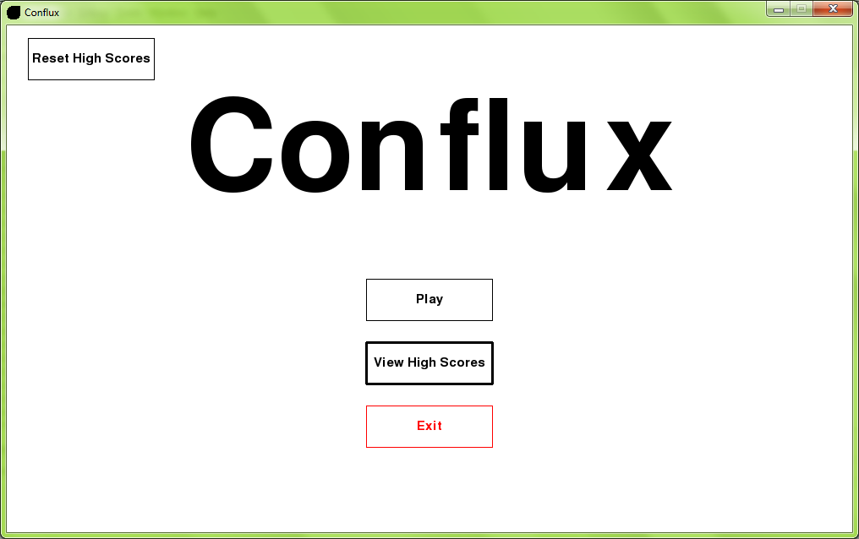

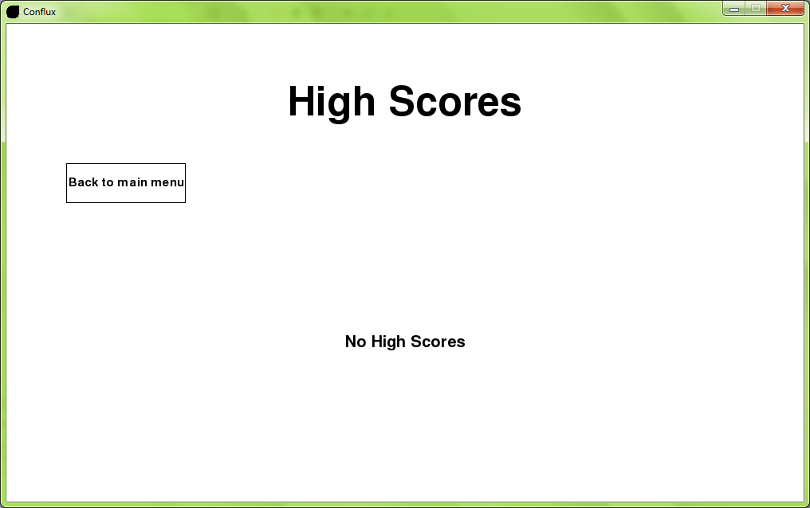

1.3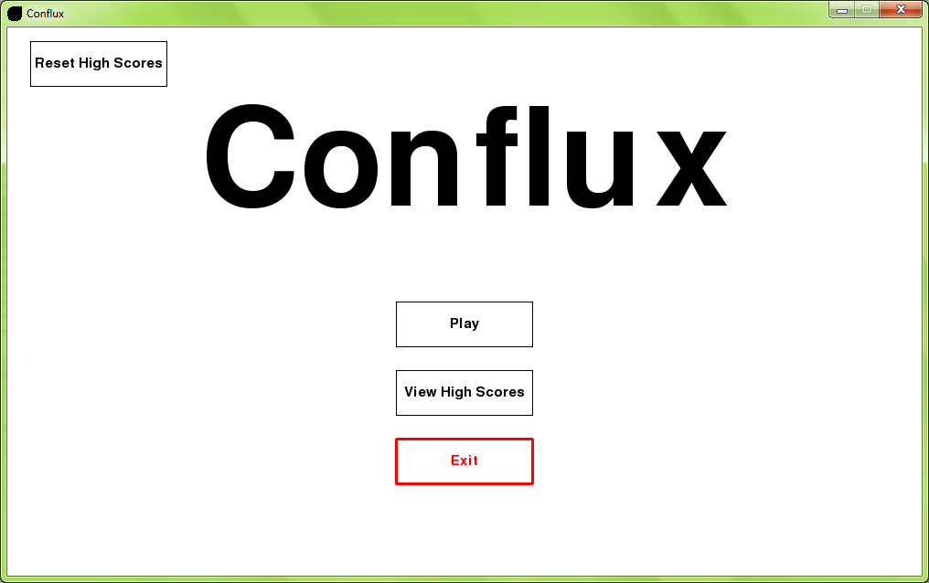

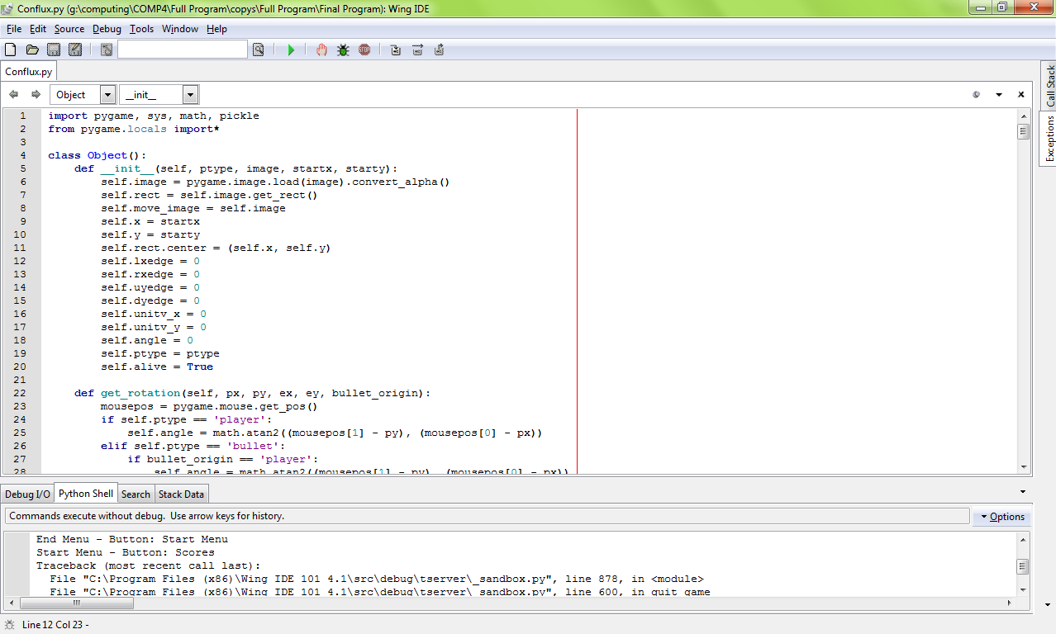

1.4

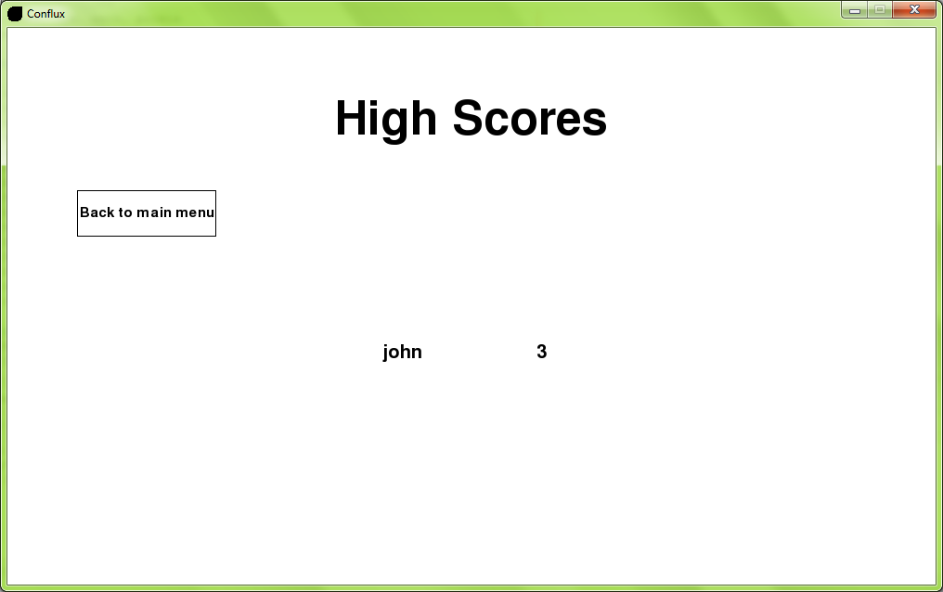

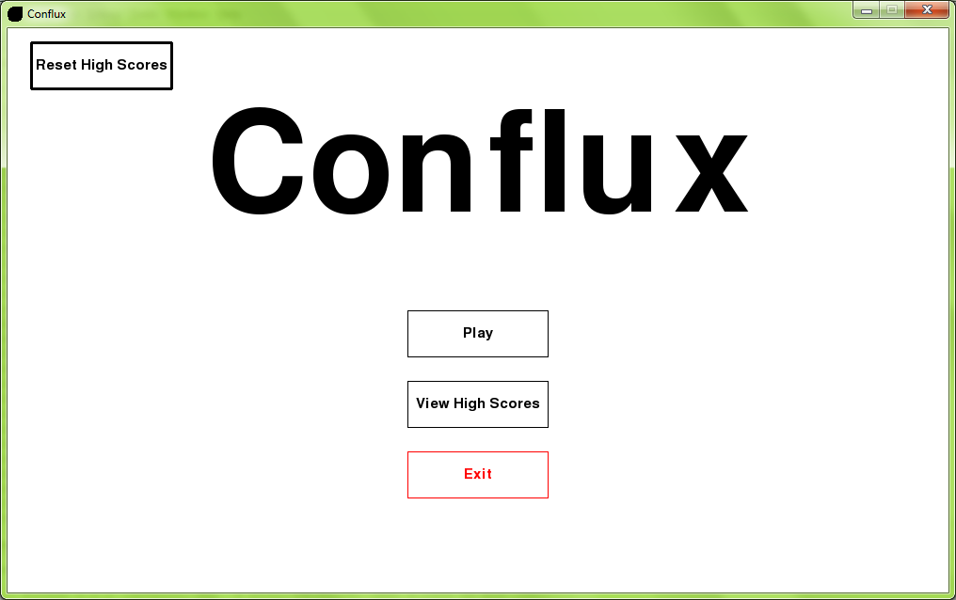

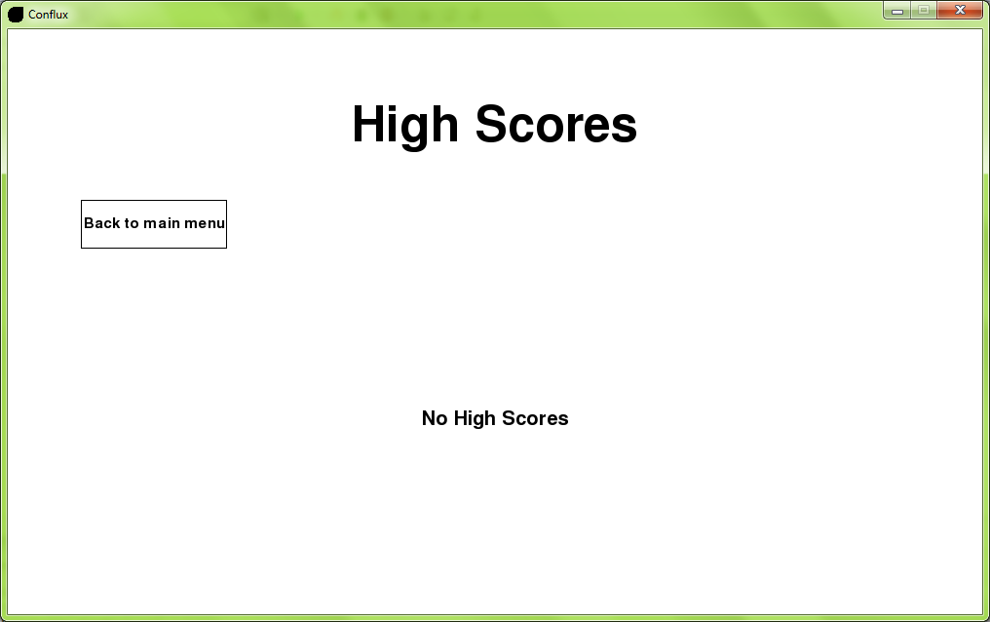

1.5

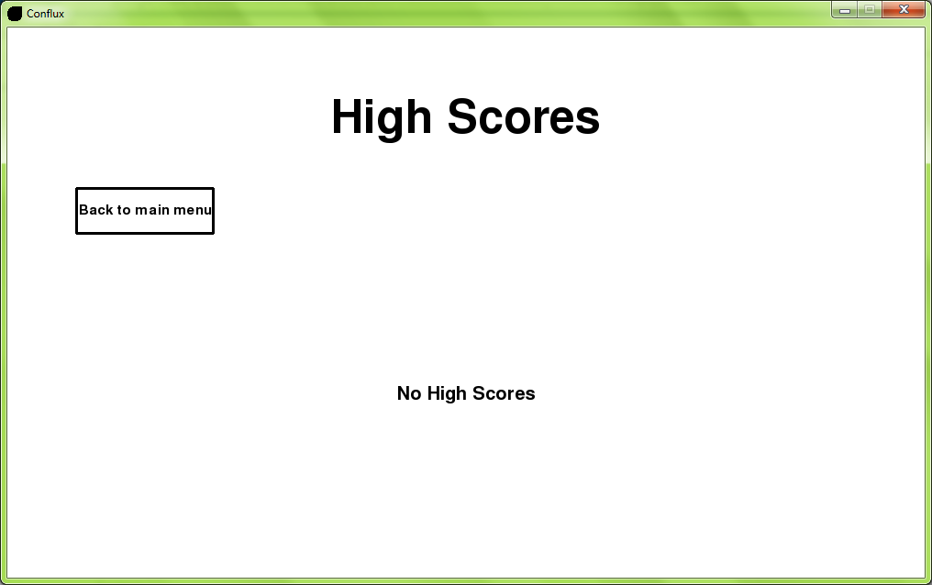

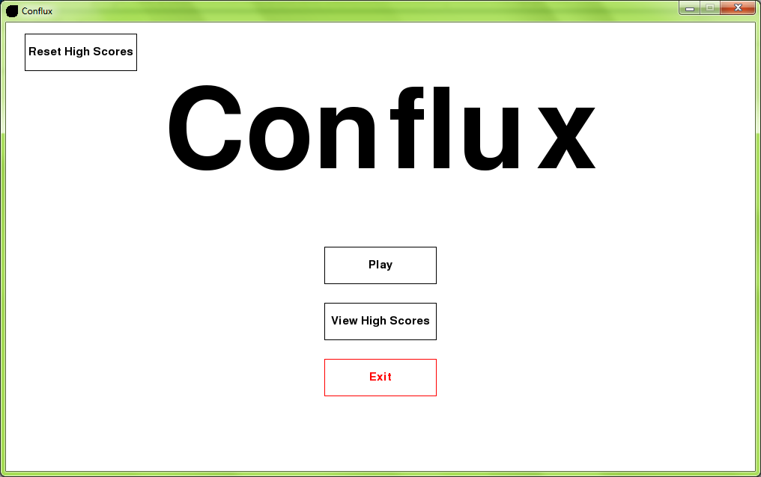

1.6

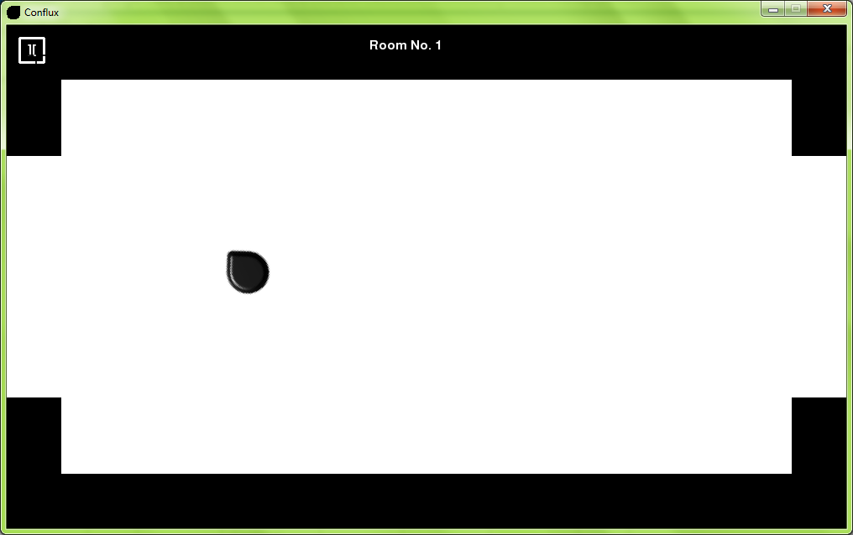

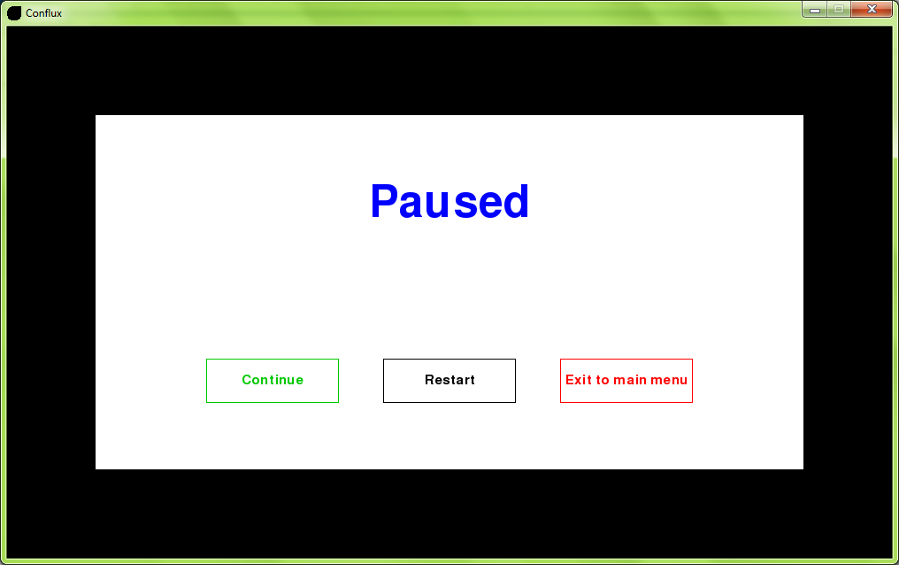

1.7

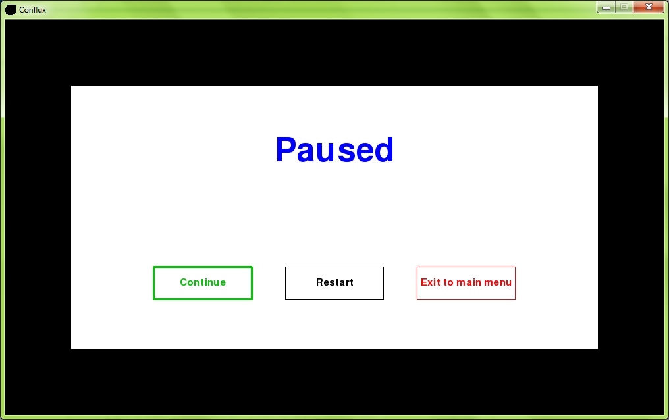

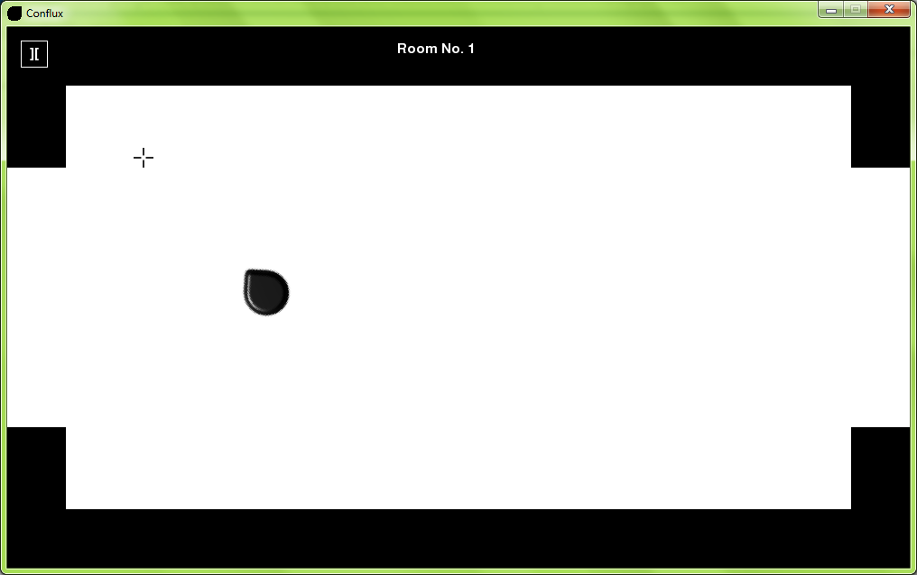

1.8

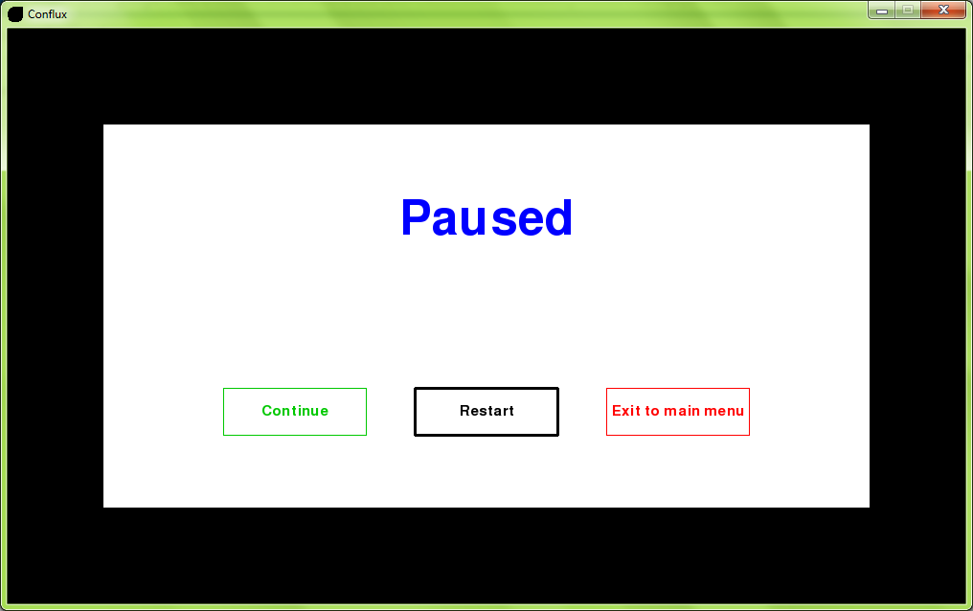

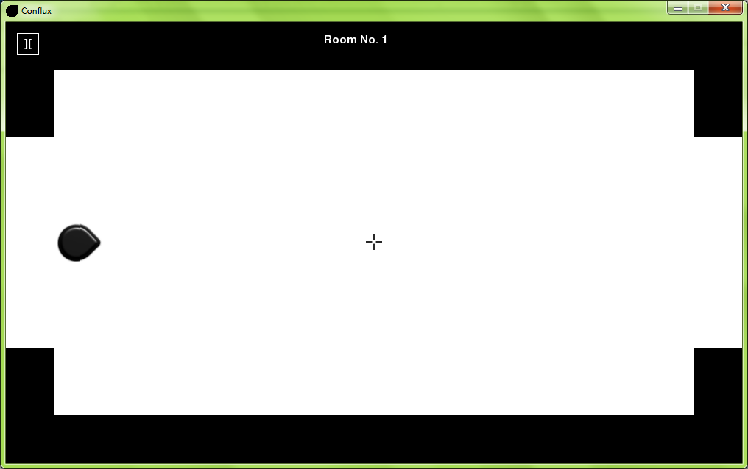

1.9

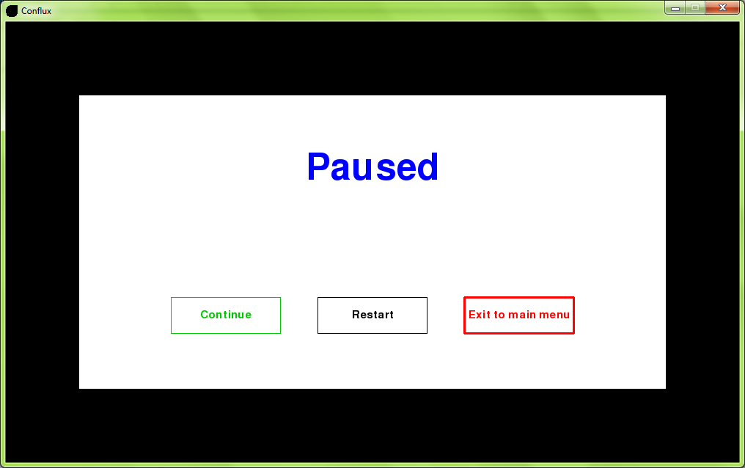

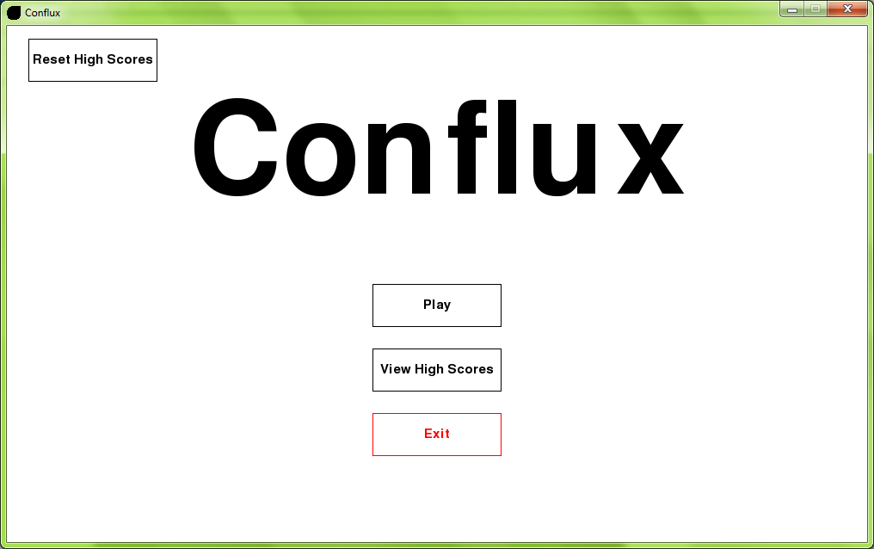

1.10a

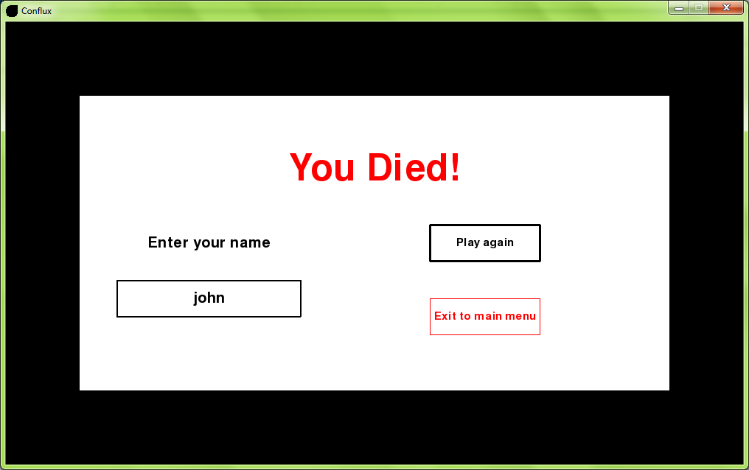

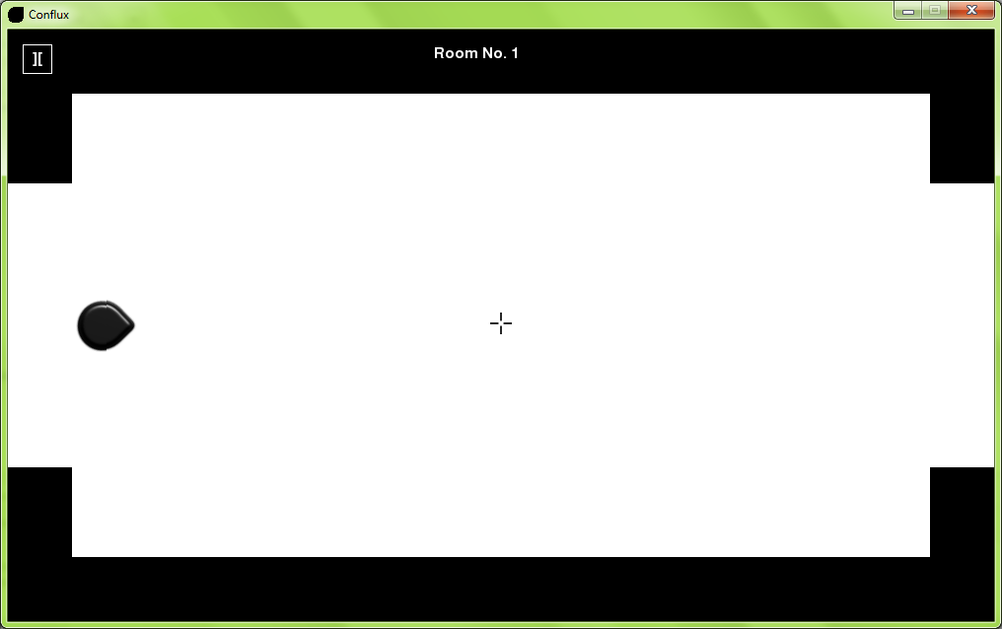

1.10b

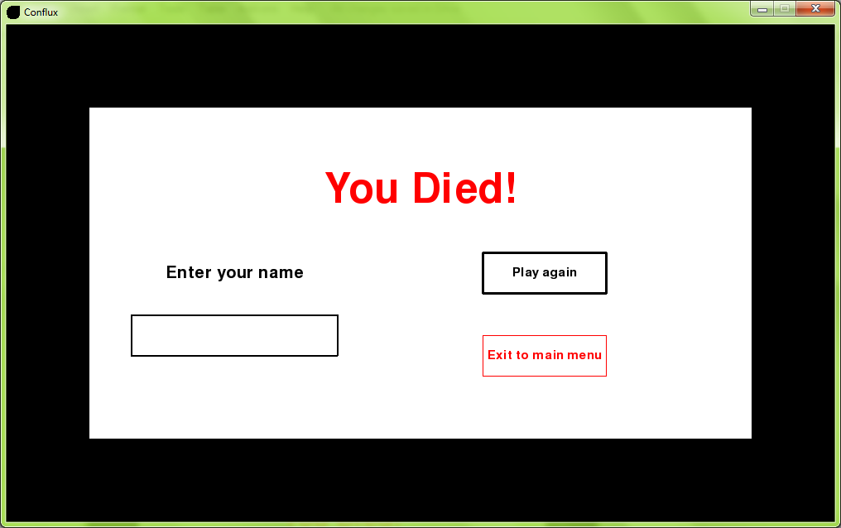

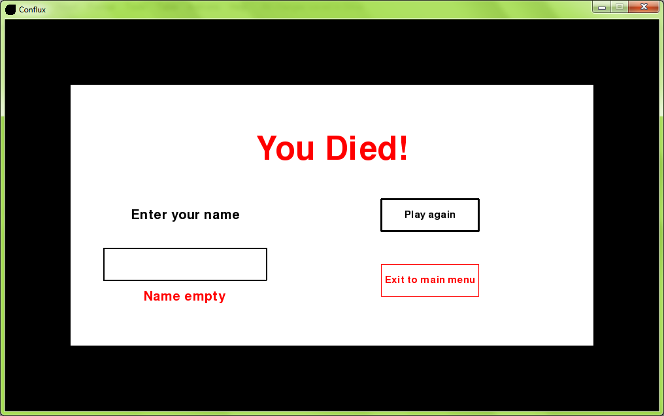

1.11a

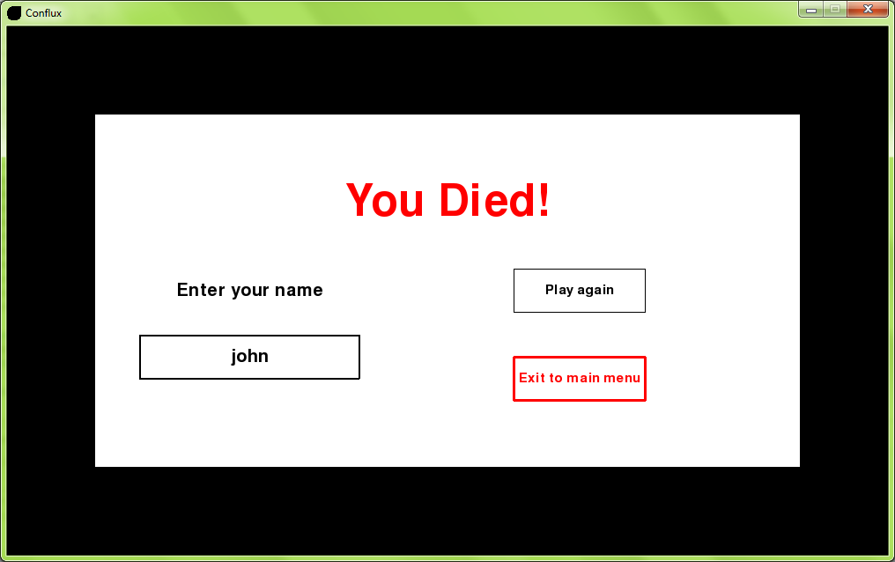

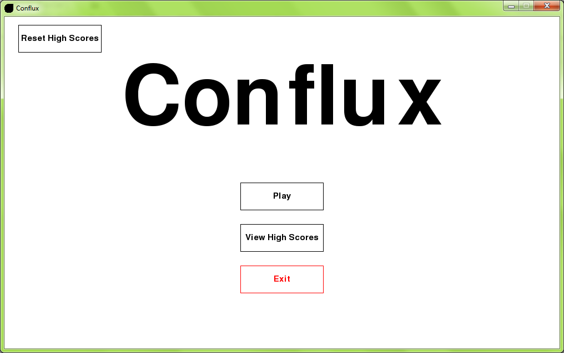

1.11b

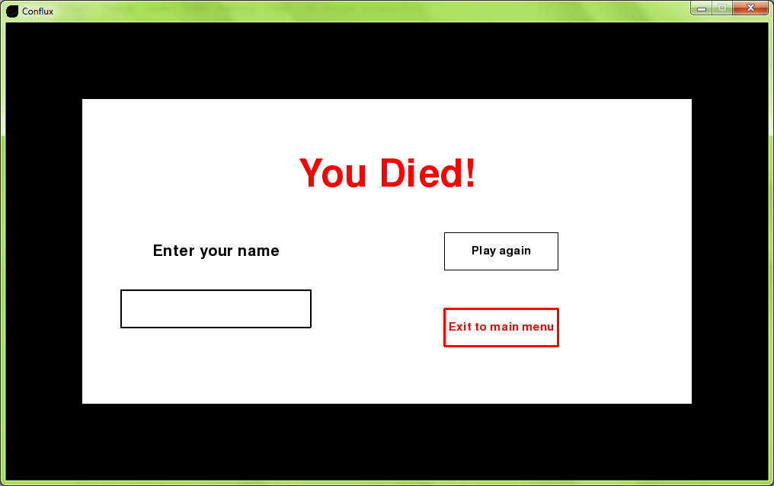

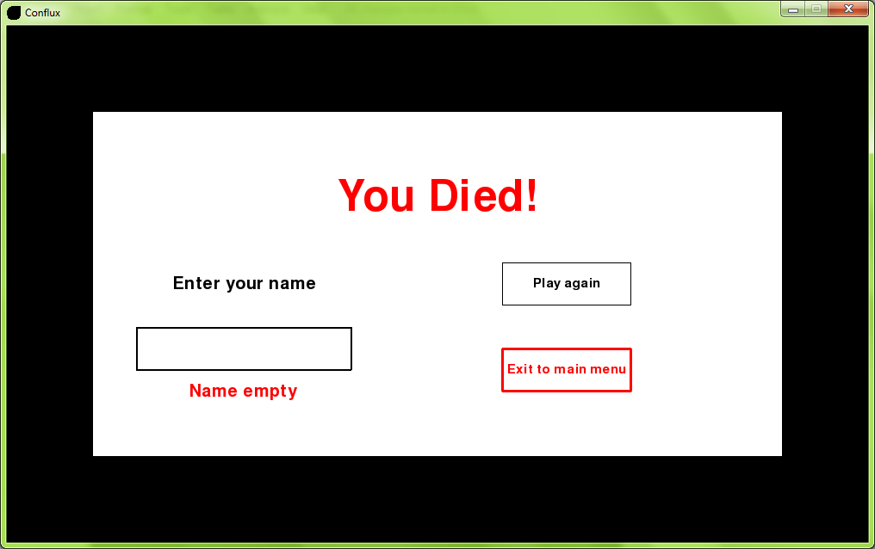

2.1a

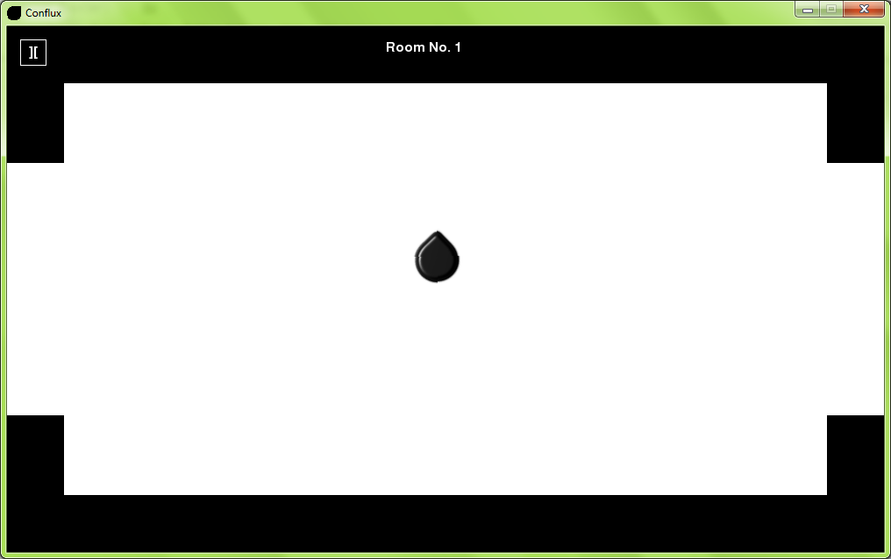

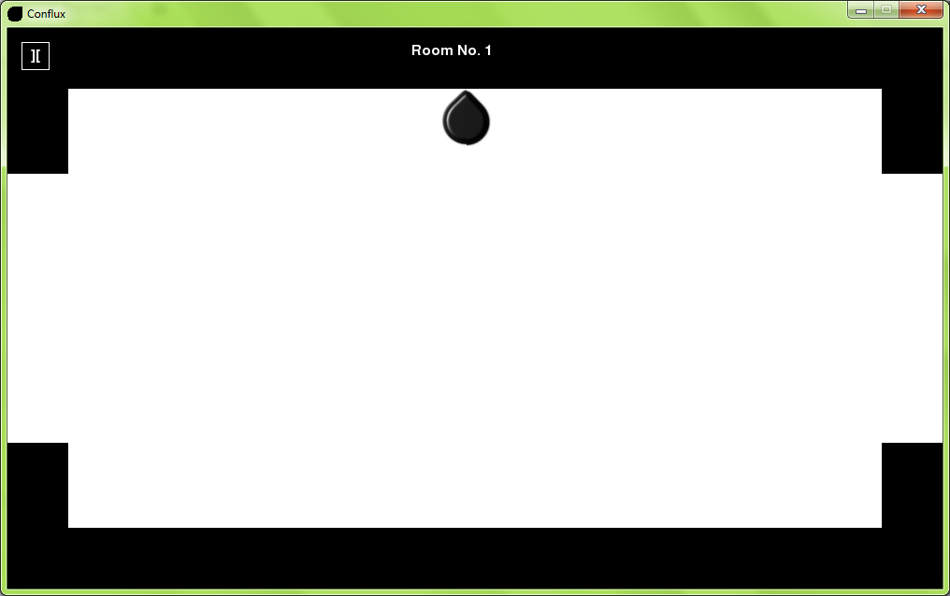

2.1b



2.2a

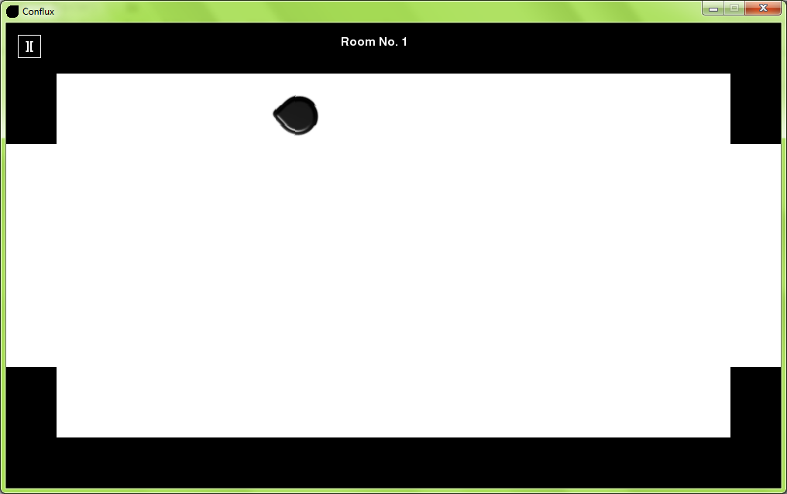

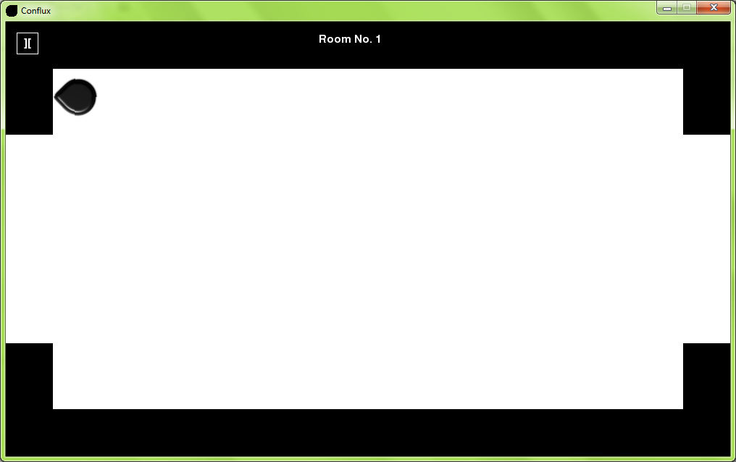

2.2b



2.3a

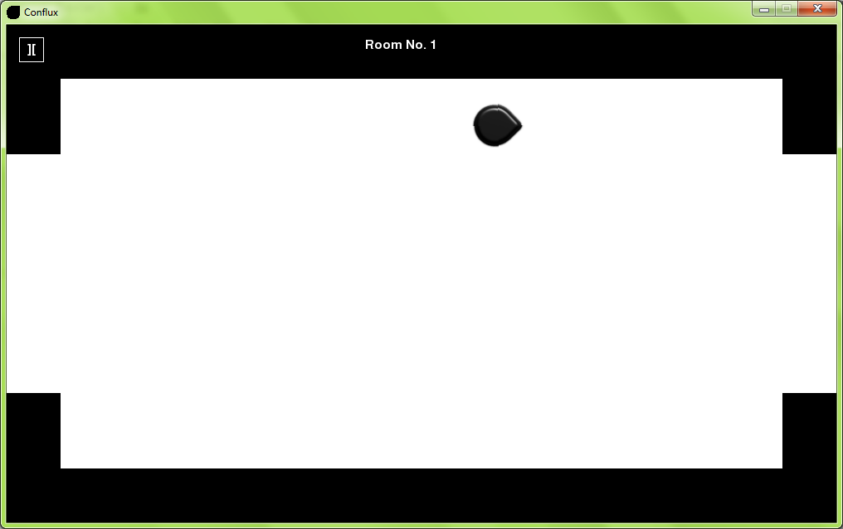

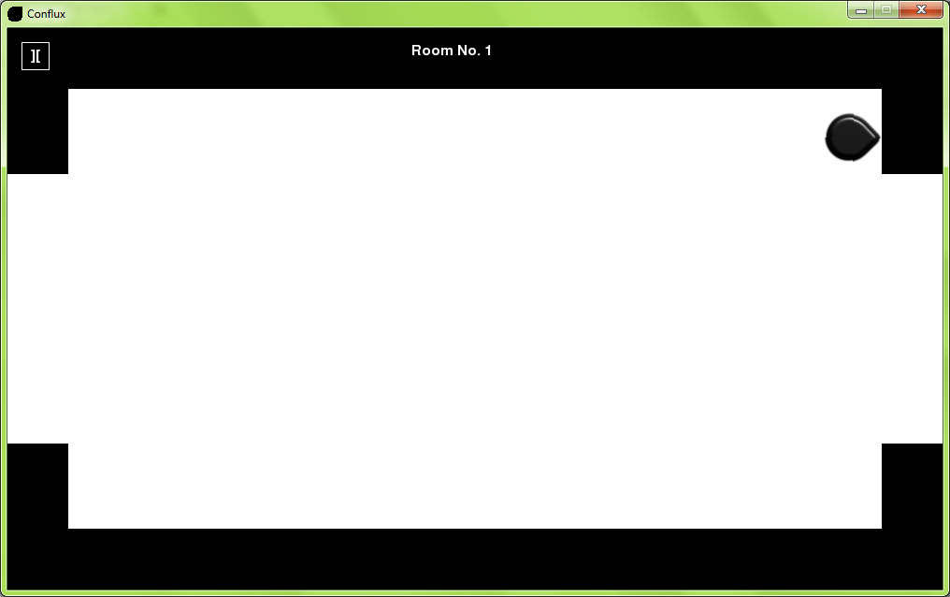

2.3b



2.4a

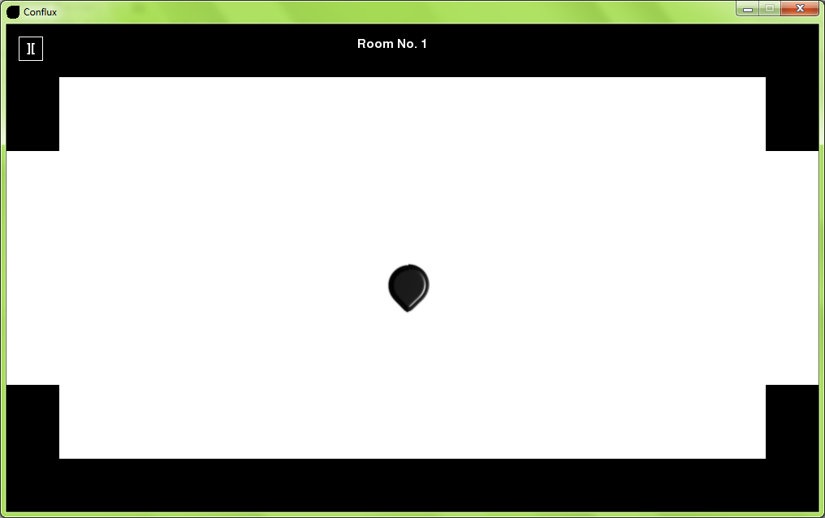

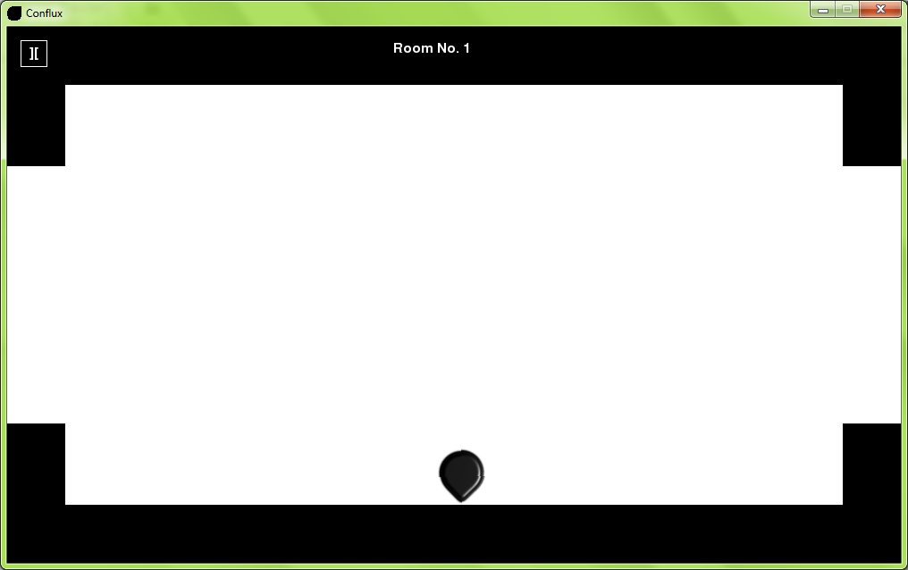

2.4b



2.5a

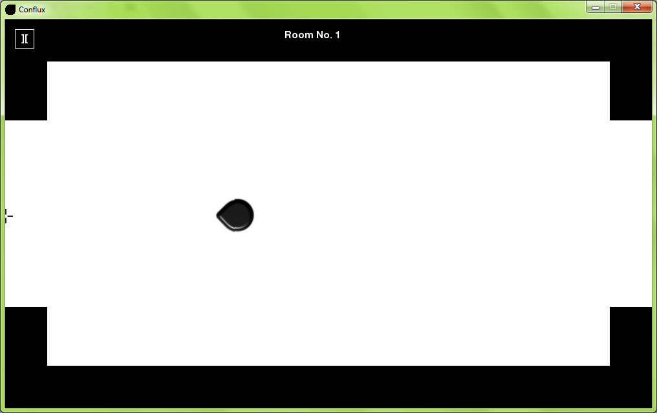

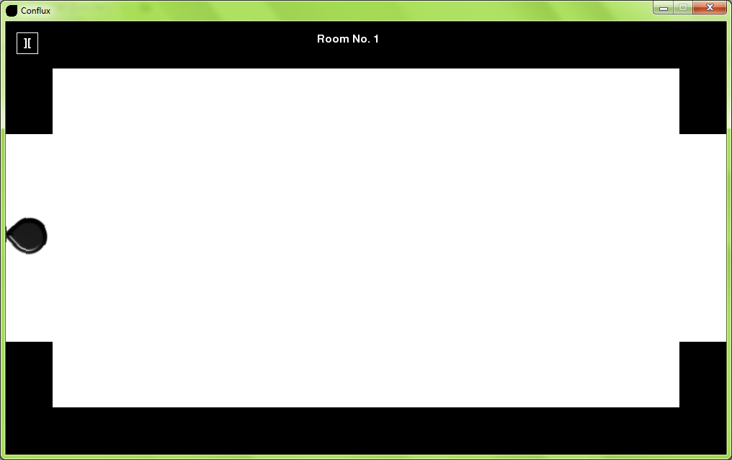

2.5b



2.6a

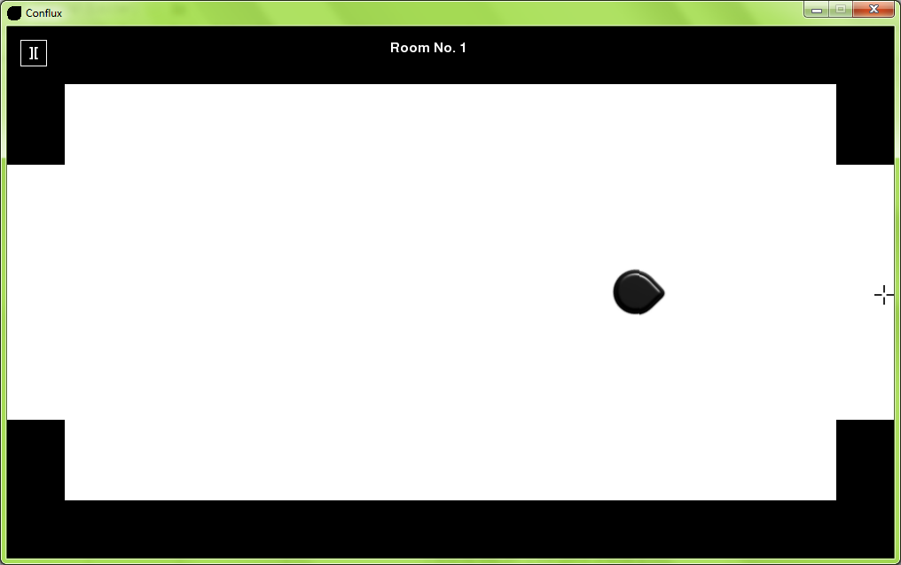

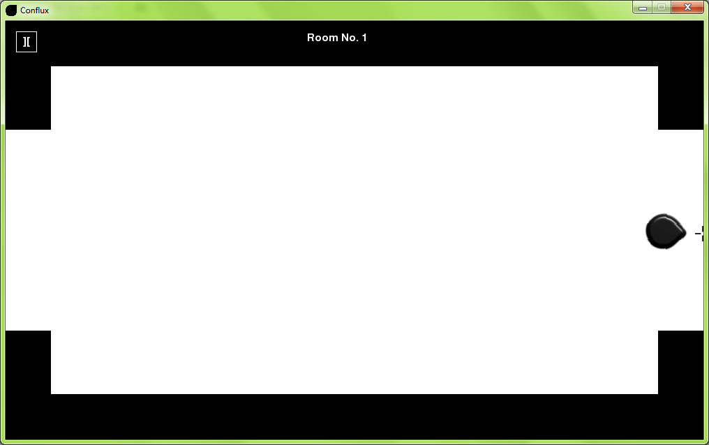

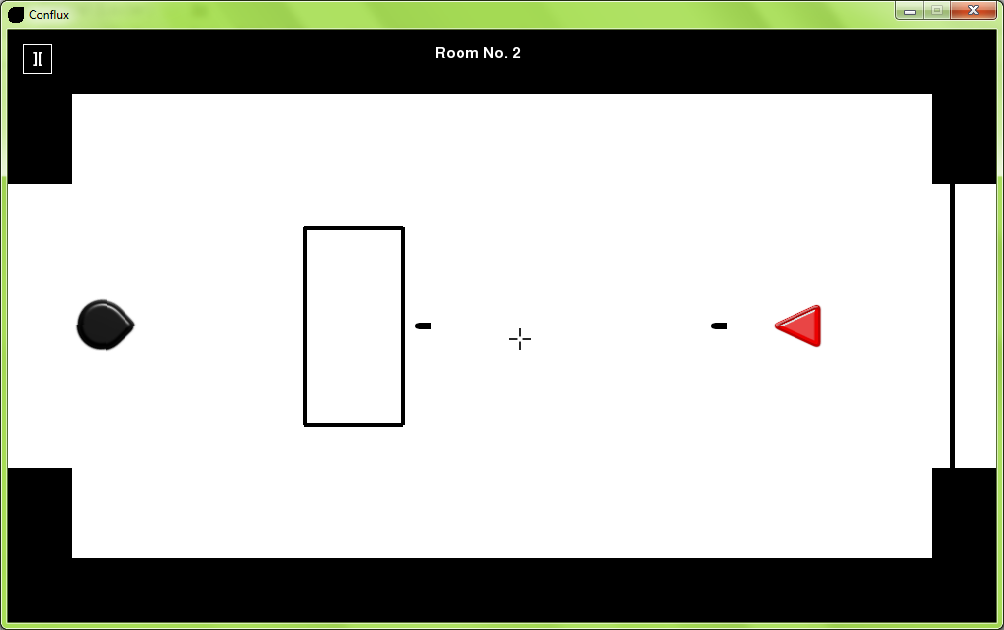

2.6b



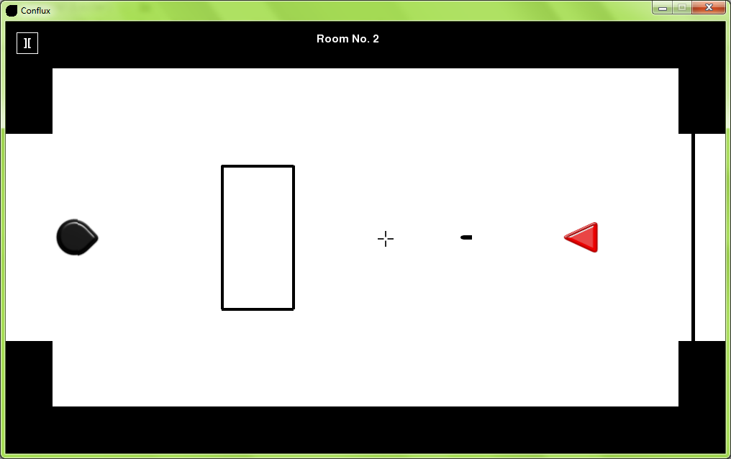

2.7a

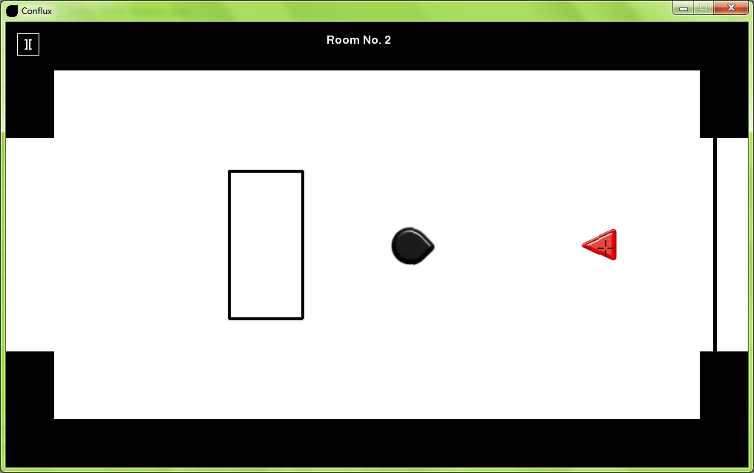

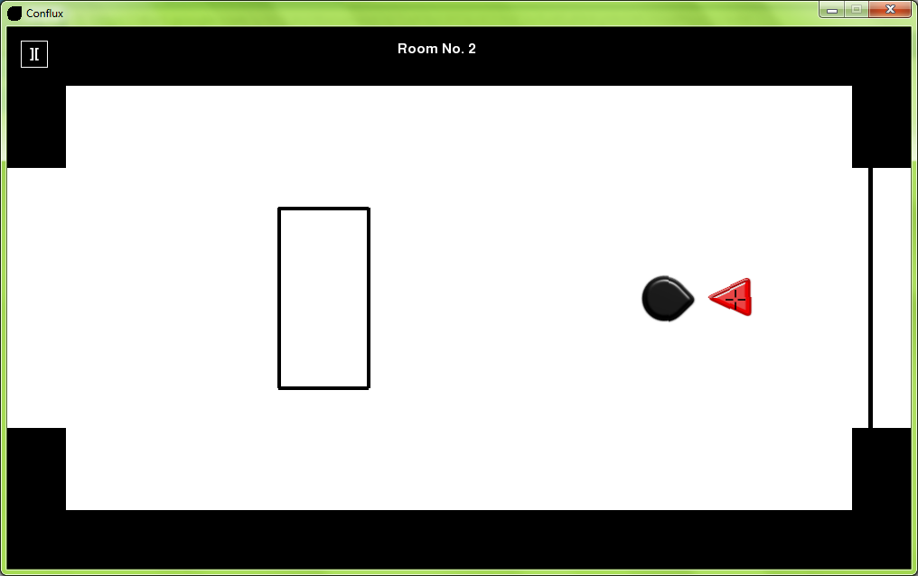

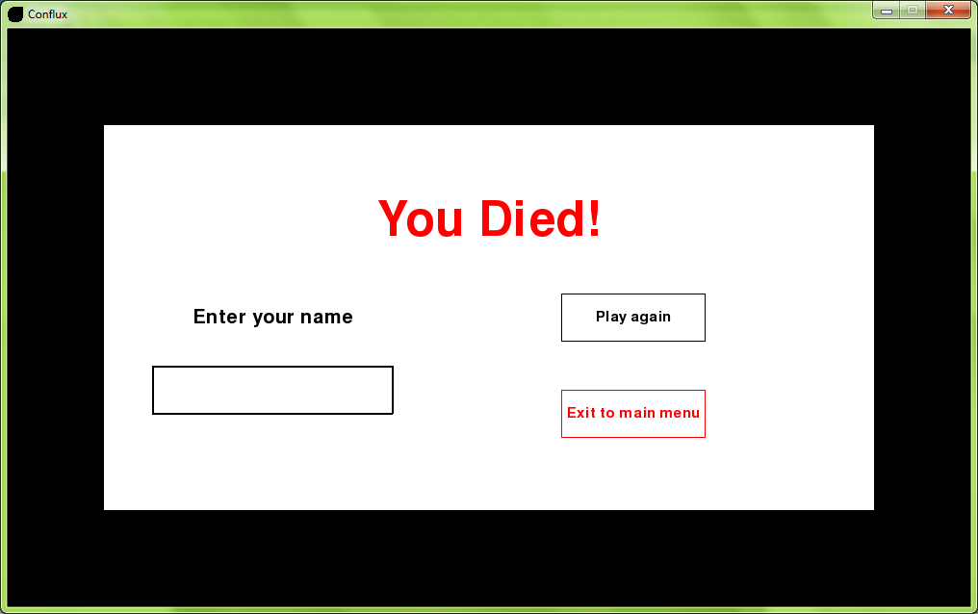

2.7b

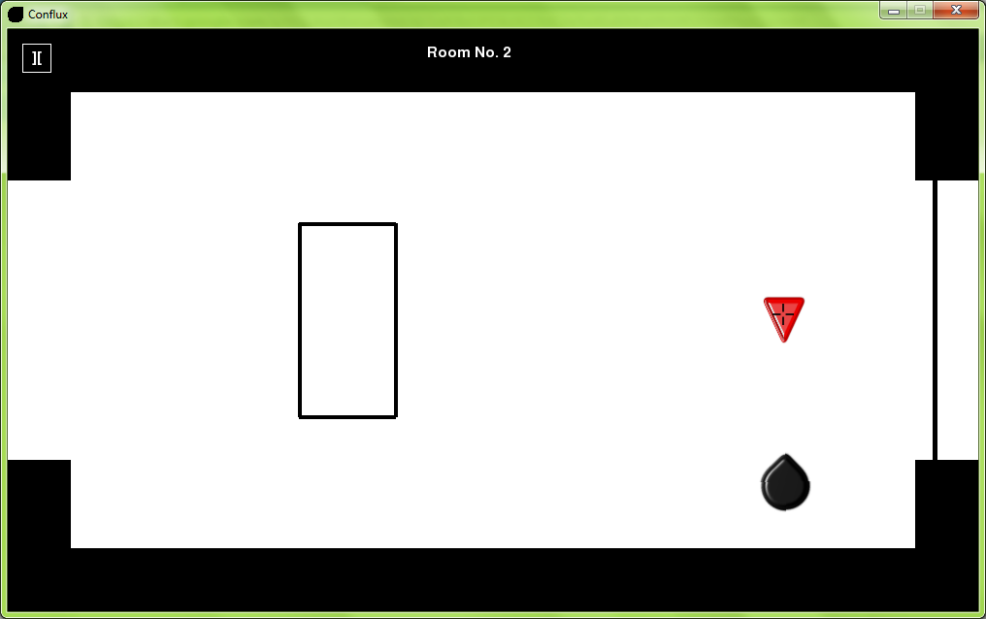

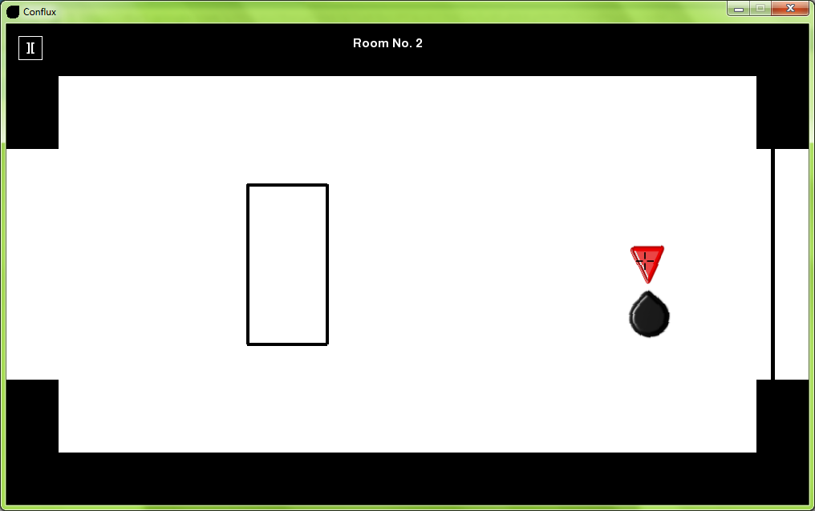



2.7c

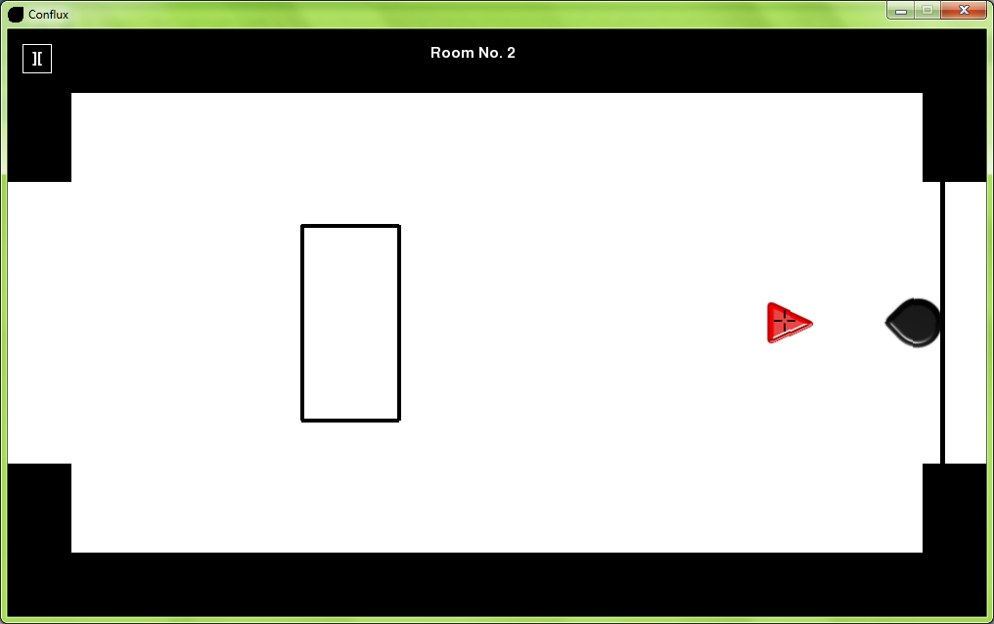

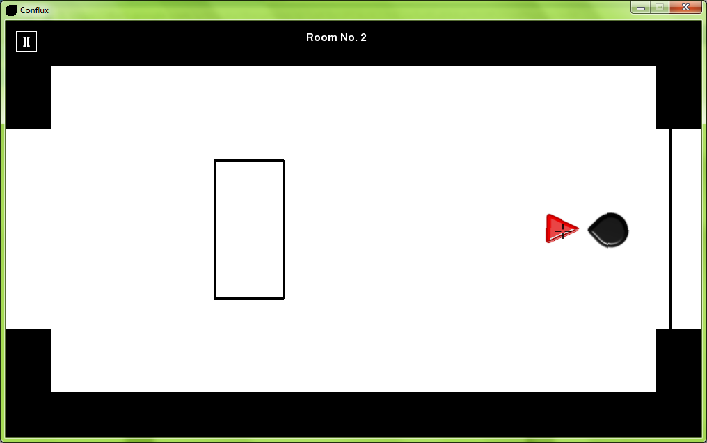



2.7d

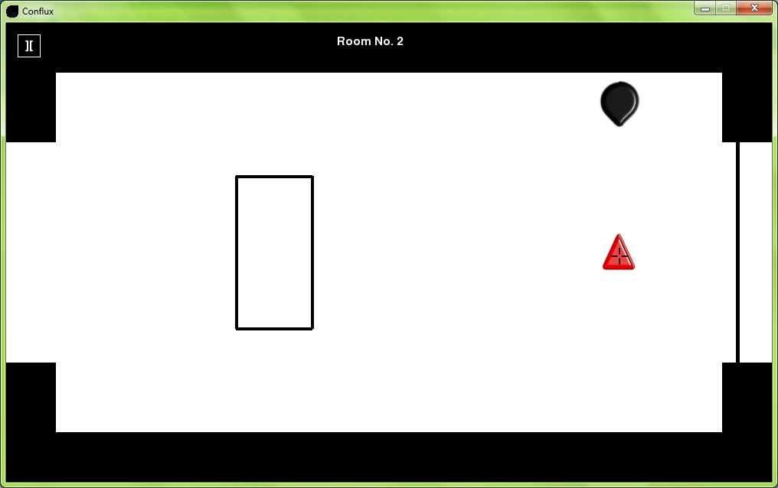

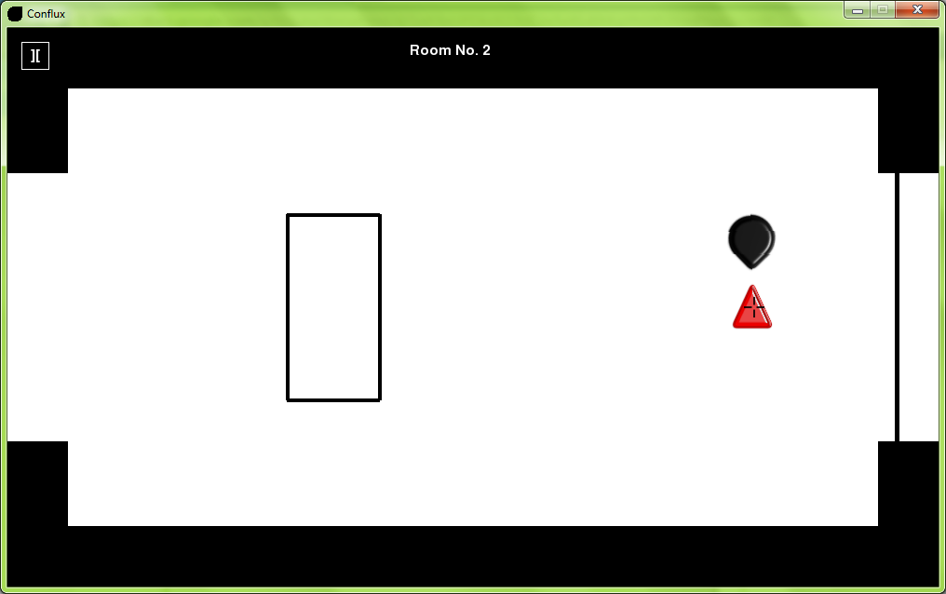



2.7e

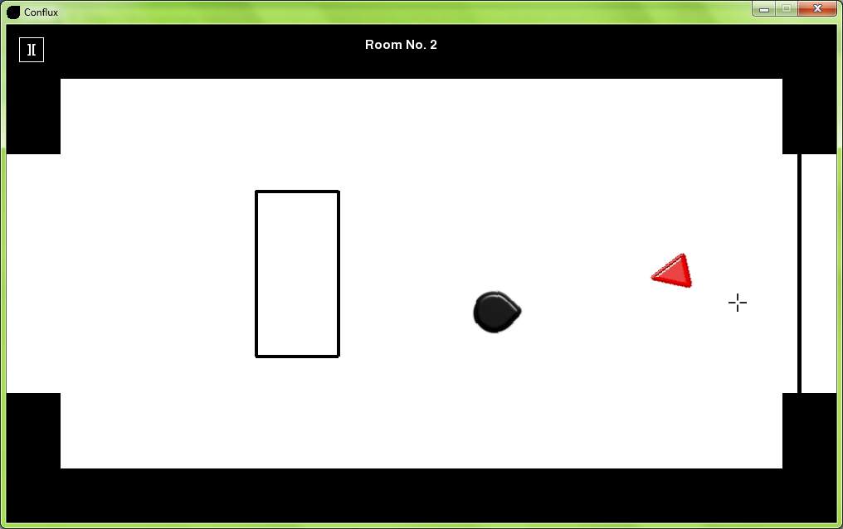

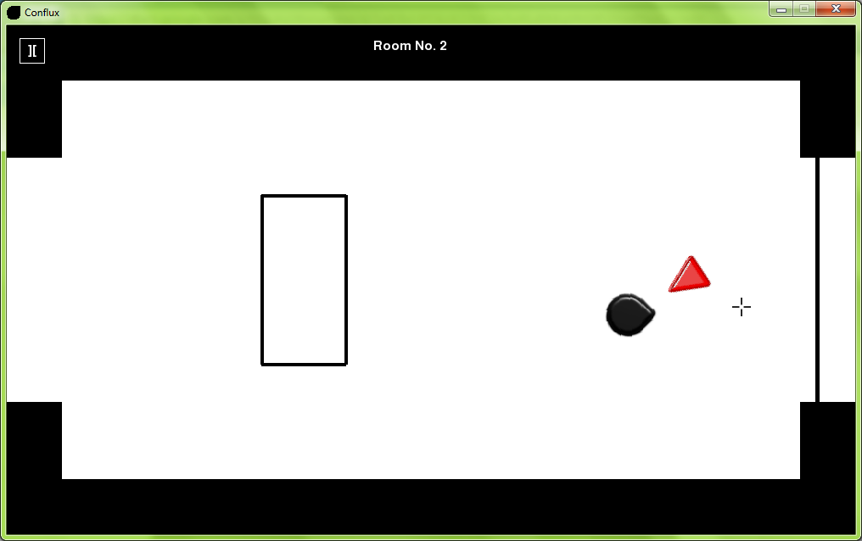



2.7f

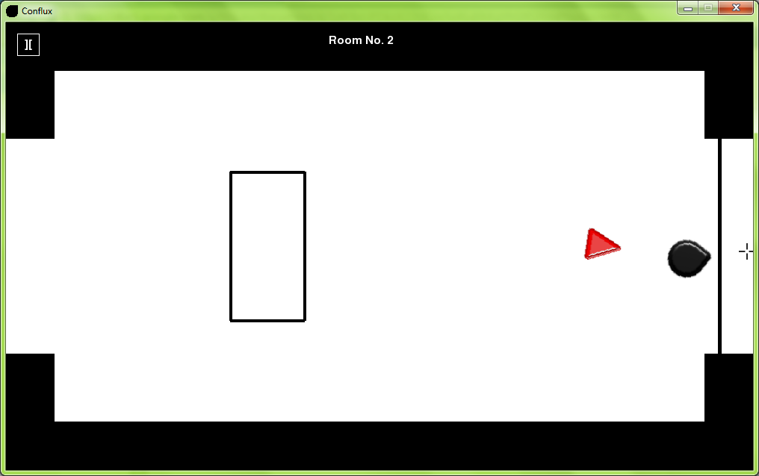

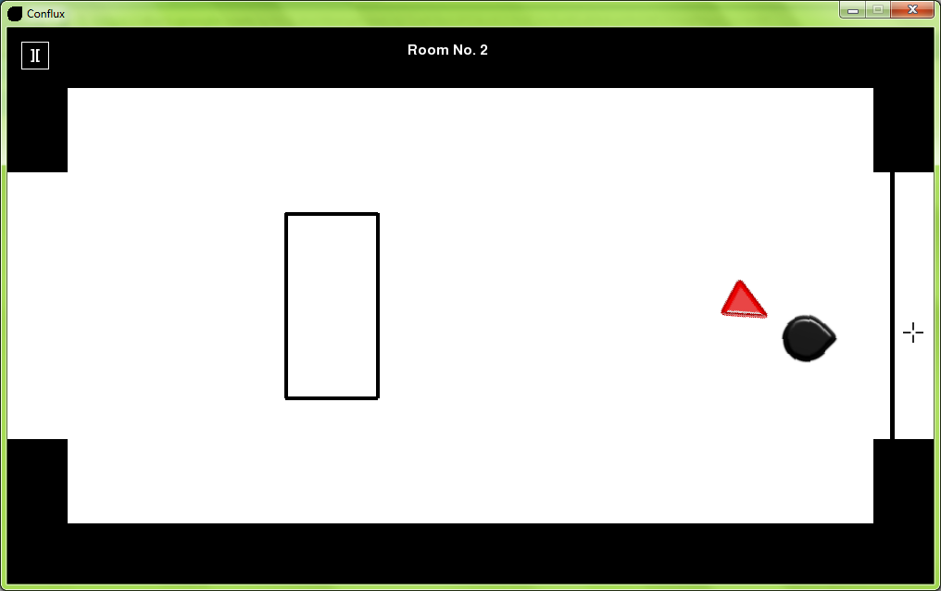



2.7g

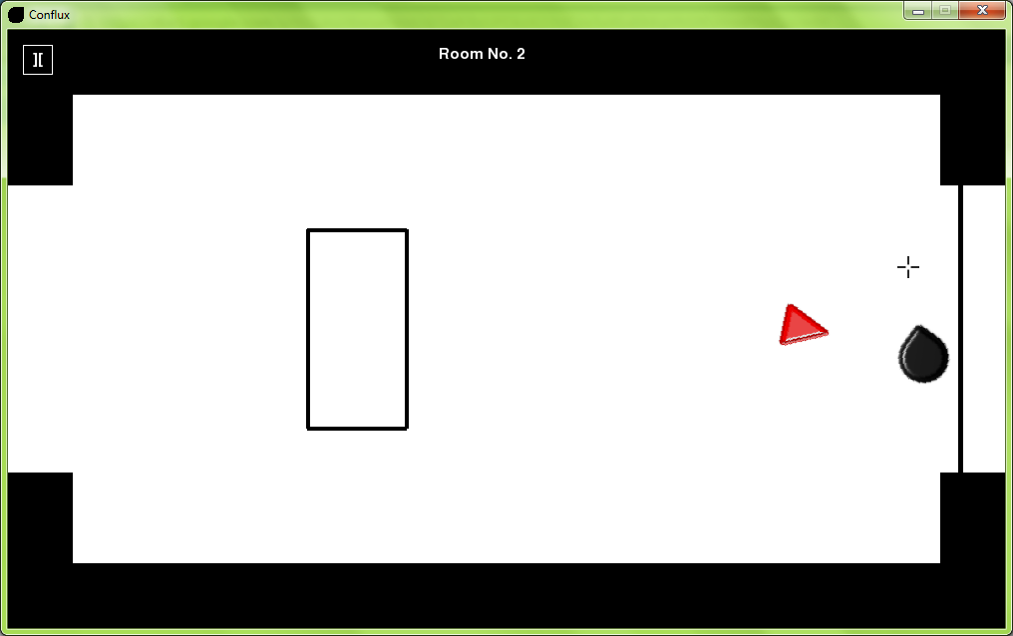

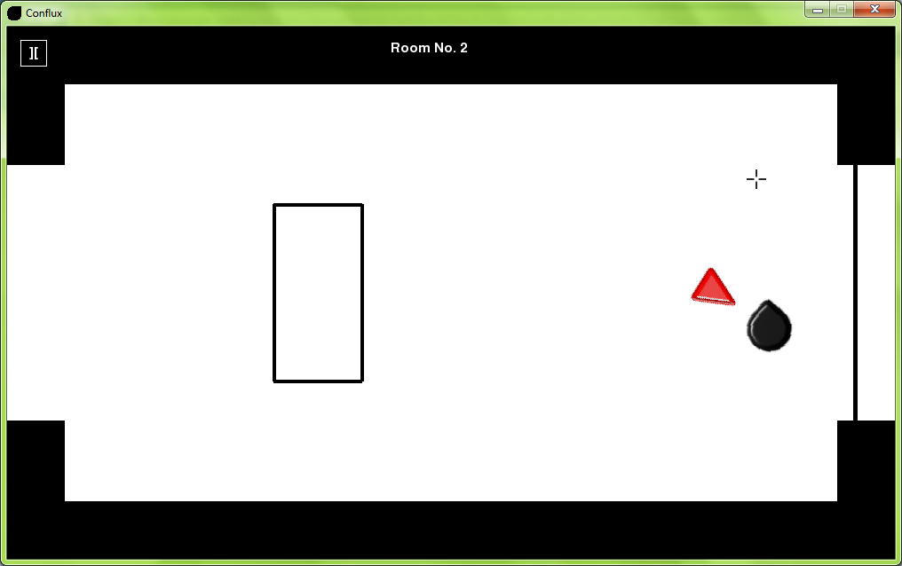



2.7h

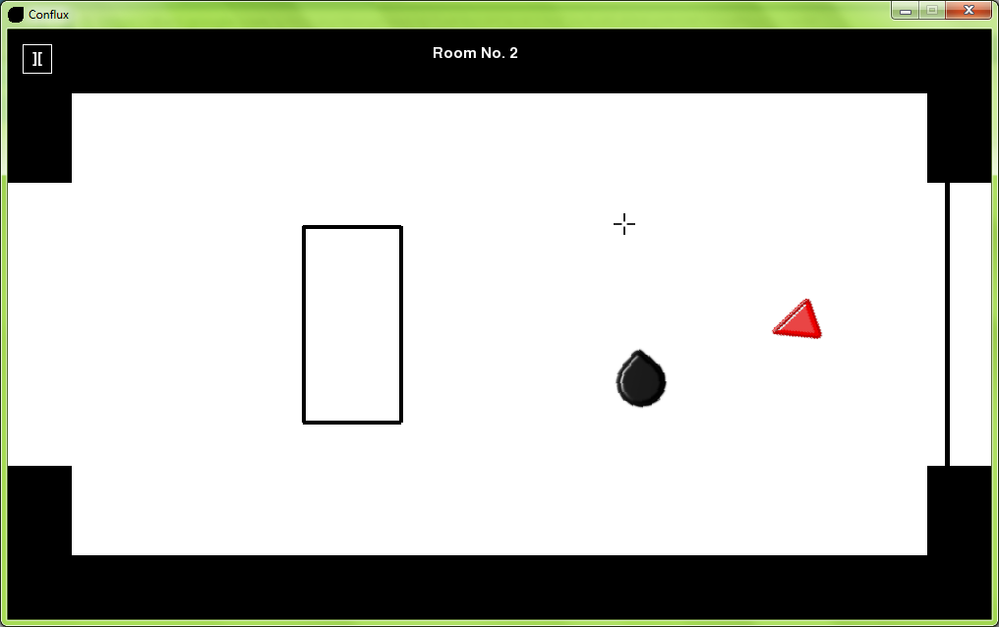

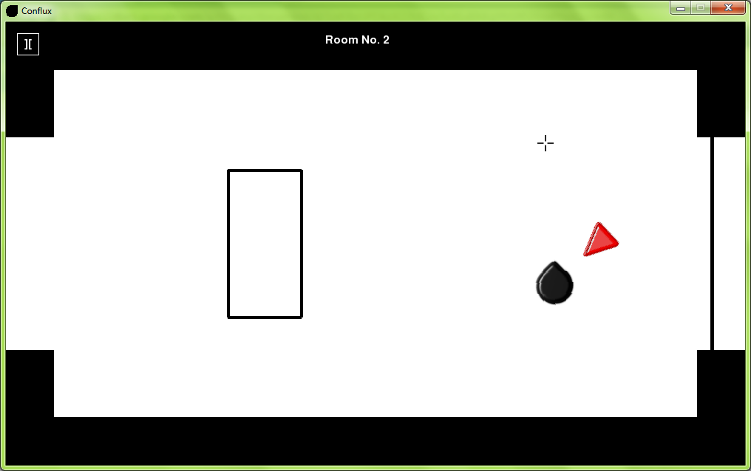



2.8a

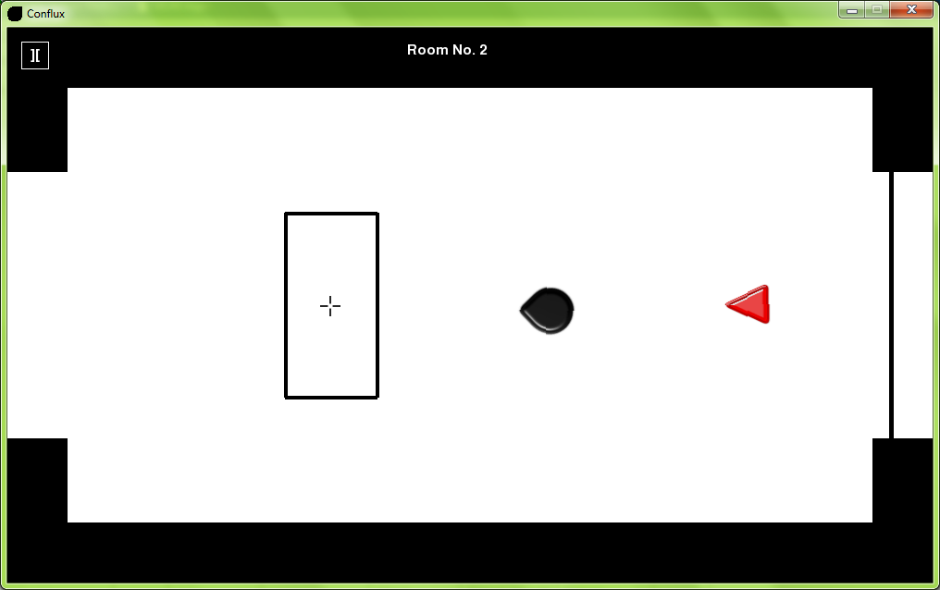

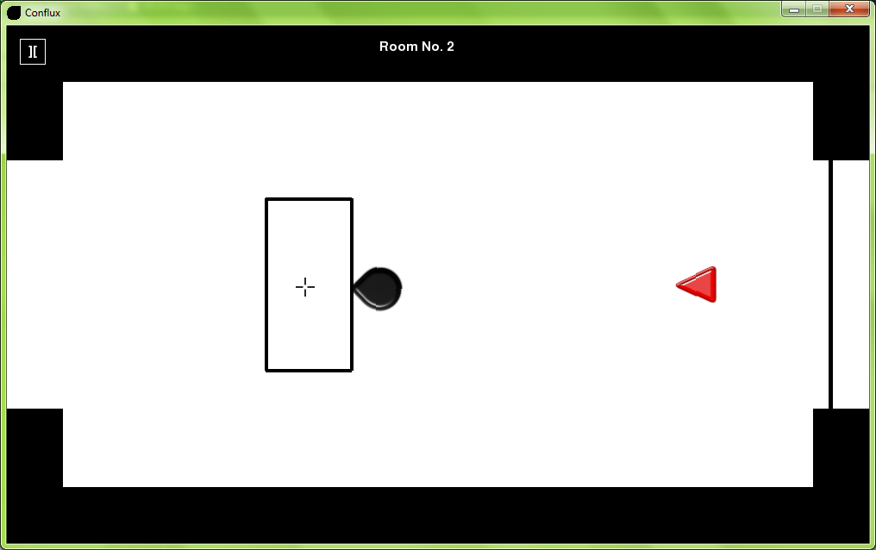

2.8b

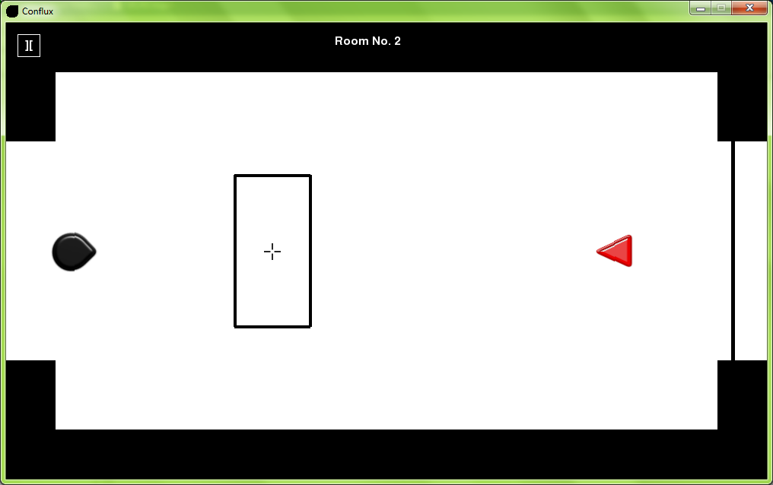

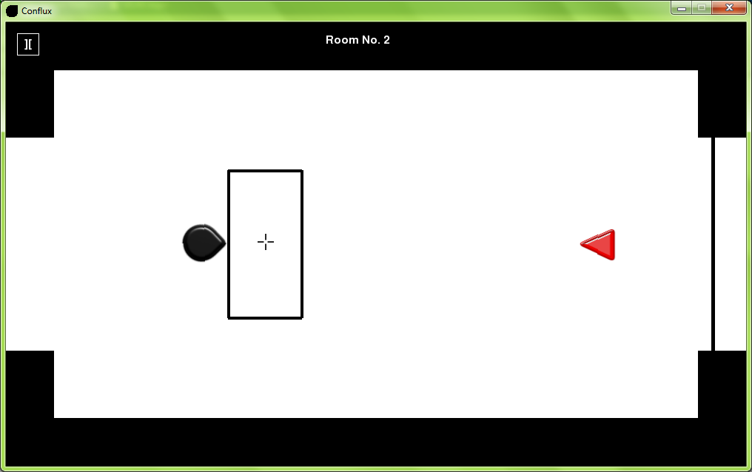

2.8c

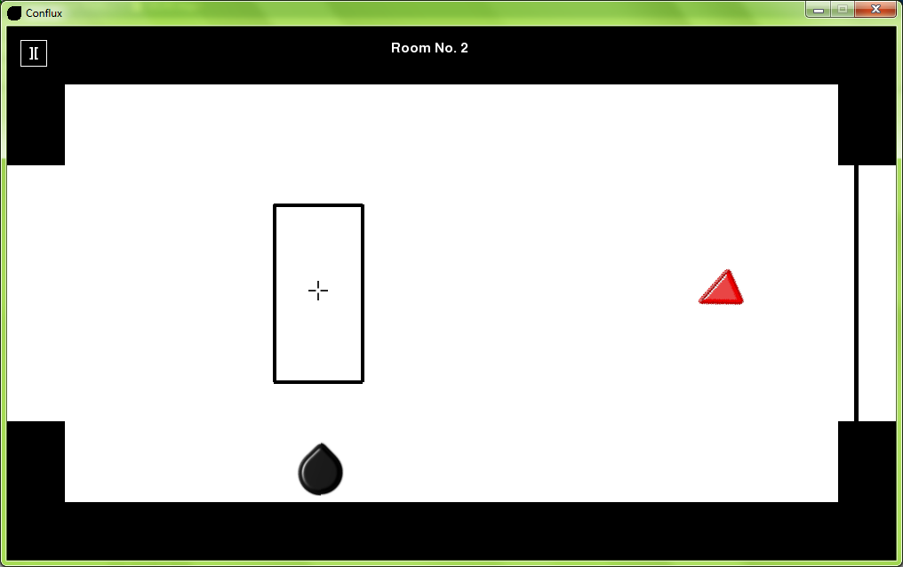

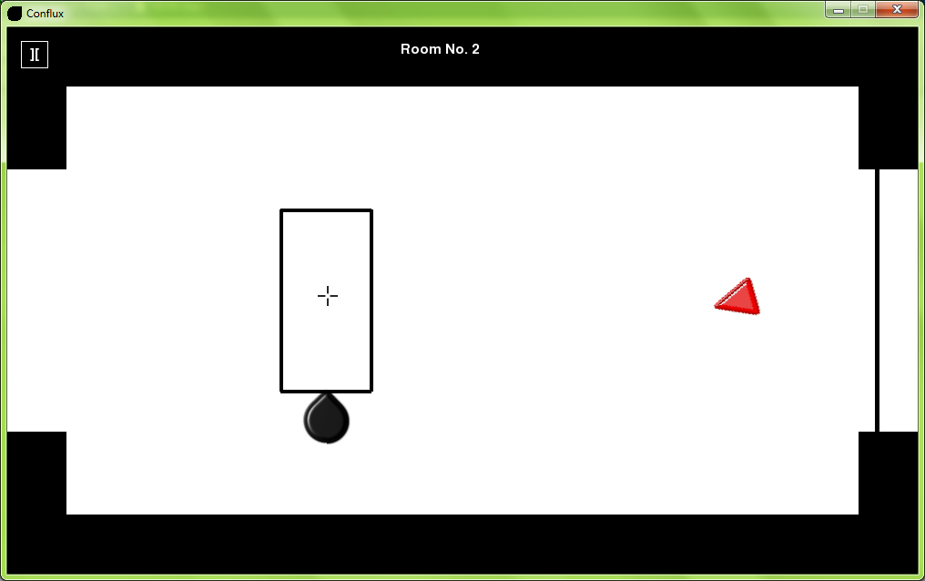

2.8d

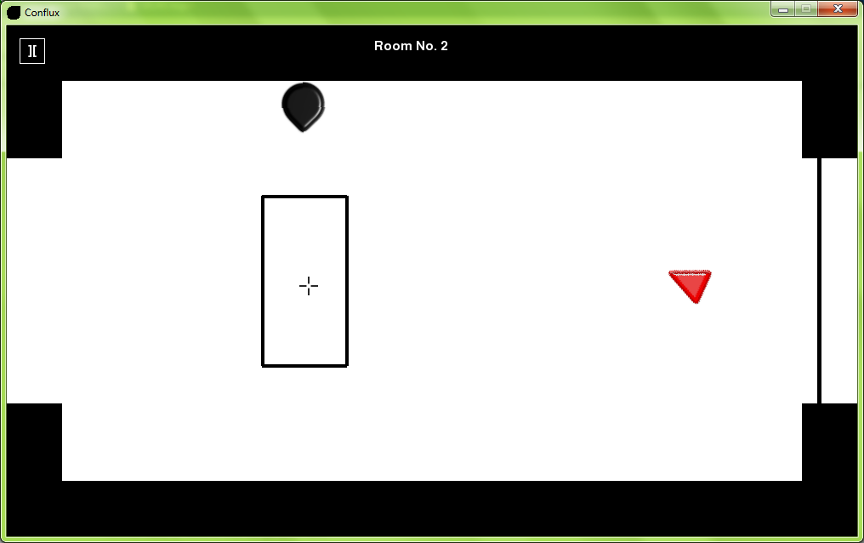

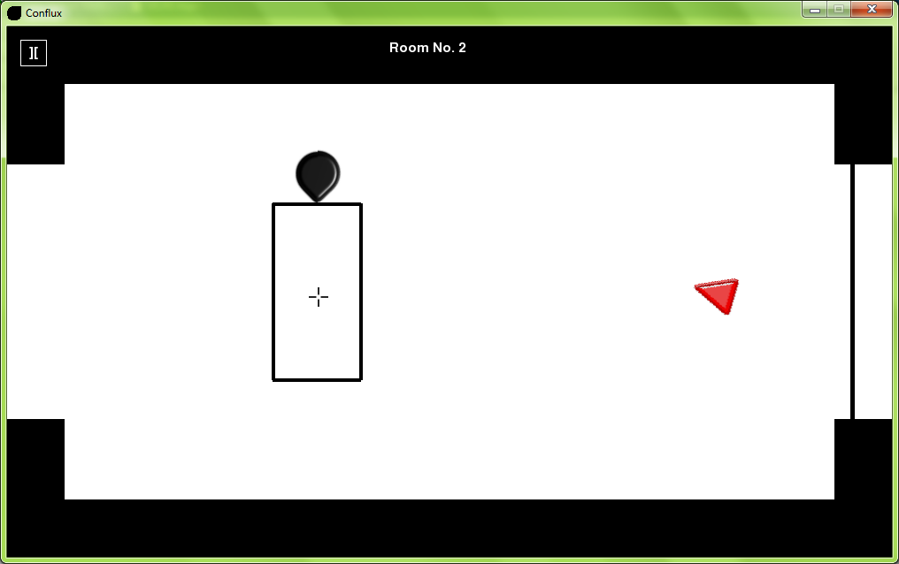

2.8e

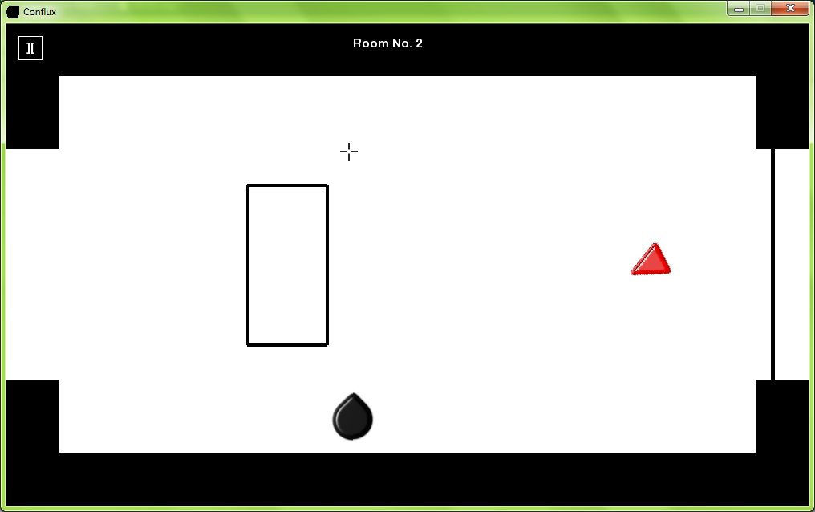

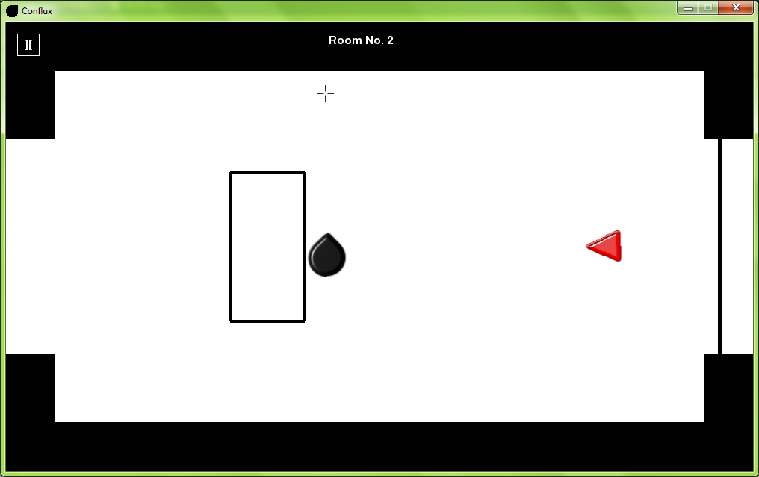

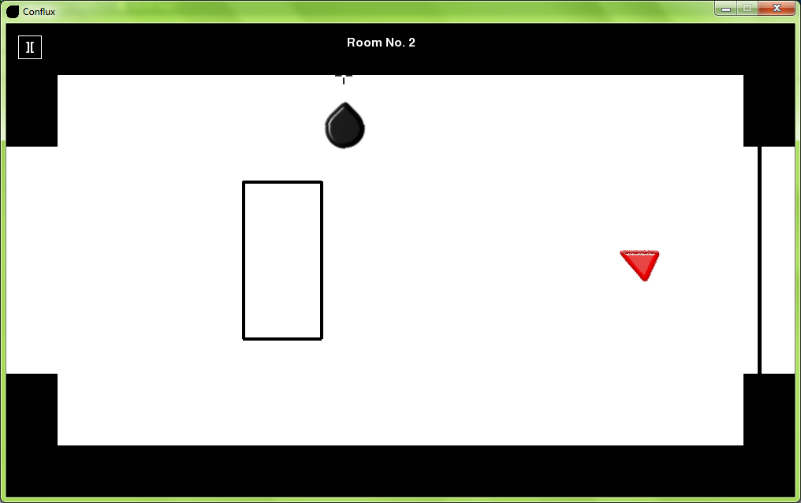

2.8f

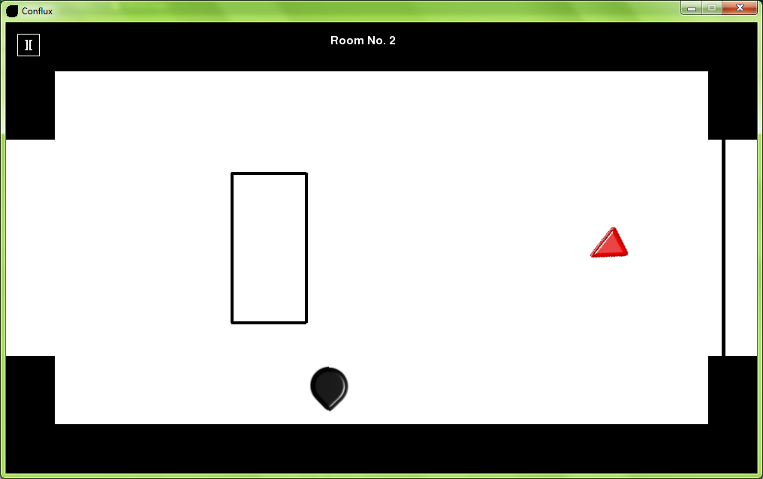

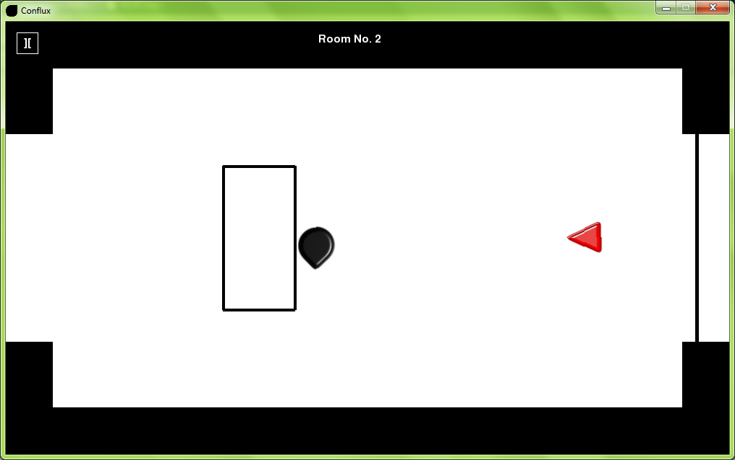

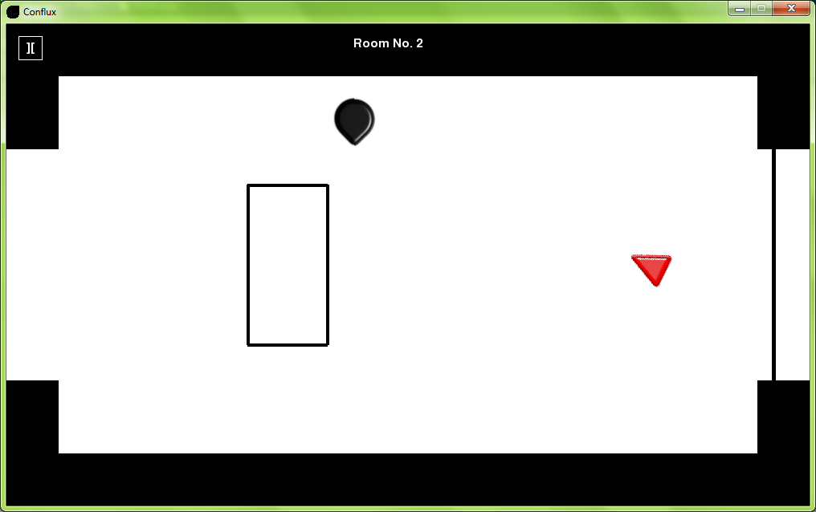

2.8g

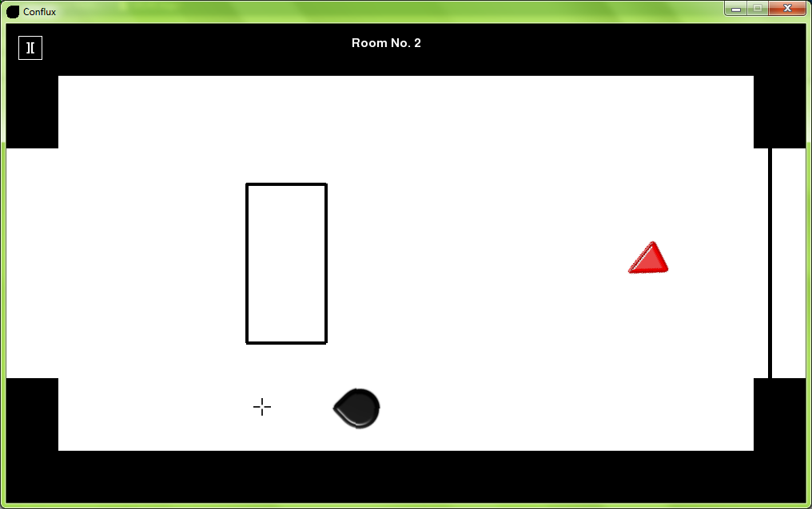

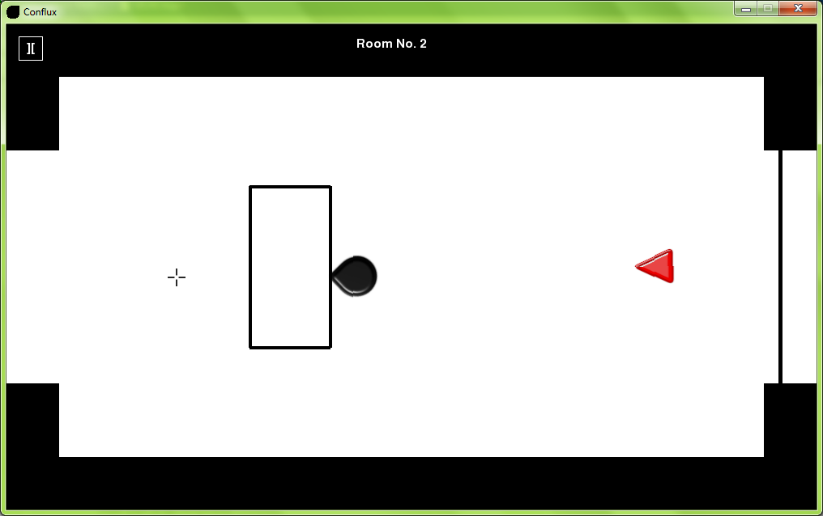

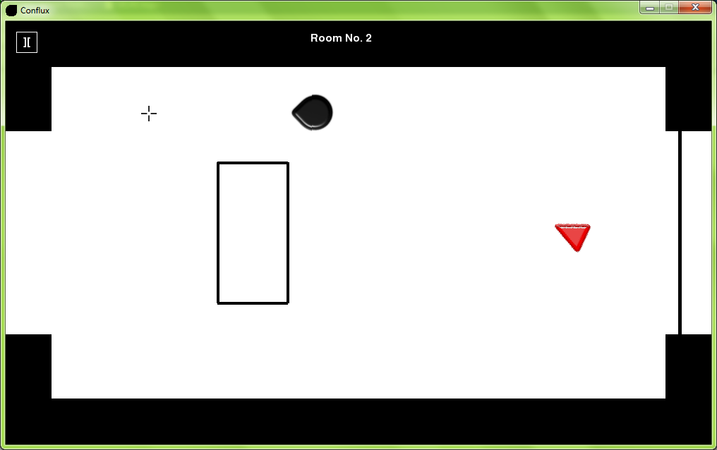

2.8h

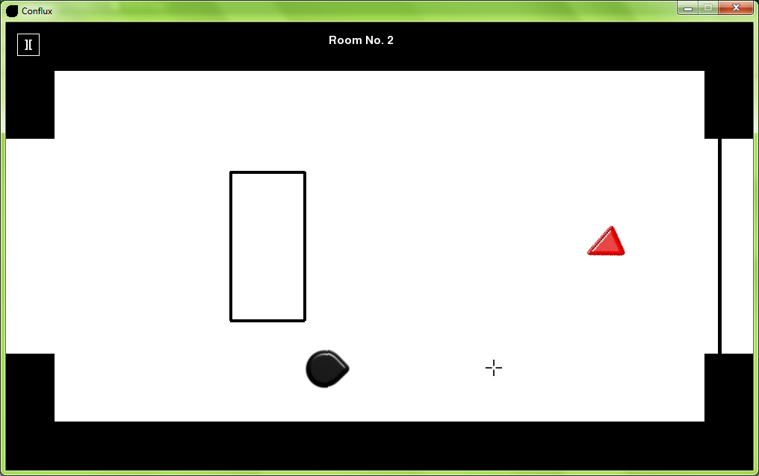

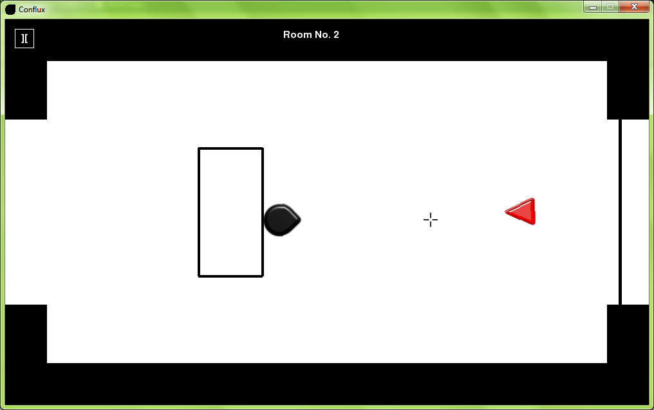

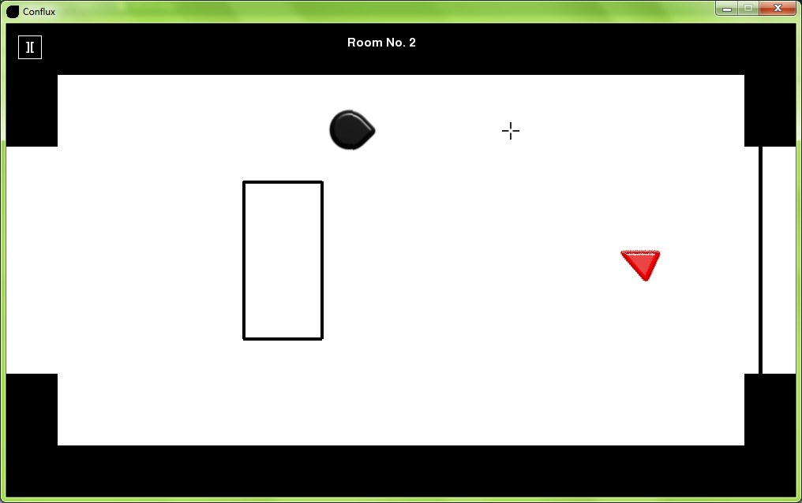

2.9a

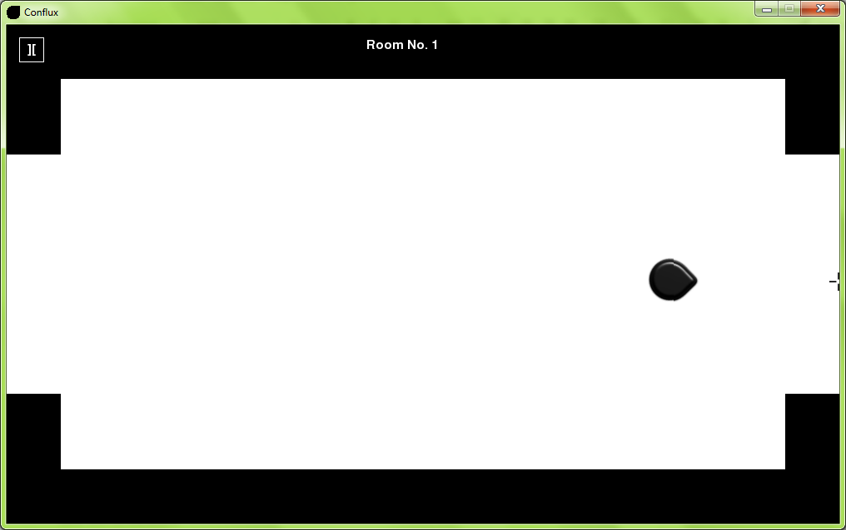

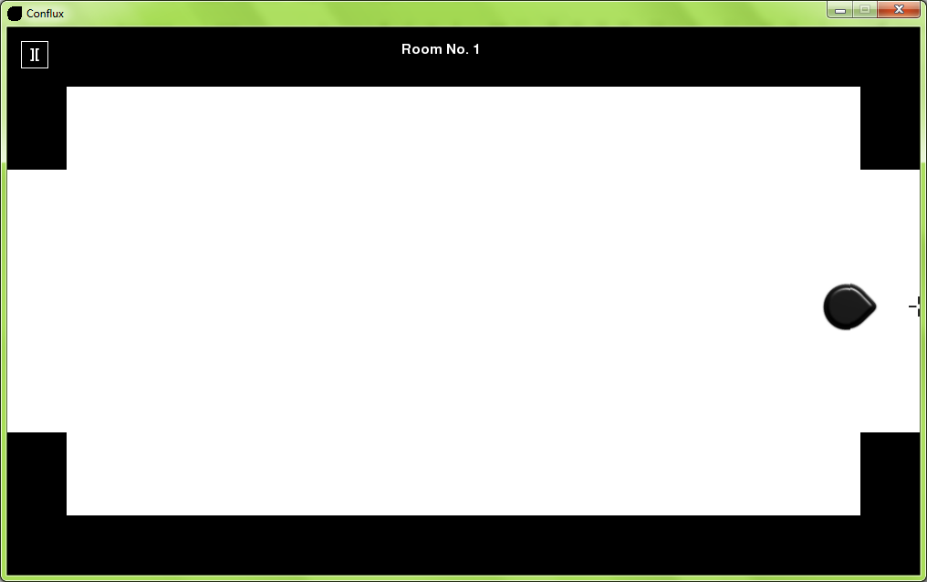

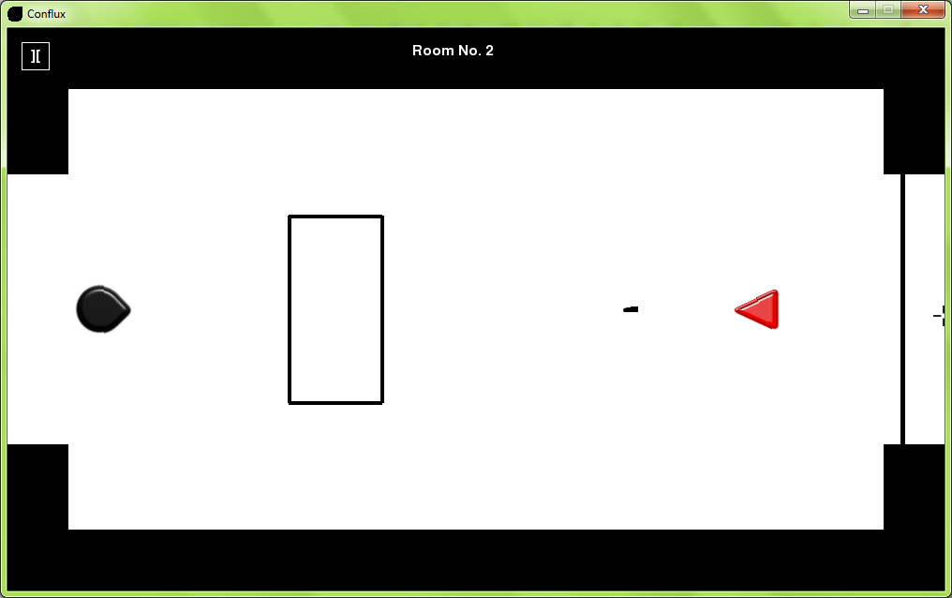

2.9b

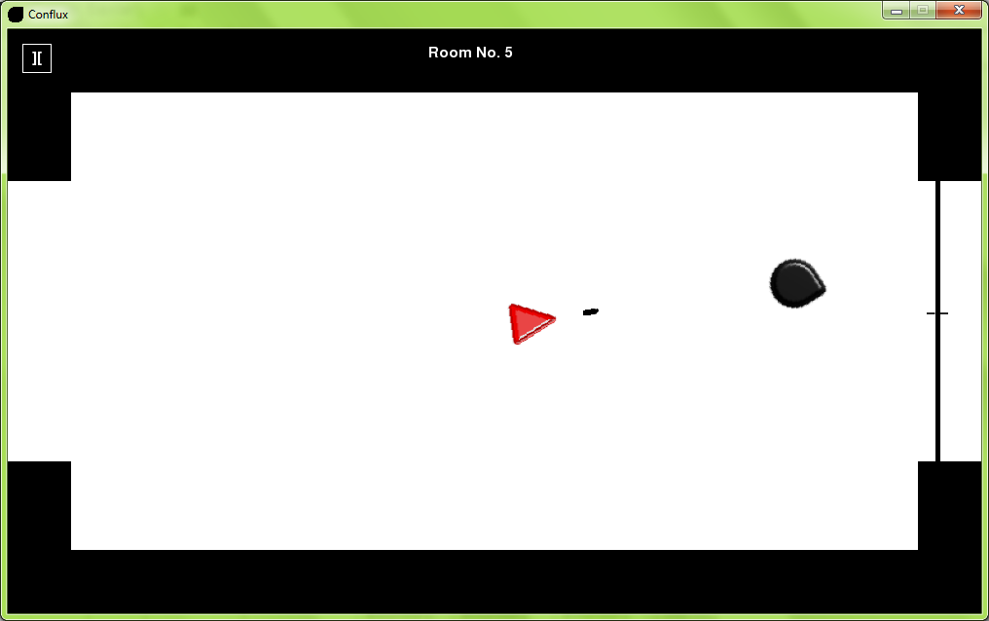

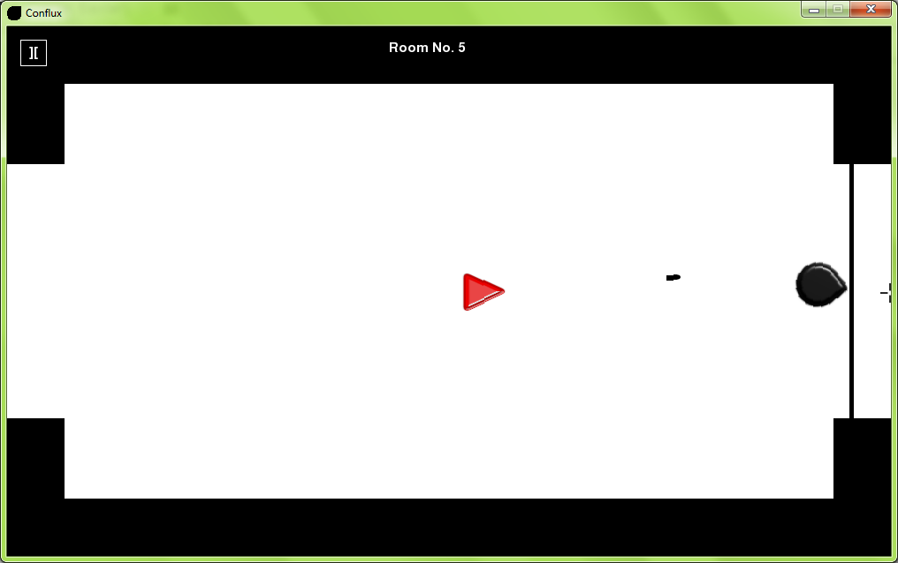

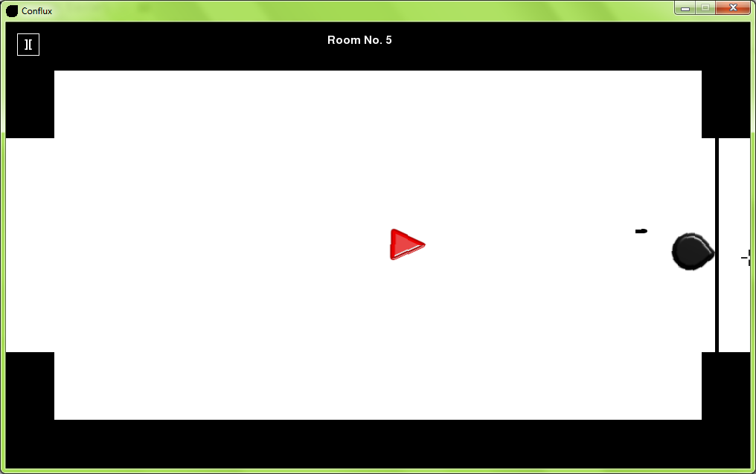

2.10a

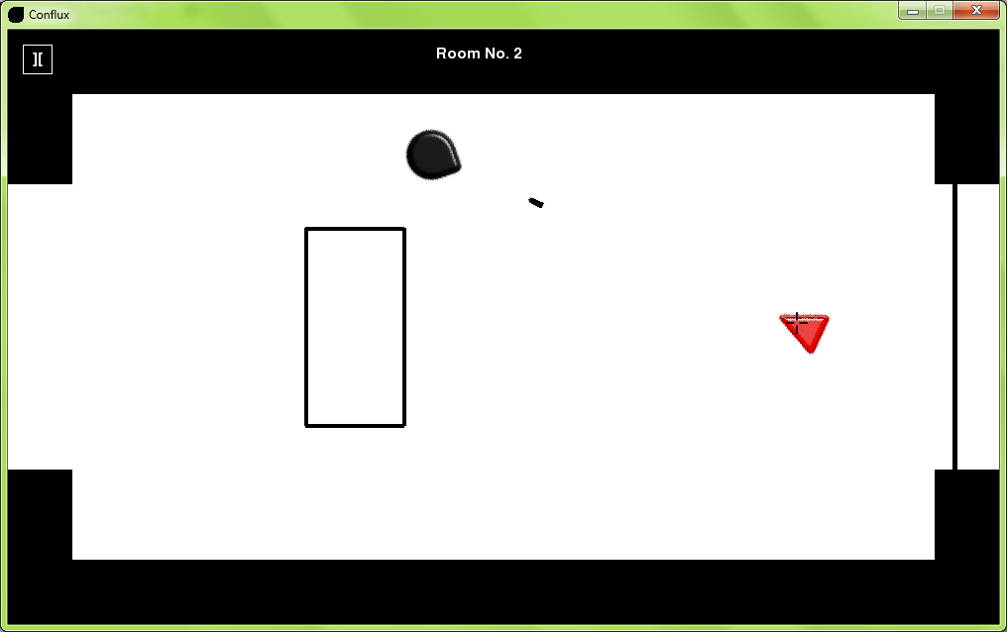

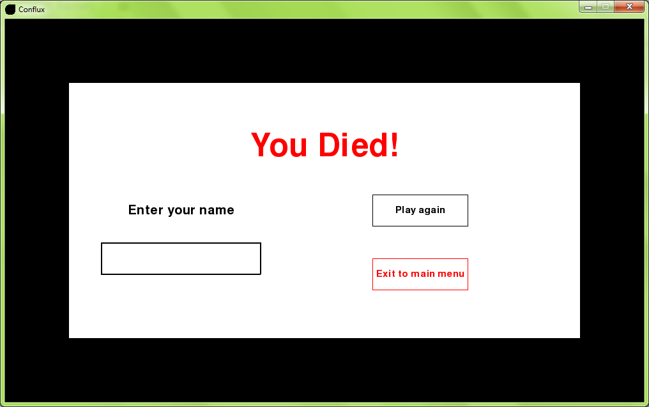

2.10b

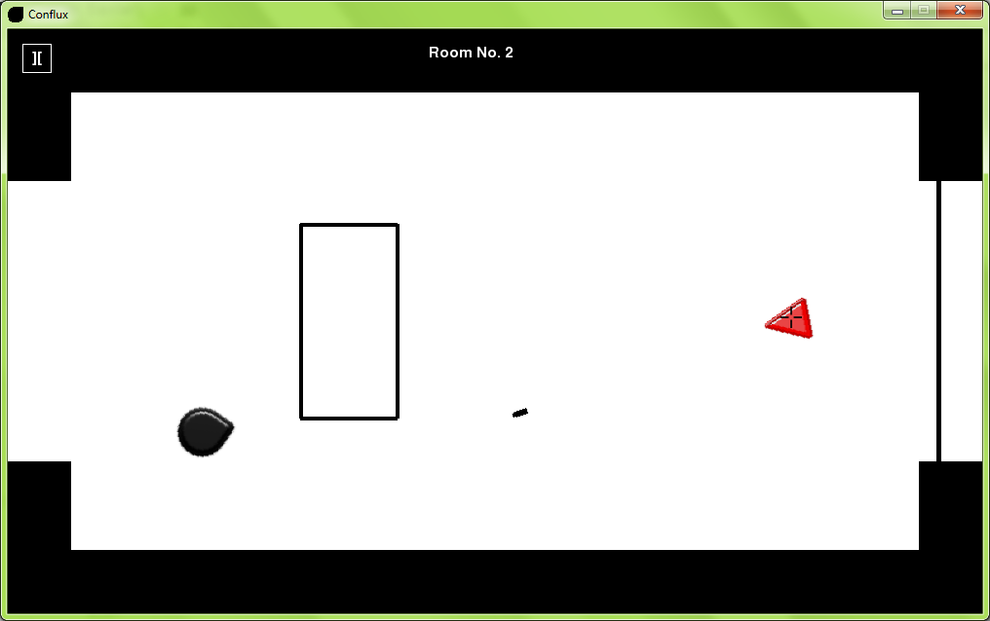

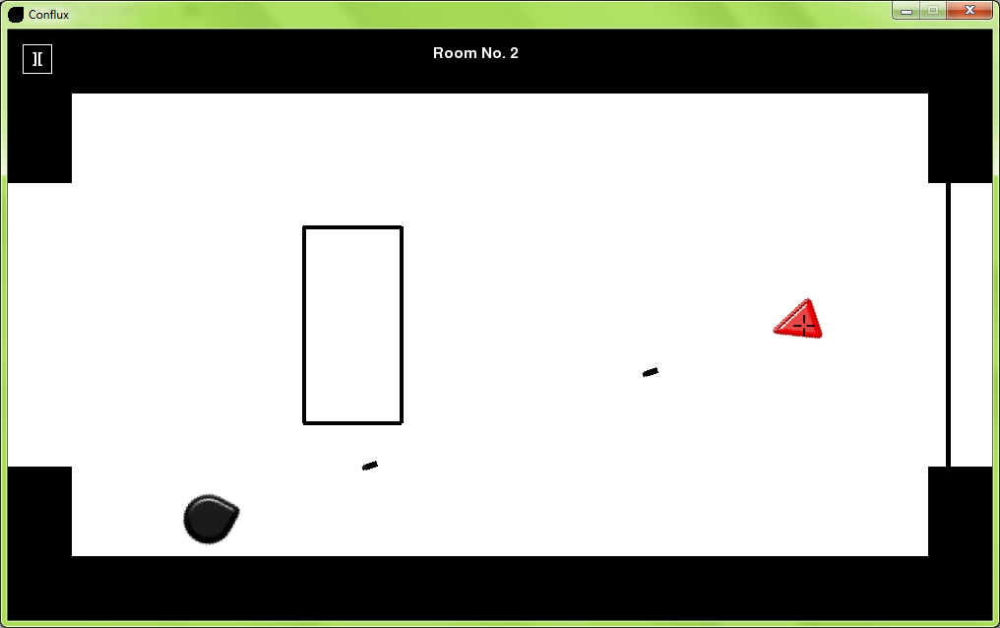

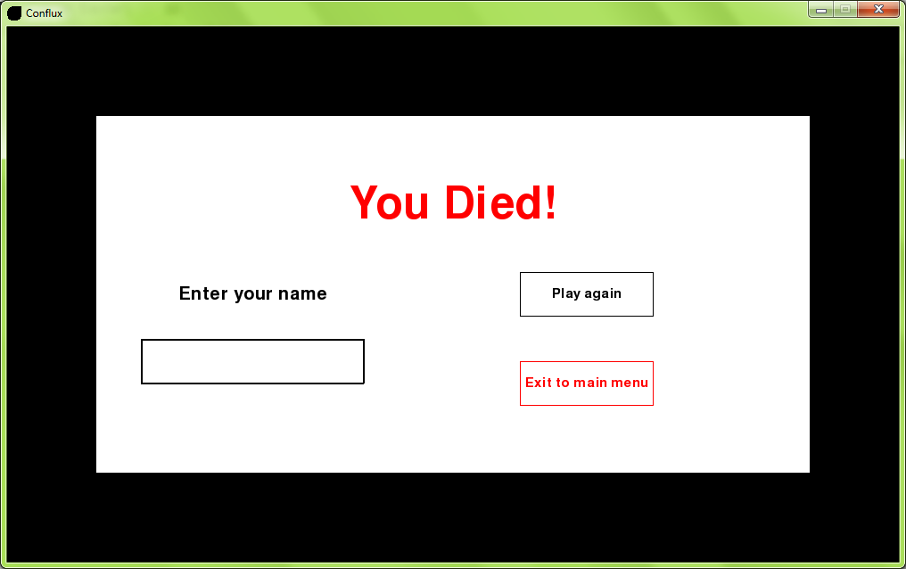

2.10c

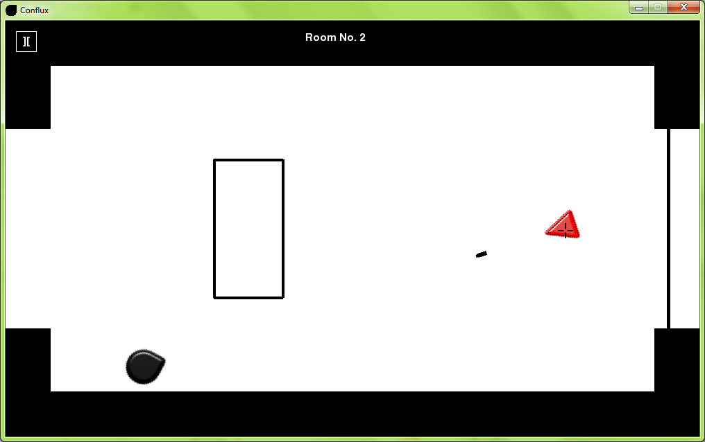

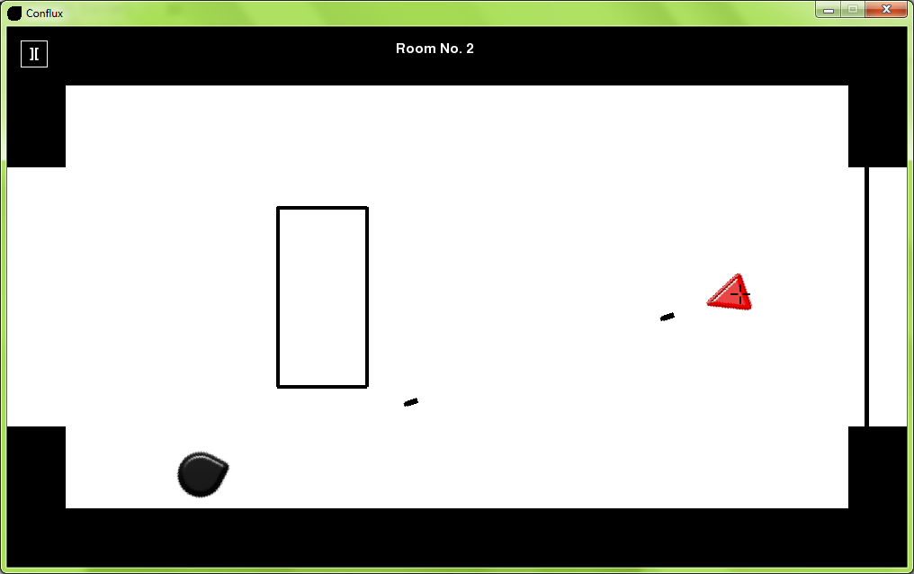

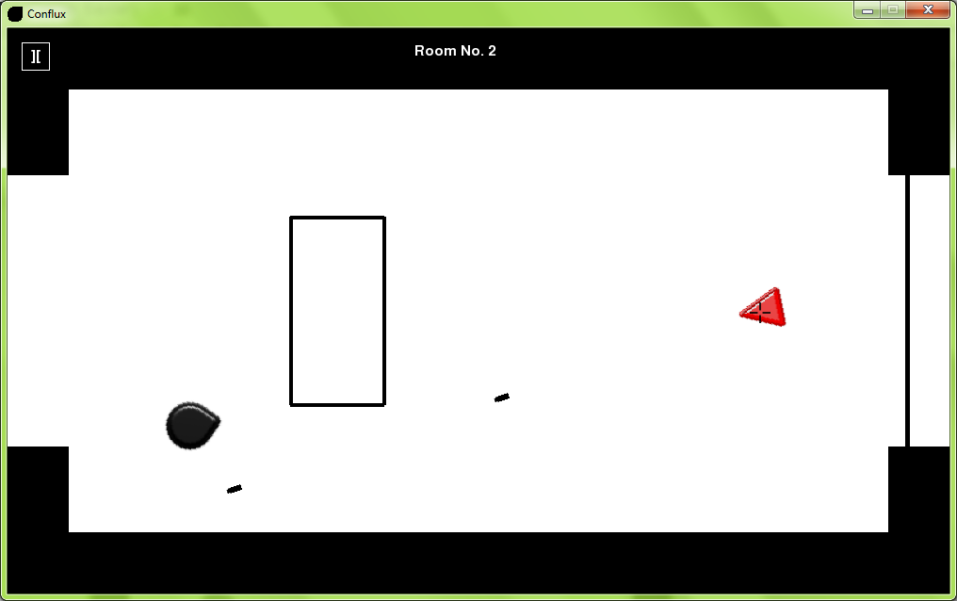

2.11a

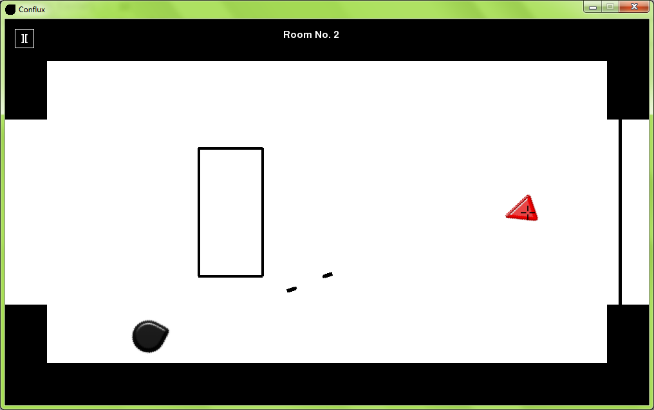

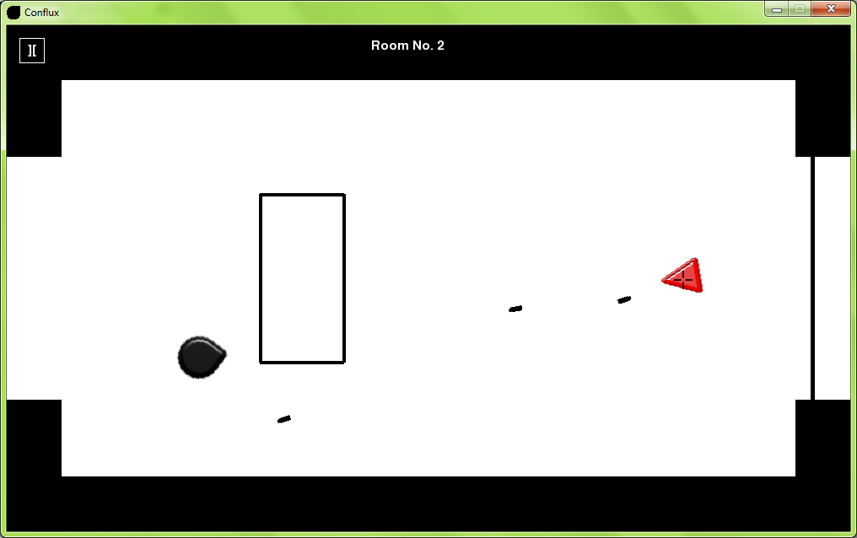

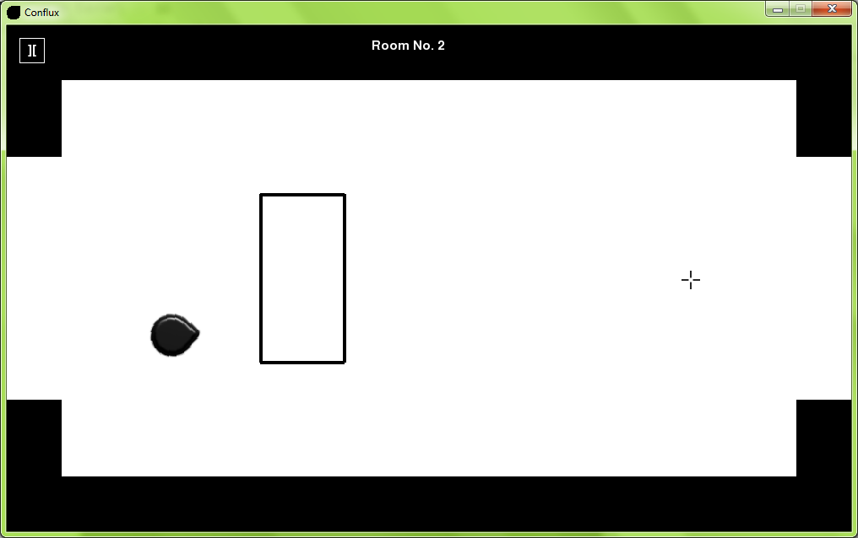

2.11b

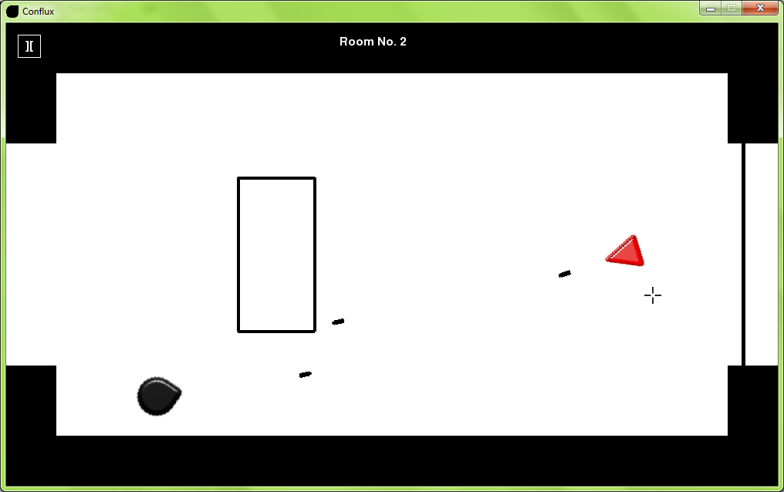

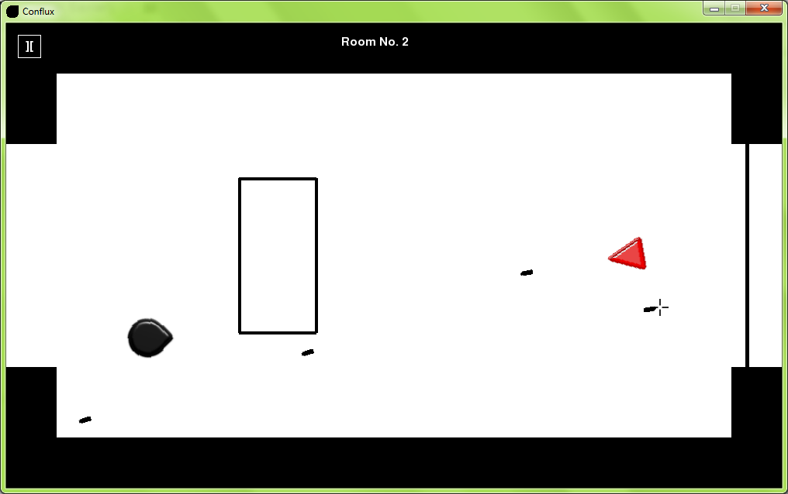

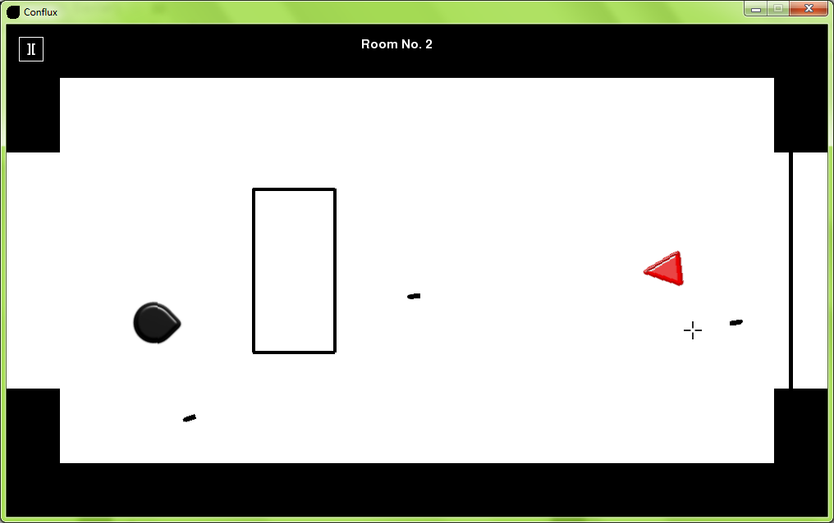

2.12a

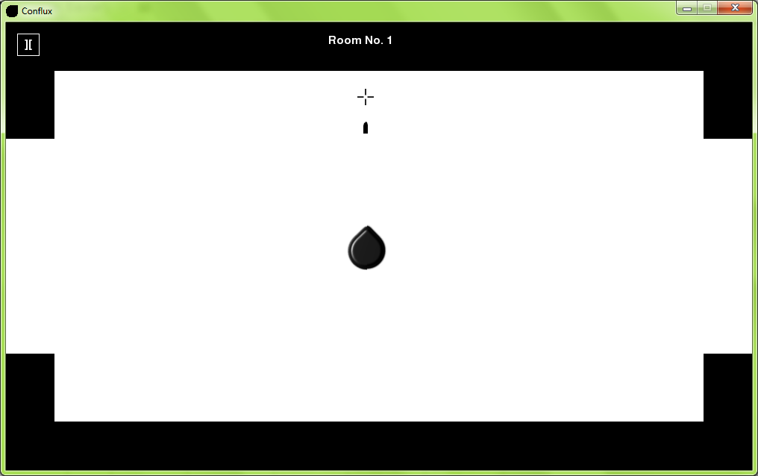

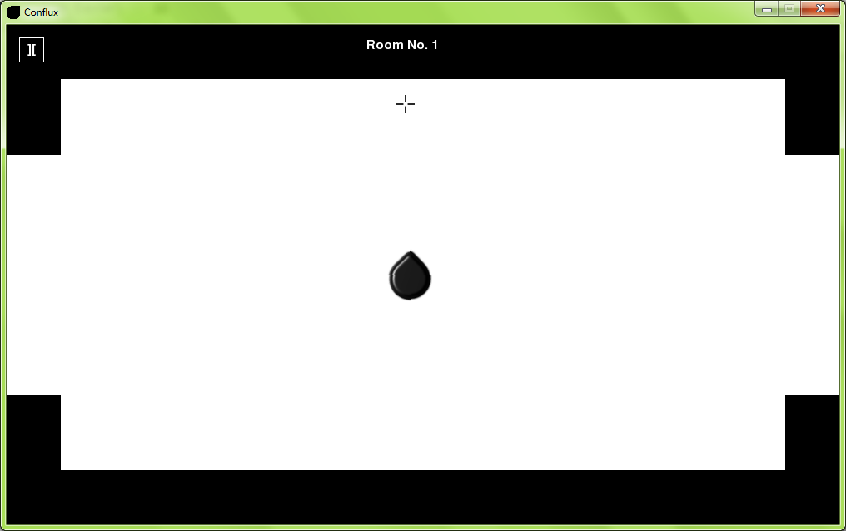

2.12b

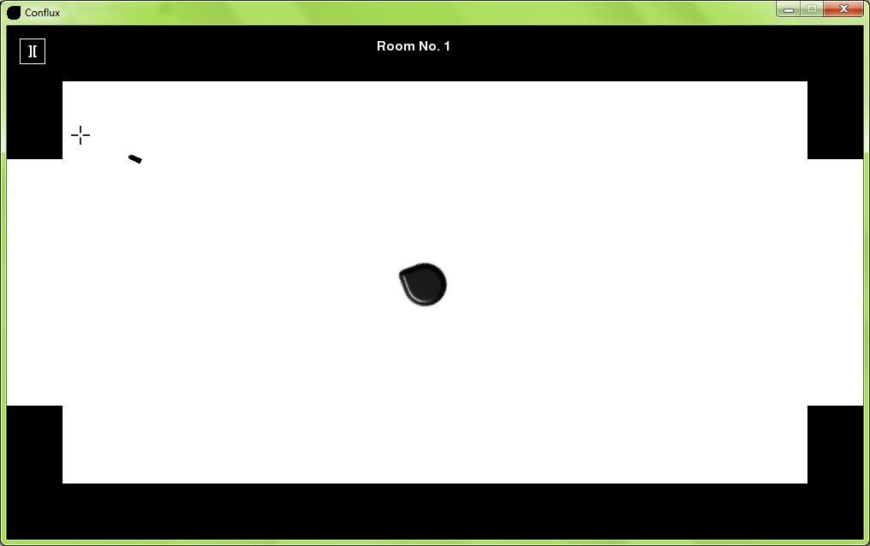

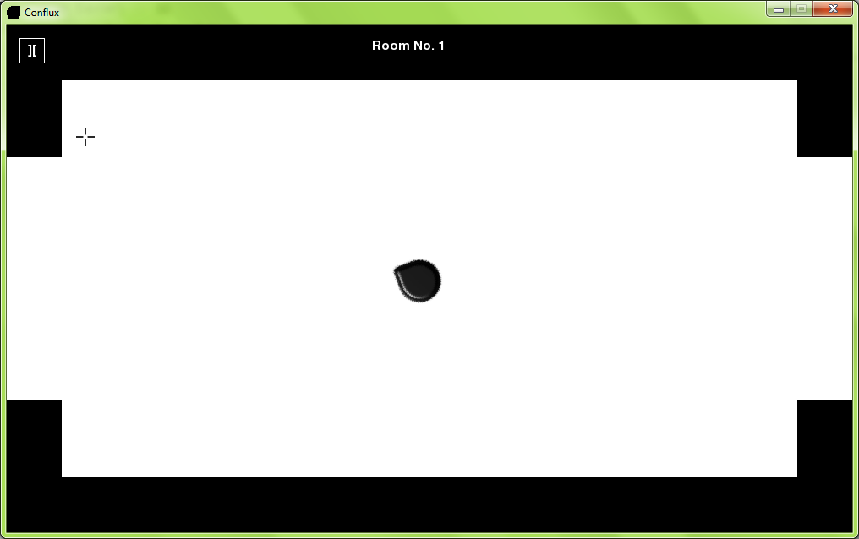

2.12c

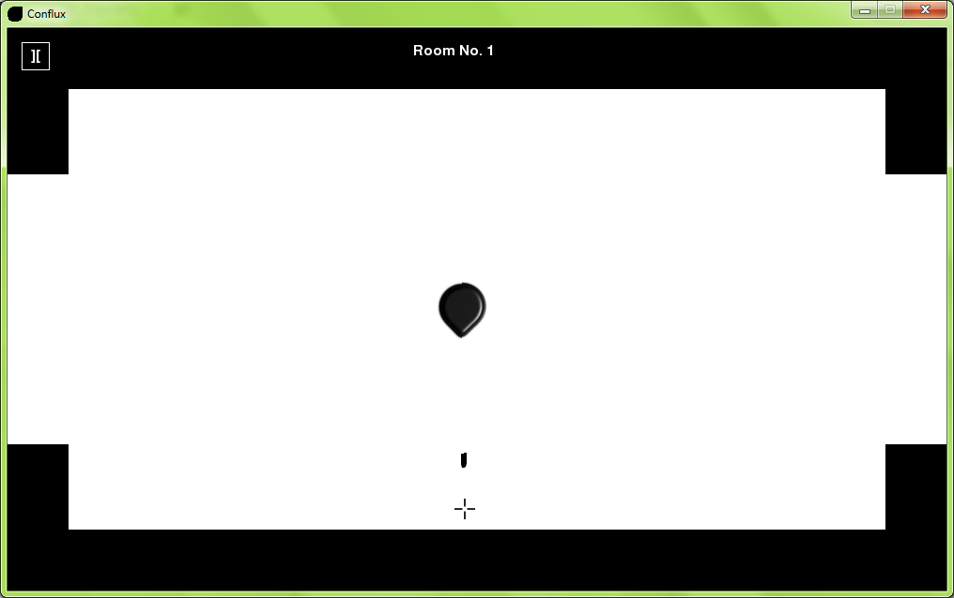

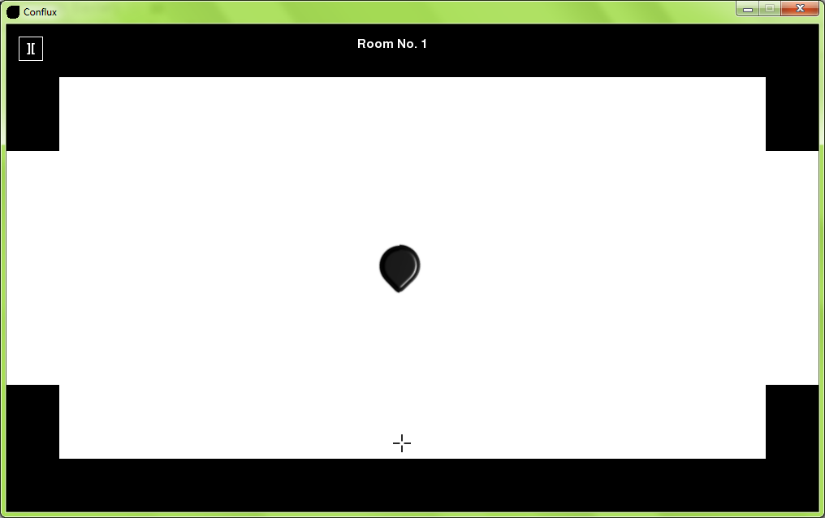

2.12d

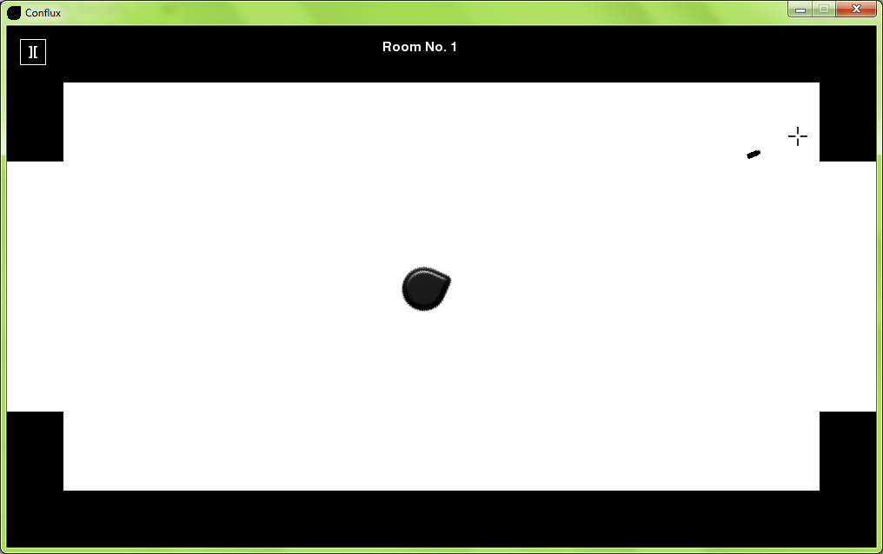

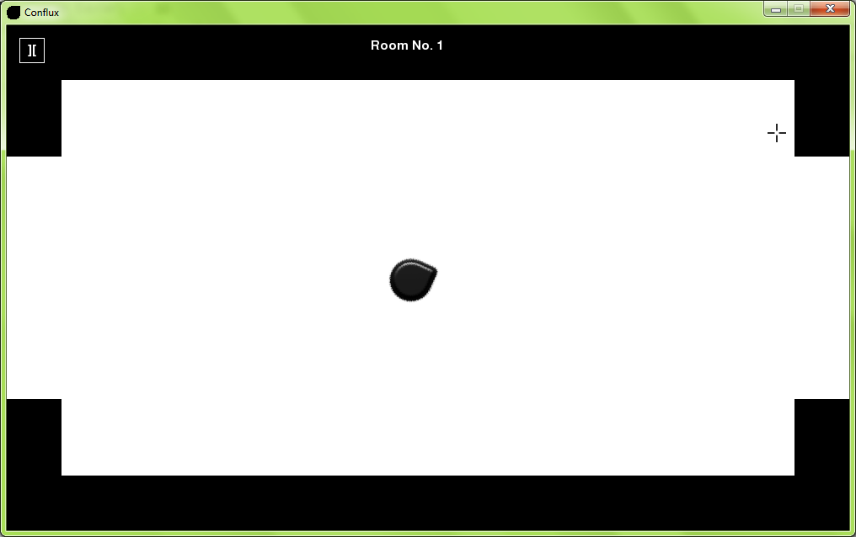

2.12e

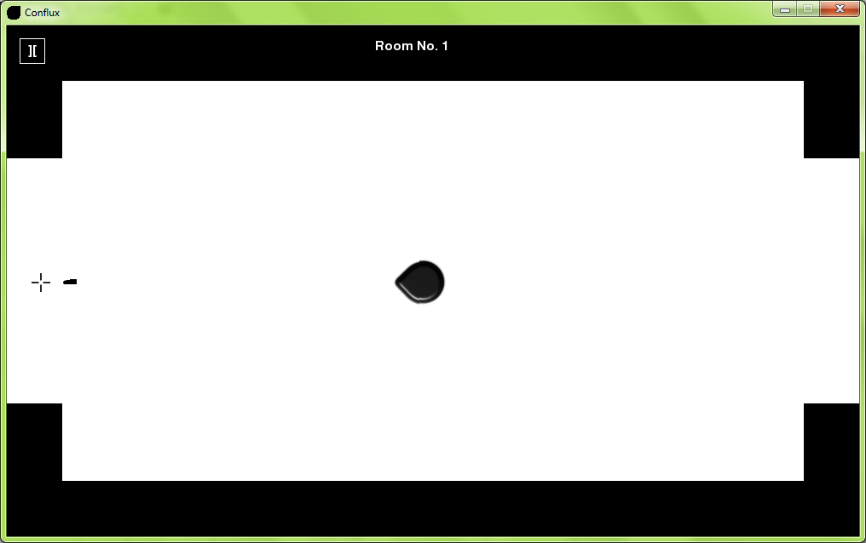

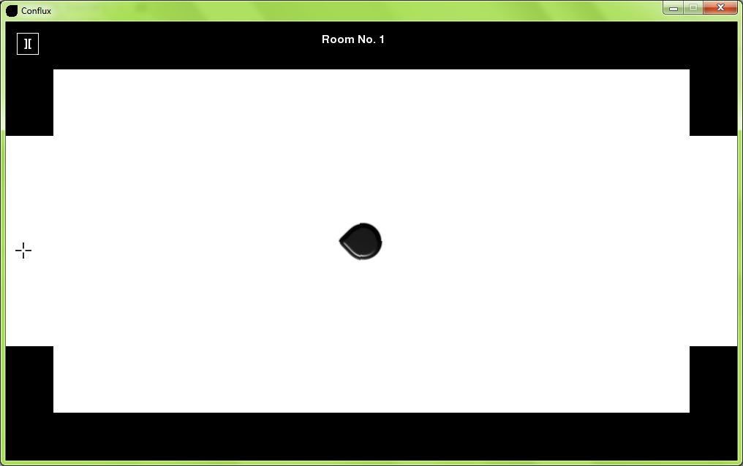

2.12f

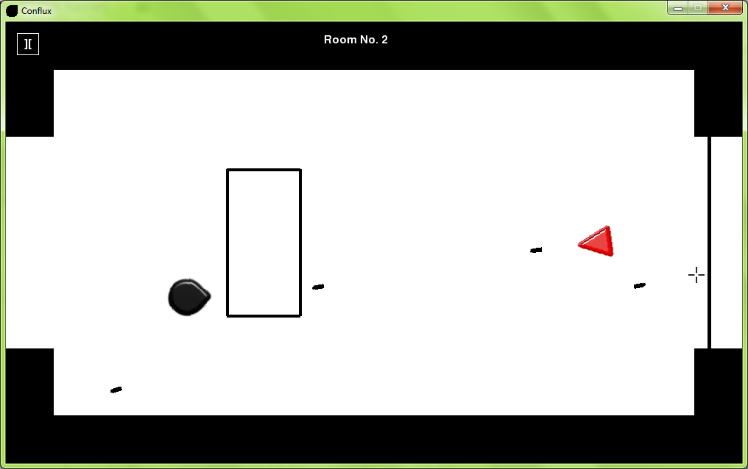

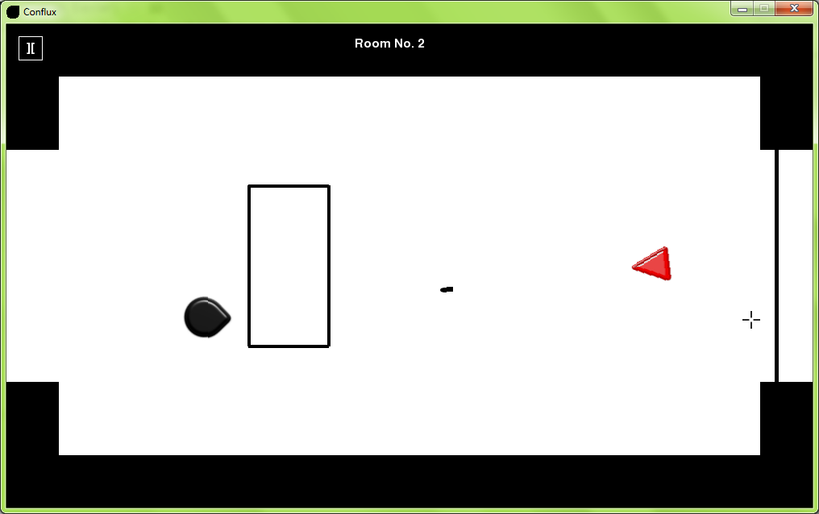

2.12g

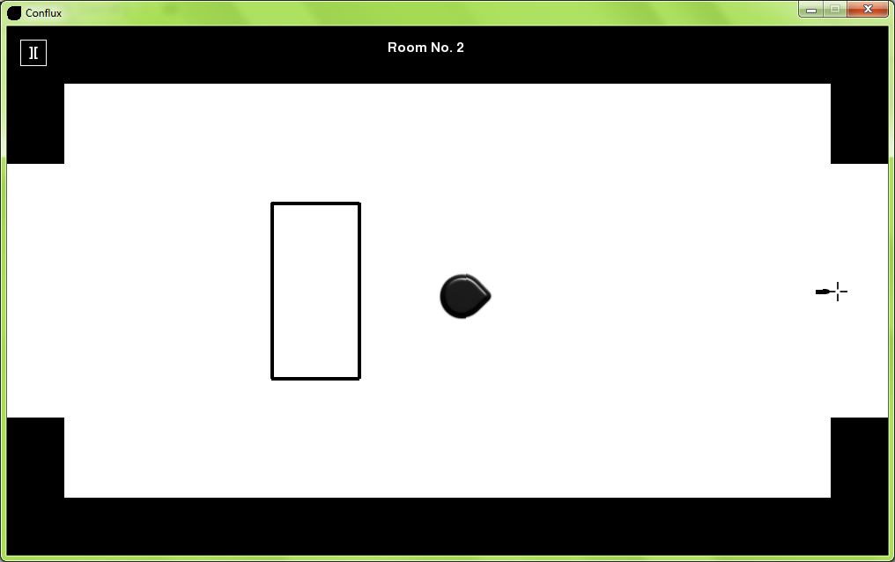

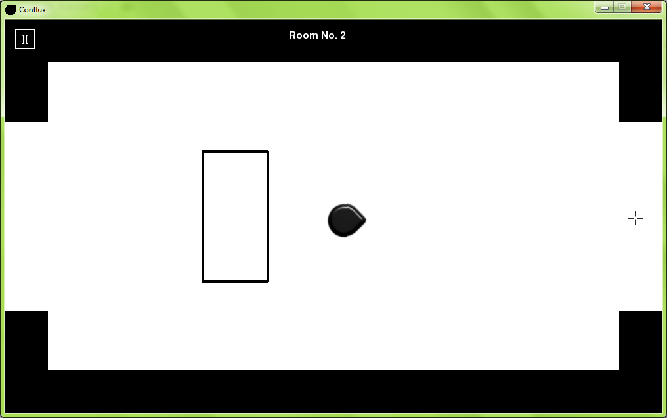

2.13a

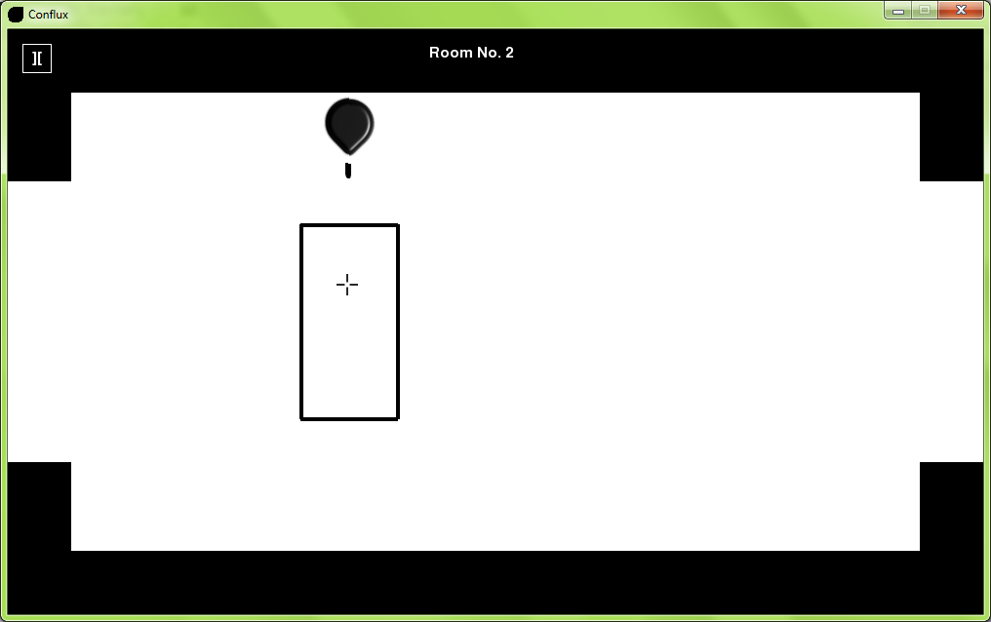

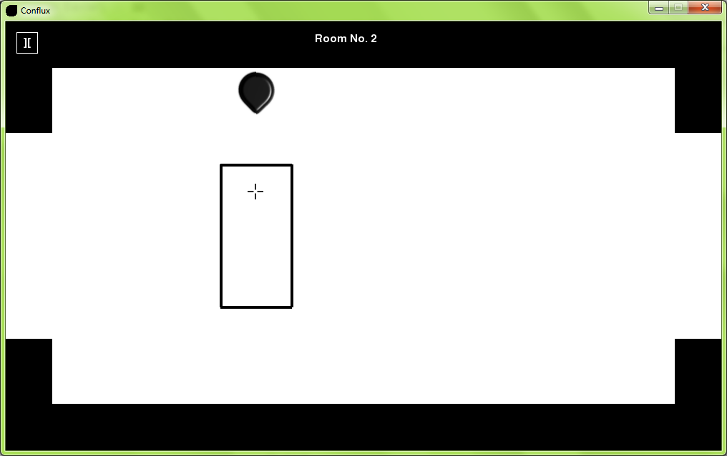

2.13b

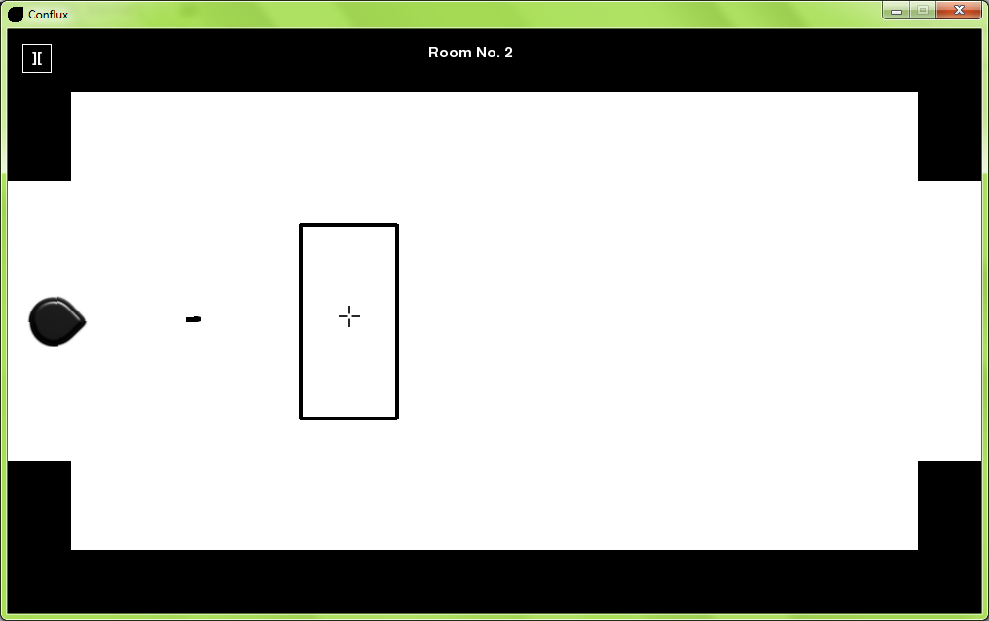

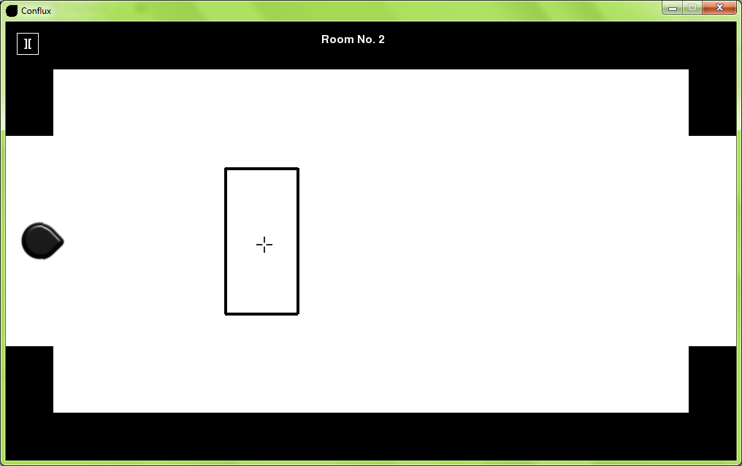

2.13c

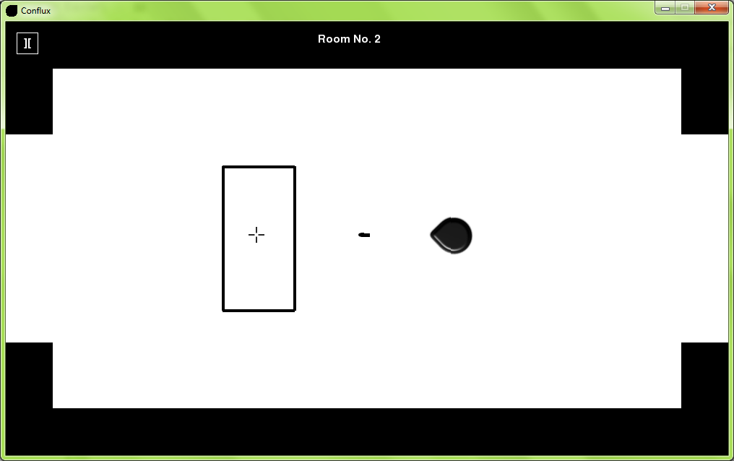

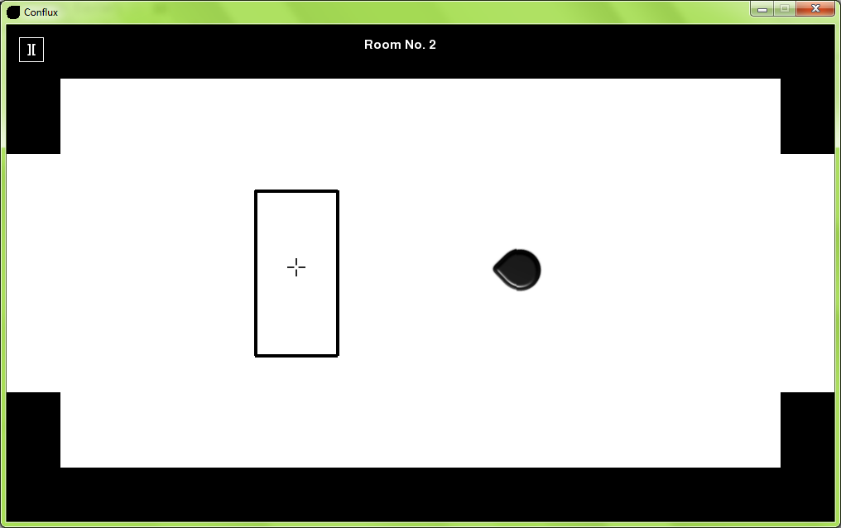

2.13d

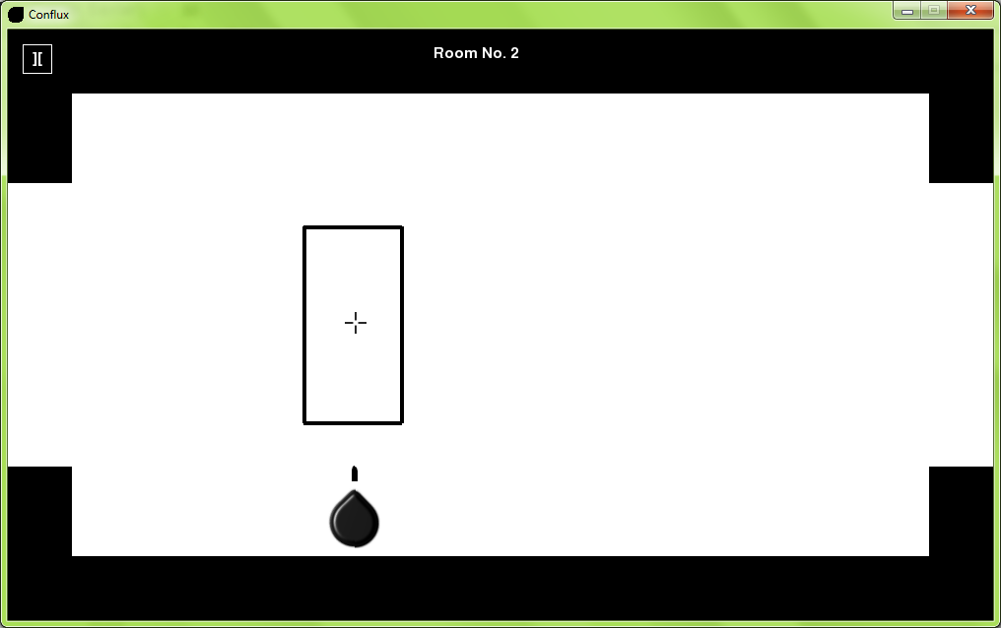

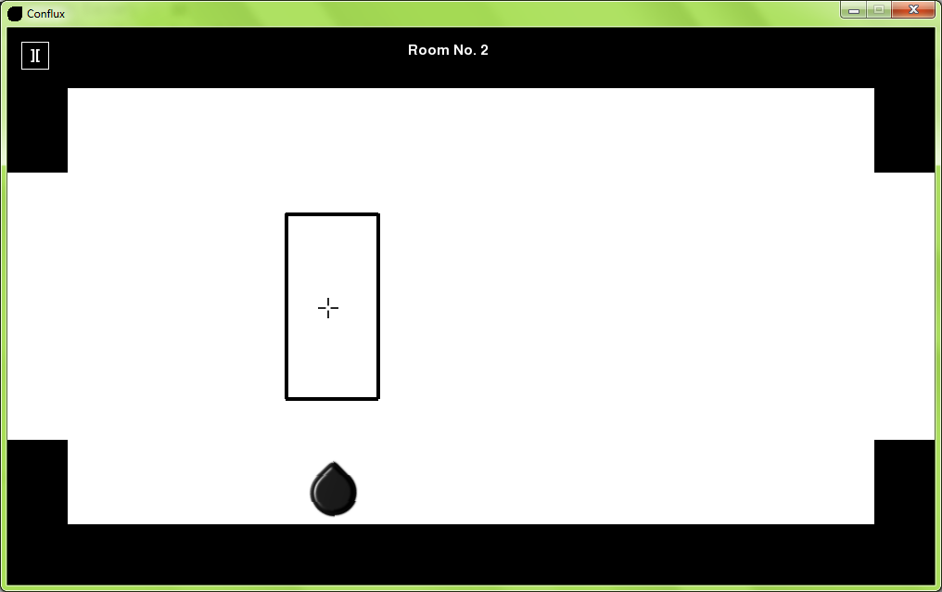

2.13e

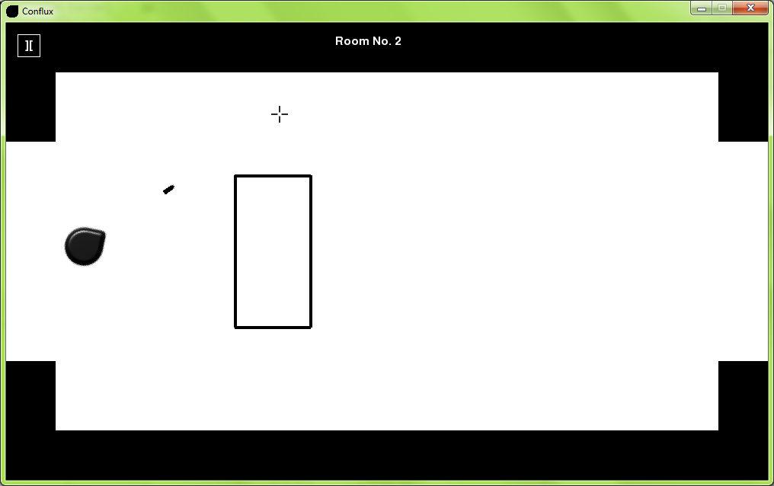

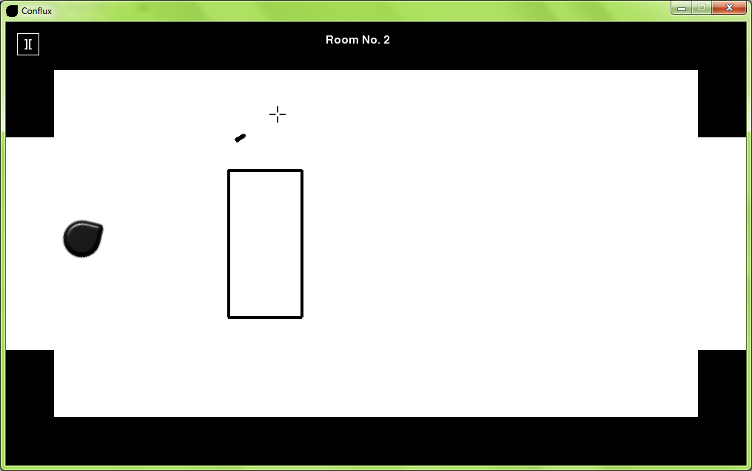

2.14a

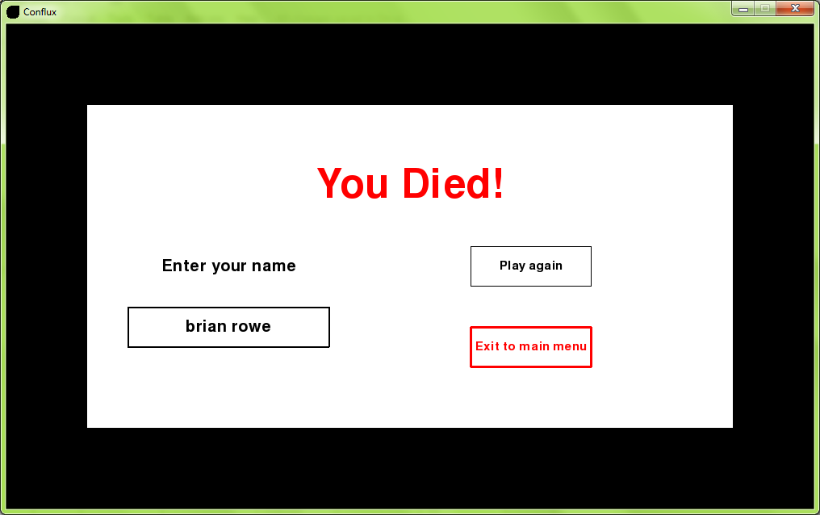

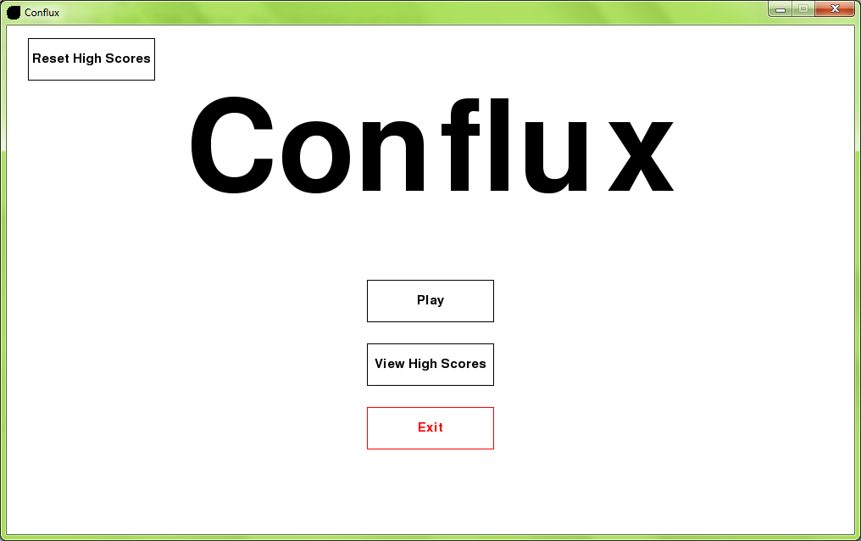

2.14b

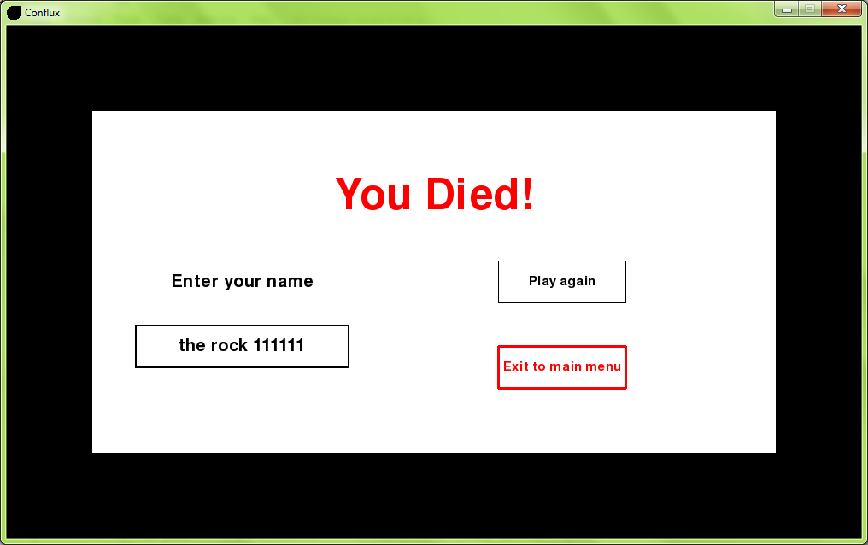



2.14c

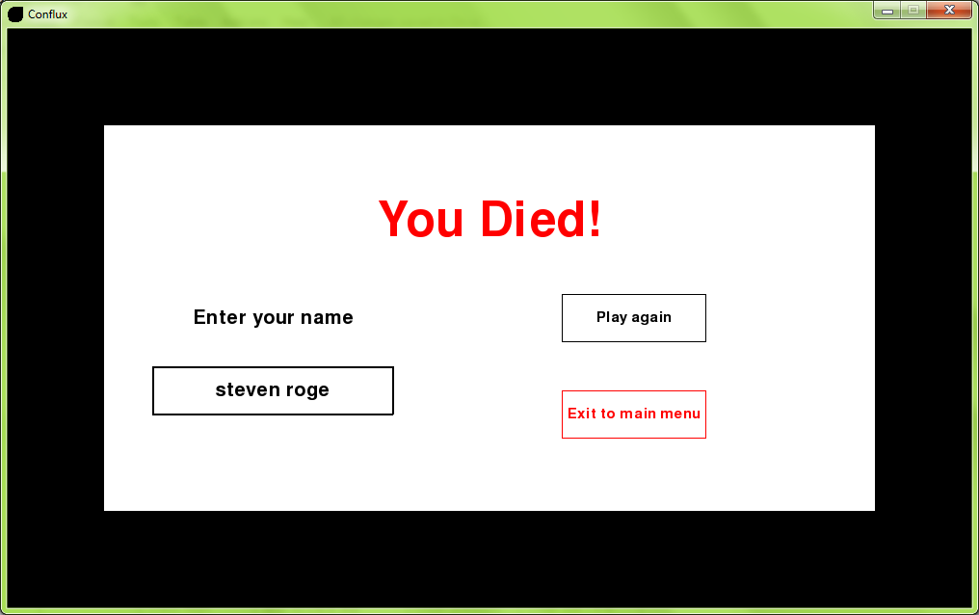

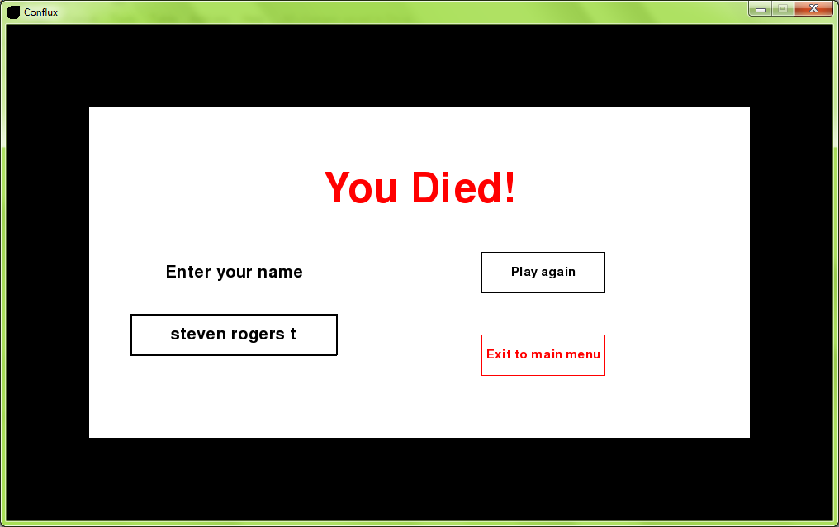



2.15a

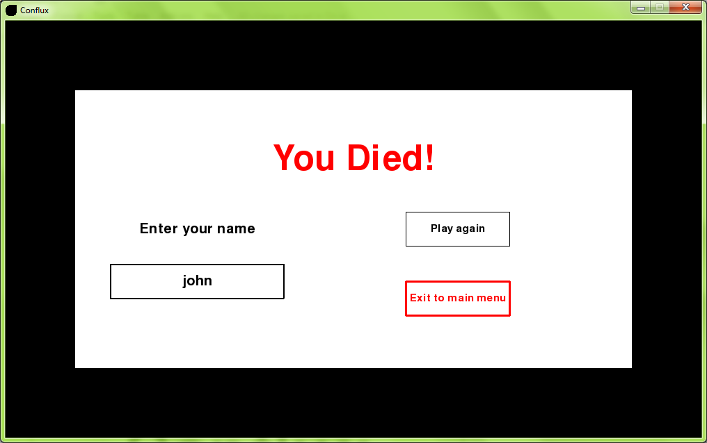

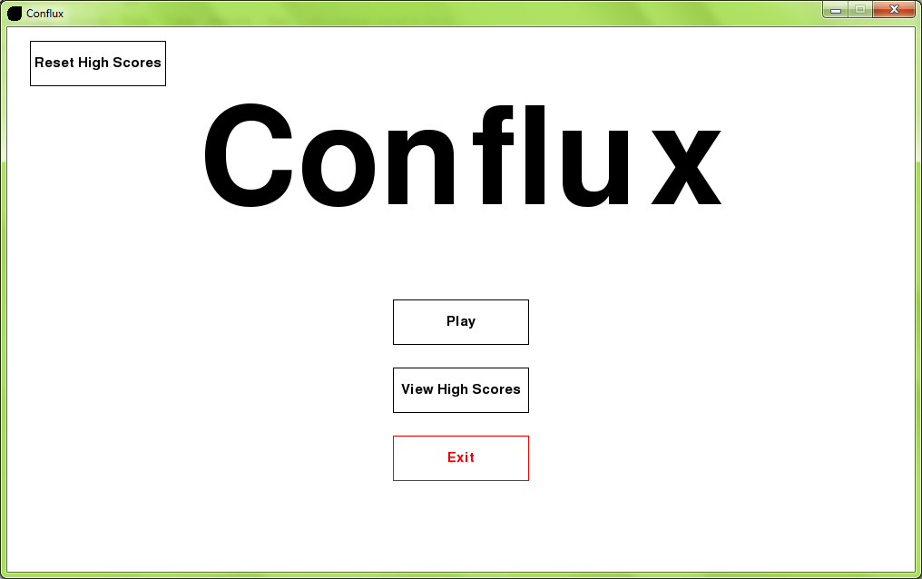

2.15b

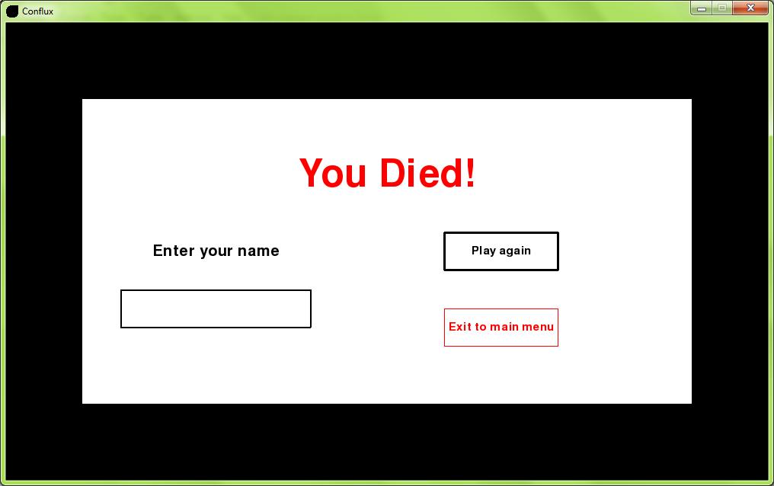

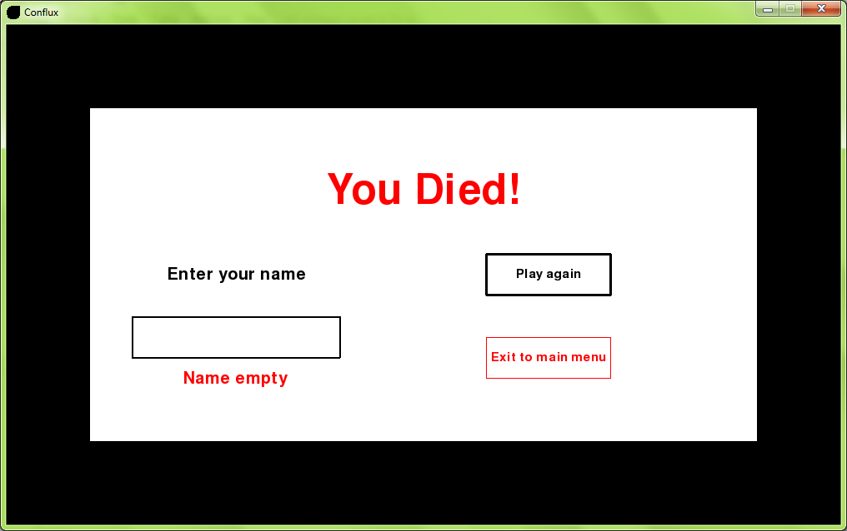

3.1



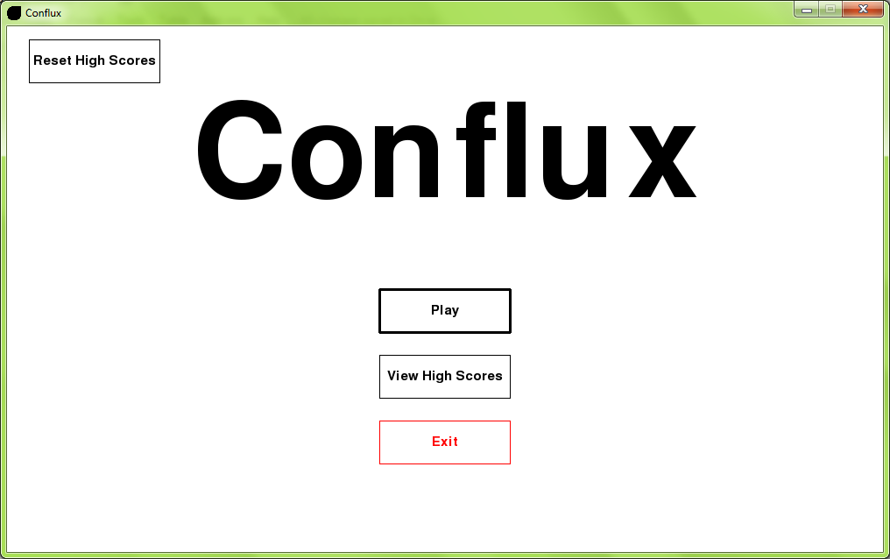

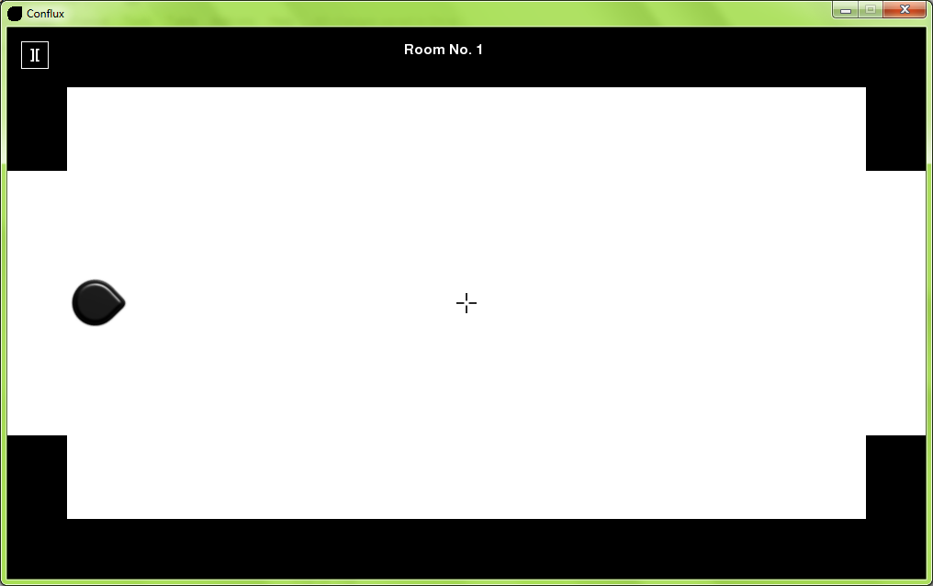

3.2



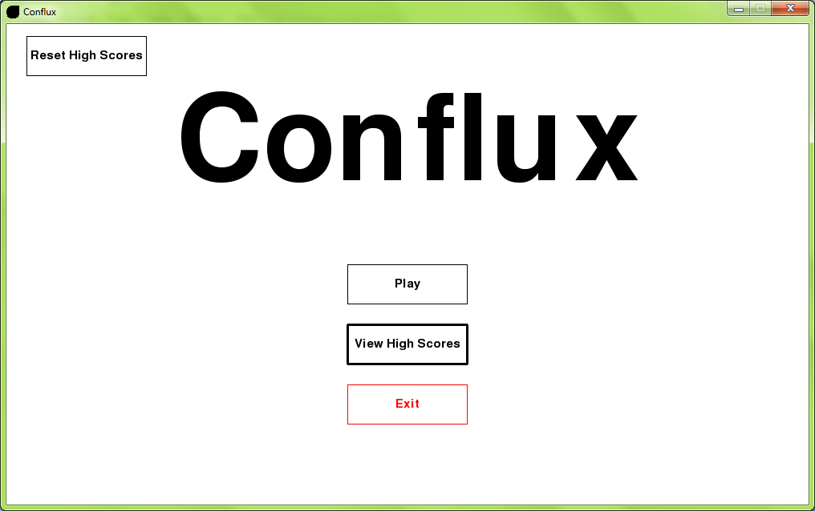

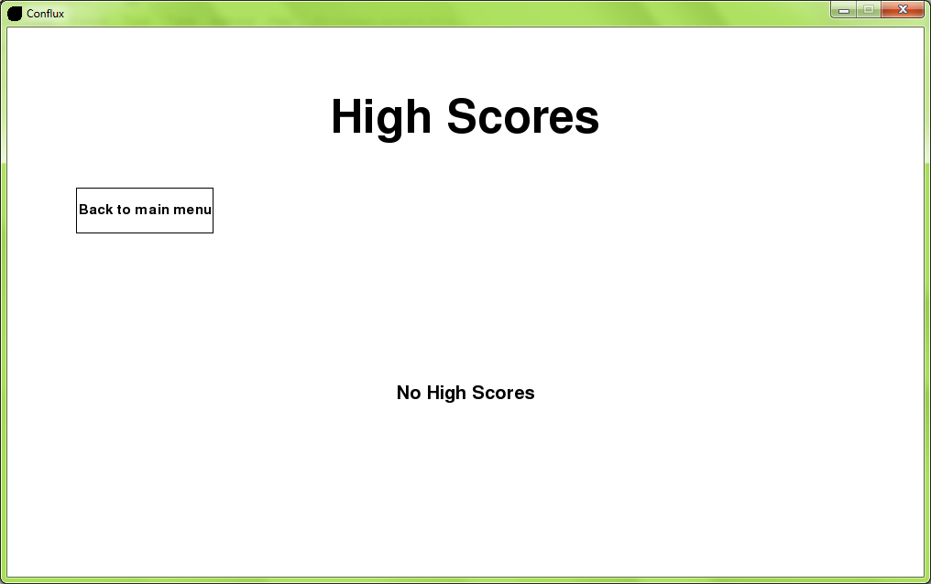

3.3



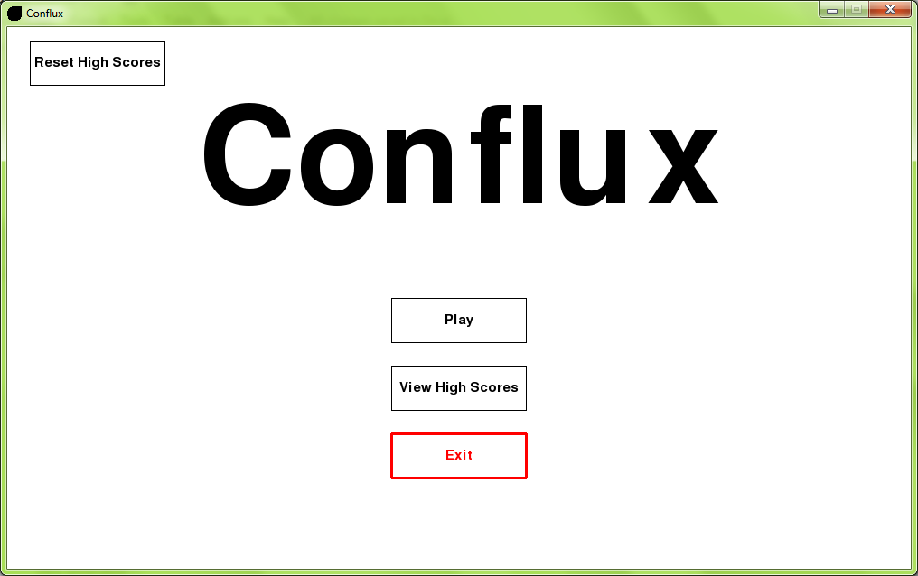

3.4



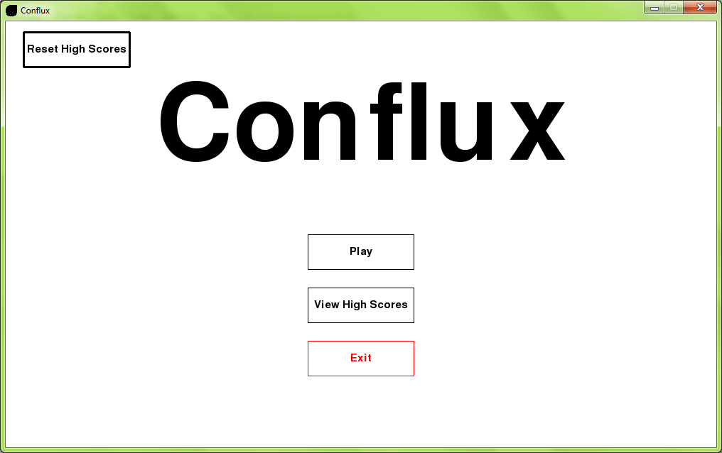

3.5

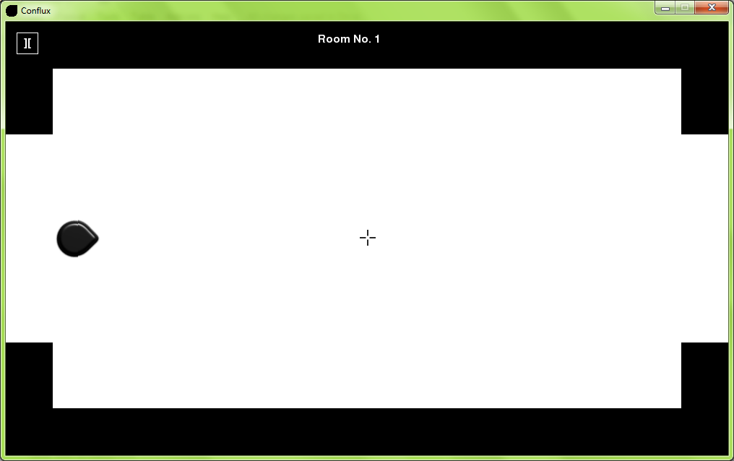

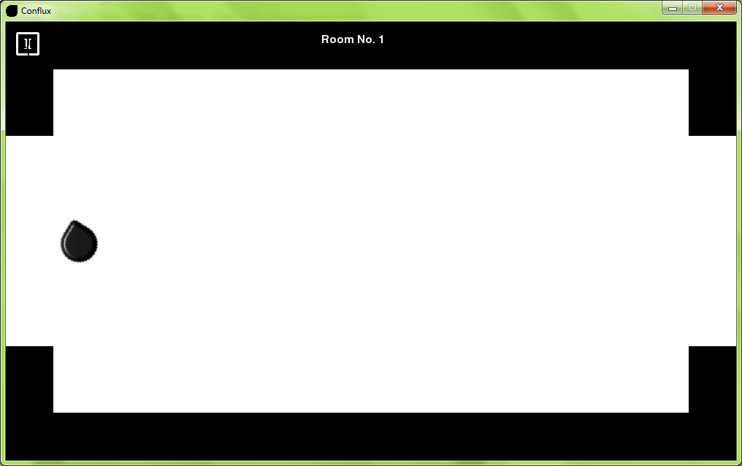

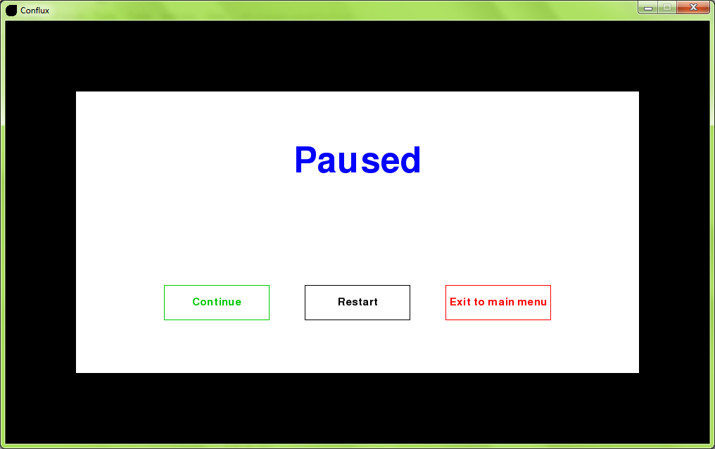

3.6



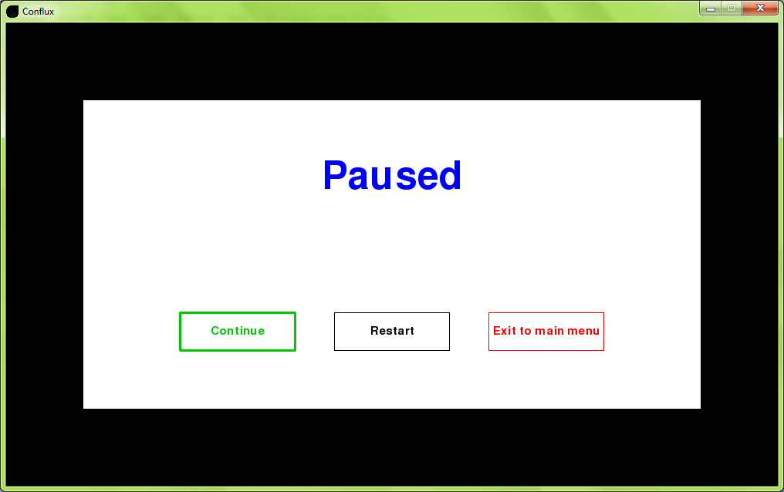

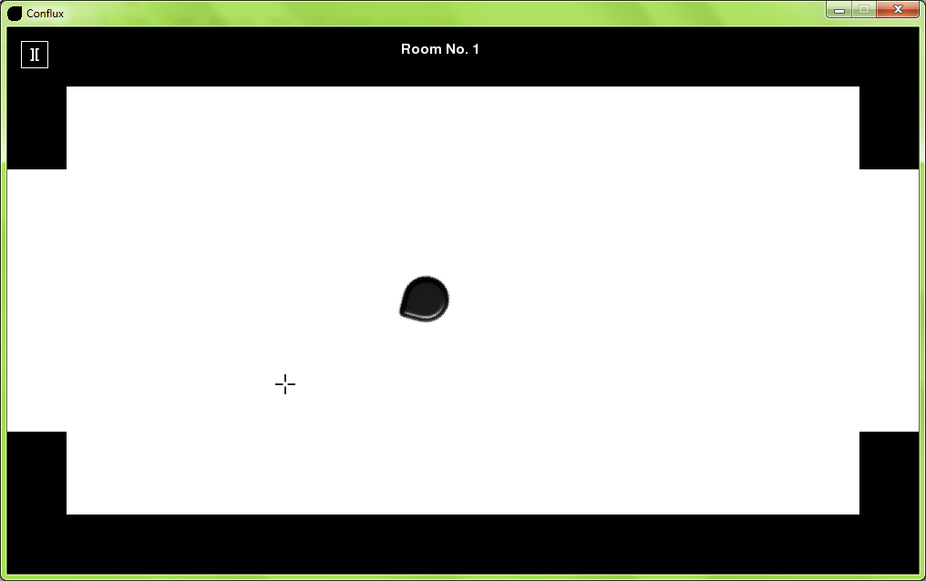

3.7



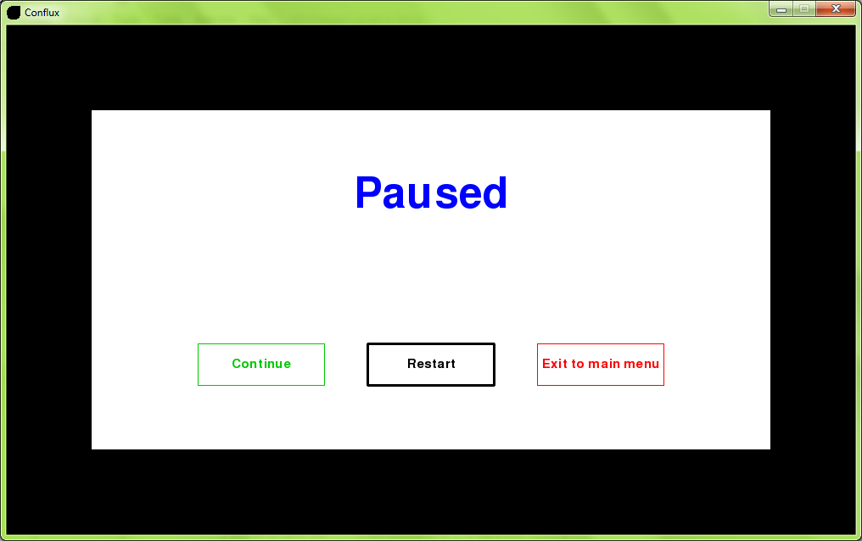

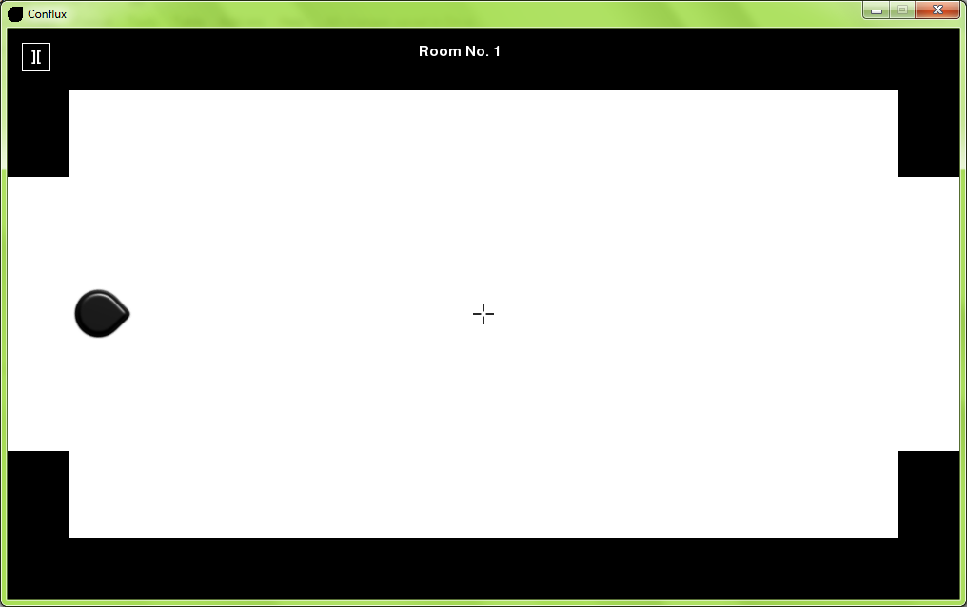

3.8



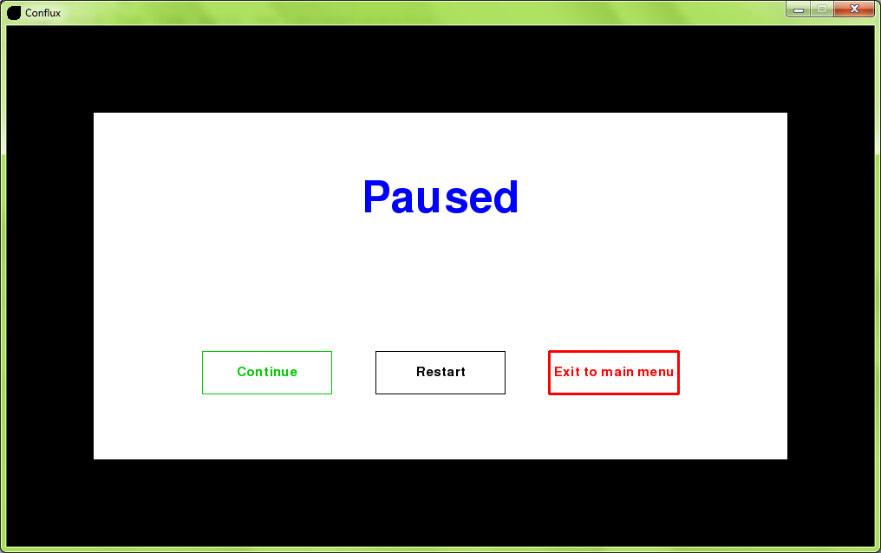



3.9

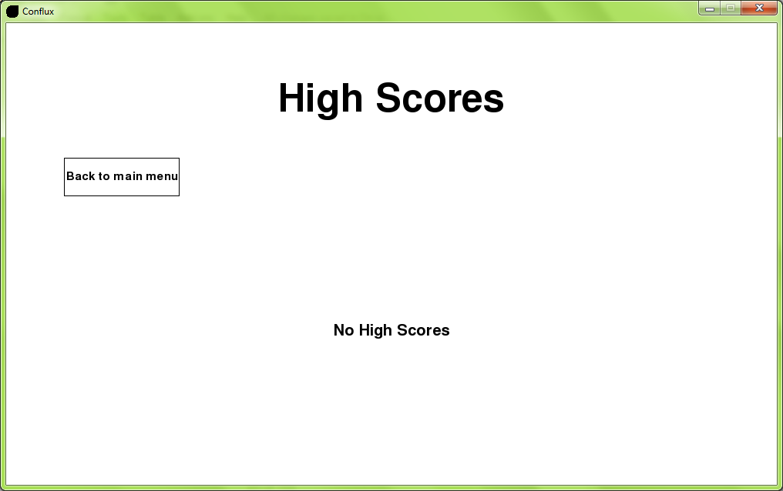

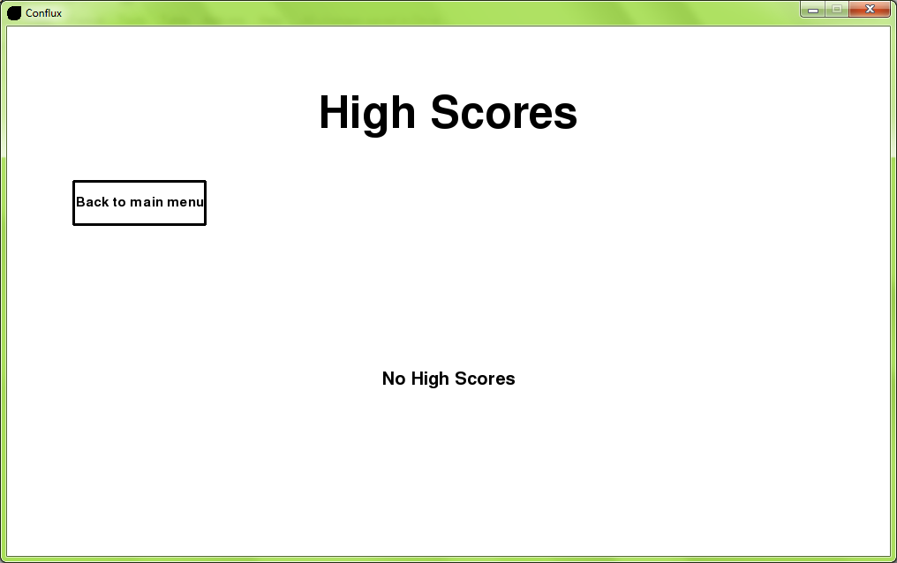



4.1a

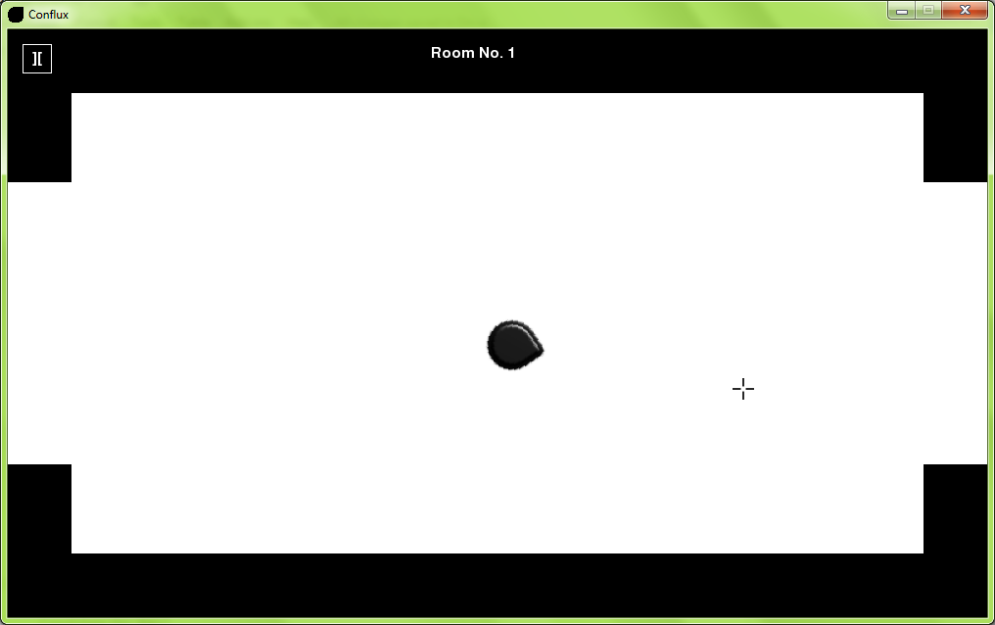

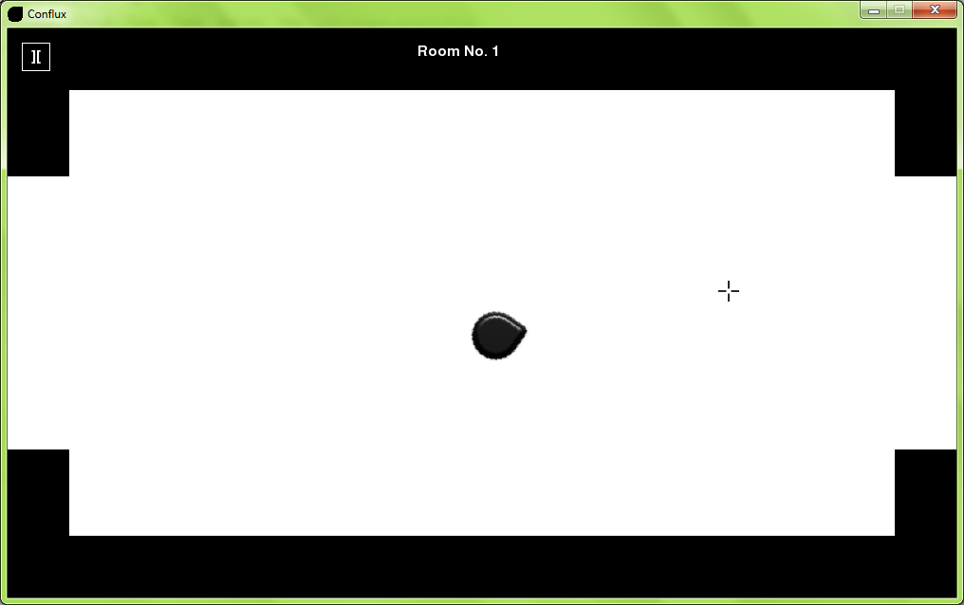

4.1b

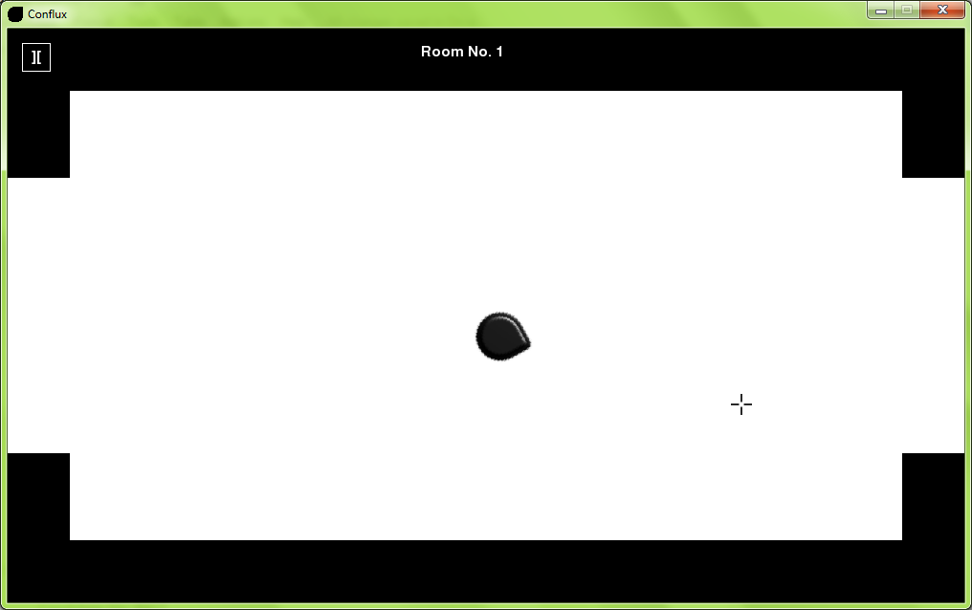

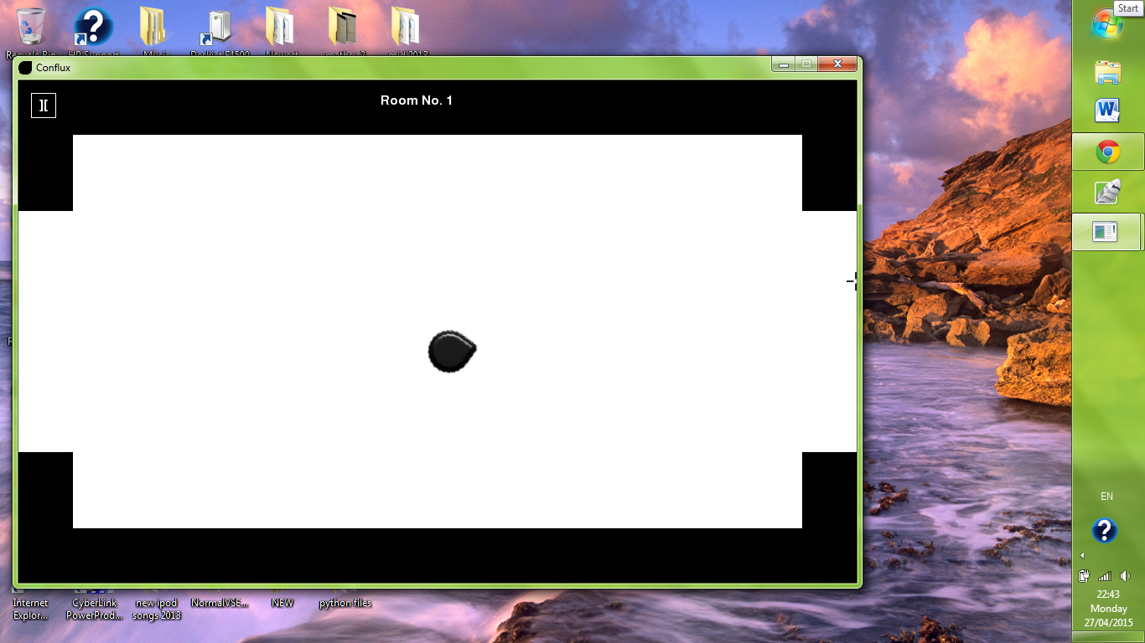

4.2

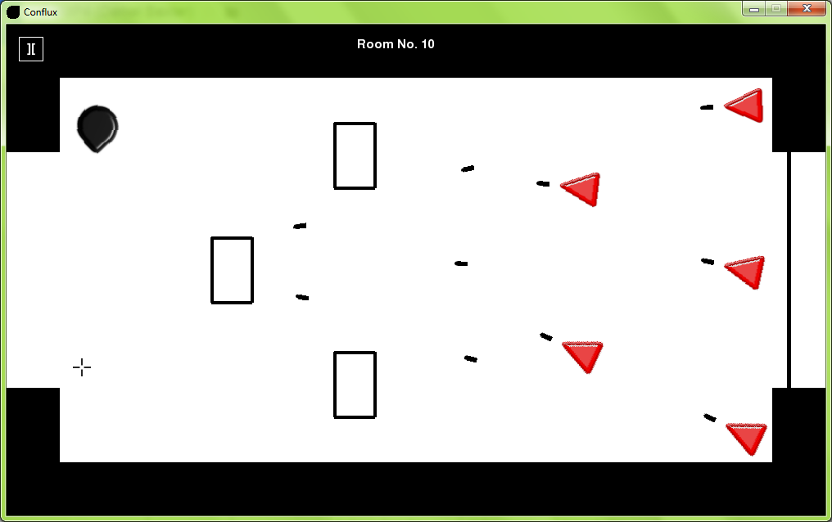

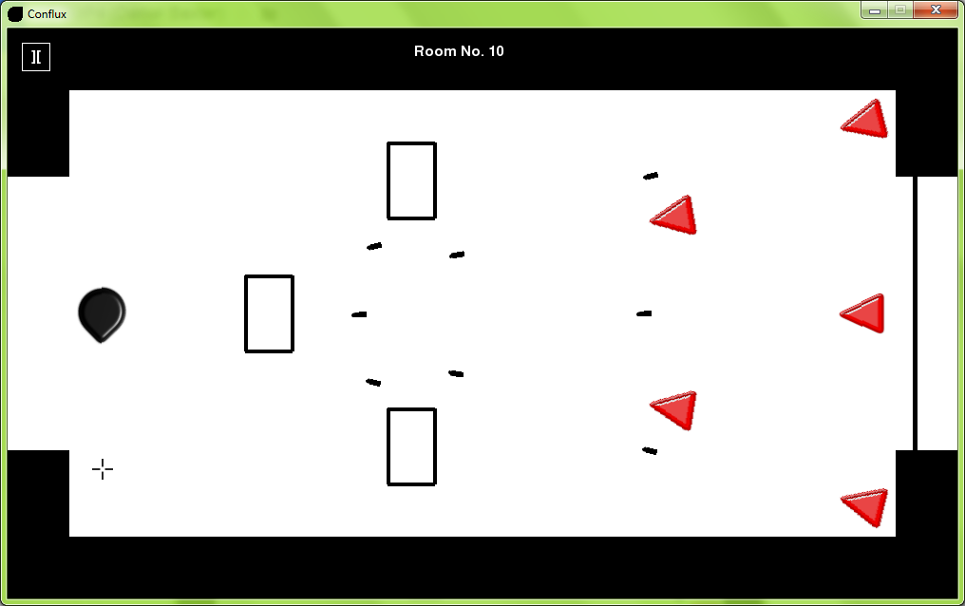

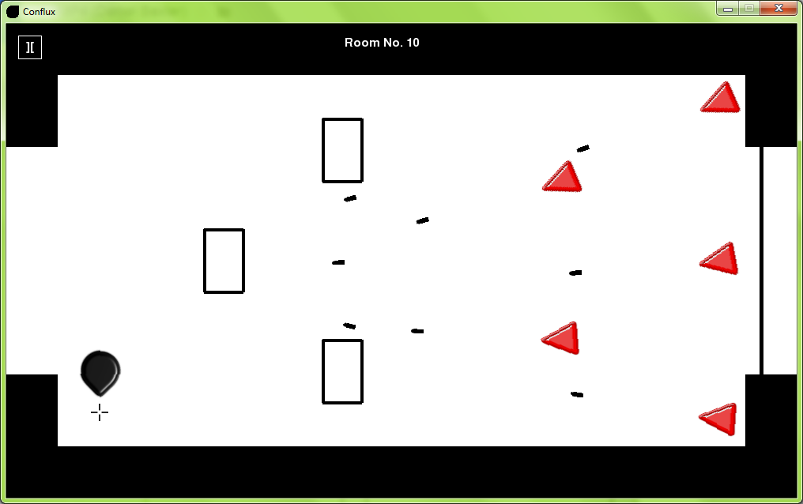

4.3

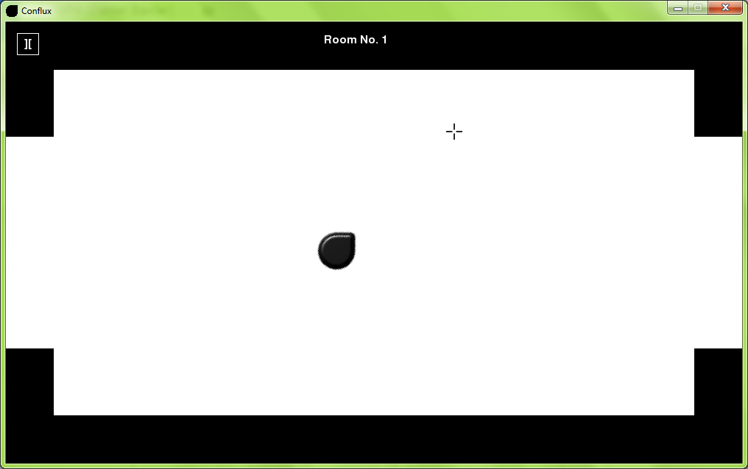

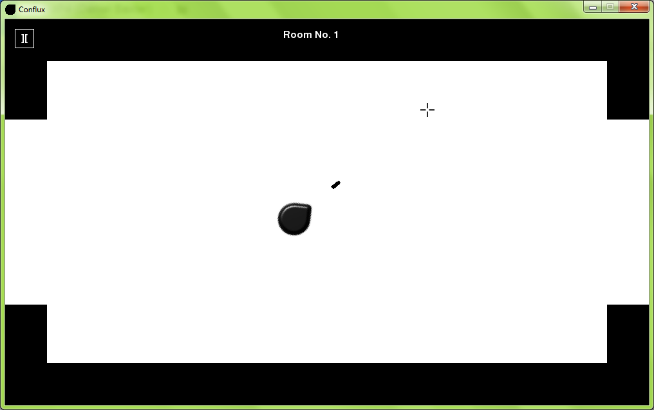

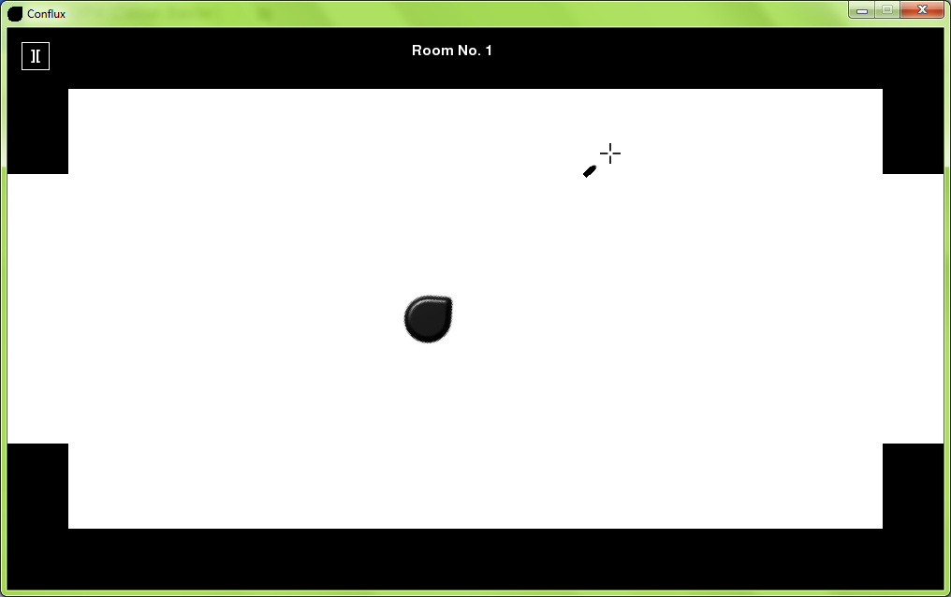

4.4

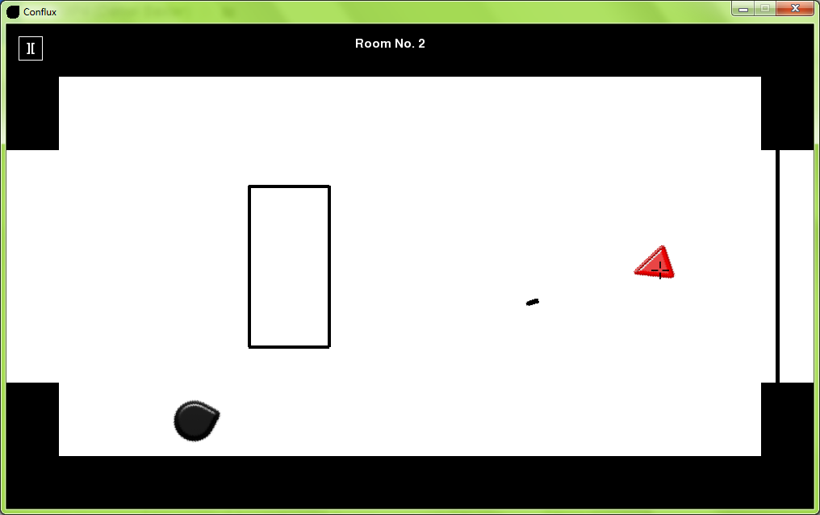

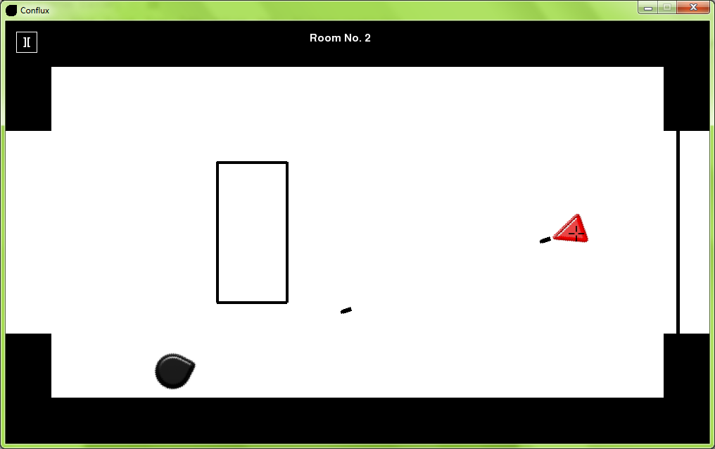

5.1

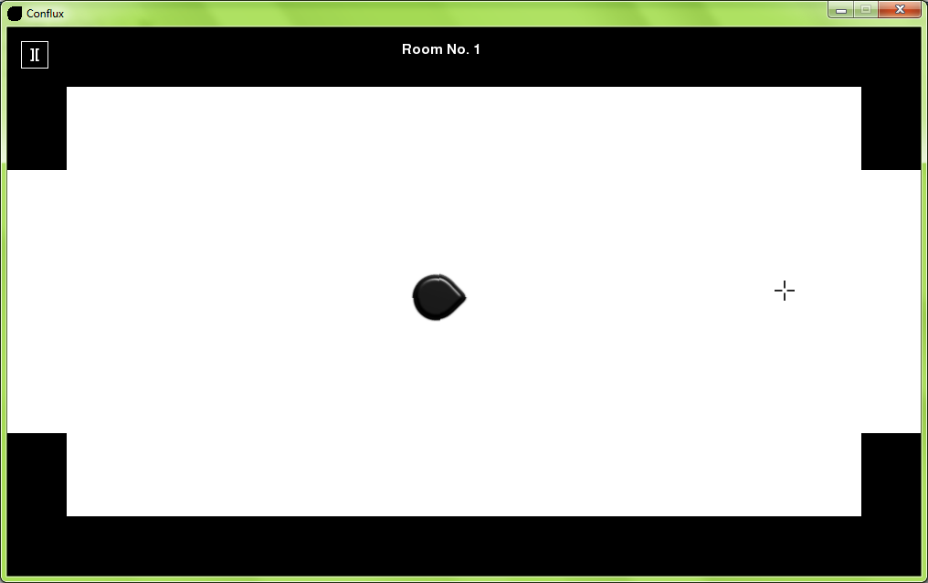

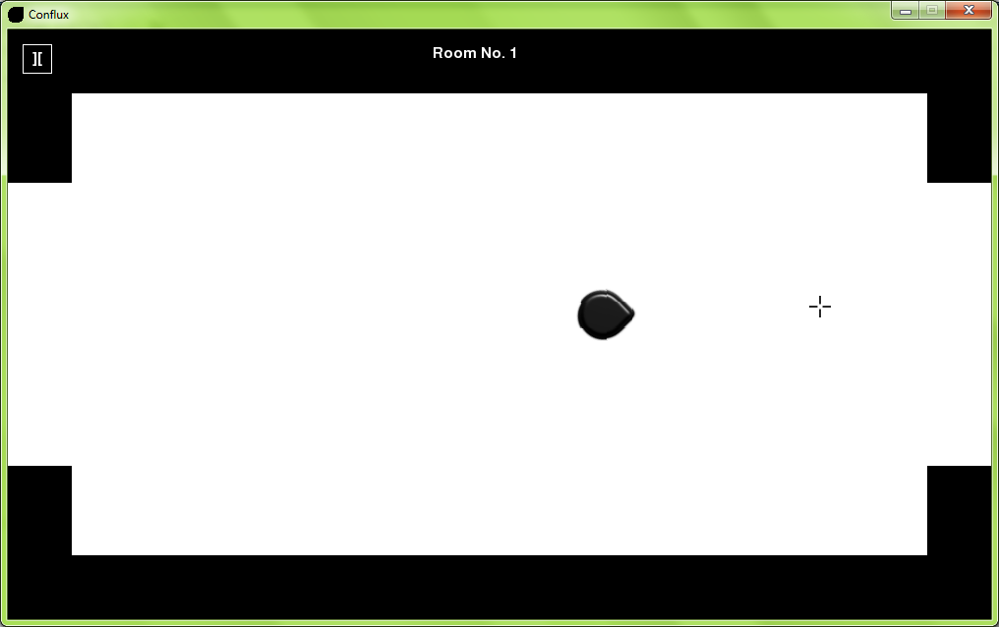

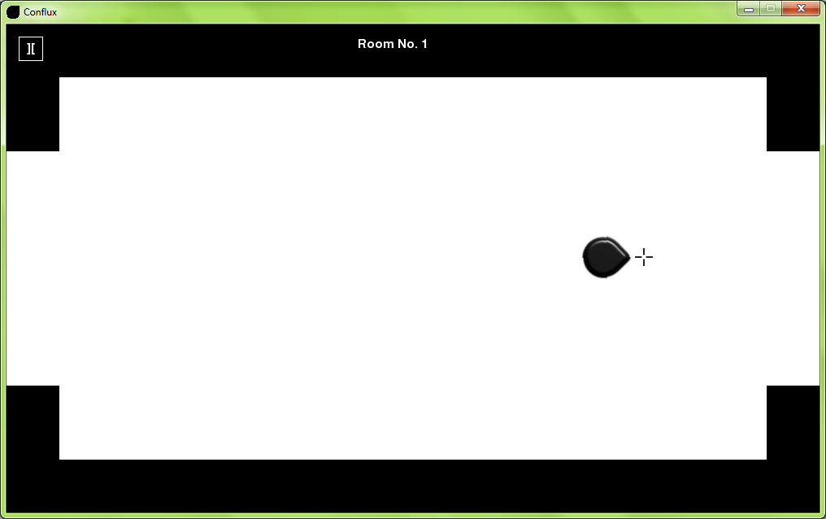

5.2

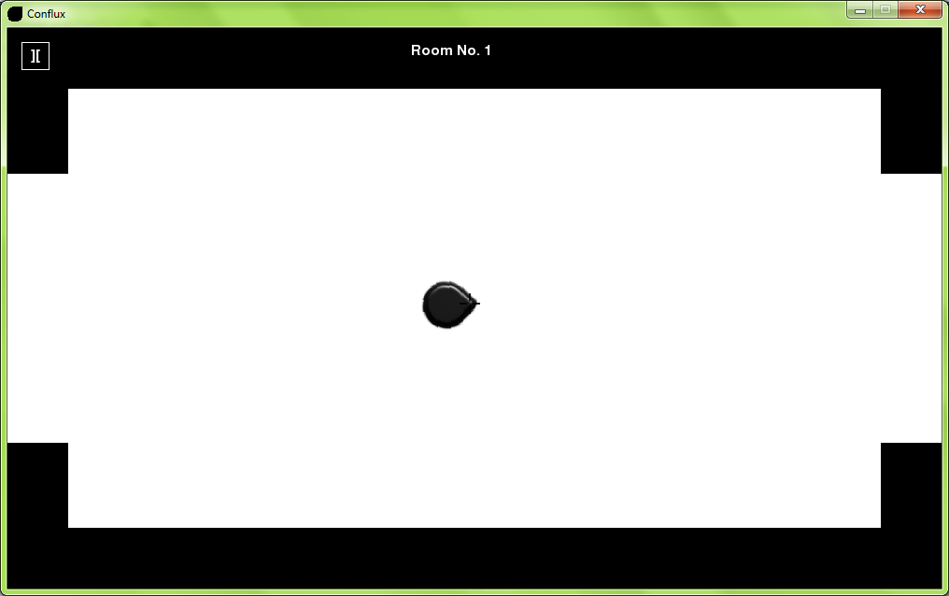

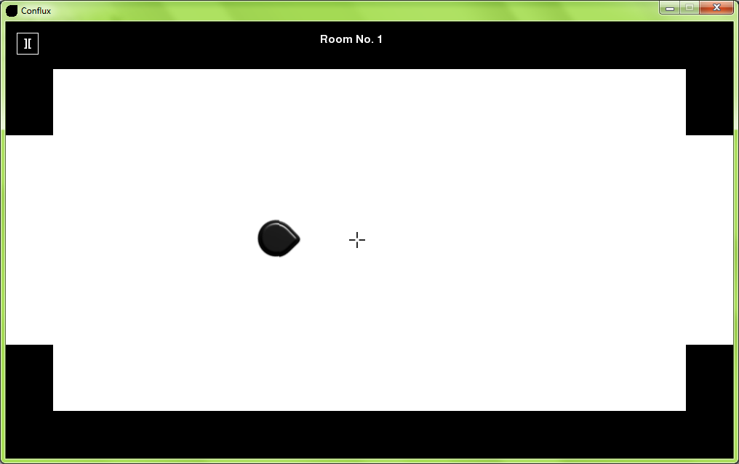

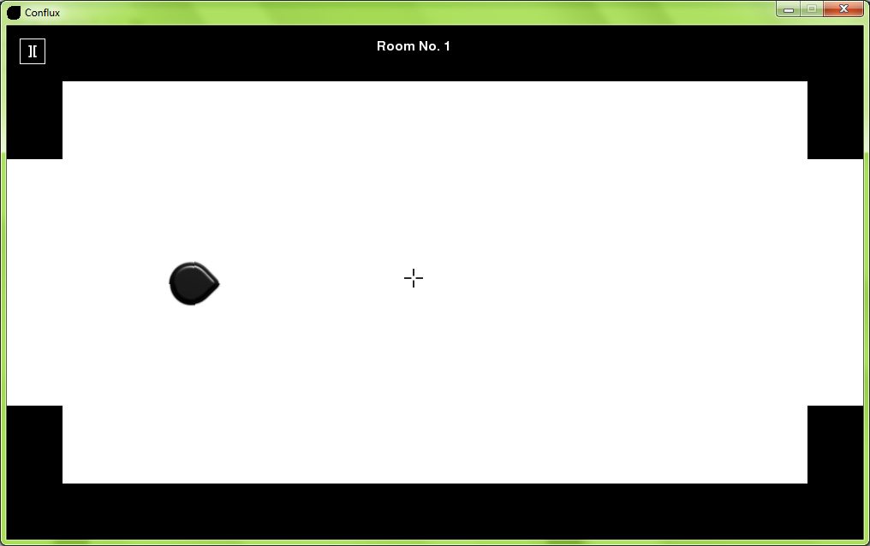

5.3

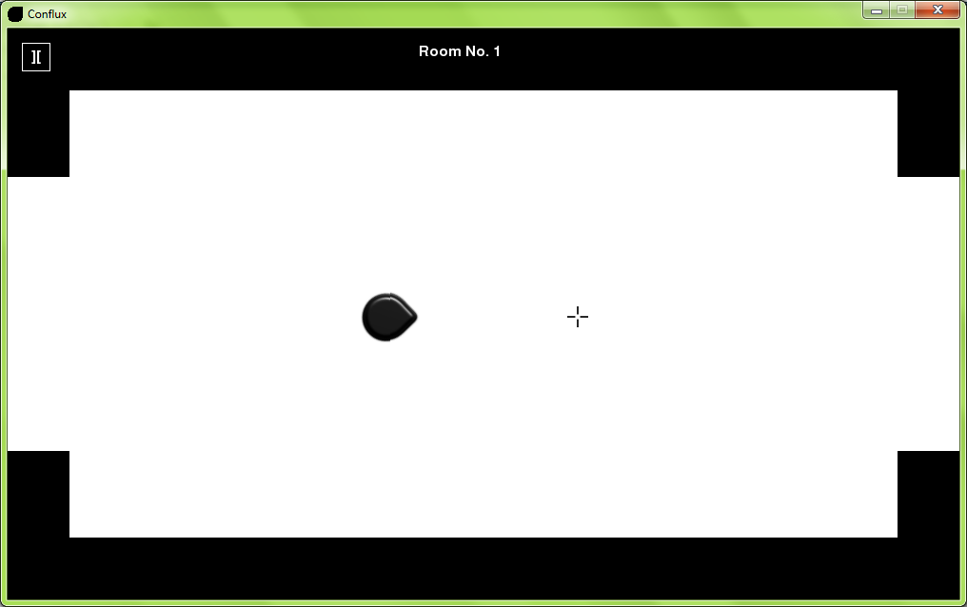

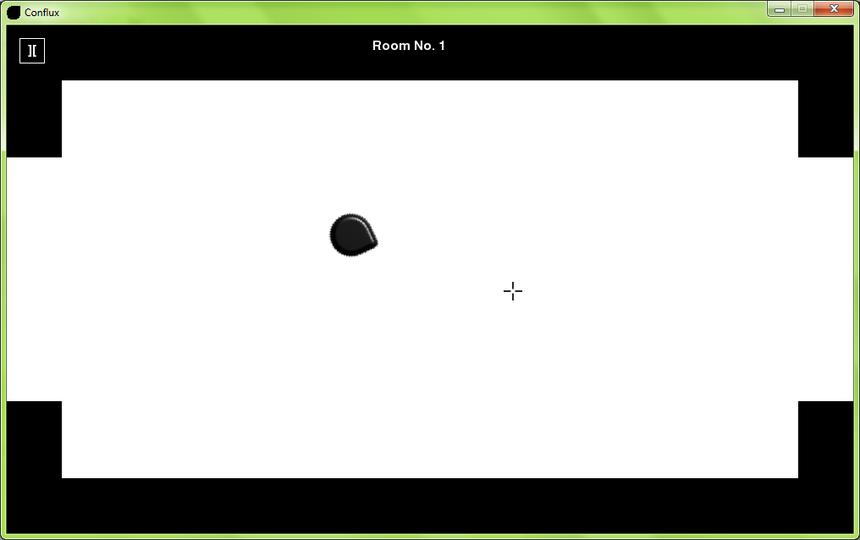

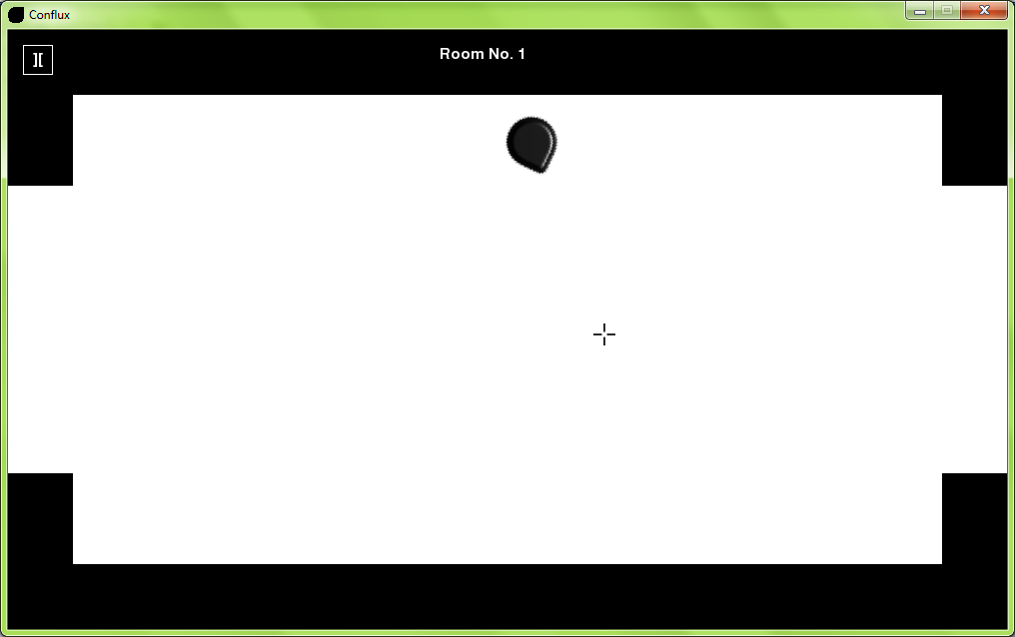

5.4



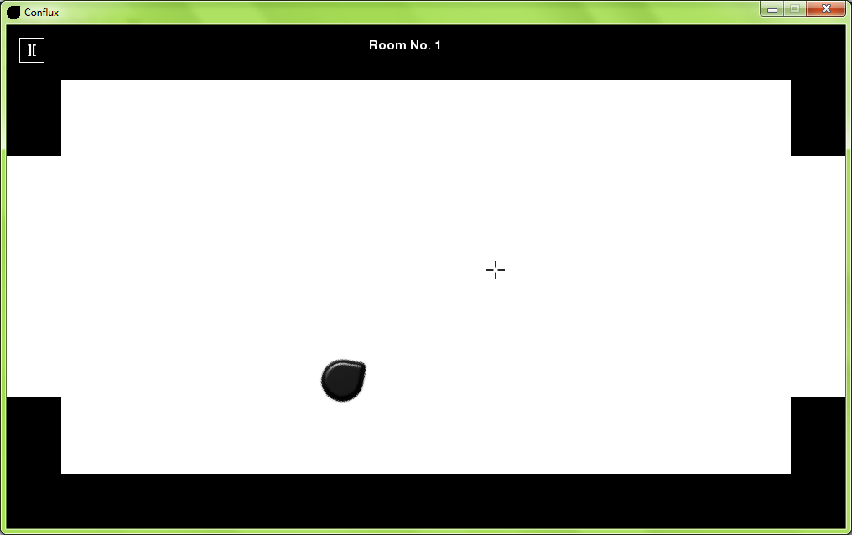

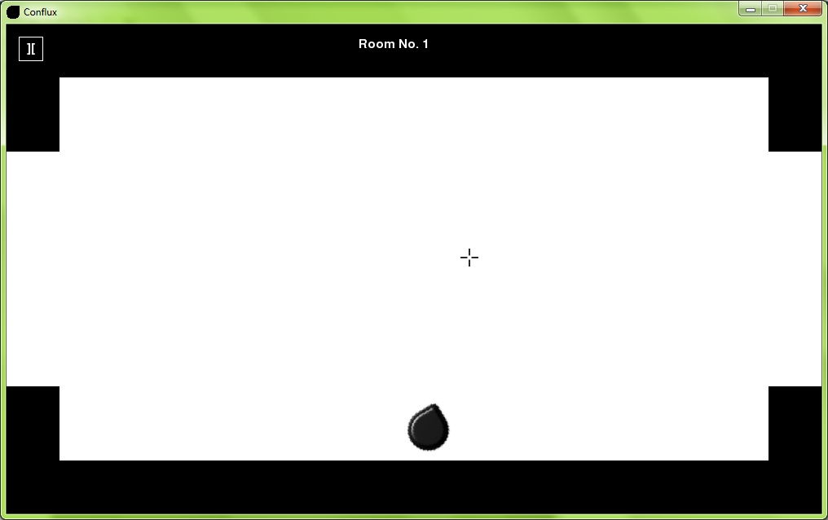

6.1

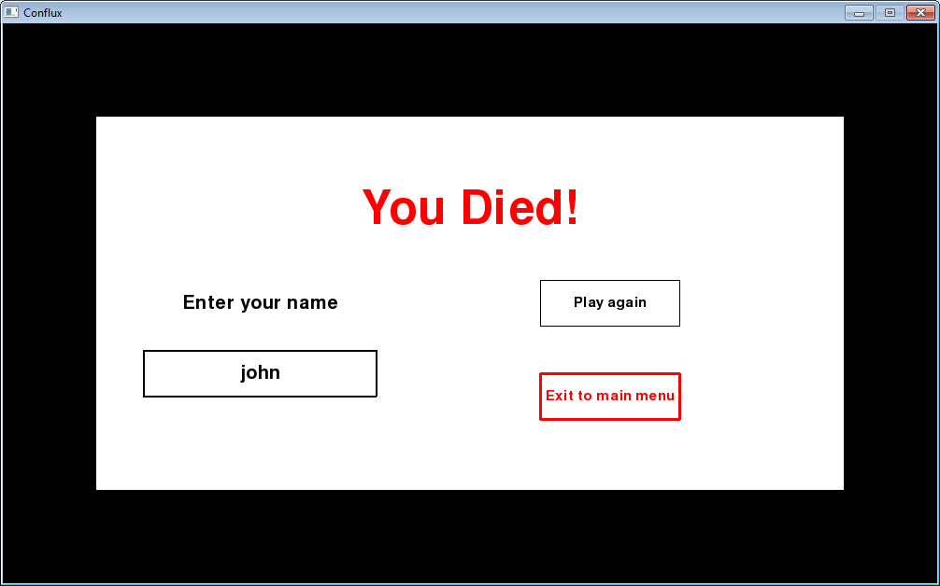

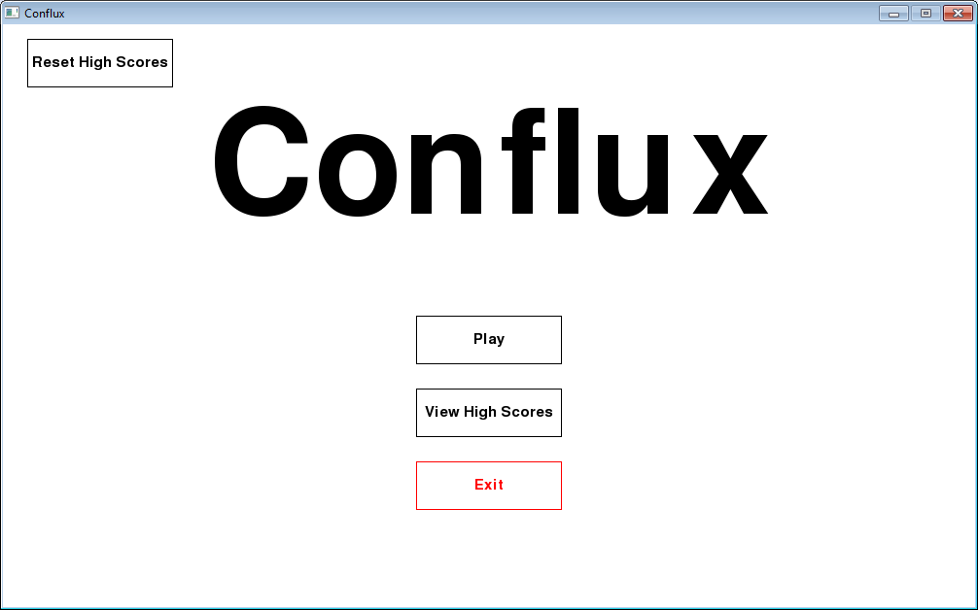

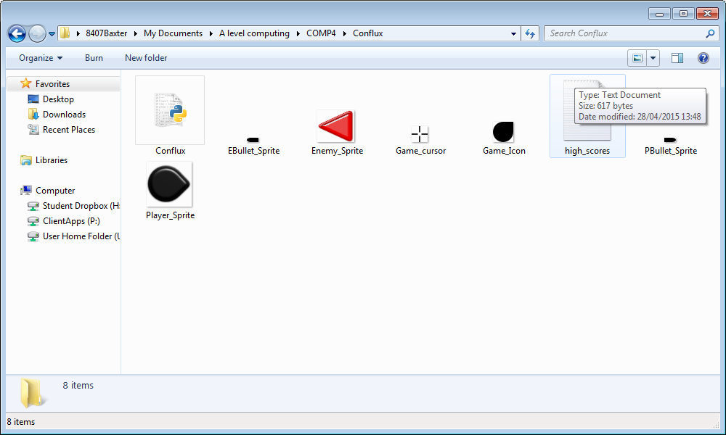

6.2a

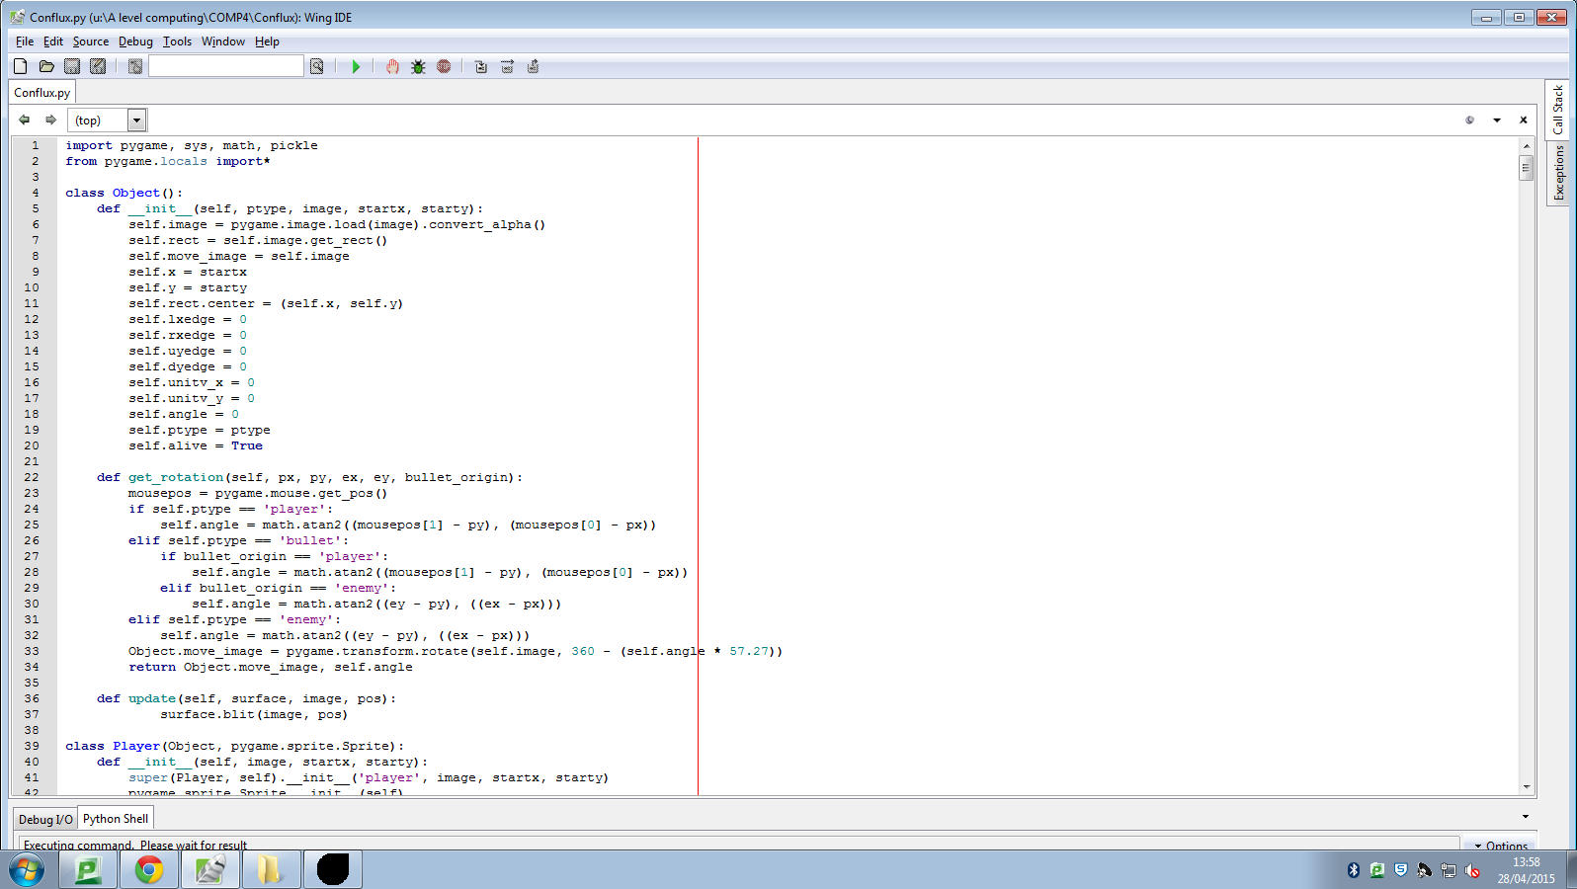

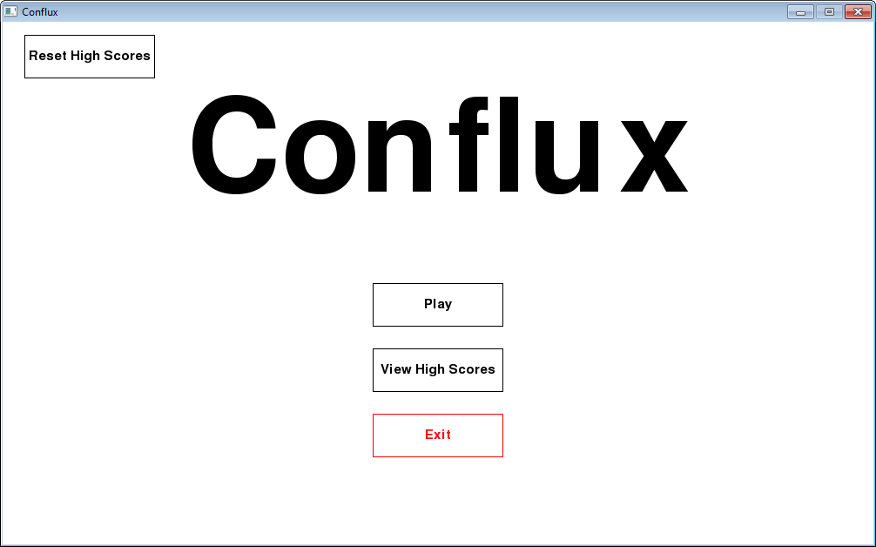

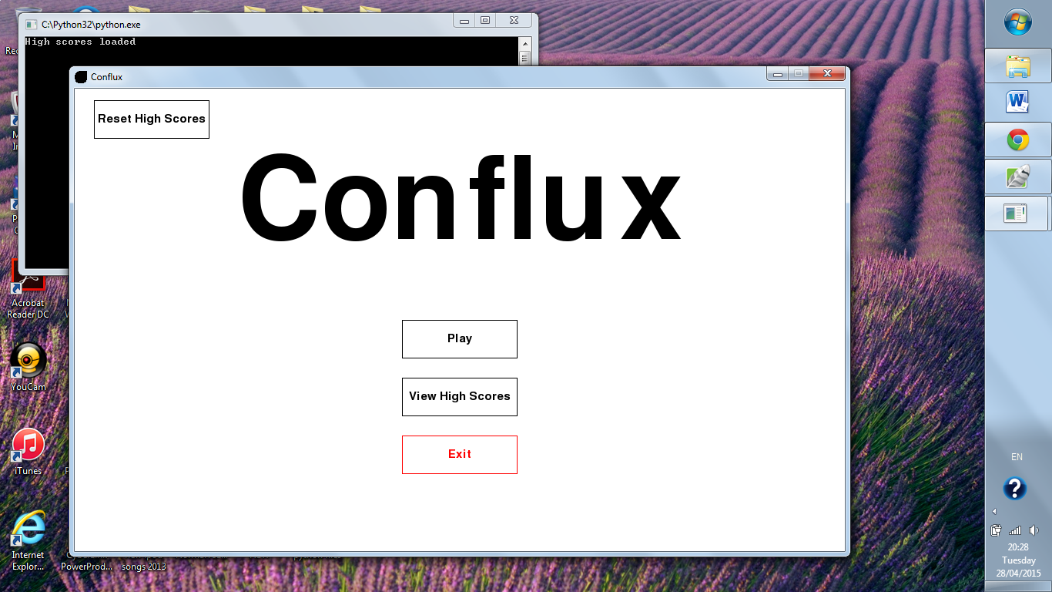

6.2b

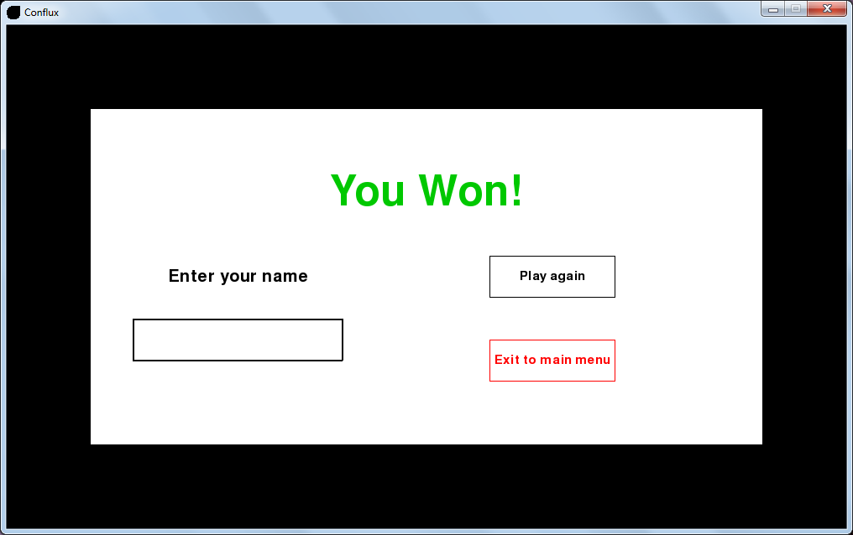

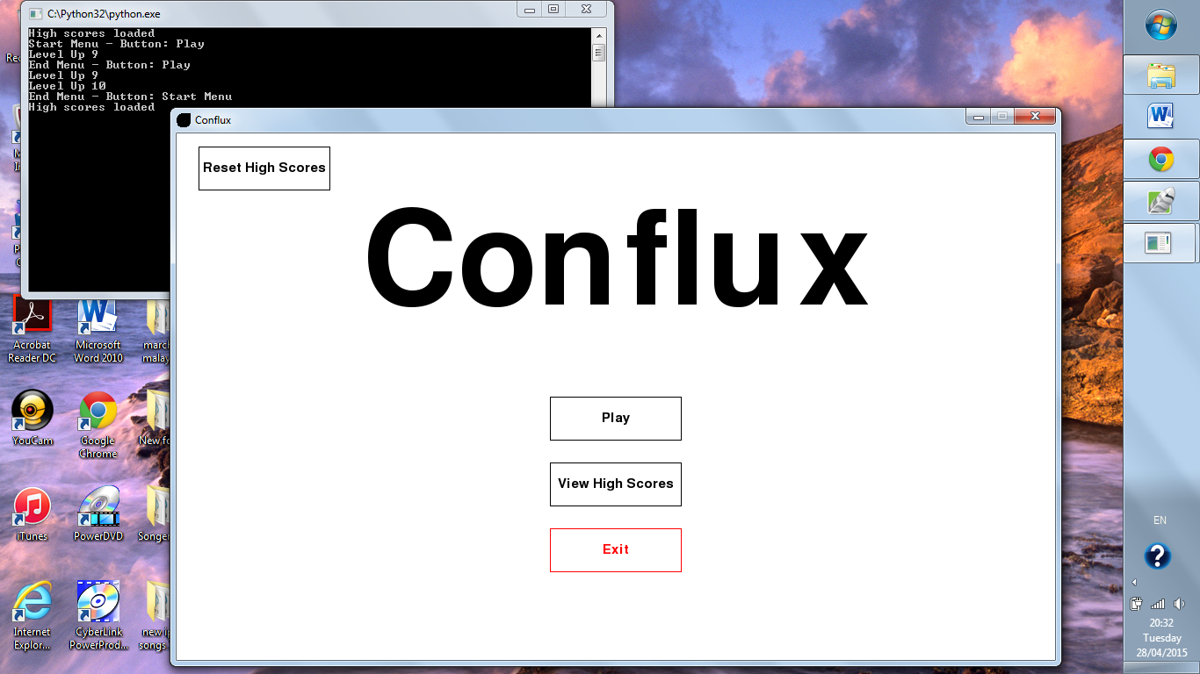

6.3



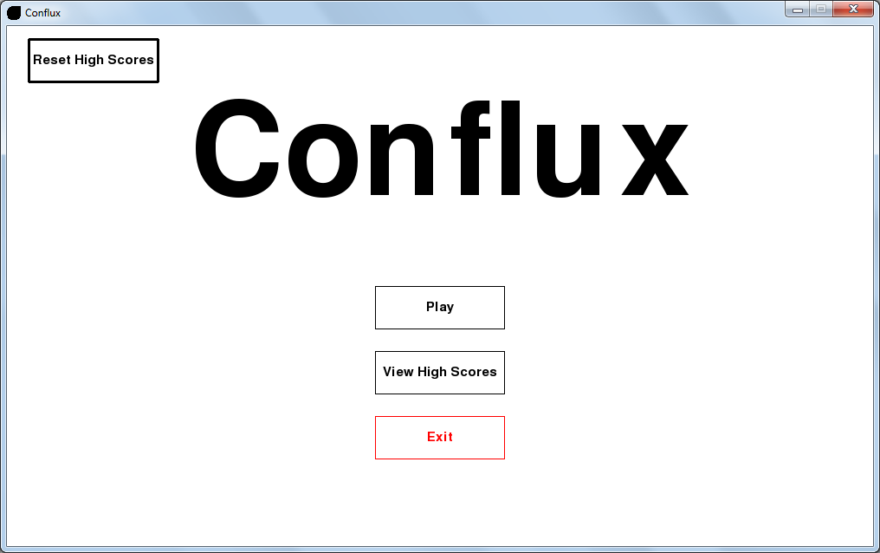

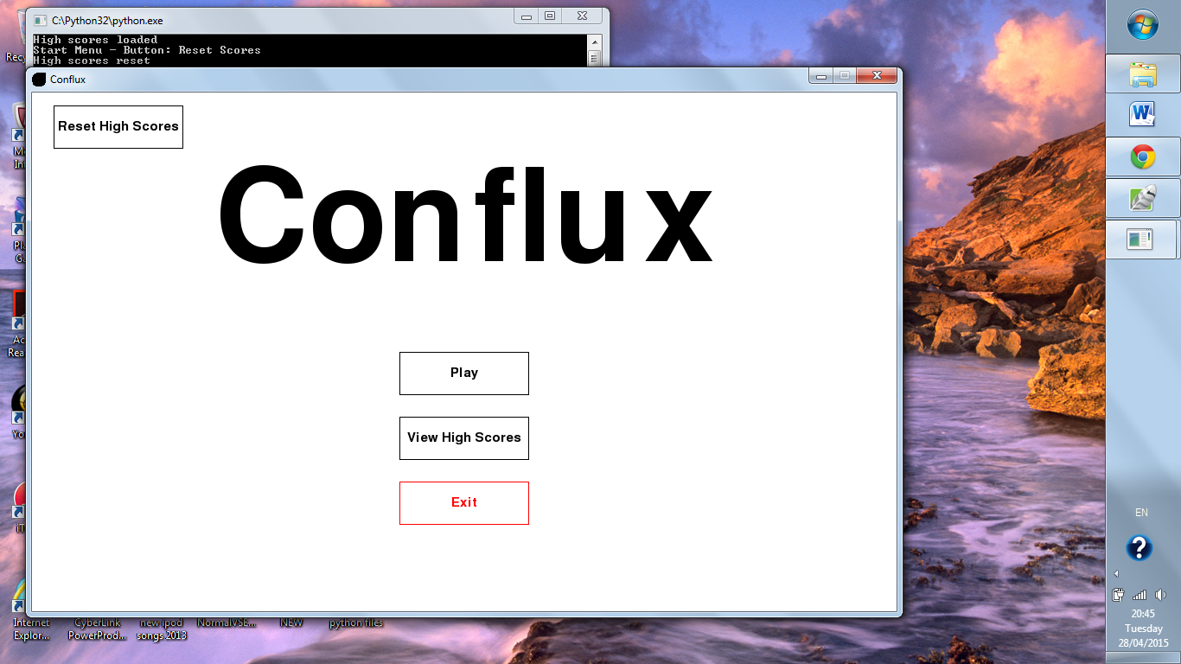

6.4



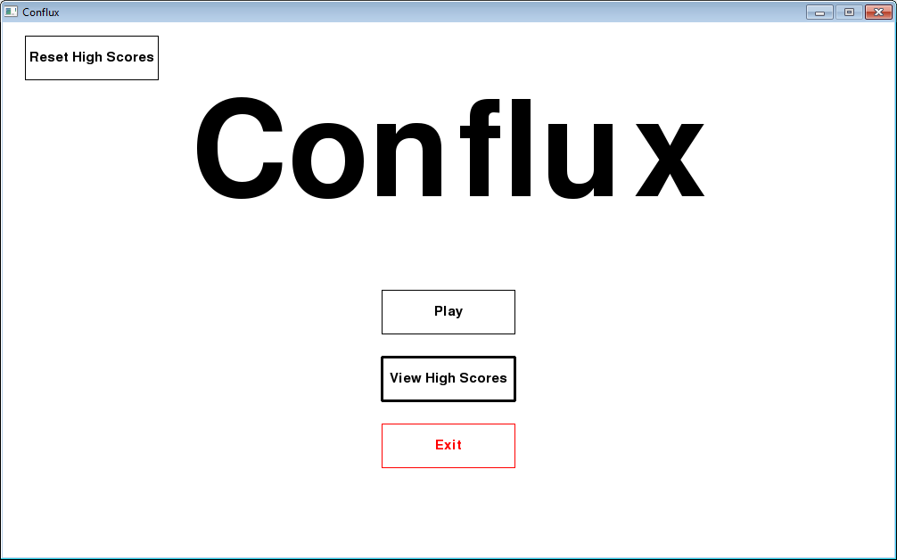

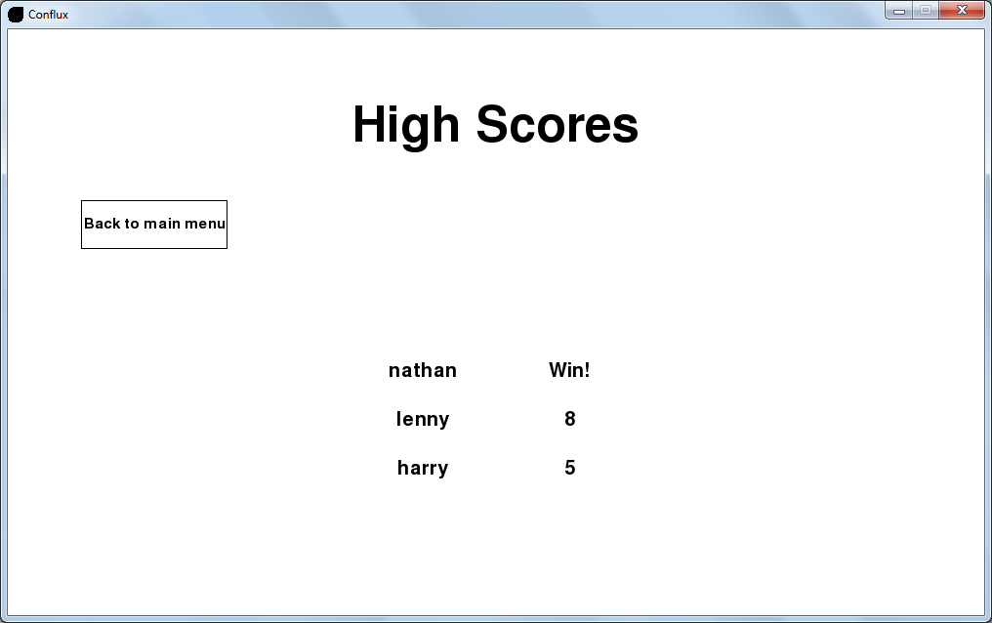

7.1a

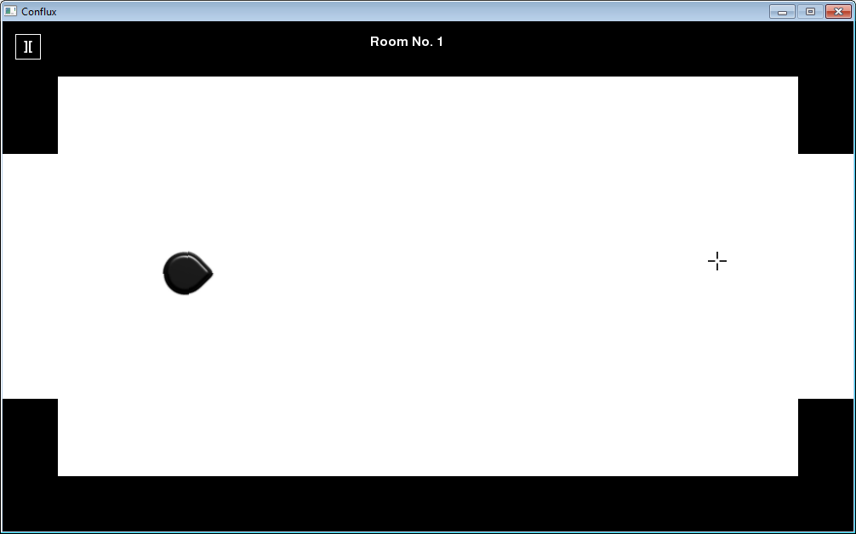

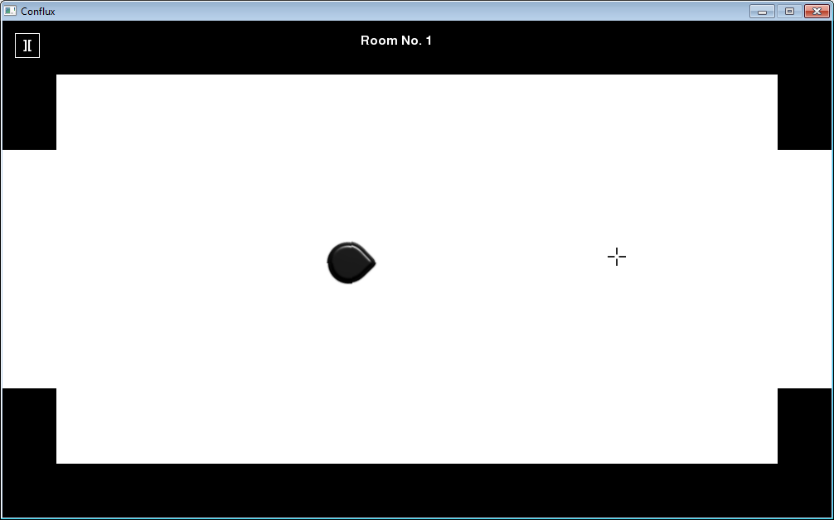

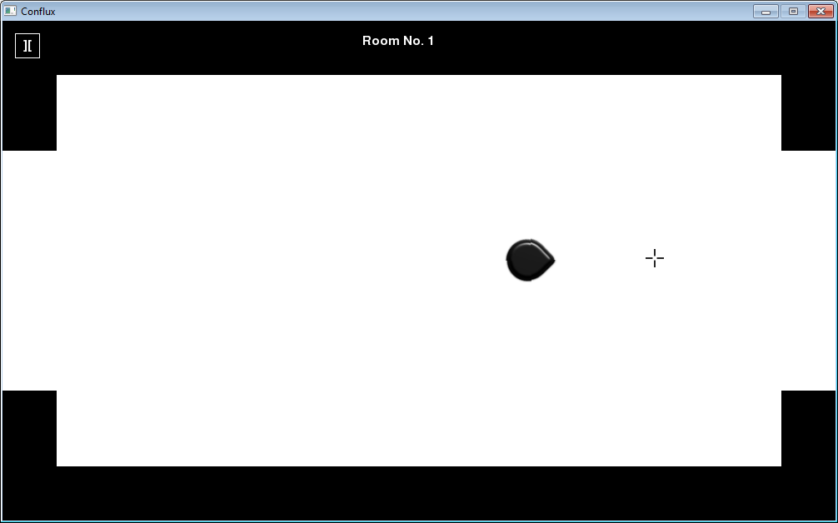

**User feedback:**

*“The forward movement of the player is really good, I love the way it always moves towards the mouse no matter where you move the mouse.”*

7.1b

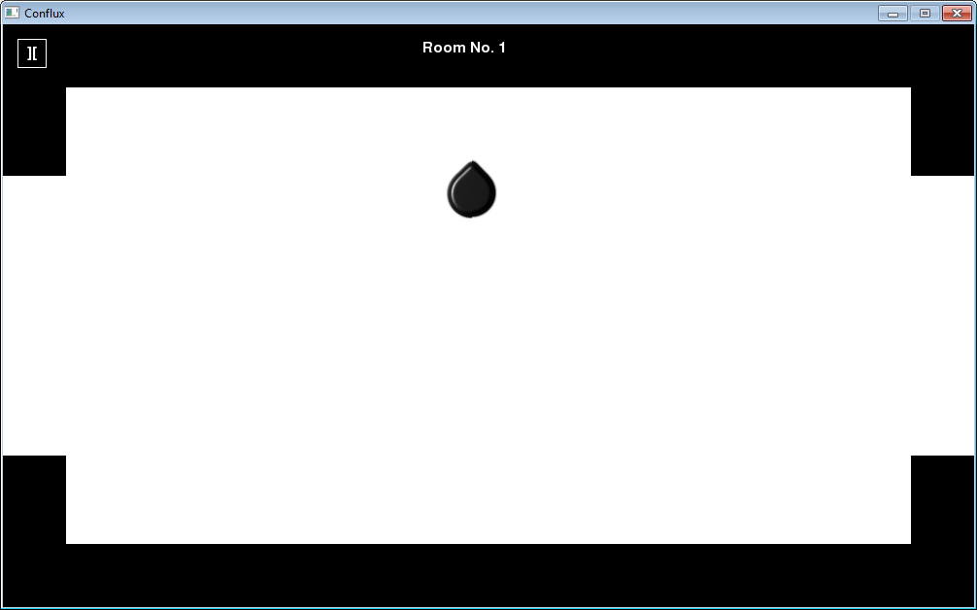

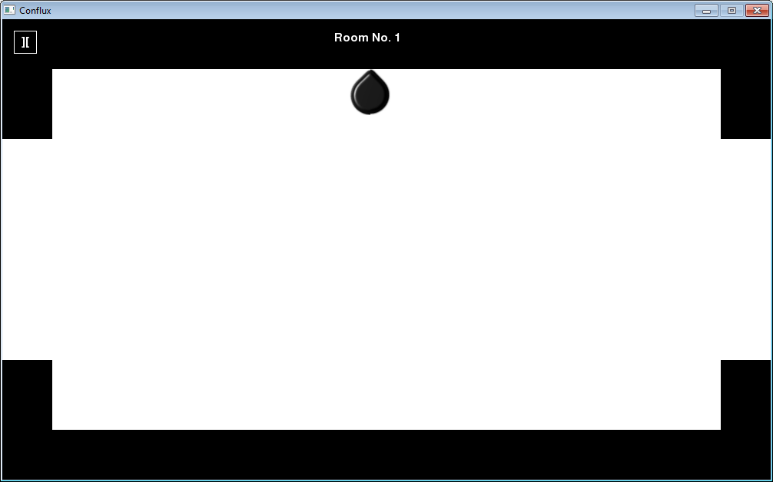



**User feedback:**

*“The map boundaries are good, but they stop the player a little too early, it would be better if it would stop them a bit later.”*

7.2a

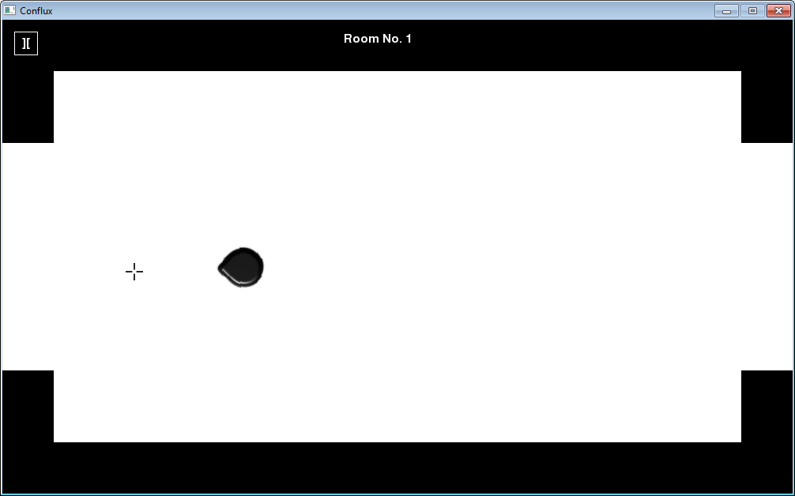

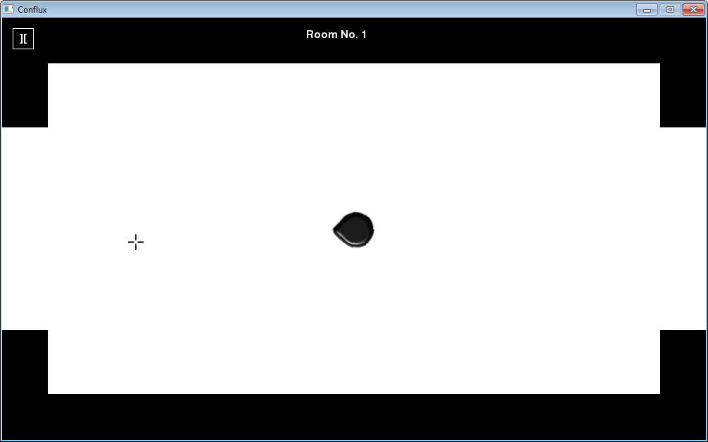

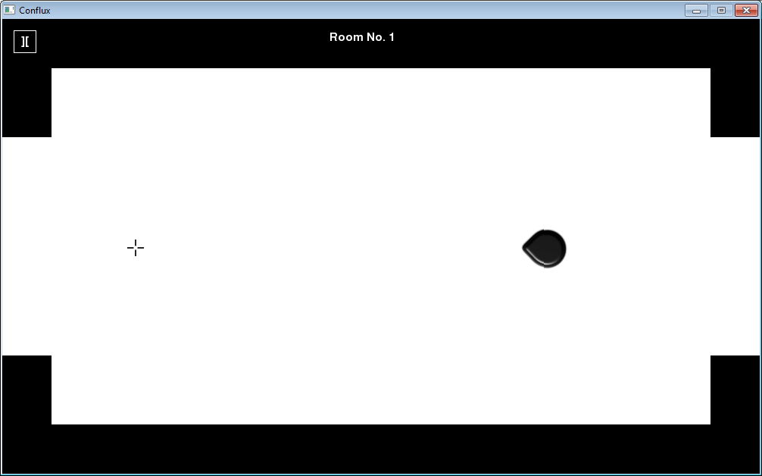

**User feedback:**

*“The backwards movement is really useful as well, it makes it a lot easier to dodge the incoming bullets.”*

7.2b

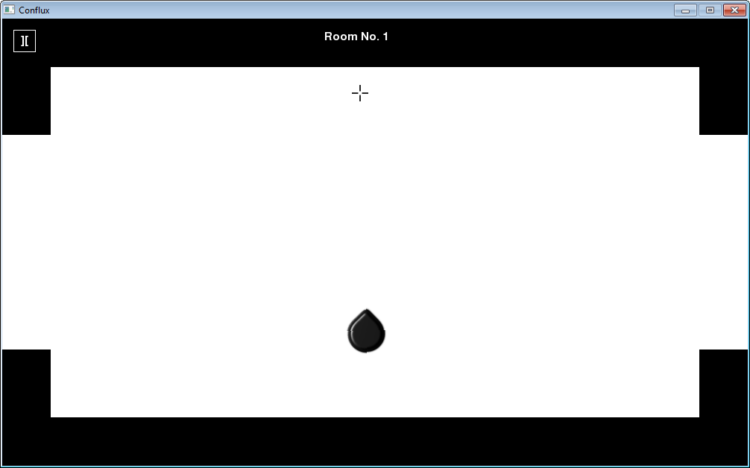

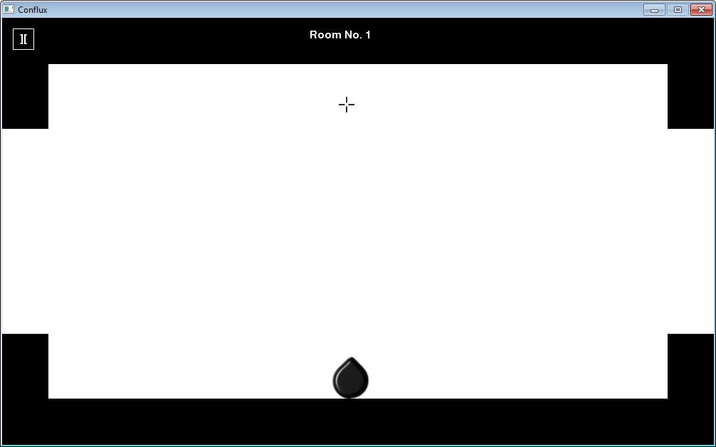



**User feedback:**

*“The map boundaries are good, but they stop the player a little too early, it would be better if it would stop them a bit later.”*

7.3a

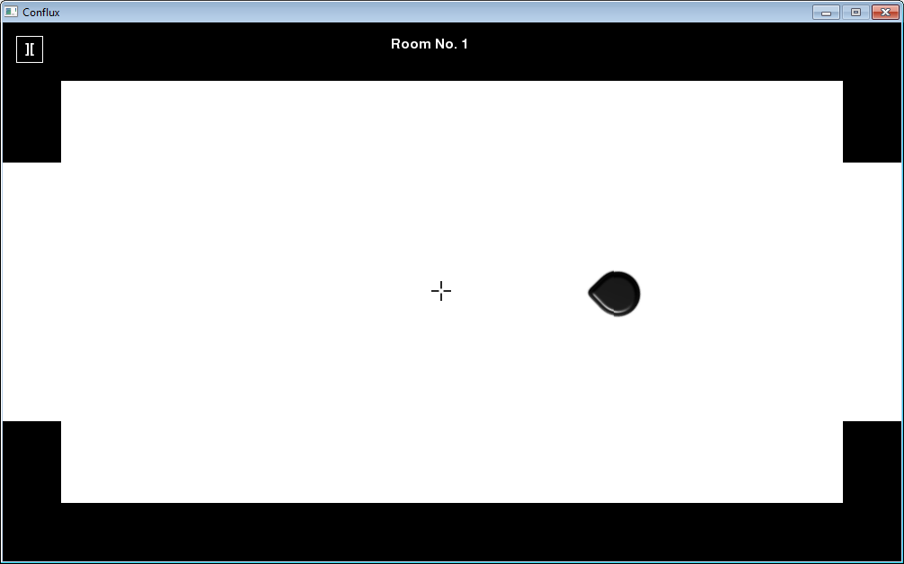

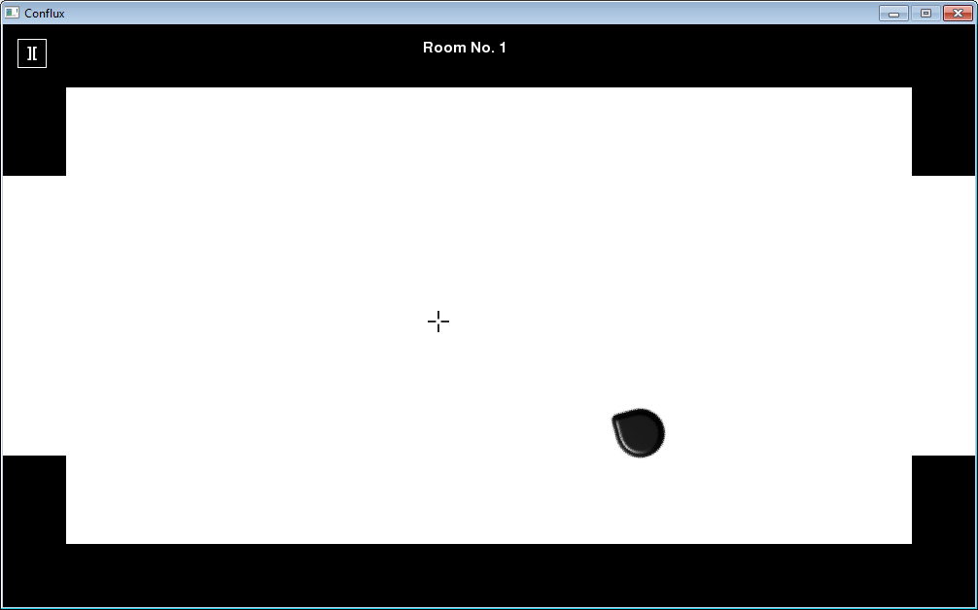

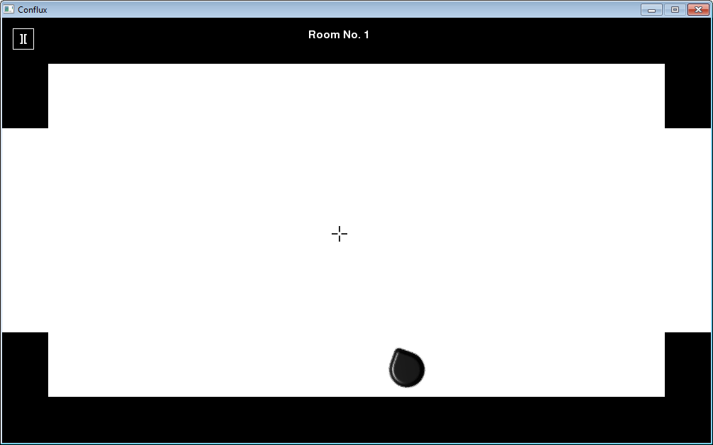

**User feedback:**

*“The left/right strafing really makes the movement dynamic, this will be great since I needed some advanced moving mechanics.”*

7.3b

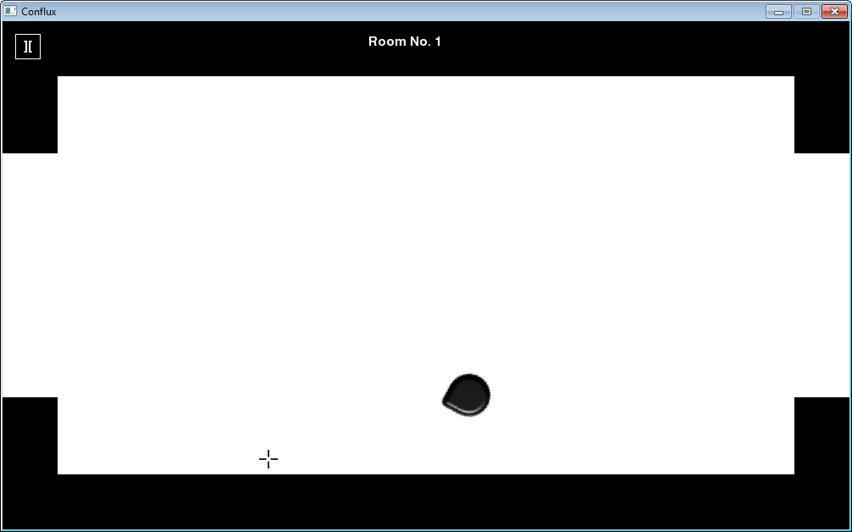

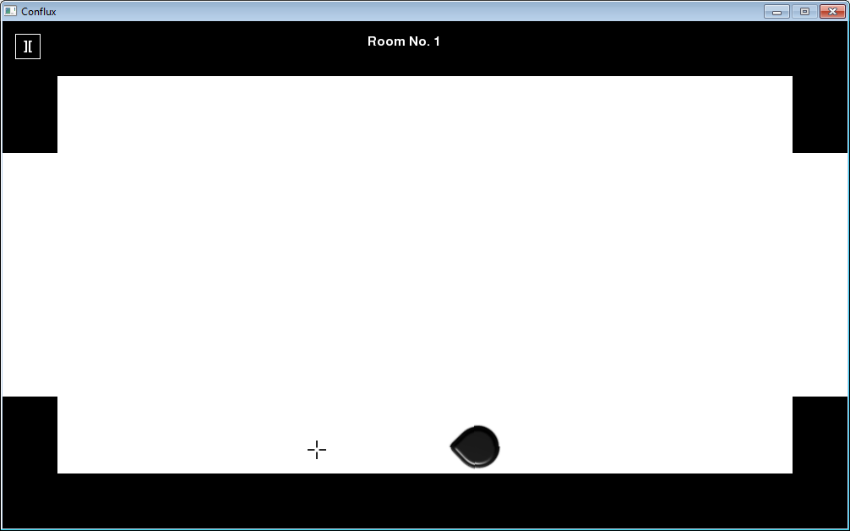



**User feedback:**

*“The map boundaries are good, but they stop the player a little too early, it would be better if it would stop them a bit later.”*

7.4a

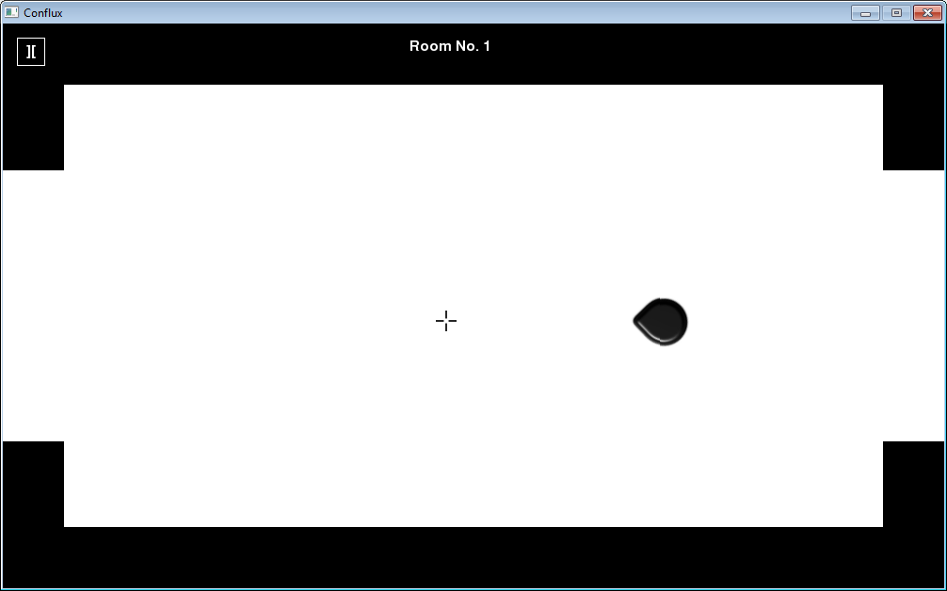

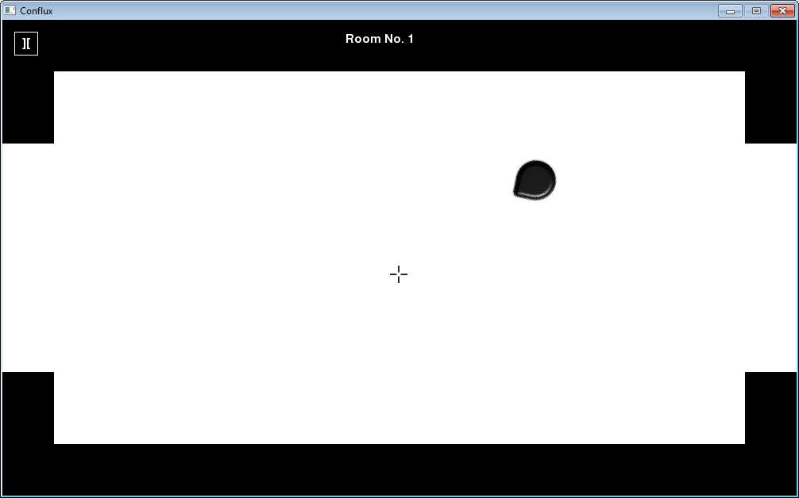

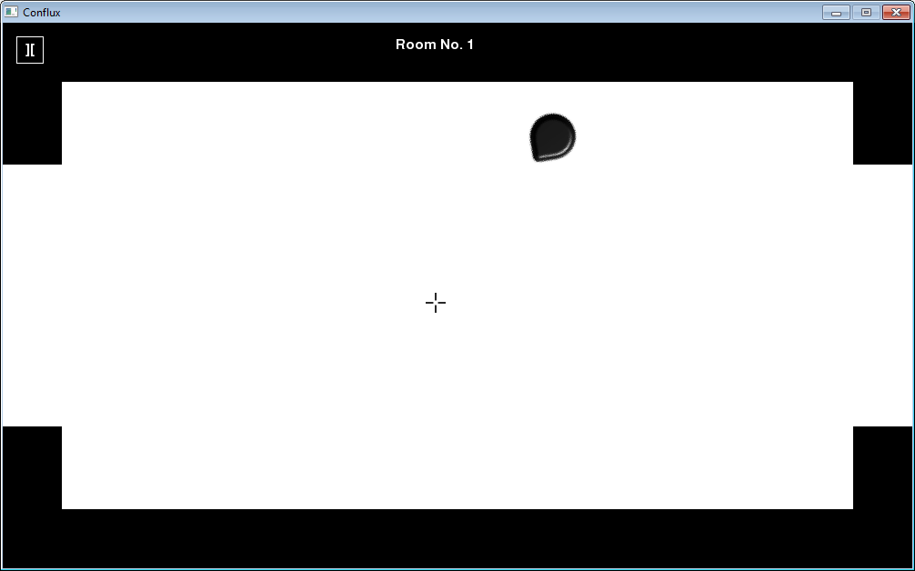

**User feedback:**

*“The left/right strafing really makes the movement dynamic, this will be great since I needed some advanced moving mechanics.”*

7.4b

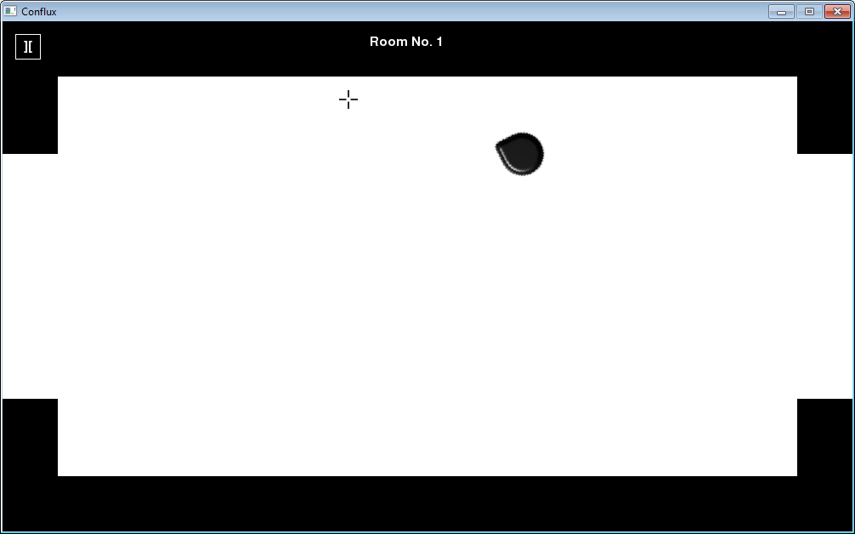

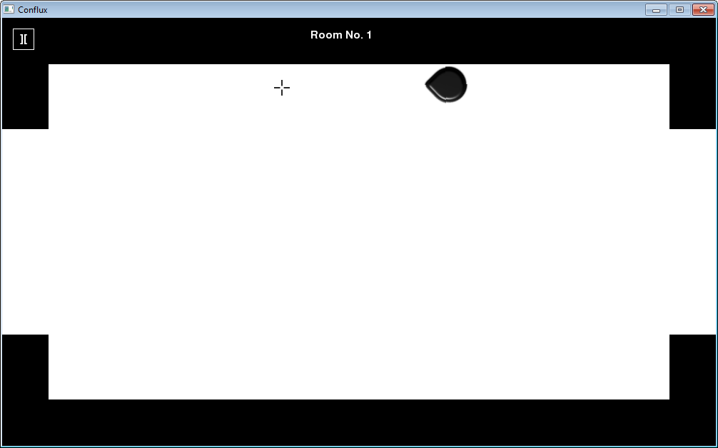



**User feedback:**

*“The map boundaries are good, but they stop the player a little too early, it would be better if it would stop them a bit later.”*

7.5

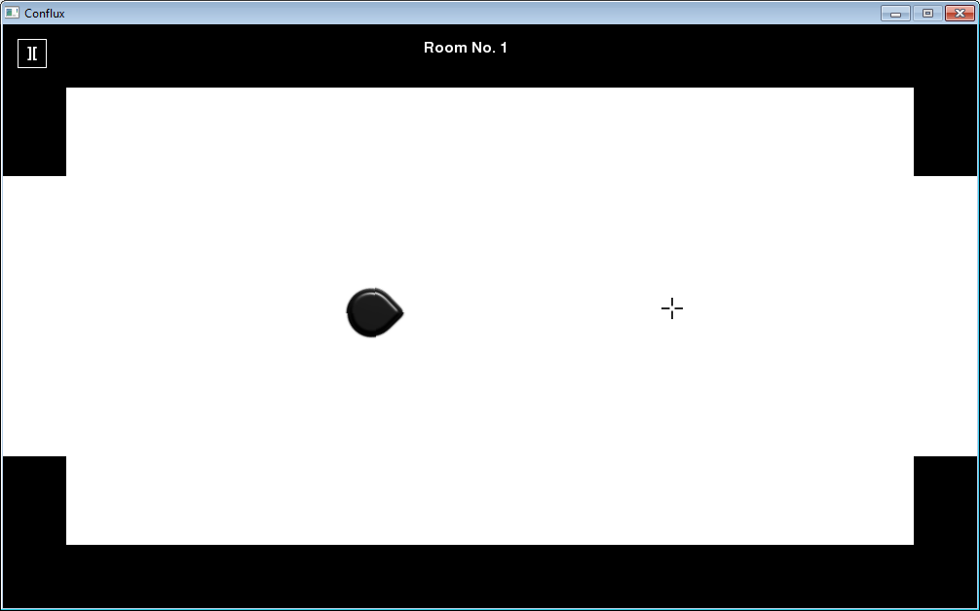

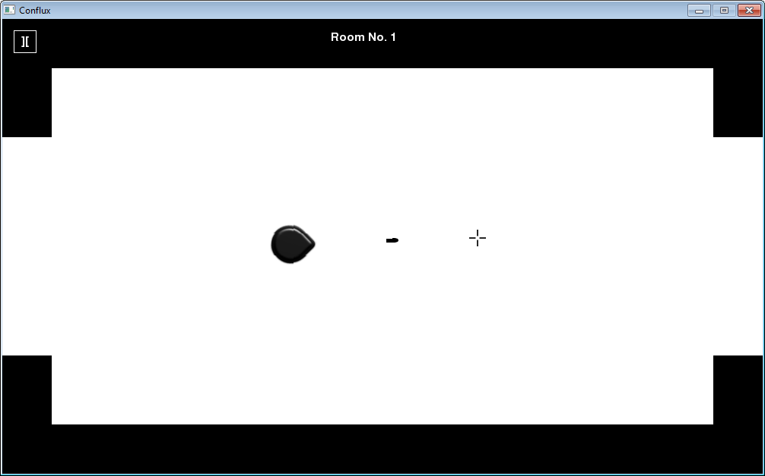

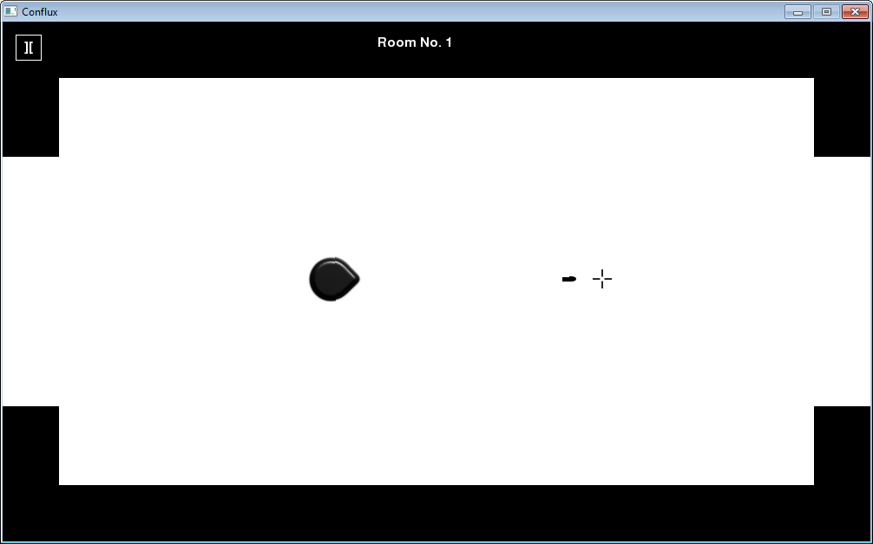

**User feedback:**

*“The player shooting was done very well, it was exactly what I wanted.”*

7.6

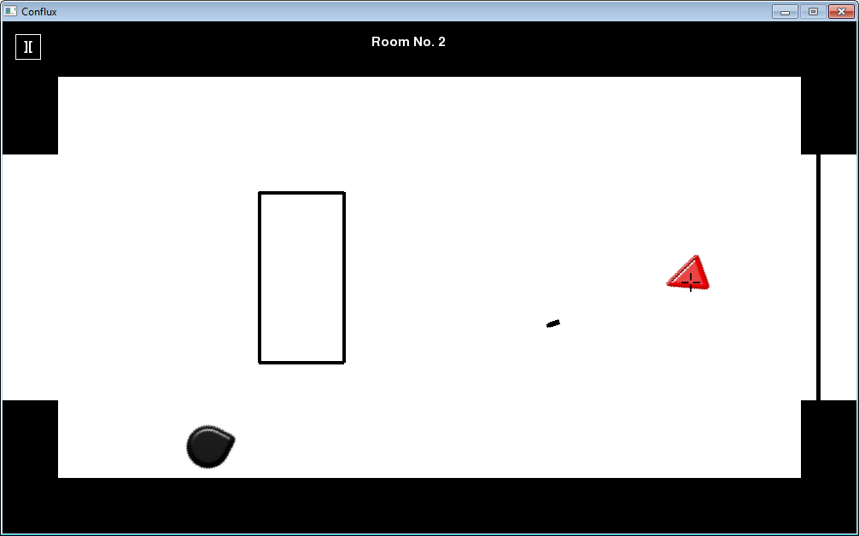

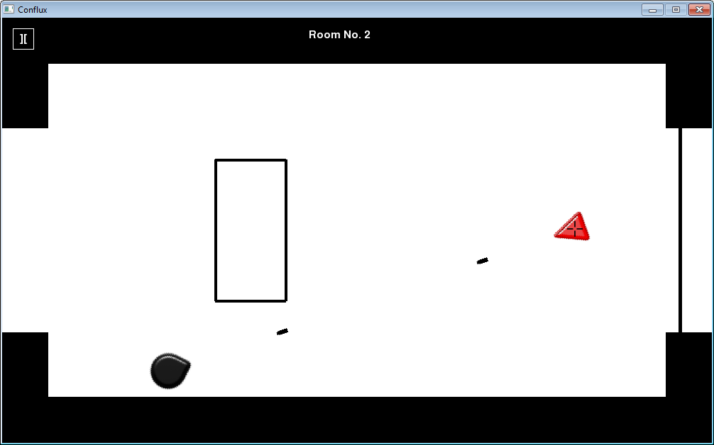

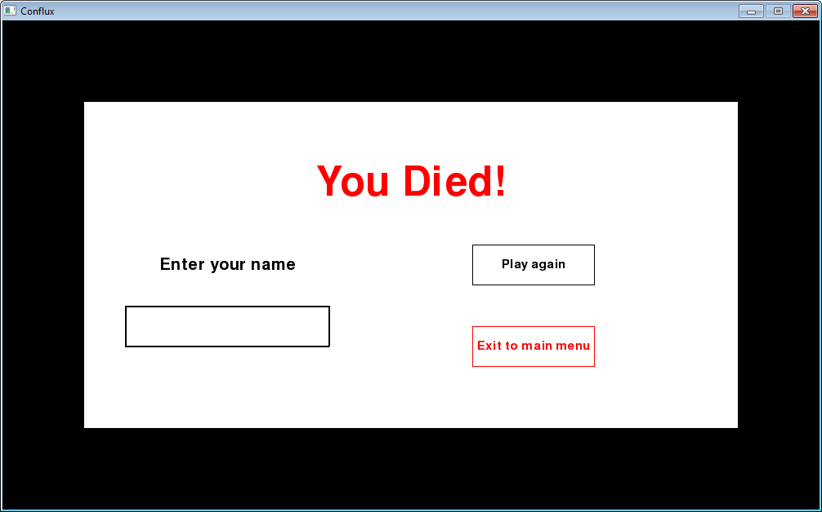

**User feedback:**

*“I’m glad the player and enemies only needs one shot to land on them for them to die, I needed the simplicity for this project. But, the collision detection for the bullets and the player seems to be a bit inaccurate as sometimes the bullet just misses me and I die anyway.”*

7.7

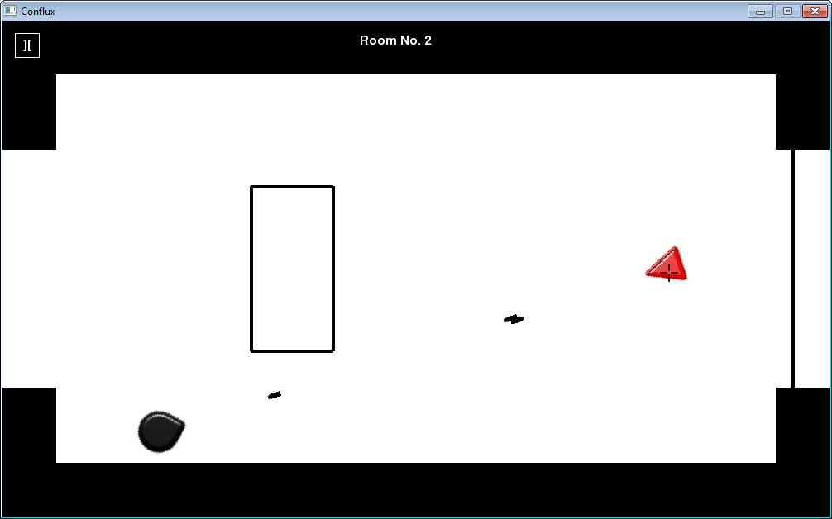

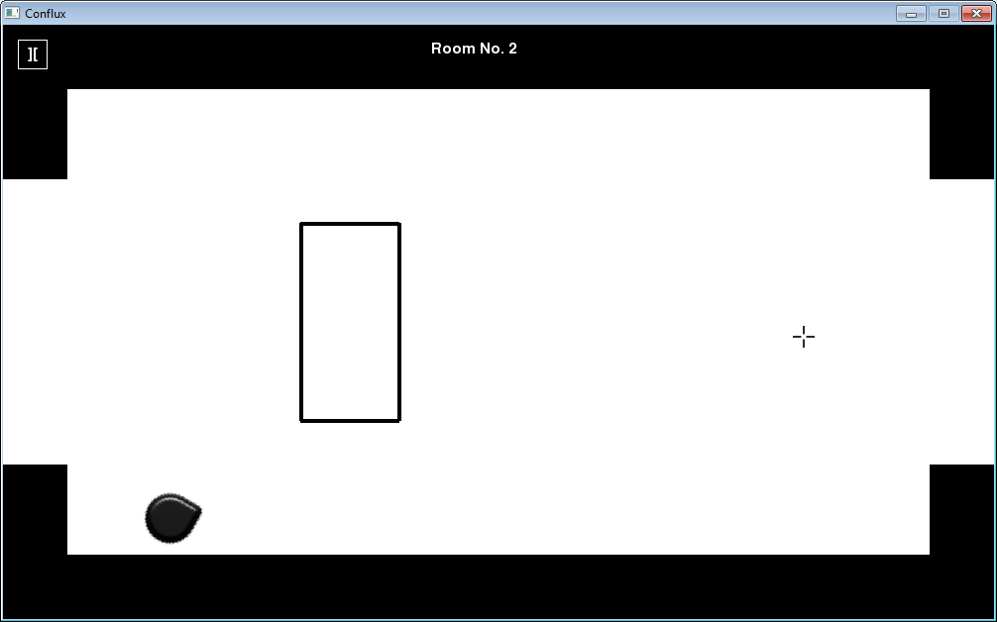

**User feedback:**

*“I’m glad the player and enemies only needs one shot to land on them for them to die, I needed the simplicity for this project. But, the collision detection for the bullets and the player seems to be a bit inaccurate as sometimes the bullet just misses me and I die anyway.”*

7.8

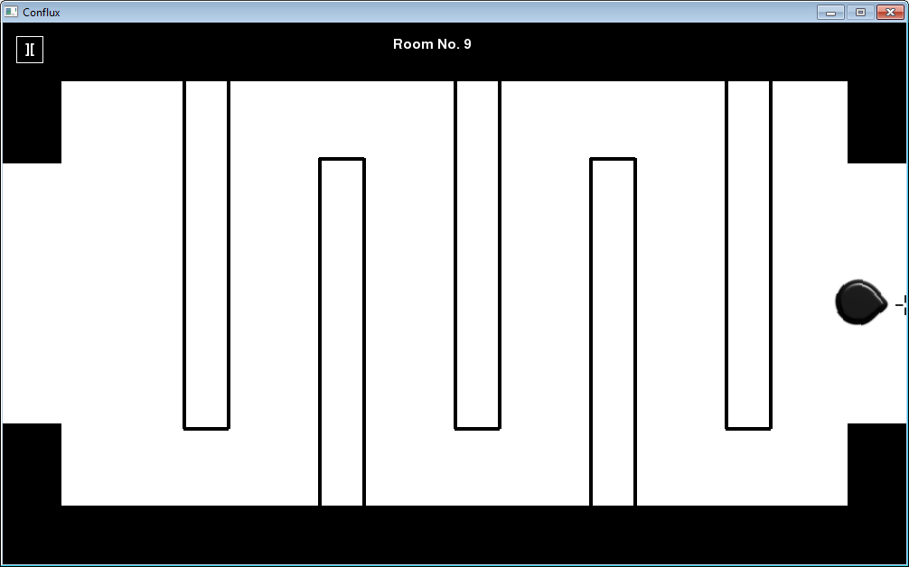

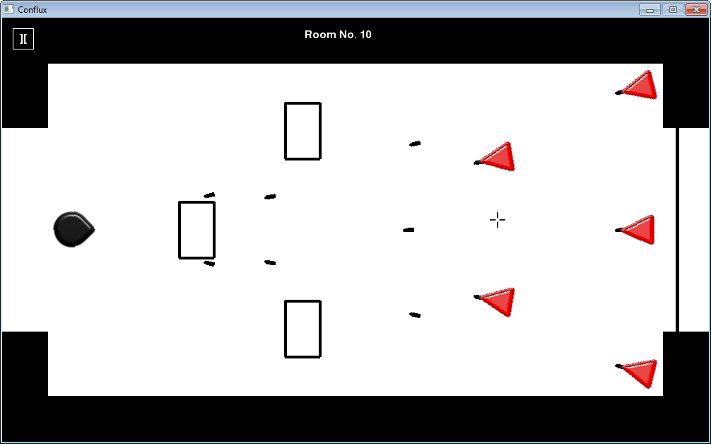

**User feedback:**

*“The way that the enemies track the player is good, it’s just what I wanted.”*

7.9

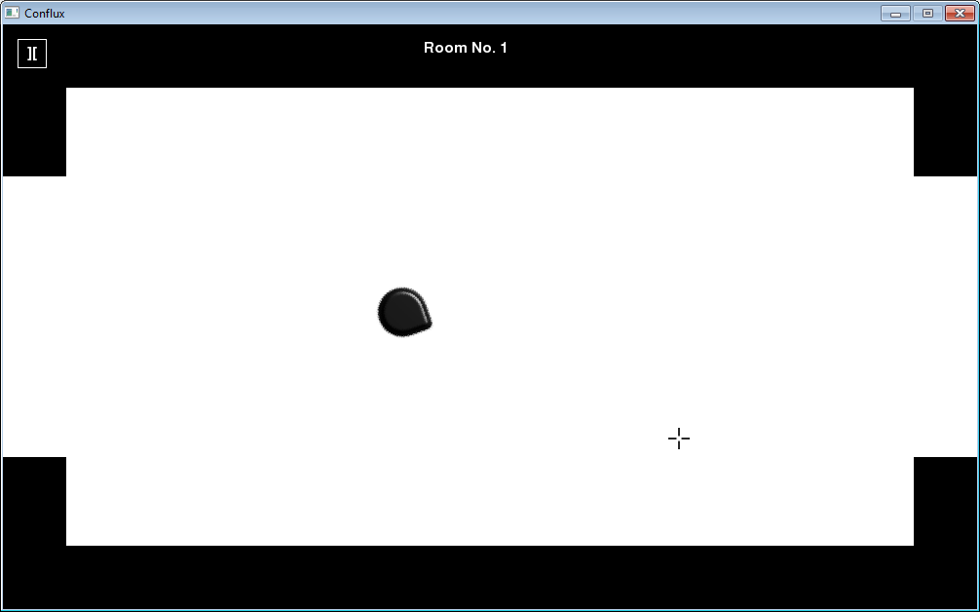

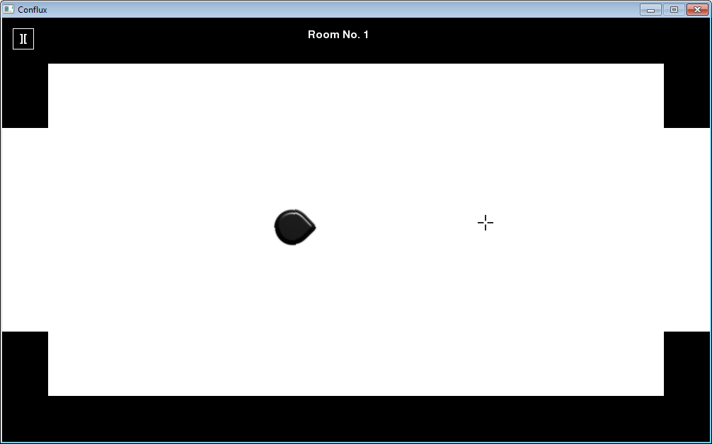

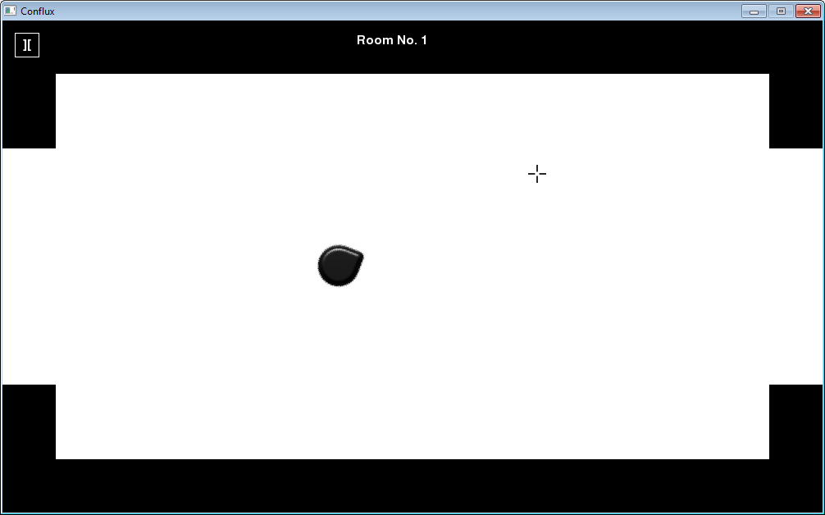

**User feedback:**

*“The player’s rotational mechanic works really well, I love this part of the game.”*

7.10

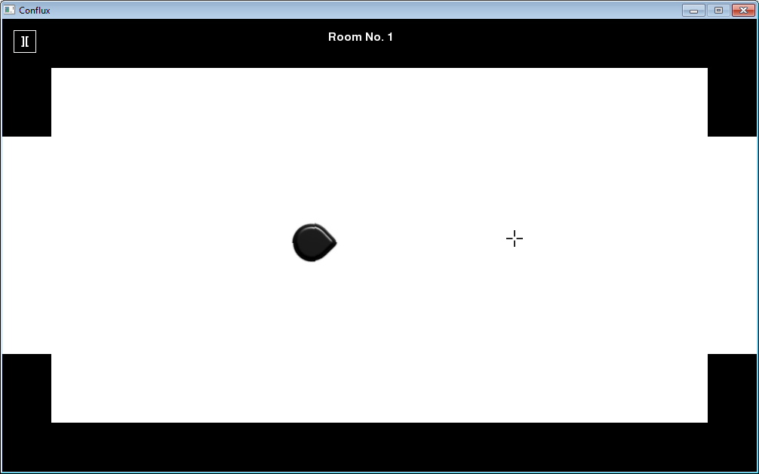

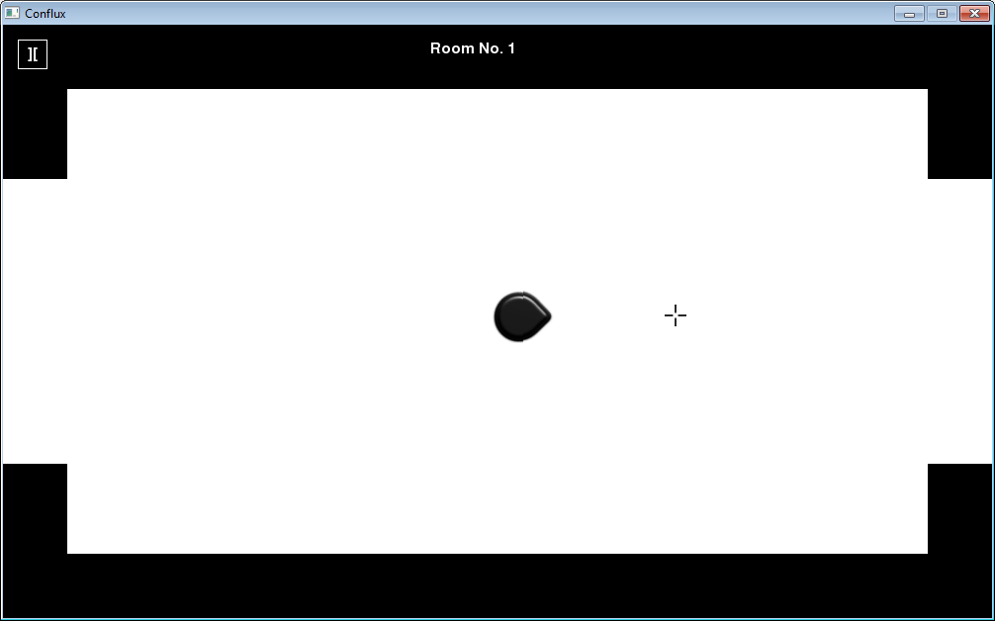

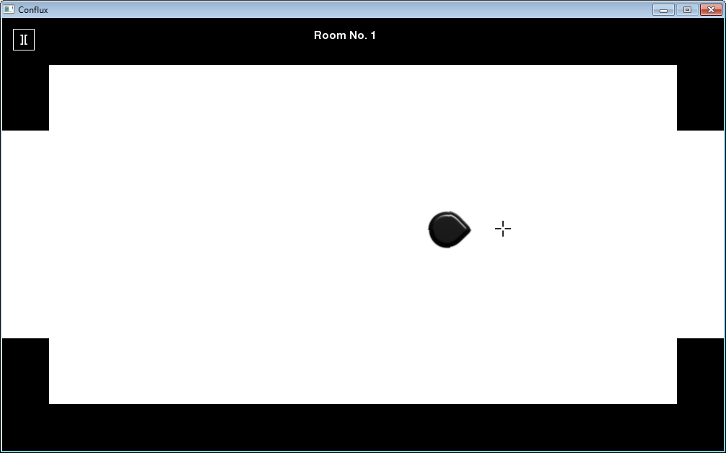

**User feedback:**

*“The WASD controls work really well with the mouse movement.”*

7.11

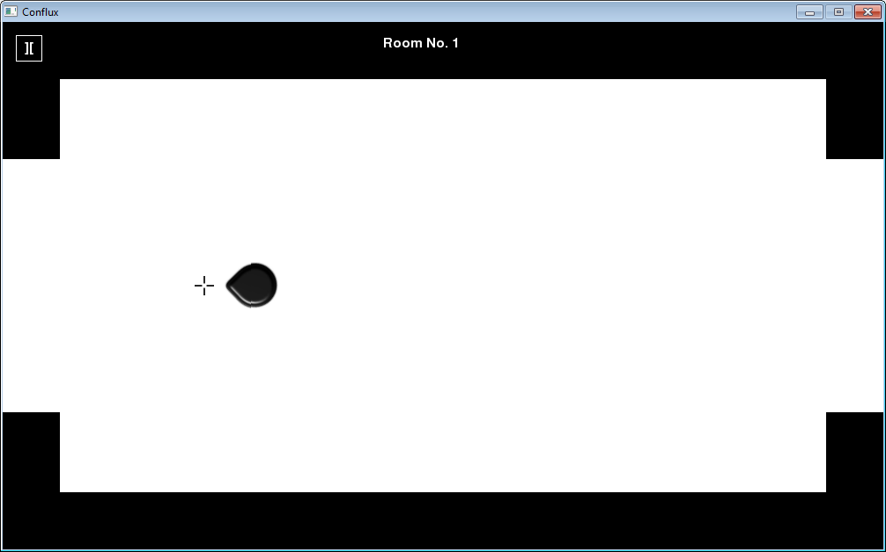

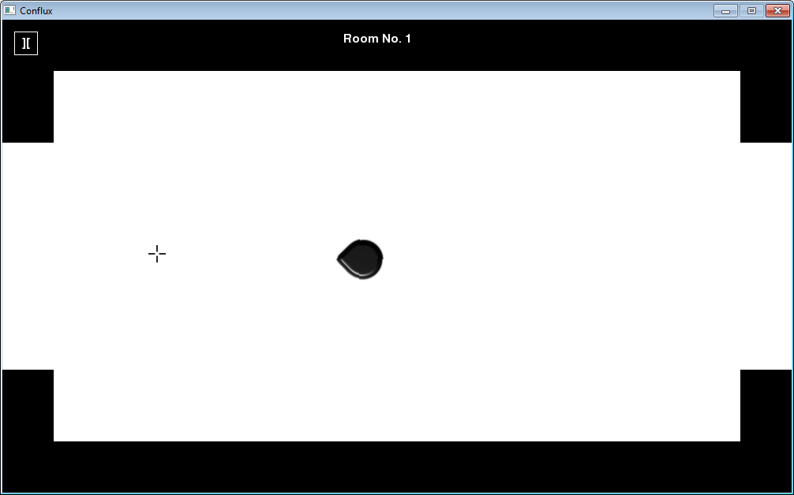

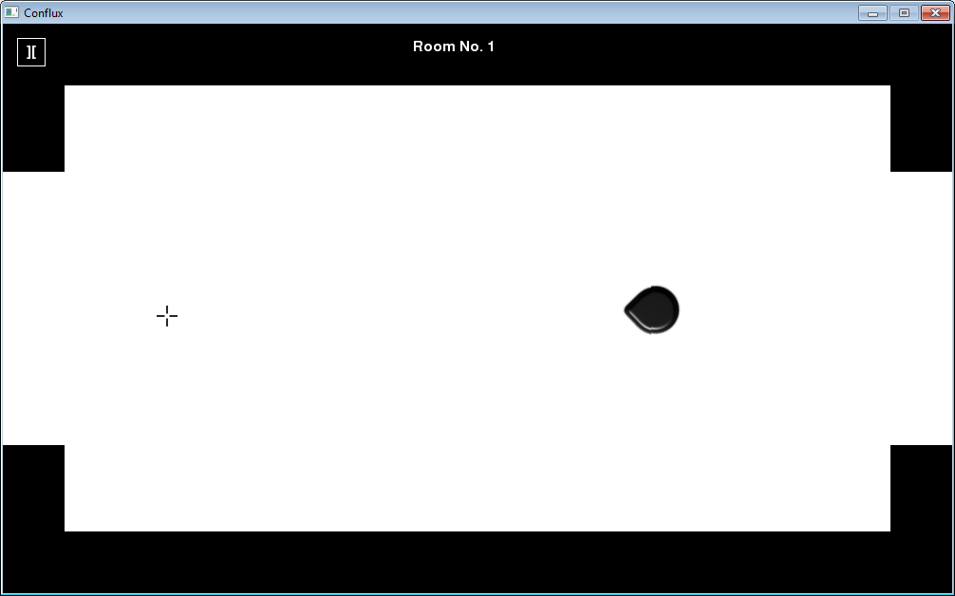

**User feedback:**

*“The WASD controls work really well with the mouse movement.”*

7.12

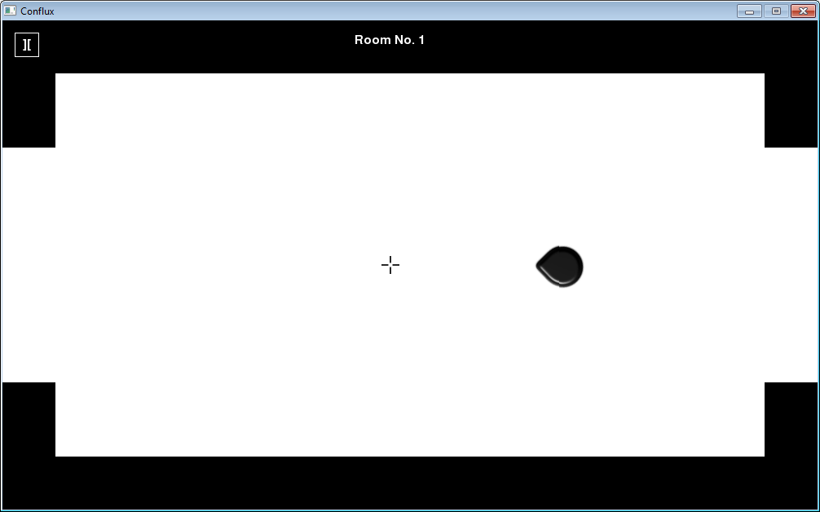

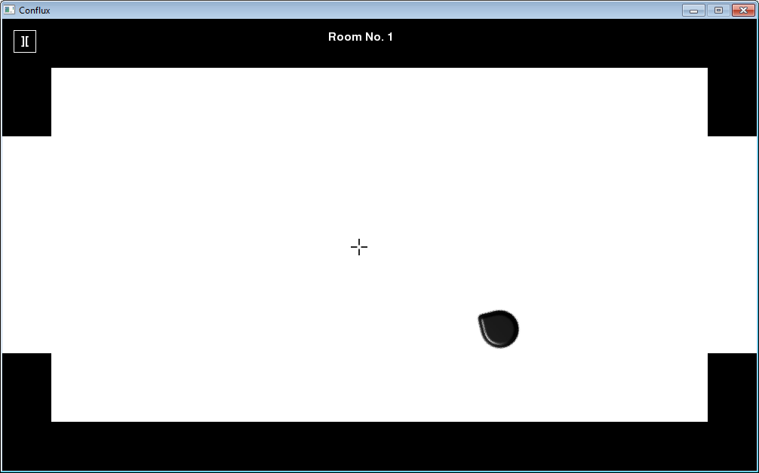

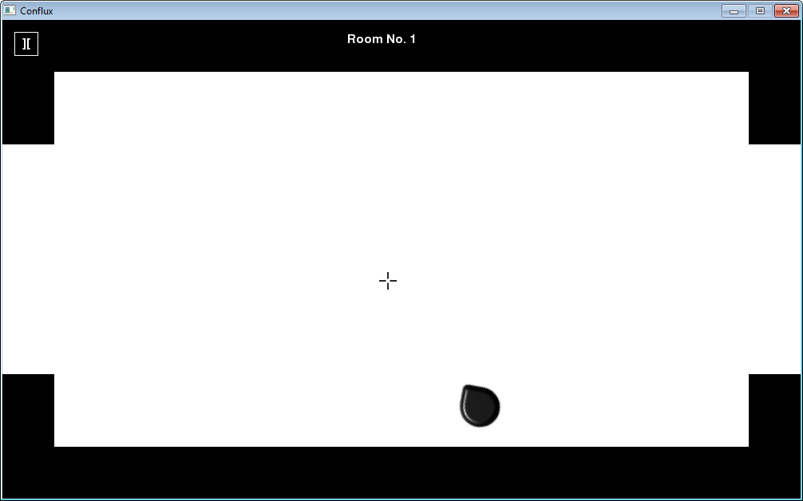

**User feedback:**

*“The WASD controls work really well with the mouse movement.”*

7.13

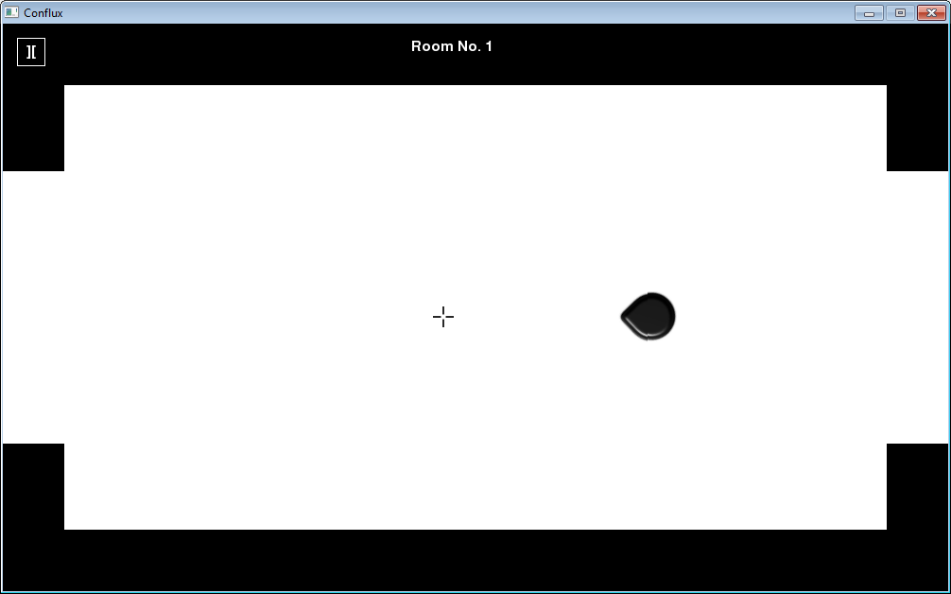

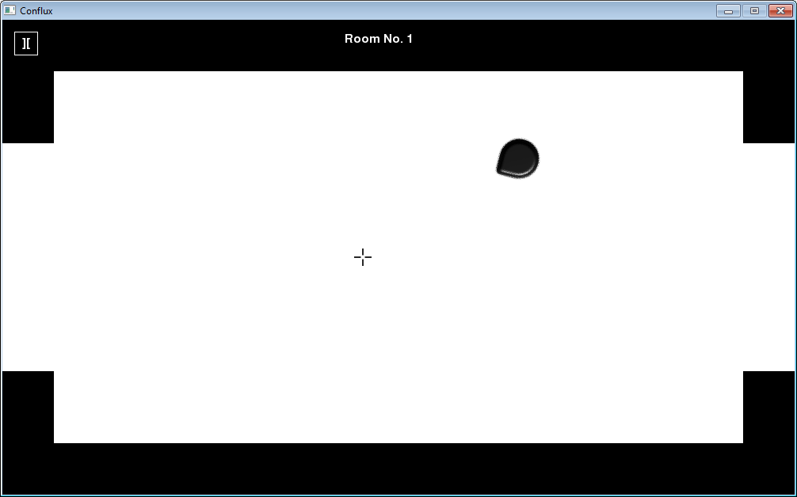

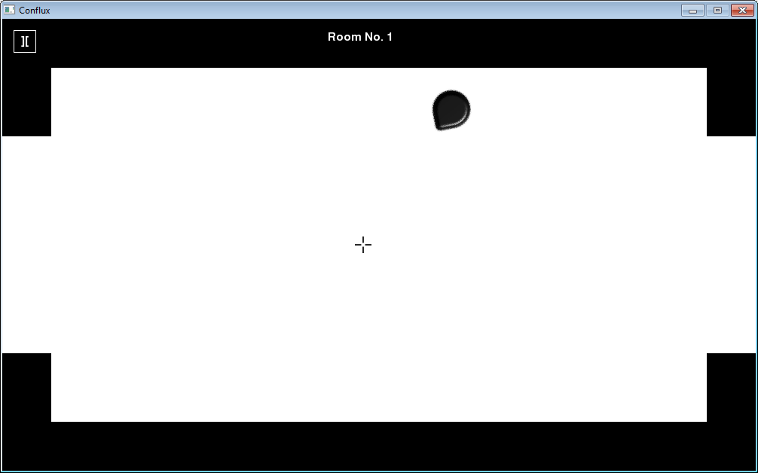

**User feedback:**

*“The WASD controls work really well with the mouse movement.”*

7.14

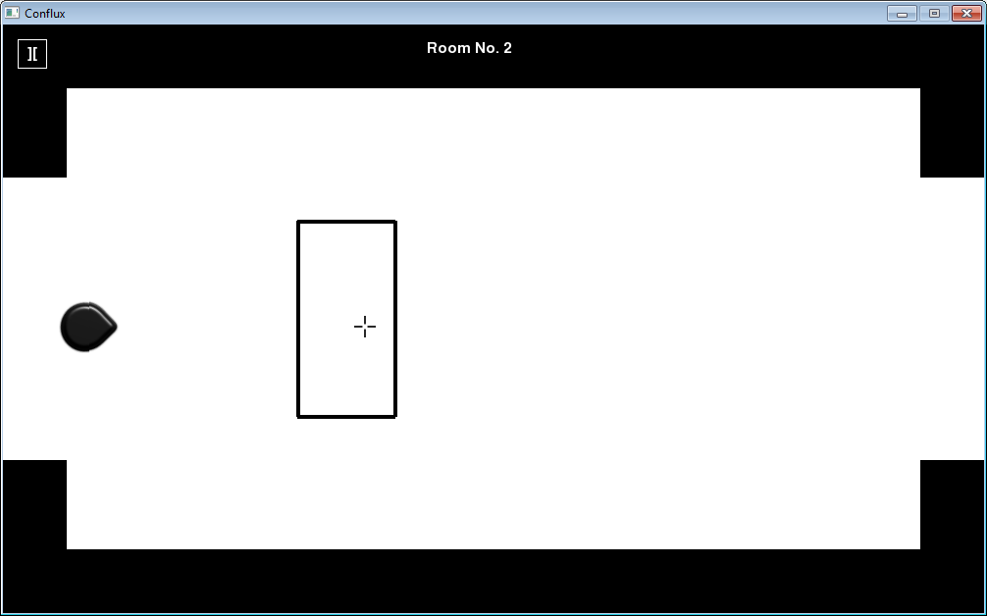

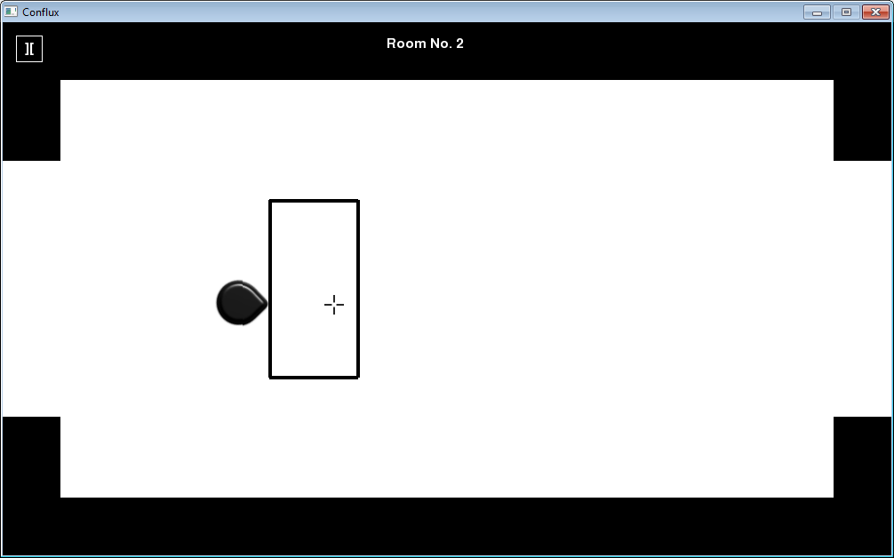



**User feedback:**

*“The barriers are great for stopping any incoming bullets and as an obstacle for the player to move around.”*

7.15

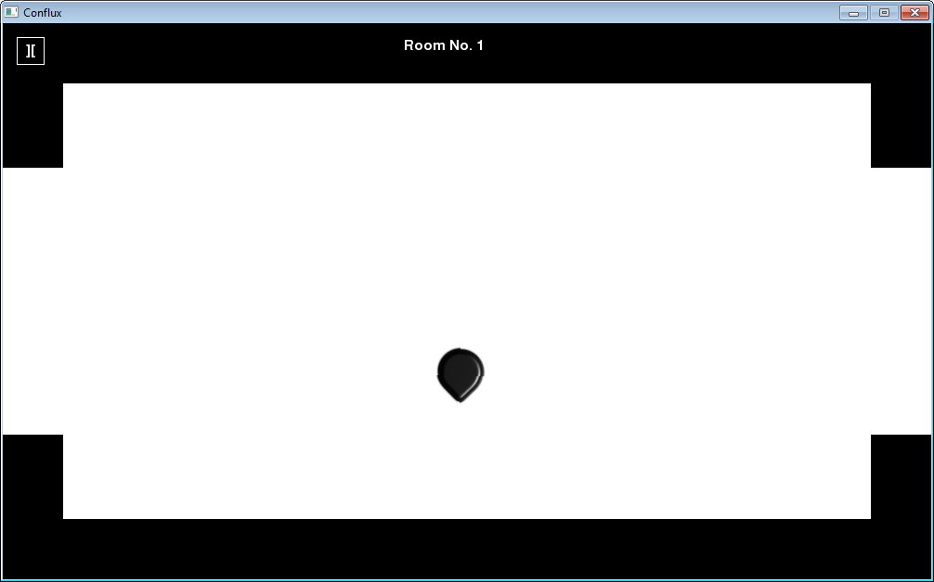

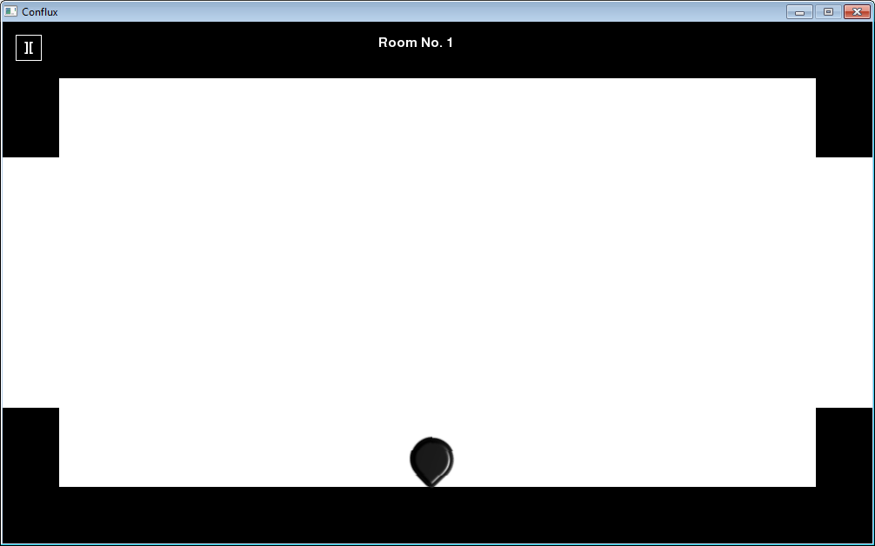



**User feedback:**

*“The map boundaries are good, but they stop the player a little too early, it would be better if it would stop them a bit later.”*

7.16

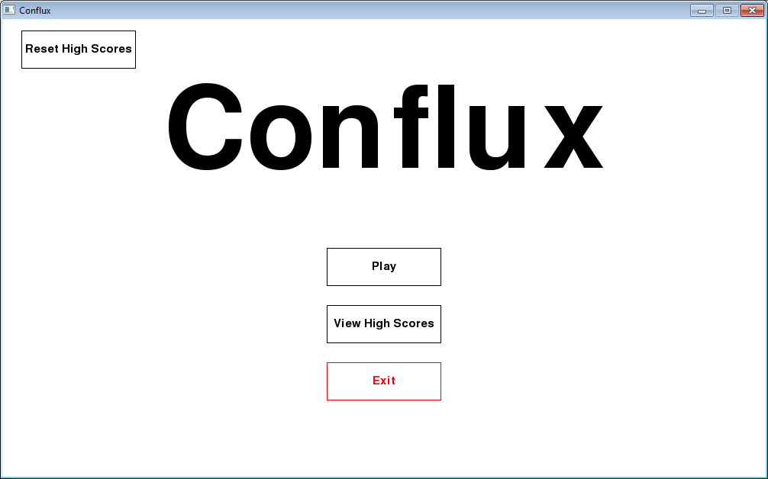

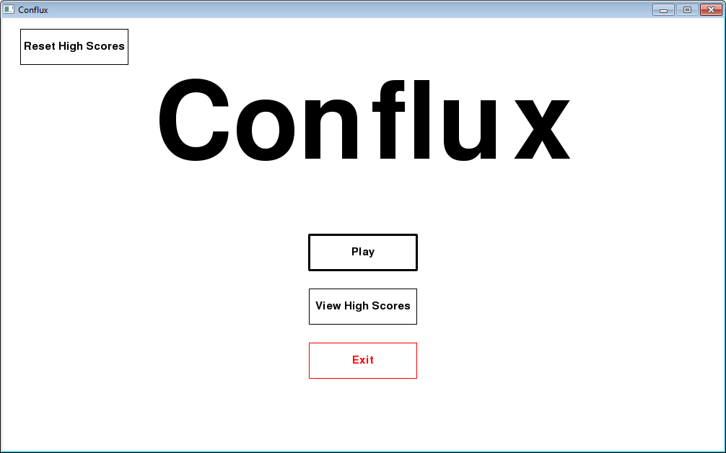

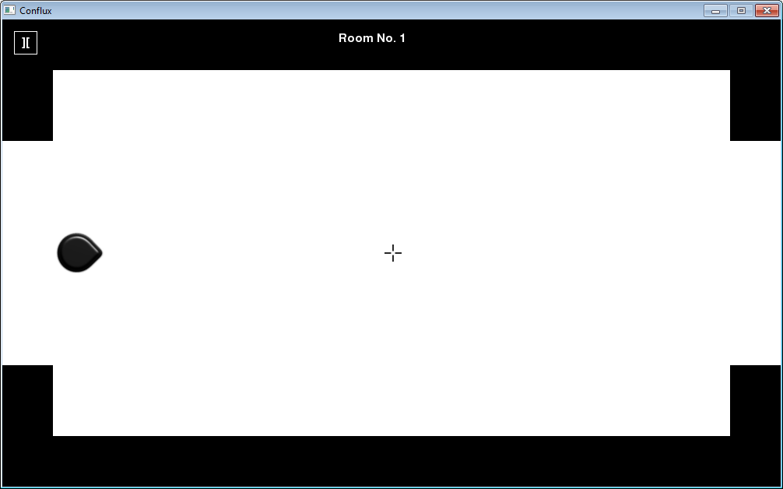

**User feedback:**

*“The main menu buttons look good and function properly.”*

7.17





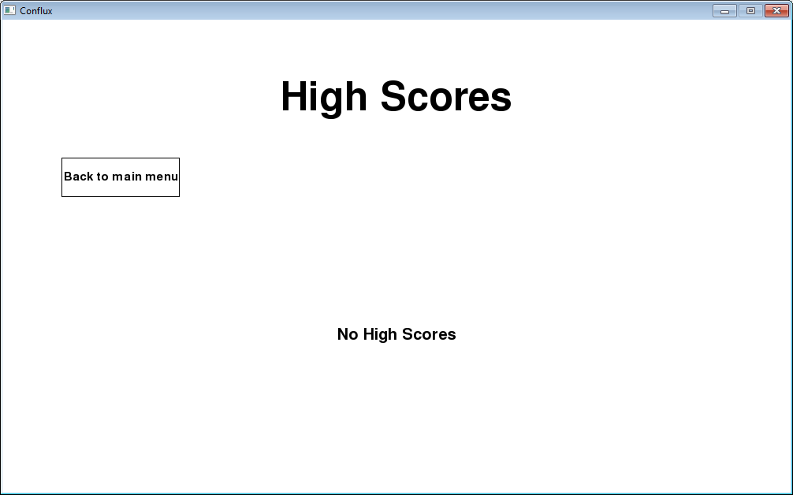

**User feedback:**

*“The main menu buttons look good and function properly.”*

7.18



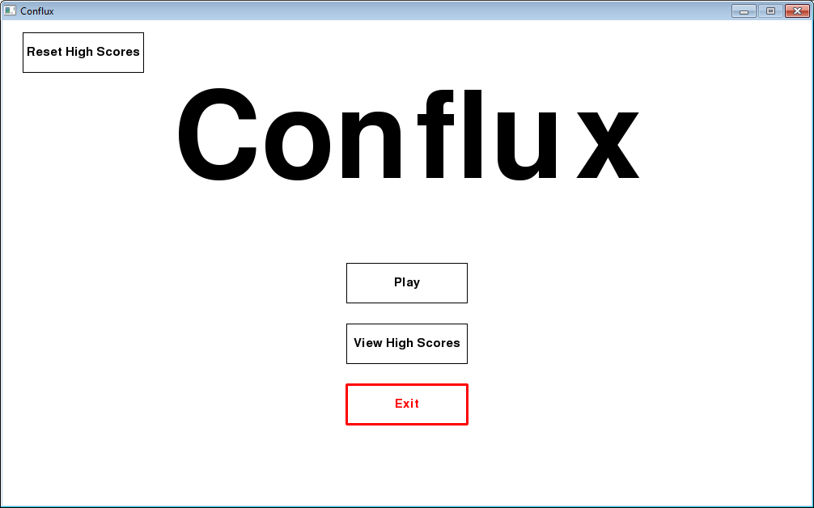

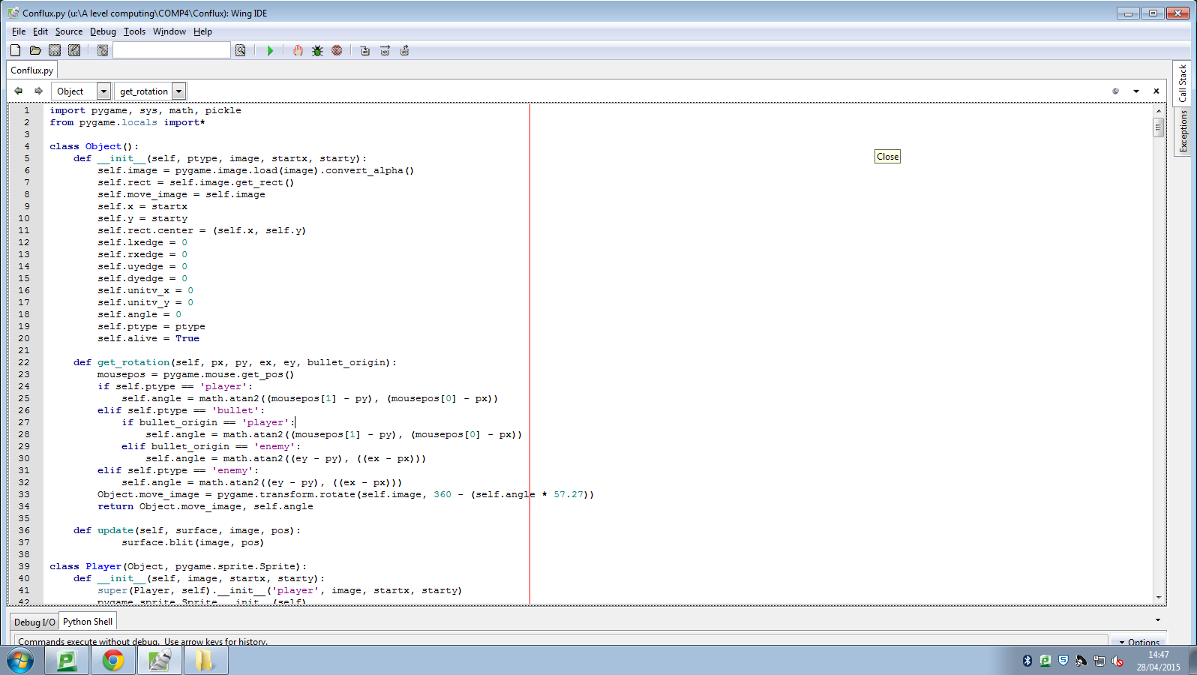

**User feedback:**

*“The main menu buttons look good and function properly.”*

7.19

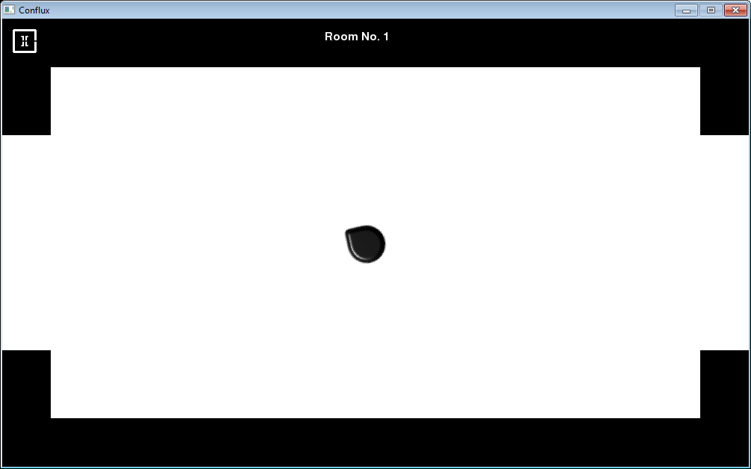

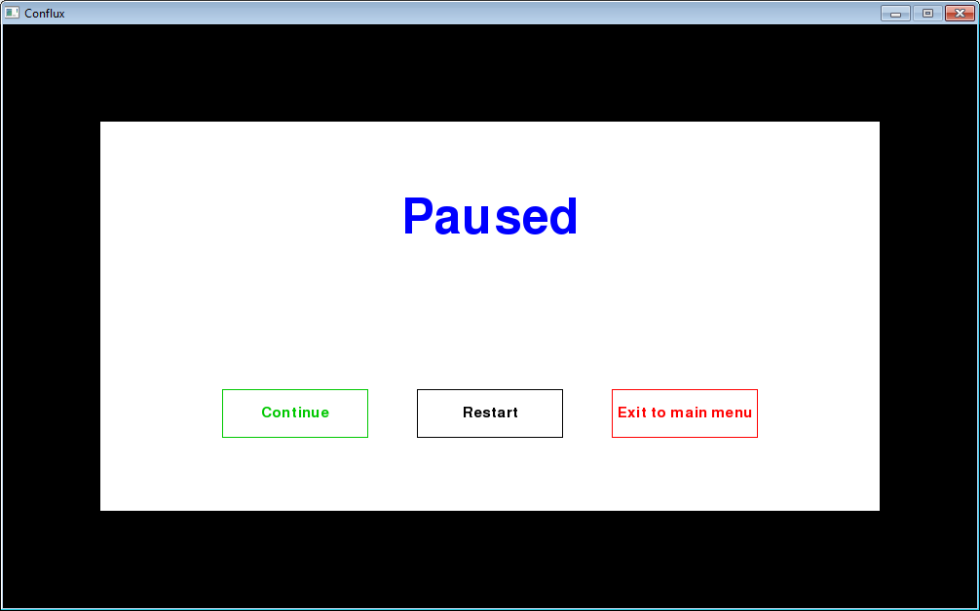

**User feedback:**

*“The pause button is in a good position and works properly, but it can be hard to find sometimes with the cursor and border both being black.”*

7.20



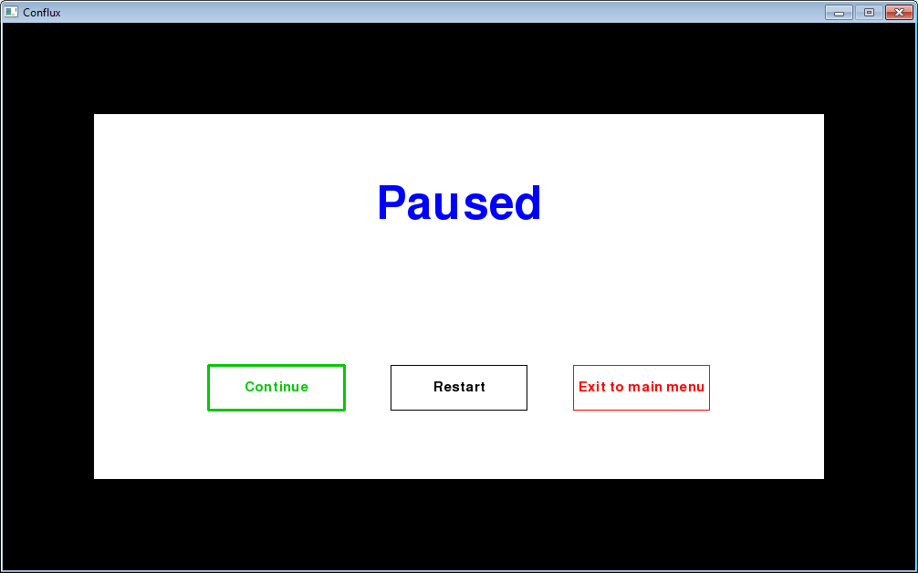

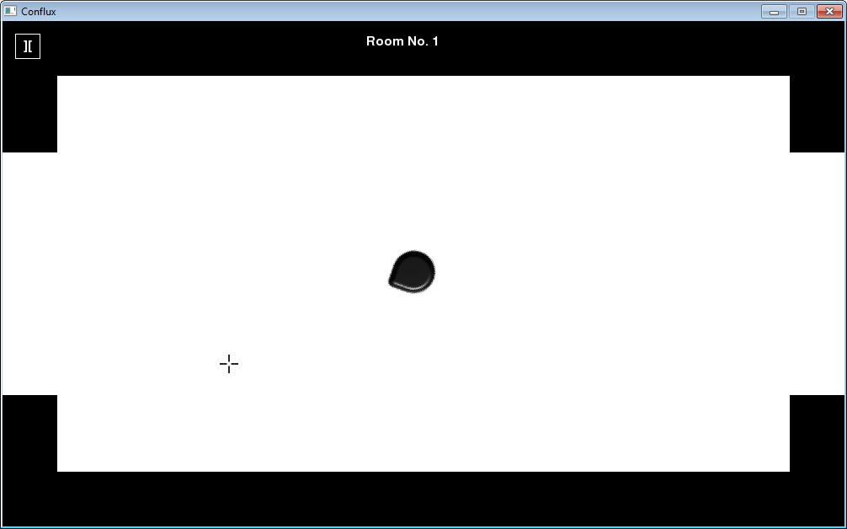

**User feedback:**

*“The pause menu buttons also look good and function properly, I like how continue works.”*

7.21



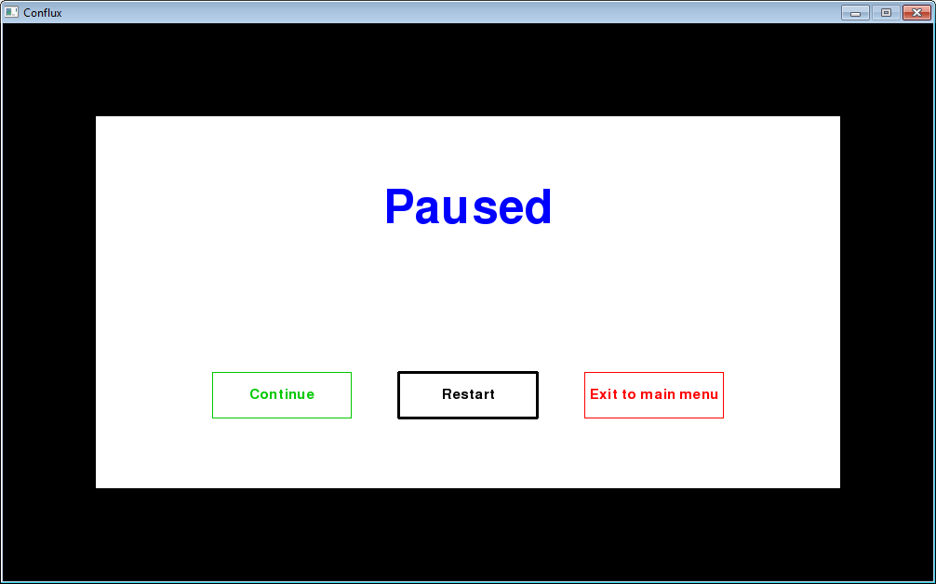

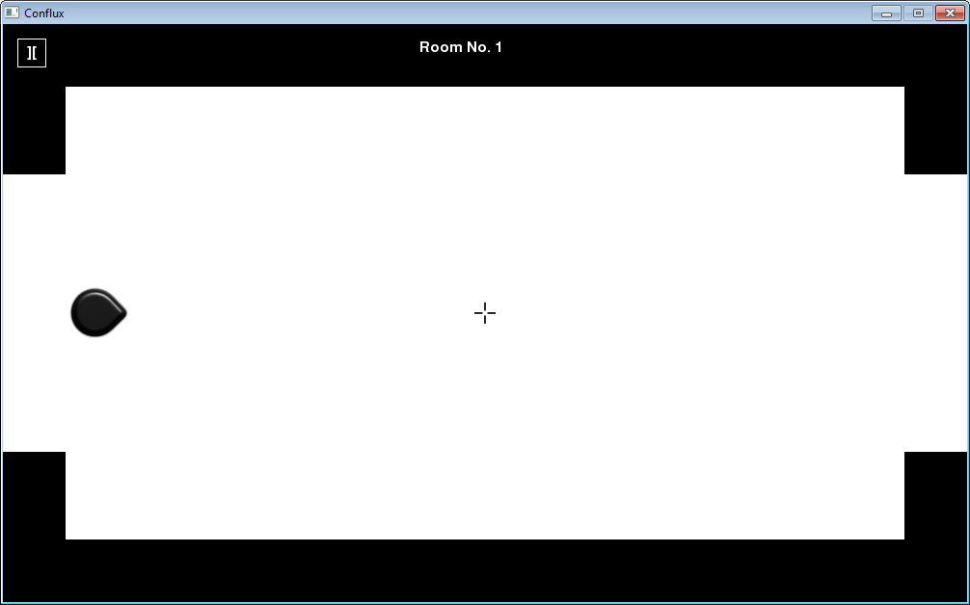

**User feedback:**

*“The other pause menu buttons also look good and function properly.”*

7.22



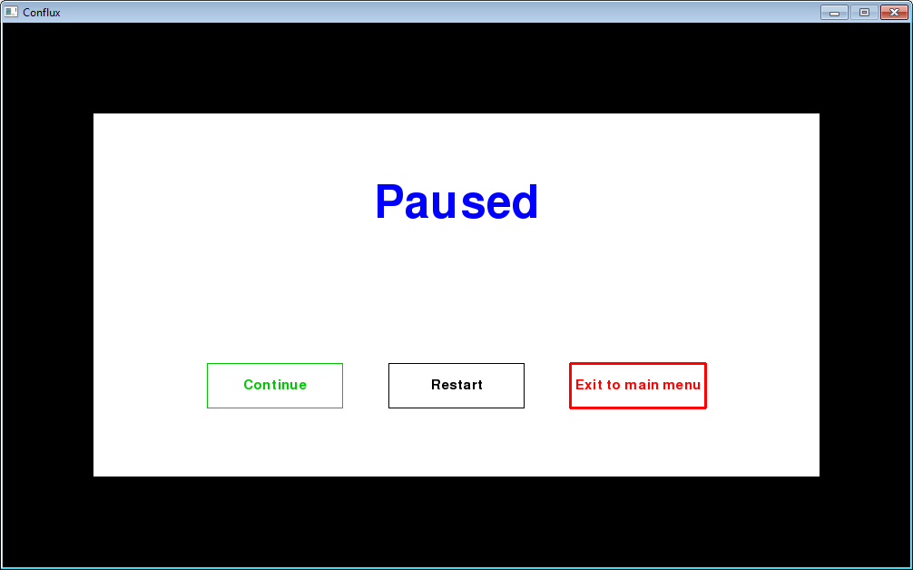

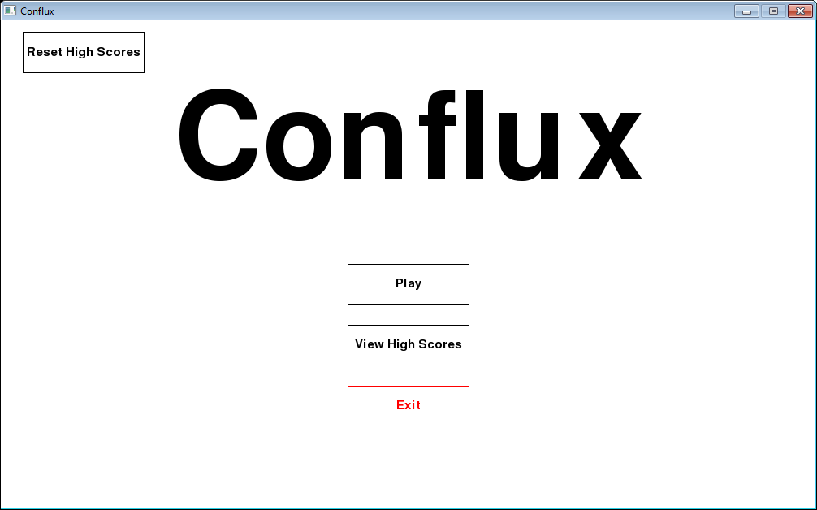

**User feedback:**

*“The other pause menu buttons also look good and function properly.”*

7.23

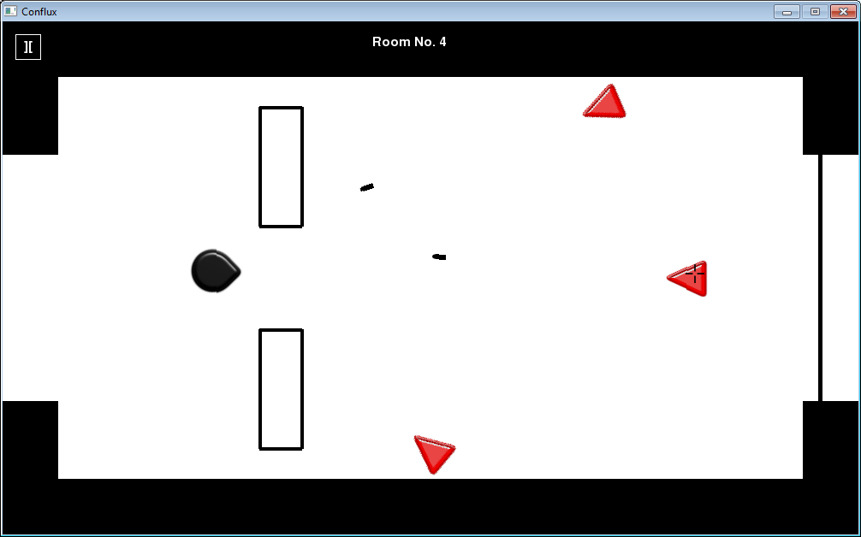

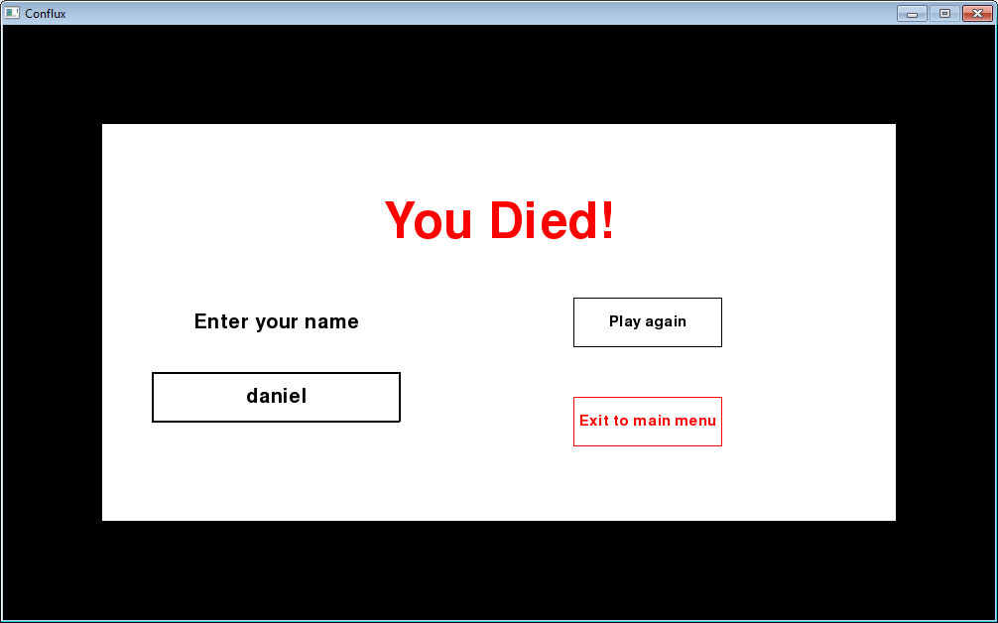

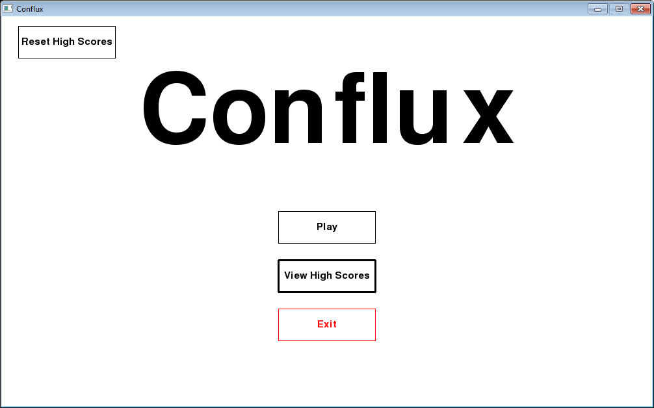

**User feedback:**  
*“The way that the room number is the player’s score is good, it should suffice for what I have to do.”*

7.24

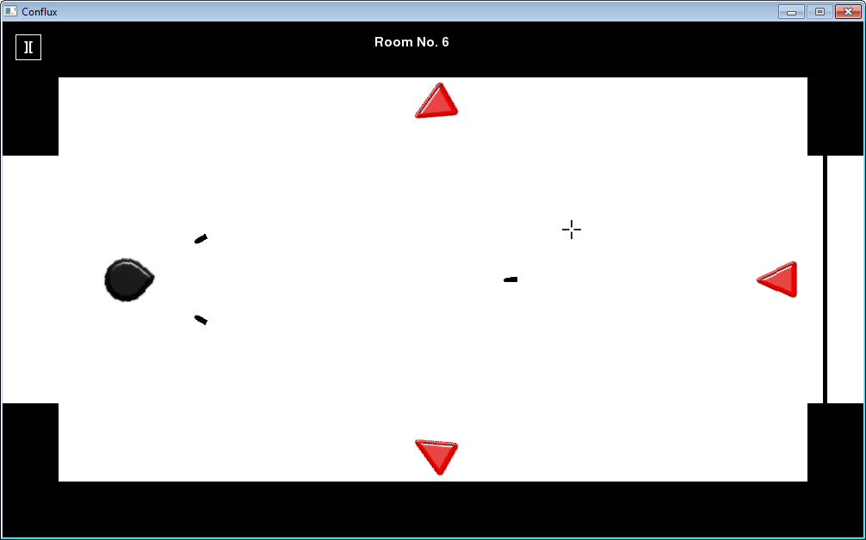

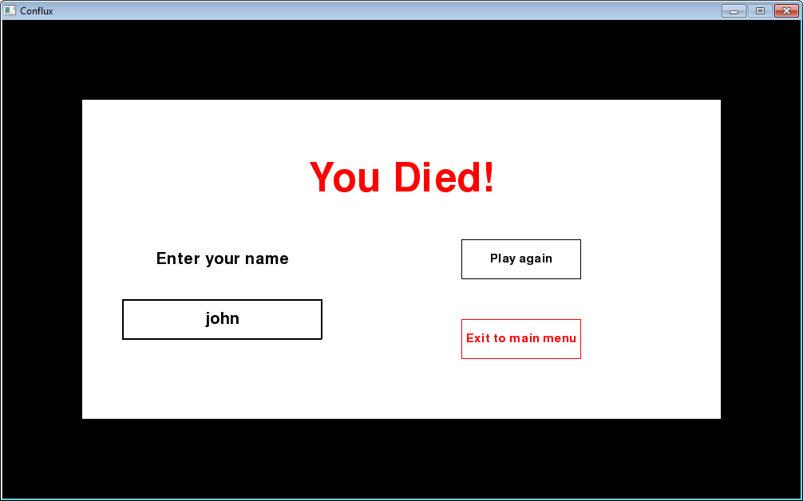



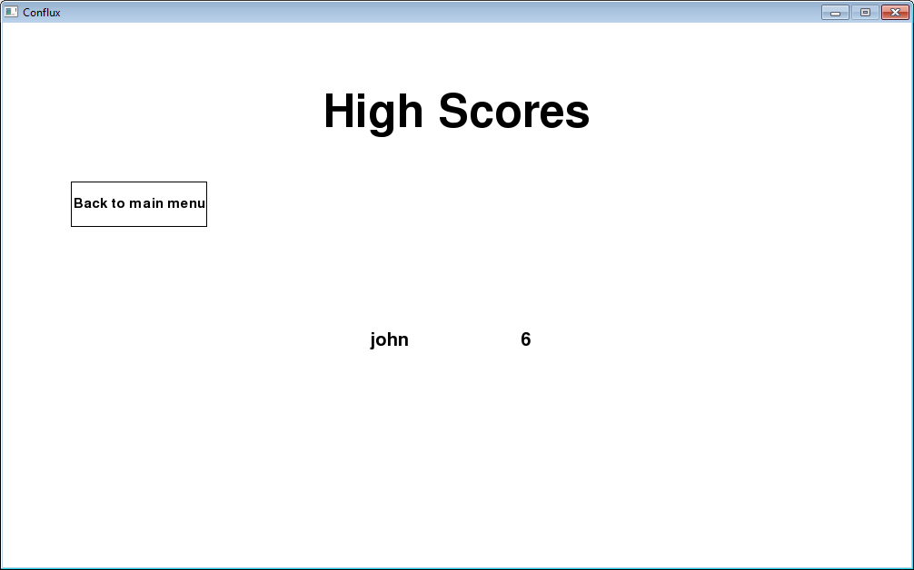

**User feedback:**

*“It’s good to see that the 3 highest scores are saved as for the testing as I needed some form of saving mechanic to design a tests for.”*

7.25

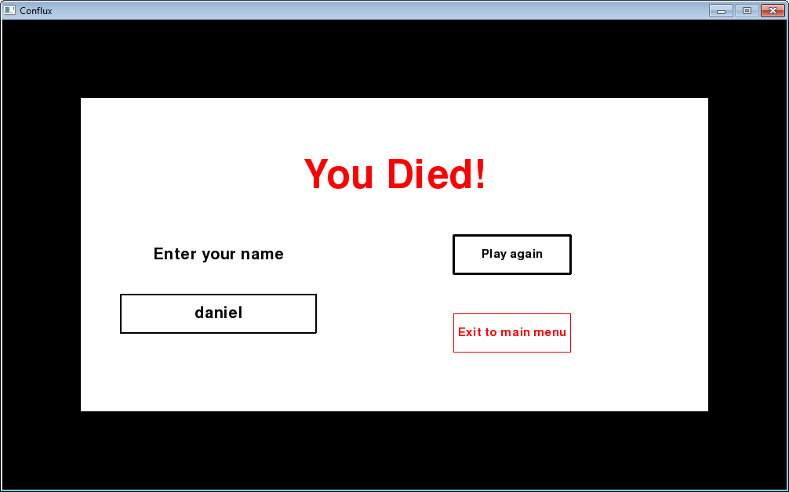

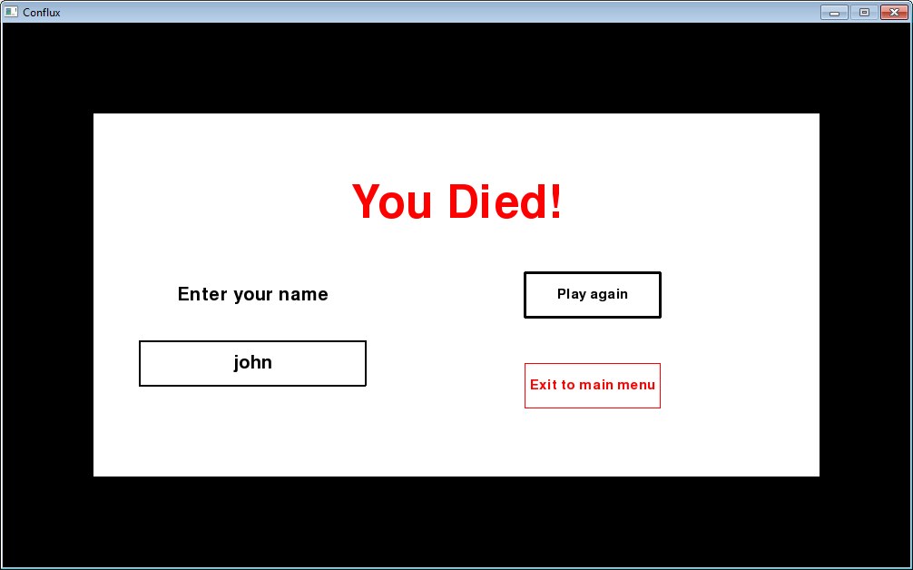

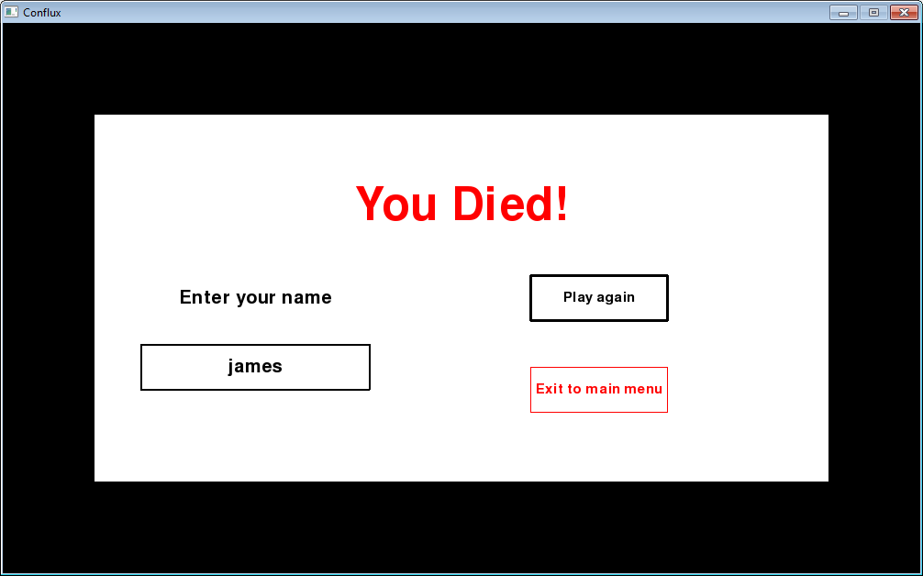



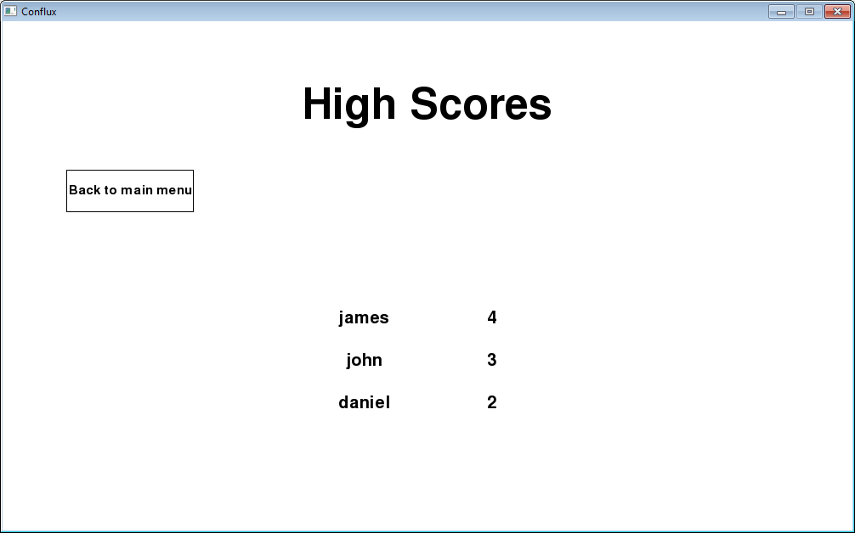

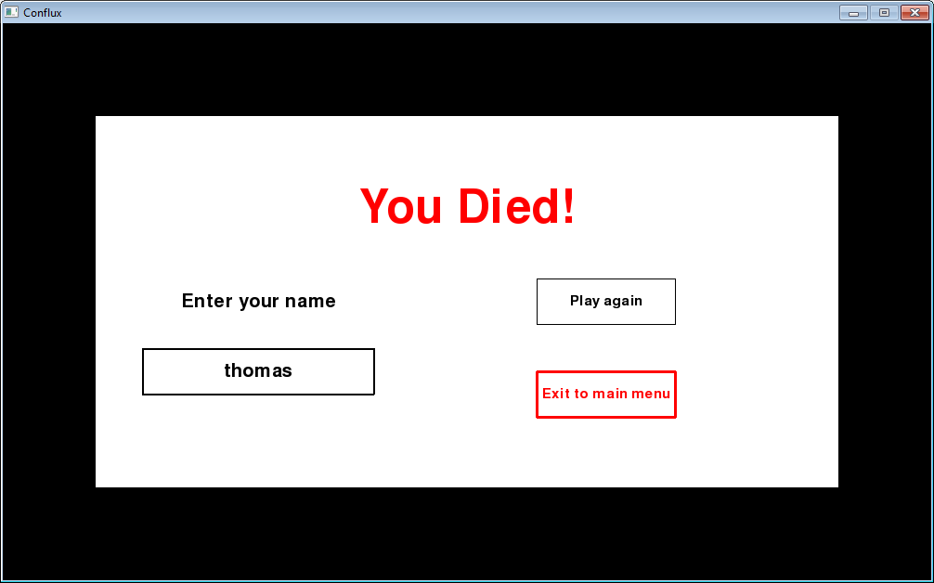



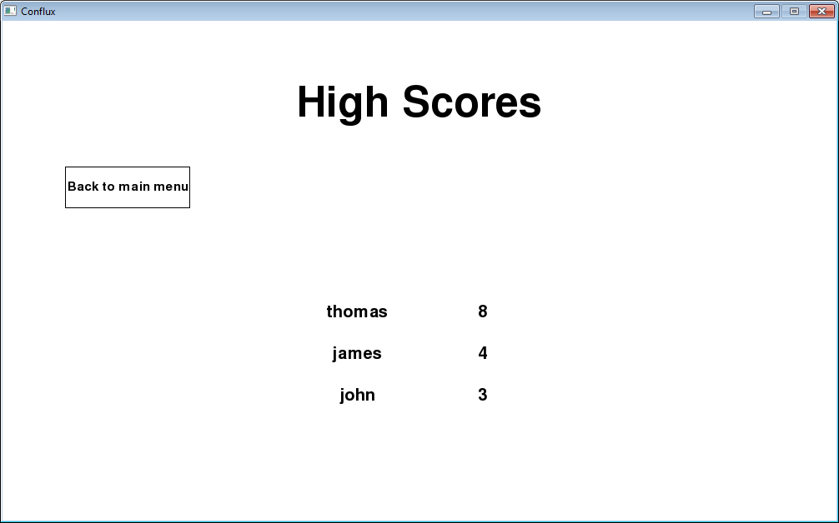

**User feedback:**

*“It’s good to see that the 3 highest scores are saved as for the testing as I needed some form of saving mechanic to design a tests for.”*

7.26

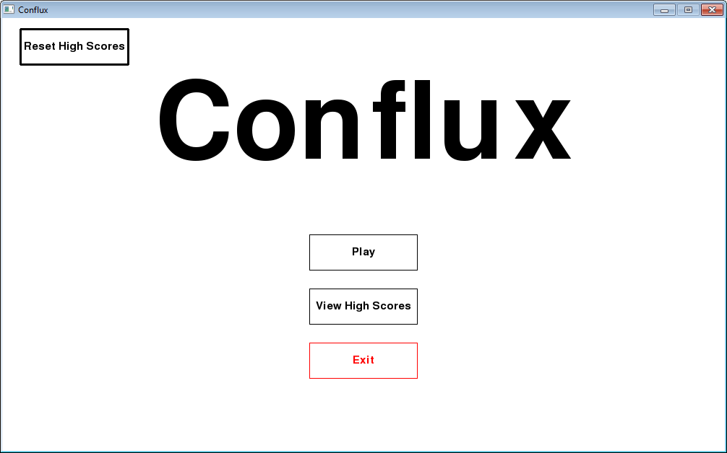









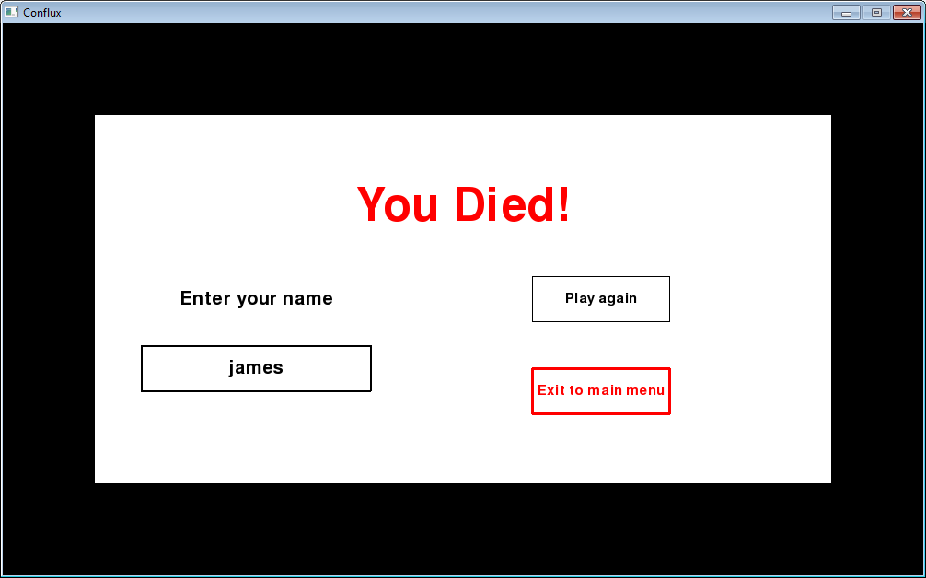



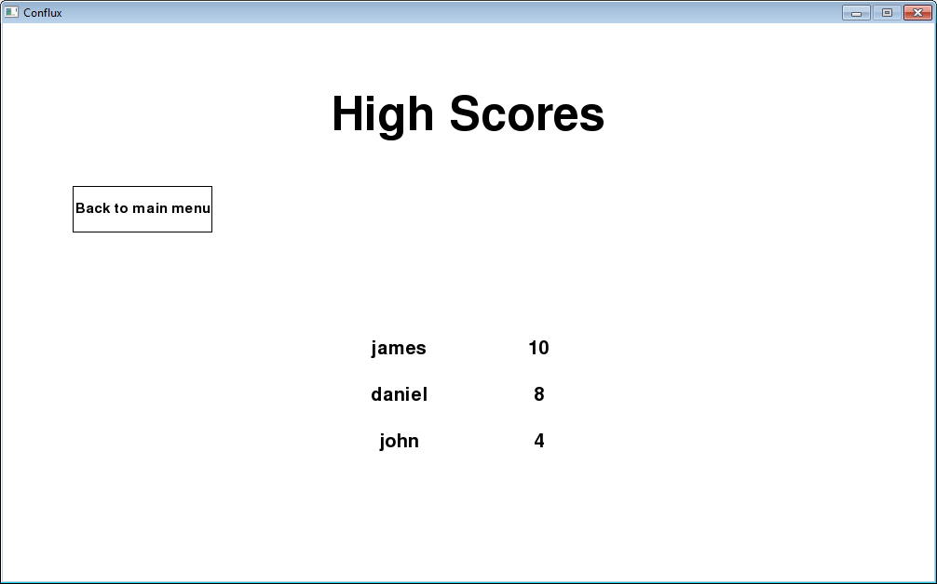

**User feedback:**

*“It’s good to see that the 3 highest scores are saved as for the testing as I needed some form of saving mechanic to design a tests for.”*

7.27















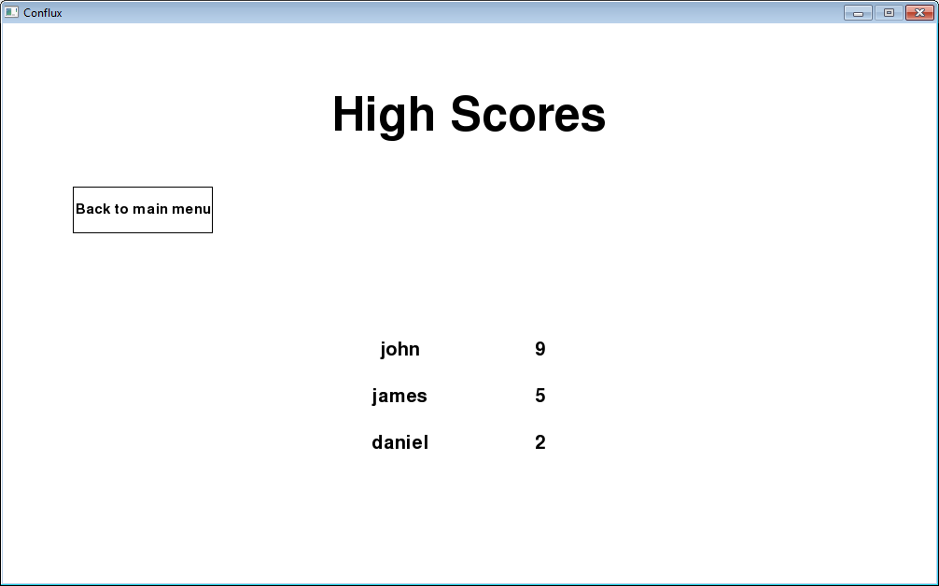

**User feedback:**

*“The high scores menu looks really professional with the player names associated with the corresponding scores.”*

7.28

**User feedback:**

*“The game performed really well when I used it, fully stable with no crashes.”*

7.29

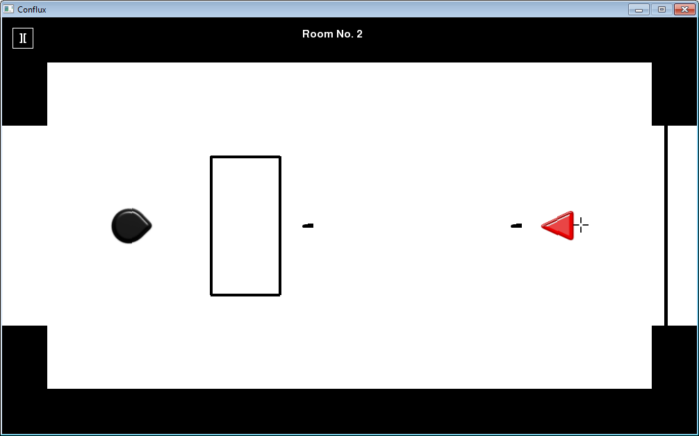

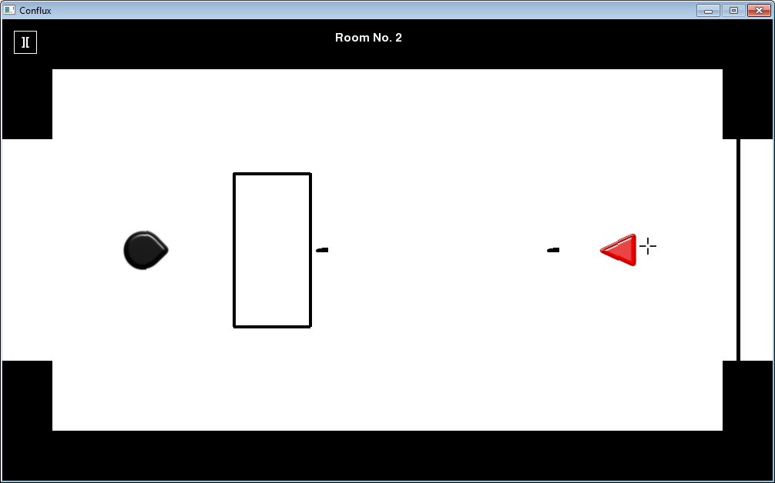

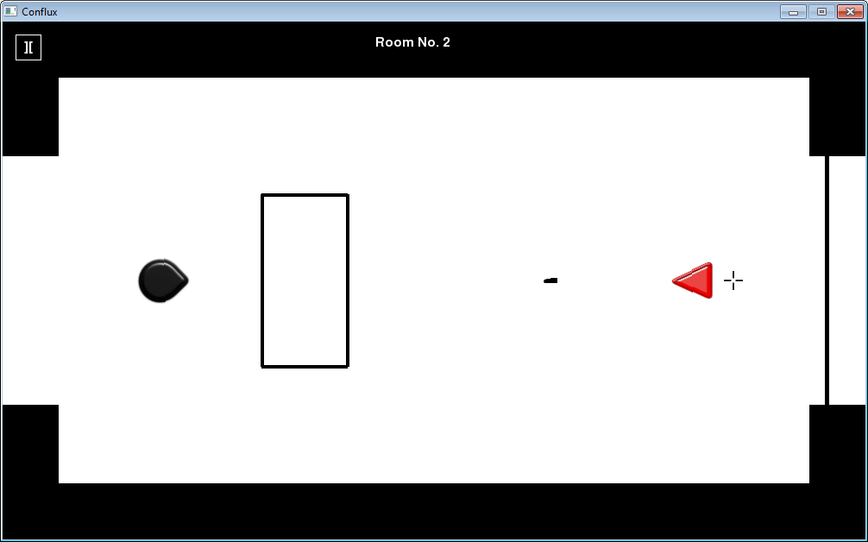

**User feedback:**

*“The game performed really well when I used it, fully stable with no crashes.”*

7.30



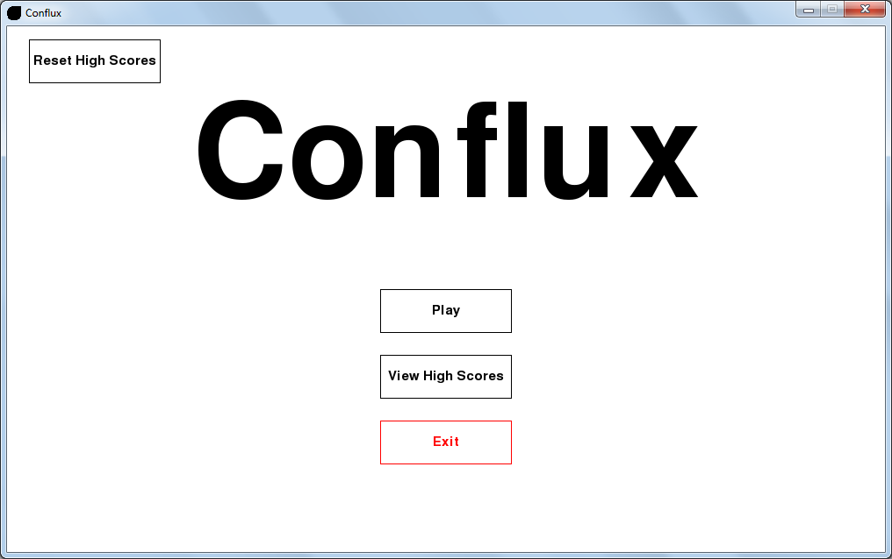

**User feedback:**

*“The main menu loaded quite quickly, in around 5 seconds, which was a pleasant surprise.”*

7.31

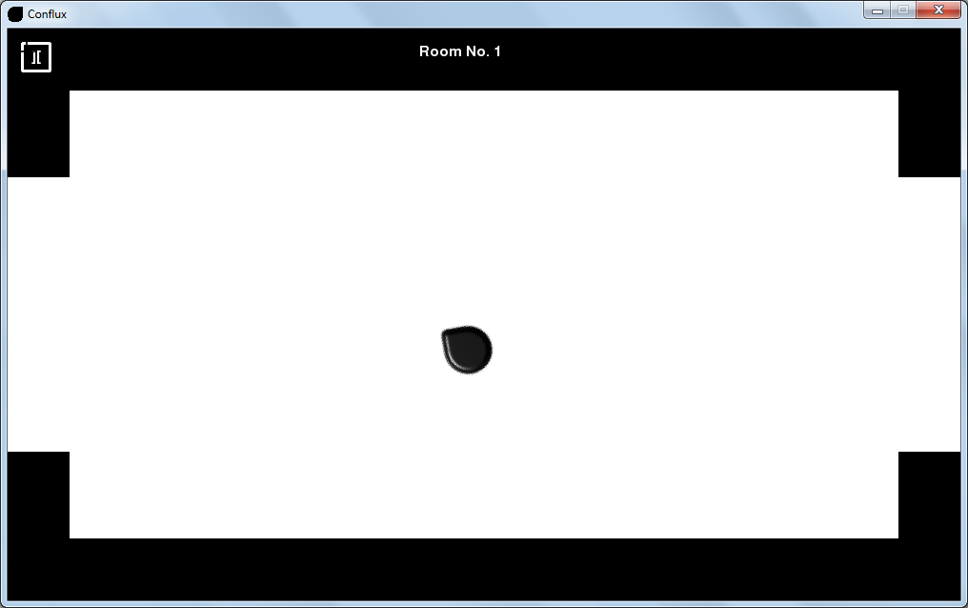

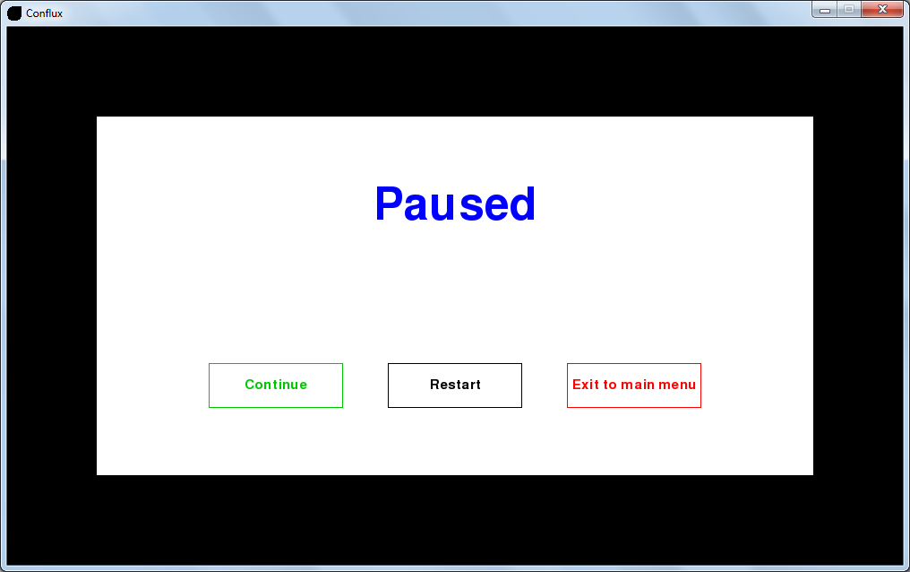

**User feedback:**

*“The pause menu also loaded quite quickly, it must have been under a second.”*

7.32







**User feedback:**

*“The high scores screen loaded quickly, at around 2 seconds.”*

7.33



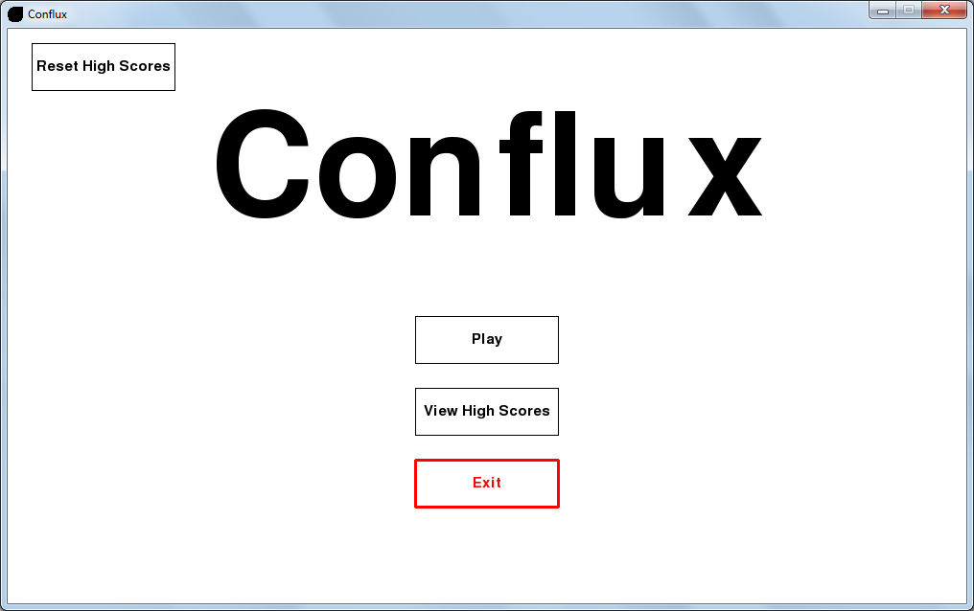



**User feedback:**

*“The game closed quickly too, in around 2 seconds.”*

7.34

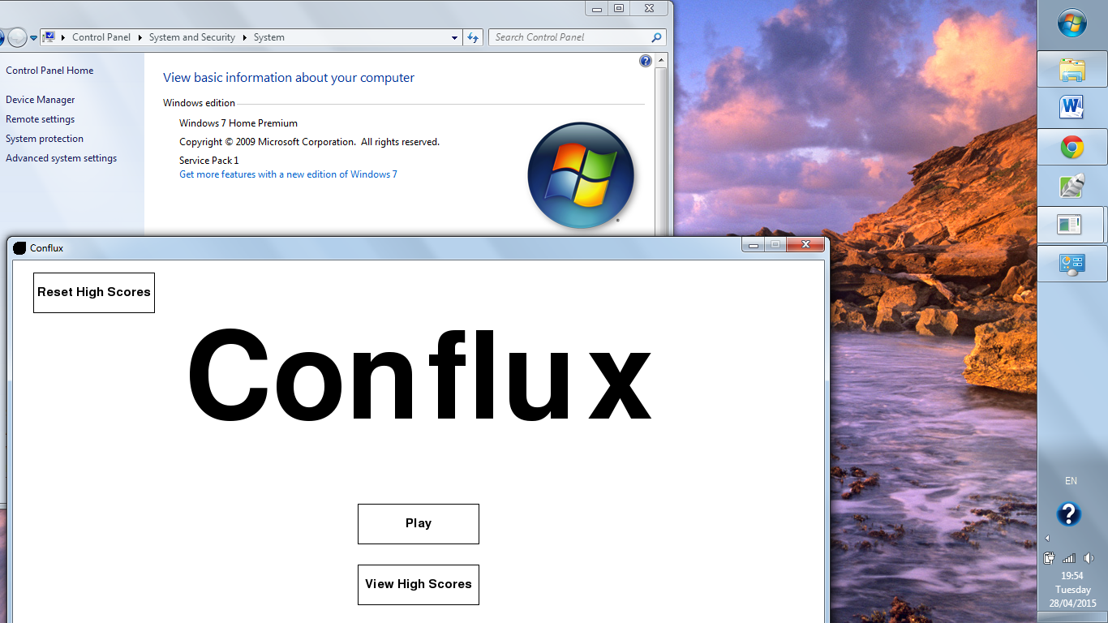

**User feedback:**

*“I’m glad it worked on my windows 7 PC.”*

7.35

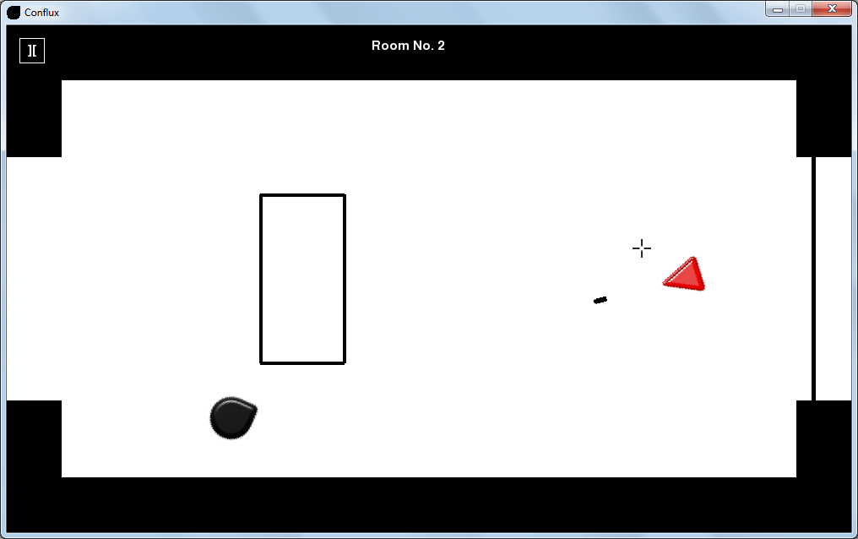

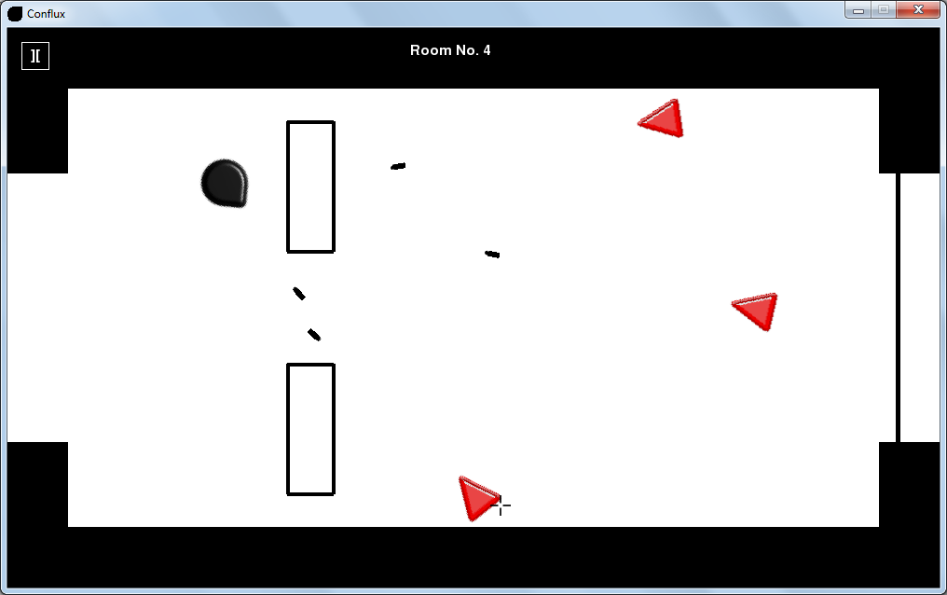

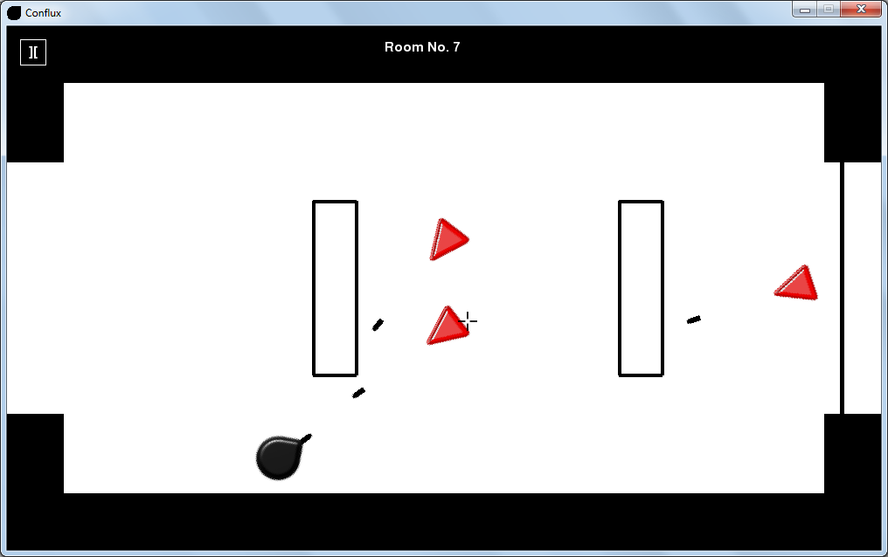

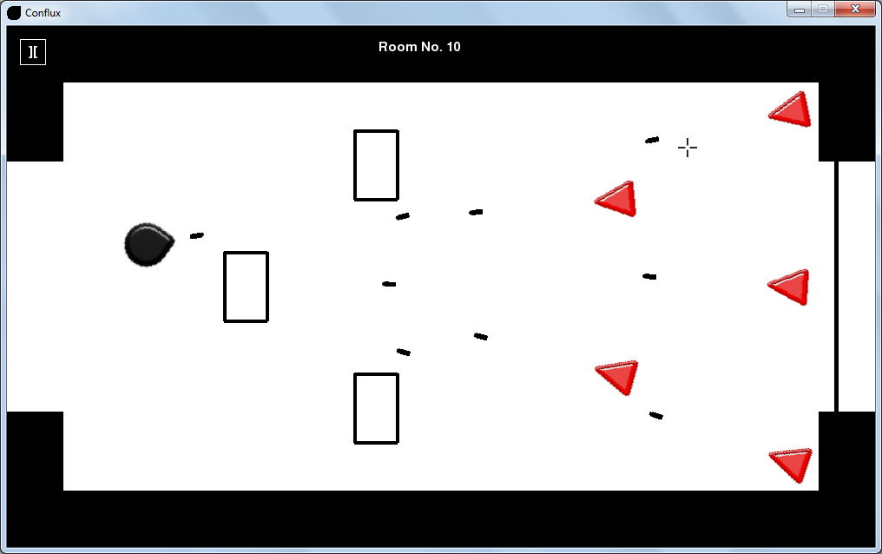

**User feedback:**

*“The game performed really well when I used it, fully stable with no crashes.”*

# System Maintenance

## System overview

My system was programmed in Python 3 with the Pygame module, in the programming environment Wing IDE for used by PCs with the Microsoft Windows 7 operating system. This choice was made as I was already familiar with using this software and the programming language for coding meaning that no time would be wasted in familiarising myself with new software.

I also used the vector graphics editor Inkscape to create the sprite images for the player, enemies, bullets etc. as I was also familiar with this software, but also it was extremely easy to quickly create quality images.

The advantages of using this compilation of software were:

* Pygame has many built in functions that made coding in the system significantly easier, such as the simple collision detection function used for the bullets and the enemy-player collisions.
* Python is a programming language with simple syntax meaning that the system was coded relatively quickly. This benefited me as I can get the system to my client in the smallest time possible and he can get straight to his required testing.
* Inkscape is an easy to use application where I could easily and quickly create the sprite images. Creating the sprite images in this way made it easier to code in the sprites for the system later.

Technical overview of the solution

The implementation of my system was done in accordance with my design section, as no significant changes were needed whilst coding.

There are a number of classes implemented in my system, these include the Object class, from which the Player, Enemy and Bullet classes inherit from, a Barrier class, a Door class, a Score class and a Game class from which the system is run. The Object class contains the fundamental rotation mechanic function used for the player to always look towards the mouse and for each instance of an enemy to track the player’s location and face them. The Player, Enemy and Bullet classes are used for their respective attributes such as position and rotation angle. The Barrier class is used to have multiple instances of a barrier with key attributes defining the barrier dimensions and position. The Door class is where all collision detection associated with the door is located, also including the door state attribute defining whether or not the door is open. Finally, the Score class is used to apply a score and name to each score object, making it easier later on to save and load the high scores data.

I ensured that my system was extensively tested for bugs as although my client intends to design and perform debugging tests on the system, he will just use this as a method of displaying knowledge rather than actually finding bugs. I needed to test it also as I needed definitive proof that there were no problems with the system before I handed over the complete system to my client.

The main themes in the system testing were the movement mechanics and collision detection as this was specifically requested by my client. The tests concluded that all aspects of the system, from the buttons, to the handling of save data, to the various movement and shooting mechanics, performed exactly as expected.

## Sample of detailed algorithm design

Object rotation

**def** get_rotation**(**self**,** px**,** py**,** ex**,** ey**,** bullet_origin**):**

mousepos **=** pygame**.**mouse**.**get_pos**()**

**if** self**.**ptype **==** 'player'**:**

self**.**angle **=** math**.**atan2**((**mousepos**[**1**]** **-** py**),** **(**mousepos**[**0**]** **-** px**))**

**elif** self**.**ptype **==** 'bullet'**:**

**if** bullet_origin **==** 'player'**:**

self**.**angle **=** math**.**atan2**((**mousepos**[**1**]** **-** py**),** **(**mousepos**[**0**]** **-** px**))**

**elif** bullet_origin **==** 'enemy'**:**

self**.**angle **=** math**.**atan2**((**ey **-** py**),** **((**ex **-** px**)))**

**elif** self**.**ptype **==** 'enemy'**:**

self**.**angle **=** math**.**atan2**((**ey **-** py**),** **((**ex **-** px**)))**

Object**.**move_image **=** pygame**.**transform**.**rotate**(**self**.**image**,** 360 **-** **(**self**.**angle **\*** 57.27**))**

**return** Object**.**move_image**,** self**.**angle

This algorithm will rotate an object towards any point or other object than is inputted to it. It is used by the player to face/move towards the mouse for movement, and by the enemies to face/track the player while they move around. It is used by the bullets to face towards their respective targets, for the player it causes the bullets to face towards the mouse, like the player. For an enemy bullet, it is used to face the bullet towards the player at the point of firing.

First, the mouse position is found using an in built pygame function, needed later to compare the player-mouse position values to get a rotational angle value. Next, as the values being compared are slightly different, an if statement is needed to make sure the right process is used when called by a particular object. If the player sprite is calling the function, then a difference of width and height is found through the respective positions of the player and mouse. This is used to find a value for the angle between the values that is saved in the variable self**.**angle. If it is an enemy sprite that is calling the function then the process is the same but the respective positions of the player and particular enemy are compared to get a different angle. The bullet rotation will be the same as the player rotation if it is fired by the player, whereas if it is an enemy bullet then the rotation will be the same as the particular enemy that the bullet was fired from. Then a new image of the object is created that is rotated by the angle calculated previously, which is then returned with the angle, the rotated image to be displayed later on and the angle to be used to calculate the movement unit vector.

Sorting high scores

**def** is_high_score**(**self**):**

self**.**high_scores**.**append**(**Score**())**

self**.**high_scores**[**self**.**no_of_scores**].**name **=** self**.**player_name

self**.**high_scores**[**self**.**no_of_scores**].**score **=** self**.**room_number

**for** i **in** range**(**1**,** self**.**no_of_scores **+** 1**):**

current_value **=** self**.**high_scores**[**i**].**score

current_pointer **=** i

**while** current_pointer **>** 0 **and** self**.**high_scores**[**current_pointer**-**1**].**score **<** current_value**:**

self**.**high_scores**[**current_pointer**],** self**.**high_scores**[**current_pointer**-**1**]** **=** self**.**high_scores**[**current_pointer**-**1**],** self**.**high_scores**[**current_pointer**]**

current_pointer **=** current_pointer **-** 1

self**.**high_scores**[**current_pointer**].**score **=** current_value

self**.**high_scores**.**pop**(**self**.**no_of_scores**)**

This example of an insertion sort algorithm is the function that is called at the end of every game, after the endgame menu has closed and the player has entered their name. It ensures that after it is run, even considering the latest score just added, the high scores will always stay up to date. It adds the latest score to the high scores and then sorts the scores from high to low, then removing the 4th score. Doing this means that even if the latest score is not in the top 3 it will still sort it and that score will get removed at the end.

Firstly, a 4th score object is added to the high scores array to accommodate the newly added score. Then, the score and player name from the game just played are placed into this new score position. Then the sorting algorithm starts by looping through the scores, assigning the score currently being analysed into the variable current_value. Then the element of the scores currently being analysed is assigned into the variable current_pointer. Next, a while loop is started with the parameters that current_pointer **>** 0(so the list element being analysed stays in a valid range, and to fully loop through the whole list) and self**.**high_scores**[**current_pointer**-**1**].**score **<** current_value(decides the order that the list will be sorted). In the loop, the score being analysed and the one before it are swapped as this is where the actual sorting takes place. After the while loop, the score that current_pointer is referring to has the current_value assigned to it, to move it to its new sorted position. Finally, the 4th score in the now sorted list is removed as it is outside the top 3.

Enemy shooting

**def** play_game**(**self**):**

**.**

**.**

**.**

**for** enemy **in** self**.**enemies_list**:**

enemy**.**fire **=** enemy**.**add_to_timer**()**

**if** enemy**.**fire **==** **True:**

bullet **=** Bullet**(**'EBullet_sprite.png'**,** enemy**.**x**,** enemy**.**y**,** enemy**.**unitv_x**,** enemy**.**unitv_y**,** 'enemy'**)**

self**.**bullets_list**.**add**(**bullet**)**

self**.**enemy_bullets_list**.**add**(**bullet**)**

bullet**.**move_image**,** bullet**.**angle **=** bullet**.**get_rotation**(**self**.**player**.**x**,** self**.**player**.**y**,** enemy**.**x**,** enemy**.**y**,** 'enemy'**)**

enemy**.**fire **=** **False**

enemy**.**bullet_timer **=** 0

.

.

.

**for** bullet **in** self**.**bullets_list**:**

bullet**.**move_bullet**(**bullet**.**x**,** bullet**.**y**)**

These sections of code form an algorithm for the enemy shooting for each enemy that is currently loaded onto the screen. It applies the rotation and movement function used by the player for individual bullets.

The first section is where the enemy actually fires the bullets, it starts with a for loop that runs for every enemy so that each enemy fires at the same time. A small function enemy**.**add_to_timer**()** is run which adds to a counter that dictates when the enemies can next fire bullets. If the timer in this function reaches a certain limit then the variable enemy**.**fire is set to true, meaning that it is time for the enemies to each fire one bullet. If it is set to true, then the if statement that follows will run, meaning a bullet object will be created, and that bullet will be added to the overall bullets list and the enemy bullets list. Next, the new bullets have to be rotated; this will only run once for each bullet fired by each enemy in on single round of firing. After this the parameter for the if statement enemy**.**fire is reset to false it doesn’t run again and the bullet timer is reset to 0 so the countdown can start again.

Finally, for each bullet currently in the self**.**bullets_list array is moved by the movement vector unique to that bullet through the bullet**.**move_bullet**()** function.

## Procedure and variable lists/descriptions for programs

|  |  |  |
| --- | --- | --- |
| **Name** | **Type** | **Description** |
| game | Variable | The game object from which the system runs |
| Self.player | Variable | The player object |
| Enemy | Variable | One iteration of the enemy object |
| Barrier | Variable | One iteration of the barrier object |
| Bullet | Variable | One iteration of the bullet object |
| Self.ptype | Variable | Type of object, can be player, enemy or bullet |
| Self.player.rect | Variable | Player rectangle used for collision detection |
| Enemy.rect | Variable | Enemy rectangle used for collision detection |
| Bullet.rect | Variable | Bullet rectangle used for collision detection |
| Player_start | Variable | The start coordinates of the player in a room |
| Cursor | Variable | The game cursor |
| Door | Variable | The door object |
| Self.enemies_list | Variable | The list of enemies |
| Self.barriers_list | Variable | The list of barriers |
| Self.bullets_list | Variable | The list of bullets |
| Self.player_bullets_list | Variable | The list of bullets fired by the player |
| Self.enemies_bullets_list | Variable | The list of bullets fired by enemies |
| Click | Variable | Detects a mouse click |
| Self.first run | Variable | States whether of not a full run of the game loop is the first of a new room |
| Self.room_number | Variable | The room number the player is currently in |
| Self.player_score | Variable | The room number/score after a game has finished |
| Self.fps | Variable | The frames per second of the game |
| Reset_player | Variable | States whether or not the player should be moved to the start coordinates when entering a new room |
| Direction | Variable | The direction that the player requests to go |
| Self.game_state | Variable | The current state of the game |
| Self.states | Variable | The list of game states |
| Mousepos | Variable | The position of the mouse |
| Self.display | Variable | The game display |
| Self.title | Variable | The title of the game |
| Self.window_width | Variable | The game window width |
| Self.window_height | Variable | The game window height |
| Self.border_size | Variable | The width of the map border |
| Self.border_step | Variable | The multiplier needed to turn the border size into the height of the borders coming down towards the centre |
| Game_icon | Variable | The icon displayed in the top right corner of the game window |
| Button_pause | Variable | The pause button |
| Room_number_msg | Variable | The message displayed at the top of the screen stating what room the player is in |
| Cols | Variable | The available colours used |
| Self.player.move_image | Variable | The rotated image of the player |
| Self.player.angle | Variable | The rotation angle of the player |
| Self.player.x | Variable | The player x position |
| Self.player.y | Variable | The player y position |
| Enemy.move_image | Variable | The rotated image of an enemy |
| Enemy.angle | Variable | The rotation angle of an enemy |
| Enemy.x | Variable | An enemy x position |
| Enemy.y | Variable | An enemy y position |
| Bullet.rotated | Variable | States if a bullet has been rotated |
| Self.player.unitv_x | Variable | The x movement unit vector of the player(the x movement) |
| Self.player.unitv_y | Variable | The y movement unit vector of the player(the y movement) |
| Enemy.unitv_x | Variable | The x movement unit vector of an enemy(the x movement) |
| Enemy.unitv_y | Variable | The y movement unit vector of an enemy(the y movement) |
| Self.player.X_change | Variable | The x distance that the player will move by |
| Self.player.Y_change | Variable | The y distance that the player will move by |
| Enemy.fire | Variable | States whether or not the enemies need to fire a round of bullets |
| Enemy.bullet_timer | Variable | The time until the enemies fire the next round of bullets |
| Bullet.move_image | Variable | The rotated image of a bullet |
| Bullet.angle | Variable | The rotation angle of a bullet |
| Self.player.lxedge | Variable | The left edge of the player image |
| Self.player.uyedge | Variable | The top edge of the player image |
| Self.player.rxedge | Variable | The right edge of the player image |
| Self.player.dyedge | Variable | The bottom edge of the player image |
| bullet.lxedge | Variable | The left edge of a bullet image |
| bullet.uyedge | Variable | The top edge of a bullet image |
| bullet.rxedge | Variable | The right edge of a bullet image |
| bullet.dyedge | Variable | The bottom edge of a bullet image |
| enemy.lxedge | Variable | The left edge of an enemy image |
| enemy.uyedge | Variable | The top edge of an enemy image |
| enemy.rxedge | Variable | The right edge of an enemy image |
| enemy.dyedge | Variable | The bottom edge of an enemy image |
| Bullet.remove_bullet | Variable | States whether or not to delete a bullet |
| Bullet.origin | Variable | States if the bullet was fired from the player or an enemy |
| Self.player.alive | Variable | States if the player is alive |
| Enemy.alive | Variable | States if an enemy is alive |
| Self.player.rect.center | Variable | The centre of the collision detection rectangle for the player |
| Enemy.rect.center | Variable | The centre of the collision detection rectangle for an enemy |
| Bullet.rect.center | Variable | The centre of the collision detection rectangle for a bullet |
| File | Variable | The save file for the high scores |
| Self.high_scores | Variable | The high scores array |
| Self.no_of_scores | Variable | The number of high scores saved |
| count | Variable | Used to move through loops |
| Self.pause | Variable | States whether not the game is paused |
| Outline_thickness | Variable | The outline thickness of the button images |
| action | Variable | The action requested when clicking a button |
| Door.x | Variable | The x position of the door |
| Door.thickness | Variable | The thickness of the door |
| Score.name | Variable | The player name of a certain score |
| Score.score | Variable | The scores of a certain score |
| Self.player_name | Variable | The player name within the current game |
| Prescence_error | Variable | States whether or not the player name Is empty(presence check) |
| Start | Variable | States whether or not the start menu should be displayed |
| viewscores | Variable | States whether or not the view high scores screen should be displayed |
| end | Variable | States whether or not the end menu should be displayed |
| Get_rotation | Method | Returns a rotated version of an object image, facing towards its desired target |
| update | Method | Redraws the object image to the screen |
| Add_to_timer | Method | Increments the bullet timer by one every frame |
| Move_bullet | Method | Adds the unit vector to the current bullet position |
| Player_and_bullet_detection | Method | Stops the player from moving through a barrier and also kills any bullets if they hit it |
| Door_detection | Method | Stops the player from moving through a closed door |
| State_manager | Method | Transitions between the various game states |
| Start_menu | Method | Displays the start menu |
| End_menu | Method | Displays the end menu at the end of a game |
| Play_game | Method | The main game loop |
| Increase_level | Method | Increases the room number and resets all room values ie barriers/enemies |
| Validate_player_name | Method | Stops the player name from exceeding 15 characters |
| Pause_menu | Method | Displays the pause menu |
| Quit_game | Method | Closes the game window |
| Save_high_scores | Method | Saves the high scores to a file |
| Load_high_scores | Method | Loads the high scores from a file |
| Is_high_score | Method | Sorts the scores array into high scores |
| Reset_high_scores | Method | Resets the high scores array with empty names and scores of 0 |
| View_high_scores | Method | Displays the view high scores screen |
| Unpause | Method | Un-pauses the game so it continues from where the player paused |
| Game_icon | Method | Sets the game icon |
| Colour_code | Method | Gets the colour being requested in other parts of the game |
| Create_button | Method | Creates a functioning button |
| Message_display | Method | Displays a message to the screen |
| Load_map | Method | Loads in all barriers and enemies specific to that room |
| Get_uvector | Method | Calculates the unit vector of an object based off its rotation angle |
| Boundary_detection | Method | Stops the player from moving outside the map boundary |
| Bullet_boundary_detection | Method | Kills any bullets if they hit the map boundary |
| Get_edges | Method | Gets the top, bottom, left, and right edges of an object used for collision detection |

# 

# 

# User manual

**Contents**

User manual

Introduction and installation instructions 290

Starting a game 290

Playing the game 291

Controls 291

Pause 292

Barriers 292

Player Death 293

Viewing high scores 293

Resetting high scores 294

Potential errors 294

## 

## 

## 

## 

## 

## 

## 

## 

## 

## Introduction and installation instructions

This game consists of several types of user inputs; they range from clicking buttons, using WASD keys and the rest of the keyboard for entering names and the mouse for aiming the character. Although the controls are relatively easy to use, a user manual is still needed as some aspects of the gameplay may seem confusing such as the player movement.

Installation

For the game to function, a few pieces of software are required, such as Python 3, more specifically the Windows 32 or 64 bit version (you will have to find out this information about your PC before you install python), which can be installed from the official Python website (<https://www.python.org/>).

Also, Pygame needs to be installed as it is a crucial module of python that is required for the game to run. It can be installed from the Pygame website (<http://pygame.org/download.shtml>) and you should install the appropriate version like you did with installing Python 3.

With this software, and the game file itself (including all needed images and other files) that I will send to you myself the game should run correctly.

## Starting a game

To open the game, you must go into the folder in which you saved the game after I sent it to you and click on the ‘Conflux’ file. From here the main menu will open where you have 4 options, play, view the high score, exit the game and reset the high scores.

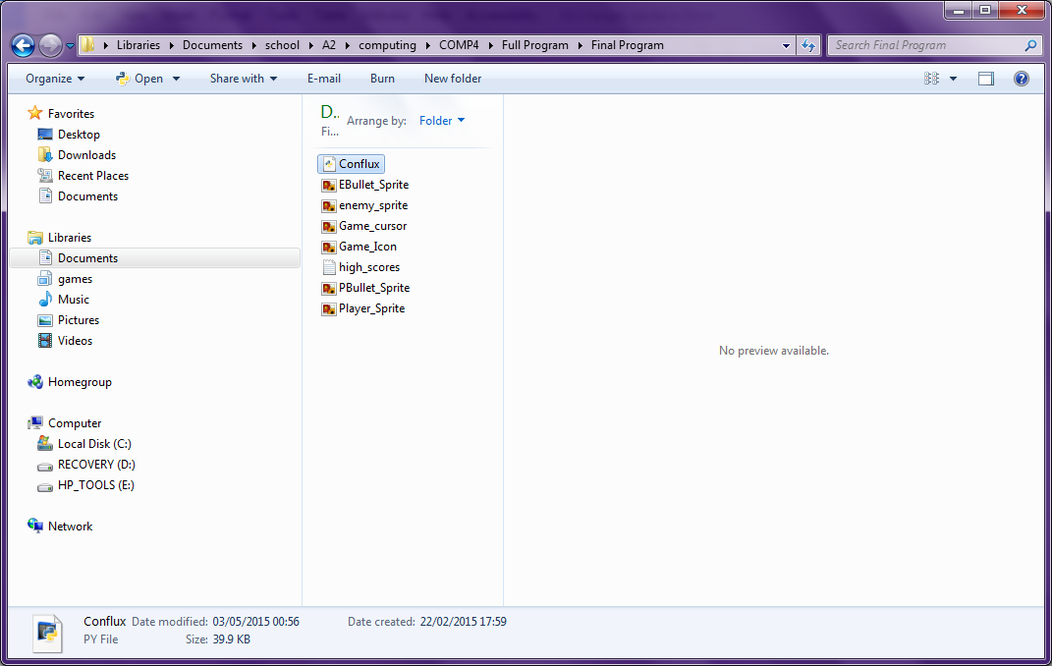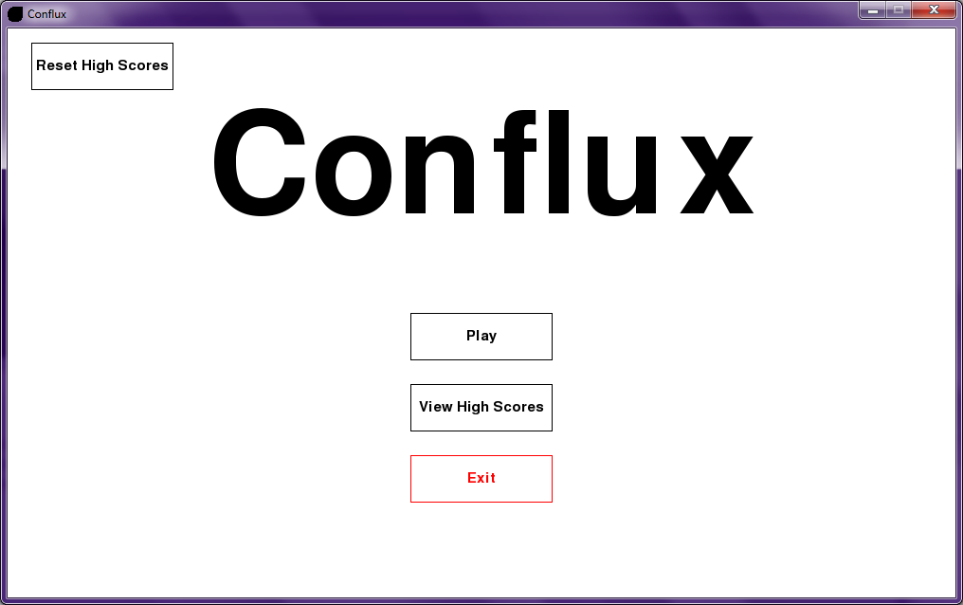

From here, you will click on the play button to start the game

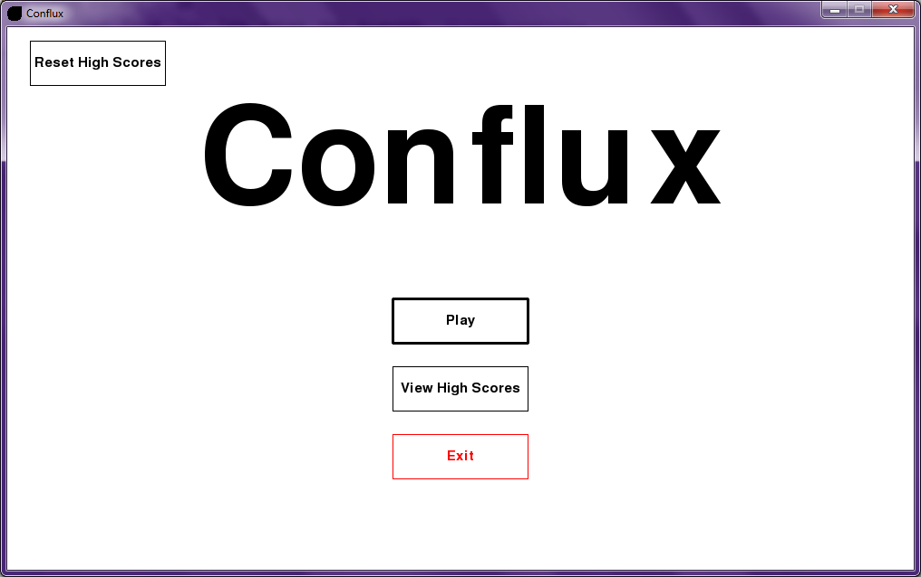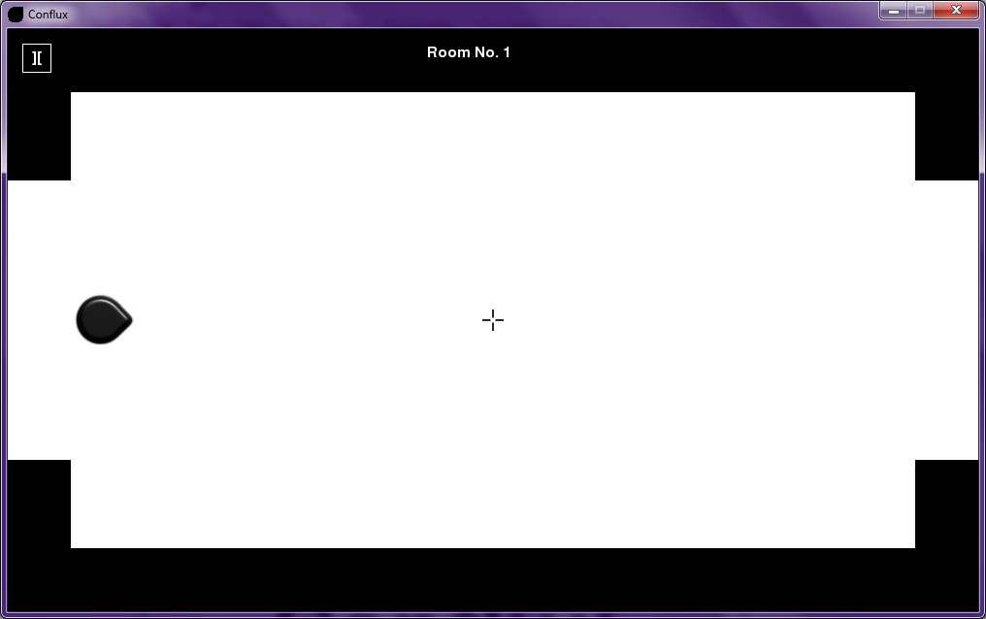

## Playing the game

### Controls

The controls to move around are:

* W always moves towards the mouse, regardless of current rotation
* S always moves away from the mouse
* A and D strafe left and right respectively from wherever you are facing, if the mouse doesn’t move and you do this, your character will move in circles around the mouse
* Moving the mouse around will make your character turn around, as they always face towards the mouse
* Clicking the mouse (left) will make your character shoot a bullet, that can be used to kill enemies.

The objective of the game is to complete all 10 rooms until you reach the end, killing all enemies in your path. To proceed to the next room, you must kill all enemies in the current room by shooting them with your bullets, while they attempt to shoot you also with their own bullets (note that only one shot it needed to kill an enemy and one for them to kill you). The door to your right will then open, where you can move through it and progress to the next room. If you have reached the end of a level and the door has not opened then there must be at least one enemy still alive in a room.

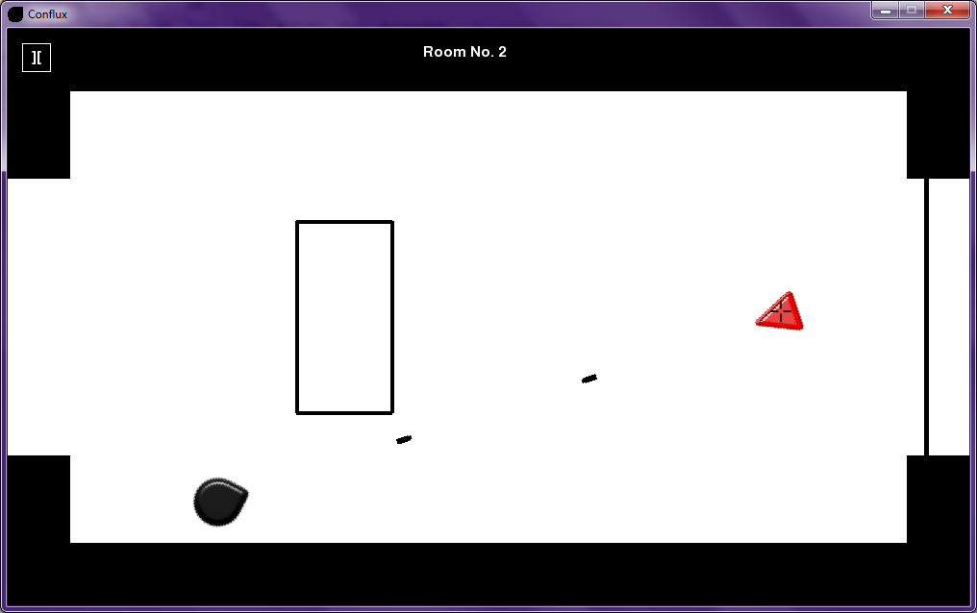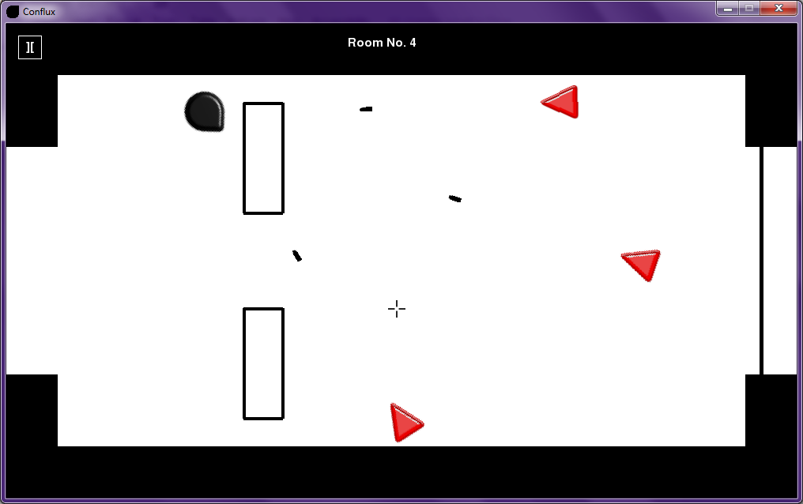

### Pause

While playing, you can pause the game by clicking the pause button in the top right corner of the game window. This will take you to a pause menu, from which you can continue from where you left off, restart the game from room 1 or exit to the main menu.

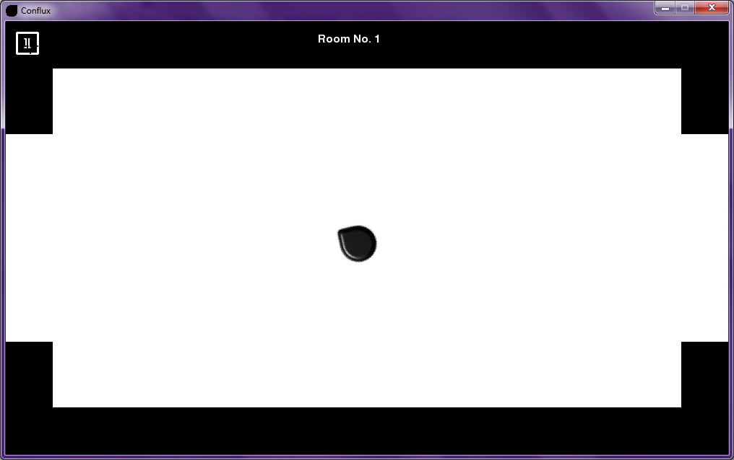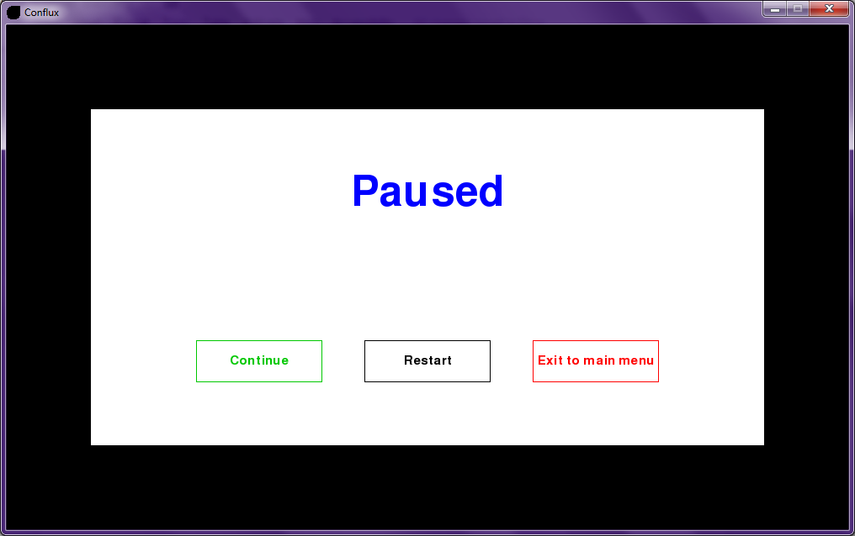

### Barriers

To help you avoid getting shot by the enemy bullets, there are some barriers that will appear in some rooms in the game that will block any bullets that hit them (including your own). Also, you can’t walk through them so to progress through the room you may have to move around to avoid them.

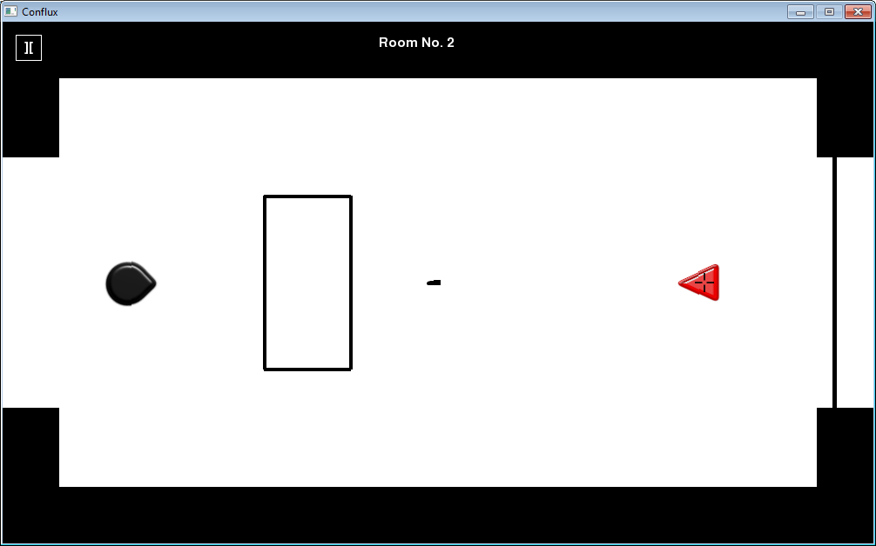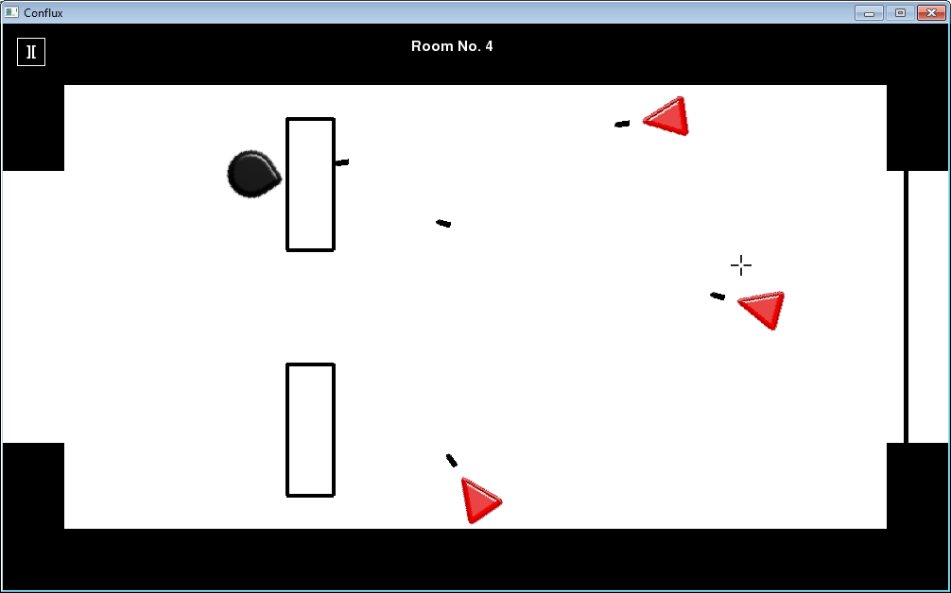

### Player Death

While fighting these enemies, you can die in 2 ways. One is if one of the enemy bullets hit you or and the other is if you collide with an enemy. If you die, then you get brought to a menu where you have to type in your name (up to 15 characters and it can’t be left blank) and you have the option to play again or go back to the main menu. Your score will be the room number that you died in.

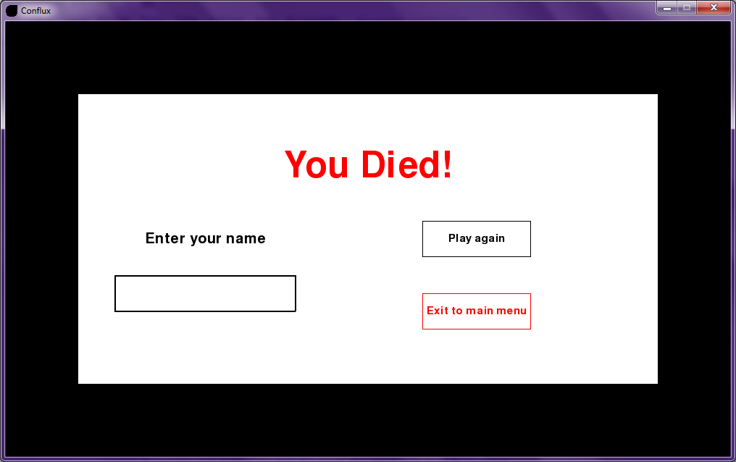

### Viewing high scores

To view the current 3 high scores recorded, you have to go to the main menu and select the button view high scores. This will show you the top 3 players and their scores (unless no scores have been recorded, then it will say no high scores). To get back to the main menu, you just click the button Back to main menu. If you have played a game and your last score is not there, then it must not have been high enough to make it to the top 3.

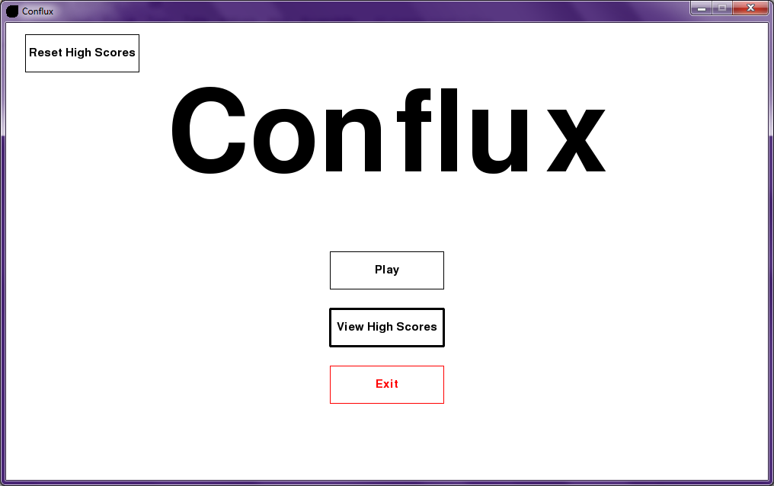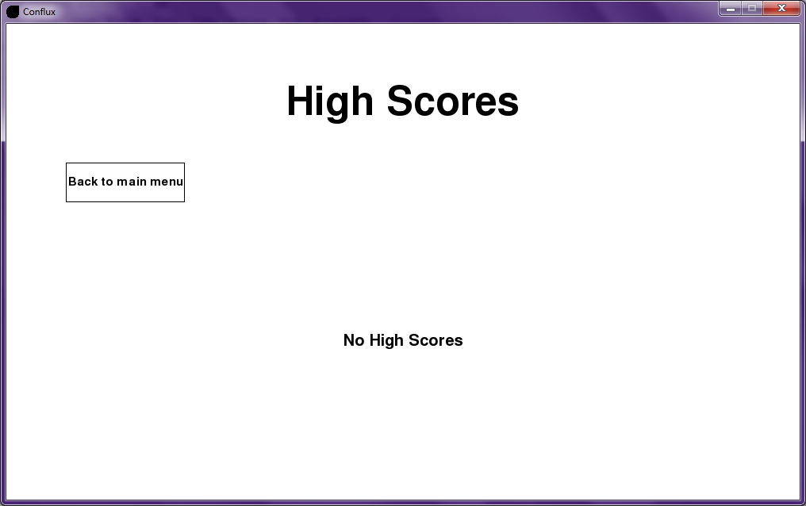

### Resetting high scores

To reset the high scores, all that you have to do is go to the main menu and click the reset high scores button in the top left corner of the screen. This should reset the scores, but just to check you can click on view high scores and should see no high scores displayed.

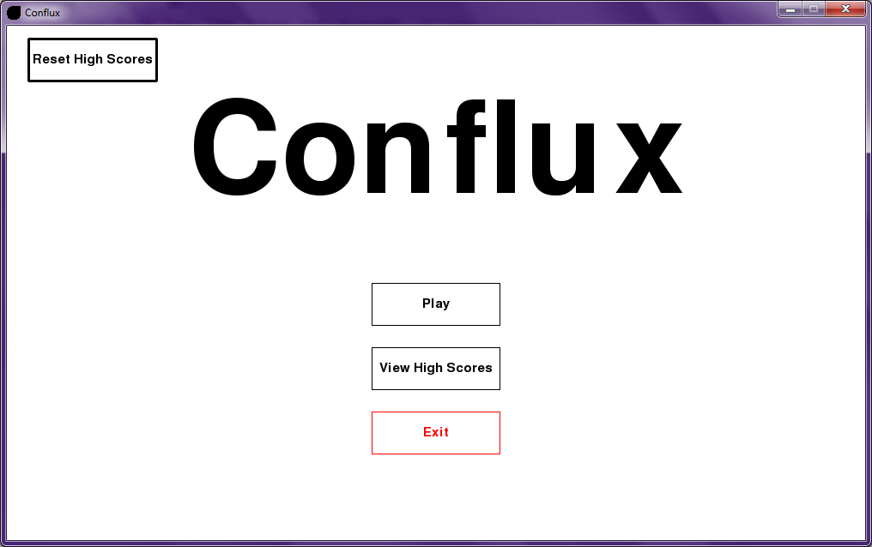

### Potential errors

The potential errors that you could face whilst trying to play the game include:

* Errors from lack of image file
* Error from lack of high scores file
* Error from lack of python install
* Error from lack of pygame install

Anything to do with a lack of files, the solution is to check the folder that I sent the system in also has a high scores file and all of the image files. For python and pygame install errors, check that your installed versions are compatible with Windows and python 3.

# Evaluation

## Comparison of project performance against numbered general and specific objectives

|  |  |  |
| --- | --- | --- |
| **Objective** | **Pass?** | **User feedback** |
| 1.The player must be able to move forward | Yes, the player can move forward | *“The forward movement of the player is really good, I love the way it always moves towards the mouse no matter where you move the mouse.”* |
| 2. The player must be able to move backwards | Yes, the player can move backwards | *“The backwards movement is really useful as well, it makes it a lot easier to dodge the incoming bullets.”* |
| 3. The player must be able to strafe left | Yes, the player can strafe left | *“The left/right strafing really makes the movement dynamic, this will be great since I needed some advanced moving mechanics.”* |
| 4. The player must be able to strafe right | Yes, the player can strafe right |
| 5. The player can shoot bullets by clicking the mouse | Yes, the player can shoot bullets | *“The player shooting was done very well, it was exactly what I wanted.”* |
| 6. The player will die if shot once by an enemy | Yes, the player dies if shot by an enemy | *“I’m glad the player and enemies only needs one shot to land on them for them to die, I needed the simplicity for this project. But, the collision detection for the bullets and the player seems to be a bit inaccurate as sometimes the bullet just misses me and I die anyway.”* |
| 7. The player will kill an enemy by shooting them once | Yes, an enemy dies from one bullet shot by the player |
| 8. The enemies will face towards the player when the player enters a room | Yes, the enemies face towards the player | *“The way that the enemies track the player is good, it’s just what I wanted.”* |
| 9. Will use the mouse to rotate/change the facing direction of the player character | Yes, the mouse is used to rotate the player | *“The player’s rotational mechanic works really well, I love this part of the game.”* |
| 10. Will use the W to move forwards(ie towards the mouse location) | Yes, the W key moves forward | *“The WASD controls work really well with the mouse movement.”* |
| 11. Will use the S to move backwards(ie away from the mouse location) | Yes, the S key moves backwards |
| 12. Will use the A to strafe left(perpendicular to the facing direction) | Yes, the A key strafes left |
| 13. Will use the D to strafe right(perpendicular to the facing direction) | Yes, the D key strafes right |
| 14. The player character must stop moving if they walk into a barrier | Yes, the player character is stopped by a barrier | *“The barriers are great for stopping any incoming bullets and as an obstacle for the player to move around.”* |
| 15. The player character must stop moving if they walk into the map boundary | Yes, the player character is stopped by the map boundary | *“The map boundaries are good, but they stop the player a little too early, it would be better if it would stop them a bit later.”* |
| 16. The player will be able to select ‘Play Game’ from the main menu | Yes, the player can click play game | *“The main menu buttons look good and function properly.”* |
| 17. The player will be able to select ‘View High Scores’ from the main menu | Yes, the player can click view high scores |
| 18. The player will be able to select ‘Exit Game’ from the main menu | Yes, the player can click exit game |
| 19. The player can pause the game from the game interface | Yes, the player can pause the game | *“The pause button is in a good position and works properly, but it can be hard to find sometimes with the cursor and border both being black.”* |
| 20. The player will be able to select ‘Continue’ from the pause menu | Yes, the player can click continue | *“The pause menu buttons also look good and function properly, I like how continue works.”* |
| 21. The player will be able to select ‘Restart’ from the pause menu | Yes, the player can click restart | *“The other pause menu buttons also look good and function properly.”* |
| 22. The player will be able to select ‘Exit to main menu’ from the pause menu | Yes, the player can click exit to main menu |
| 23. The player score is the room number reached before the player die | Yes, the player score is the room number the player died in | *“The way that the room number is the player’s score is good, it should suffice for what I have to do.”* |
| 24. The game must save the scores of players | Yes, the scores of players are stored | *“It’s good to see that the 3 highest scores are saved as for the testing as I needed some form of saving mechanic to design a tests for.”* |
| 25. The game must correctly store the high scores of players | Yes, the scores saved are the top scores |
| 26. The game must store 3 high scores | Yes, 3 high scores are stored |
| 27. The game must store 3 player names | Yes, the top 3 player names are scored with the scores | *“The high scores menu looks really professional with the player names associated with the corresponding scores.”* |
| 28. The system must run smoothly | Yes, the system runs smoothly | *“The game performed really well when I used it, fully stable with no crashes.”* |
| 29. The system must not crash | Yes, the system does not crash |
| 30. The game must load the program from clicking the game icon to displaying the main menu in under 10 seconds | Yes, the game loads in under 10 seconds | *“The main menu loaded quite quickly, in around 5 seconds, which was a pleasant surprise.”* |
| 31. The pause menu must load in under 5 seconds | Yes, the pause menu loads in under 5 seconds | *“The pause menu also loaded quite quickly, it must have been under a second.”* |
| 32. The high scores must load in under 10 seconds | Yes, the high scores screen loads in under 10 seconds | *“The high scores screen loaded quickly, at around 2 seconds.”* |
| 33. The game must close in under 5 seconds after requested from the main menu | Yes, the game closes in under 5 seconds | *“The game closed quickly too, in around 2 seconds.”* |
| 34. The game will run on PC’s with the Windows 7 operating system | Yes, the game runs on windows 7 PC’s | *“I’m glad it worked on my windows 7 PC.”* |
| 35. The game will run at 60fps (frames per second) | Yes, the game runs smoothly at 60 frames per second | *“The game performed really well when I used it, fully stable with no crashes.”* |

## Analysis of user feedback

Overall, the user feedback on my implemented solution was positive. The user was satisfied with the standard of the user interface, the buttons, the loading times of the menus and everything surrounding the sorting and saving of the game’s high scores. The only criticism came with the collision detection accuracy and the positioning of the pause game button.

The main concern of my client was the advanced moving mechanics of the player, as this was specifically requested. He was greatly satisfied with the implementation of this mechanic and the other aspects of the game that also use this, including the rotation of the enemies to track the player and the bullet rotation to always be accurate.

The criticisms that he made about the collision detection were when the player hit the map boundary and the bullets hitting him. He pointed out that the barrier stops the player sooner than expected leaving a small gap in between. Also, he stated that sometimes he would lose the game when the bullet just misses him rather than actually hitting him. These issues can be fixed by replacing the rect method for collision detection in pygame with a more accurate one ensuring that the collisions are more accurate.

The other criticism was about the pause button, which was that the button was hard to find sometimes due to the map border (where the pause button resides) and the game cursor are both the same colour, black. This can be fixed by adding a feature that changes the colour of the game cursor when it is moved inside the map border.

The fact that my client was generally satisfied with the implantation of my system, due to the system passing the objectives set out for it, shows that the system was a success.

## Possible extensions to the system

There are some possible improvements that could be applied to the system, some due to the user feedback received and others due to observed possible extra features that could be added later.

The improvements to be made from the user feedback include the refining of the sprite collision detection, making it more accurate to enhance the gaming experience. This could be a huge improvement, especially the bullet and player collision detection, as the method with the current system directly impacts the life of the player.

Another possible addition to the system is the expansion/redesign of the room mechanics, increasing the room count and possibly adding a randomly generated aspect for the placement and quantity of the enemies and barriers. Rooms incorporating verticality or even a boss room could be added.

Something else that could be added is the change of the high score from the current room number system to one where a timer is implemented and the score would be the time taken to win the whole game. This would mean that when a player loses a game, the score wouldn’t have to be saved and this would also solve the problem of the scores being filled with maximum values after 3 player wins.

If the length of the game was increased then the use of a save game mechanic could be useful whereby the whole game at one point could be saved, with the room number reached, enemies killed etc. This would also require a load game mechanic to load the saved game from the save file.

Another piece of functionality that could be added is giving the enemies the ability to actually move and give them advanced artificial intelligence. This would enhance the gameplay and provide another level of advanced movement mechanics that the user specifically requested but applied to the enemies rather than the player.

Some other improvements could be to enhance the player attacks and abilities by adding a second type of attack in the form of tracking bullets or bombs. Also, abilities could be added that could be used on a timer or be in the form of power-ups picked up from the ground.

# 

# 

# 

# Appendix

**import** pygame**,** sys**,** math**,** pickle

**from** pygame**.**locals **import\***

**class** **Object():**

**def** __init__**(**self**,** ptype**,** image**,** startx**,** starty**):**#ptype is the user of the class, player, enemy or a bullet. the image is the sprite image displayed to the screen and the startx and starty are the starting coordinates of that sprite

self**.**image **=** pygame**.**image**.**load**(**image**).**convert_alpha**()**#load in the image

self**.**rect **=** self**.**image**.**get_rect**()**#get the image rectangle for use in collision detection

self**.**move_image **=** self**.**image#the move image for use later when it is rotated

self**.**x **=** startx

self**.**y **=** starty

self**.**rect**.**center **=** **(**self**.**x**,** self**.**y**)**#the center of the image rectangle

self**.**lxedge **=** 0#the left edge of the sprite image

self**.**rxedge **=** 0#the right edge of the sprite image

self**.**uyedge **=** 0#the upper edge of the sprite image

self**.**dyedge **=** 0#the lower edge of the sprite image

self**.**unitv_x **=** 0#the movement unit vector x of the sprite

self**.**unitv_y **=** 0#the movement unit vector y of the sprite

self**.**angle **=** 0#the rotation angle of the sprite

self**.**ptype **=** ptype#the user of the class

self**.**alive **=** **True**#the life state of the spite

**def** get_rotation**(**self**,** px**,** py**,** ex**,** ey**,** bullet_origin**):**#the player x/y coordinates, the enemy calling its x/y coordinates and the origin of the bullet(player/enemy fired)

mousepos **=** pygame**.**mouse**.**get_pos**()**#gets the mouse position

**if** self**.**ptype **==** 'player'**:**#if the player is calling the method

self**.**angle **=** math**.**atan2**((**mousepos**[**1**]** **-** py**),** **(**mousepos**[**0**]** **-** px**))**#calculates the rotation angle for the player to face towards the mouse using trigonometry

**elif** self**.**ptype **==** 'bullet'**:**

**if** bullet_origin **==** 'player'**:**#if the bullet has been fired by the player

self**.**angle **=** math**.**atan2**((**mousepos**[**1**]** **-** py**),** **(**mousepos**[**0**]** **-** px**))**#calculates the rotation angle for the player bullet to face toward the mouse using trigonometry

**elif** bullet_origin **==** 'enemy'**:**#if the bullet has been fired by an enemy

self**.**angle **=** math**.**atan2**((**ey **-** py**),** **((**ex **-** px**)))**#calculates the rotation angle for an enemy bullet to face towards the player using trigonometry

**elif** self**.**ptype **==** 'enemy'**:**#if an enemy is calling the method

self**.**angle **=** math**.**atan2**((**ey **-** py**),** **((**ex **-** px**)))** #calculates the rotation angle for the enemy calling the method to face towards the player using trigonometry

Object**.**move_image **=** pygame**.**transform**.**rotate**(**self**.**image**,** 360 **-** **(**self**.**angle **\*** 57.27**))**#rotates the sprite image by the angle calculated previously

**return** Object**.**move_image**,** self**.**angle#outputs the rotated sprite image and the angle of rotation

**def** update**(**self**,** surface**,** image**,** pos**):**#the background that the images are displayed on, the image being displayed and the position it is displayed

surface**.**blit**(**image**,** pos**)**#copies the image to the background at the position inputted

**class** **Player(**Object**,** pygame**.**sprite**.**Sprite**):**#subclass of Object

**def** __init__**(**self**,** image**,** startx**,** starty**):**#initialising the player image and starting coordinates

super**(**Player**,** self**).**__init__**(**'player'**,** image**,** startx**,** starty**)**#inheriting from Object

pygame**.**sprite**.**Sprite**.**__init__**(**self**)**#state that Player is a sprite

self**.**X_change **=** 0#x difference per frame for movement

self**.**Y_change **=** 0#y difference per frame for movement

**class** **Enemy(**Object**,** pygame**.**sprite**.**Sprite**):**#subclass of Object

**def** __init__**(**self**,** image**,** startx**,** starty**):**#initialising the enemy image and starting coordinates

super**(**Enemy**,** self**).**__init__**(**'enemy'**,** image**,** startx**,** starty**)**#inheriting from Object

pygame**.**sprite**.**Sprite**.**__init__**(**self**)**#state that Enemy is a sprite

self**.**bullet_timer **=** 0#the time until the next time the enemies shoot

self**.**fire **=** **False**#states whether or not the enemies should fire

**def** add_to_timer**(**self**):**

self**.**bullet_timer **+=** 1#adds to the timer

**if** self**.**bullet_timer **==** 60**:**#after 1 second, the enemies can fire

self**.**fire **=** **True**

**return** self**.**fire#output the fire variable

**class** **Bullet(**Object**,** pygame**.**sprite**.**Sprite**):**#subclass of Object

**def** __init__**(**self**,** image**,** startx**,** starty**,** uvectx**,** uvecty**,** origin**):**#initialising the bullet image, starting coordinates, movement unit vector and the origin(fired by player/enemy)

super**(**Bullet**,** self**).**__init__**(**'bullet'**,** image**,** startx**,** starty**)**#inheriting from Object

pygame**.**sprite**.**Sprite**.**__init__**(**self**)**#state that Bullet is a sprite

self**.**uvectx **=** uvectx#movement unit vector x

self**.**uvecty **=** uvecty#movement unit vector y

self**.**rotated **=** **False**#states whether or not the bullet has already been rotated

self**.**speed **=** 5#speed of the bullet

self**.**remove_bullet **=** **False**#states whether or not the bullet should be removed from the list of bullets

self**.**origin **=** origin#states where the bullet was fired from(player or enemy)

**def** move_bullet**(**self**,** x**,** y**):**

self**.**x **+=** self**.**uvectx**\***self**.**speed#moves bullet by vector x

self**.**y **+=** self**.**uvecty**\***self**.**speed#moves bullet by vector y

**def** update**(**self**,** surface**,** image**,** pos**):**#the background that the bullet is displayed on, the bullet image and the position it is displayed

surface**.**blit**(**image**,** pos**)**#copies the bullet image to the background at the position inputted

**class** **Barrier(**pygame**.**sprite**.**Sprite**):**

**def** __init__**(**self**,** tcx**,** tcy**,** width**,** height**):**#top corner x/y coordinates, the dimensions(width and height)

pygame**.**sprite**.**Sprite**.**__init__**(**self**)**#state that barrier is a class

self**.**topcornerx **=** tcx#top corner x of barrier

self**.**topcornery **=** tcy#top corner y of barrier

self**.**width **=** width#width of barrier

self**.**height **=** height#height of barrier

**def** player_and_bullet_detection**(**self**,** pcx**,** pcy**,** pl**,** pr**,** pu**,** pd**,** x_change**,** y_change**,** f_user**,** kill_bullet**):**#player/bullet centre x/y coordinates, player/bullet left/right/top/bottom edges, x/y position change, the user of the method and kill bullet to state to remove the bullet from the bullets list

**if** pr **>** self**.**topcornerx **and** pl **<** **(**self**.**topcornerx **+** self**.**width**)** **and** pu **<** **(**self**.**topcornery **+** self**.**height**)** **and** pd **>** self**.**topcornery**:**#if the player/a bullet is attempting to enter the barrier

**if** pcx **<** self**.**topcornerx**:**#if they are trying to enter from the left

**if** f_user **==** 'player'**:**#if method used by player

**if** x_change **>** 0**:**#if they are continuing movement inside the barrier

x_change **=** 0#stops the player from moving

**elif** f_user **==** 'bullet'**:**#if method used by bullet

kill_bullet **=** **True**#remove the bullet from the bullets list

**if** pcx **>** **(**self**.**topcornerx **+** self**.**width**):**#if they are trying to enter from the right

**if** f_user **==** 'player'**:**#if method used by player

**if** x_change **<** 0**:**#if they are continuing movement inside the barrier

x_change **=** 0#stops the player from moving

**elif** f_user **==** 'bullet'**:**#if method used by bullet

kill_bullet **=** **True**#remove the bullet from the bullets list

**if** pcy **>** **(**self**.**topcornery **+** self**.**height**):**

**if** f_user **==** 'player'**:**#if method used by player

**if** y_change **<** 0**:**#if they are continuing movement inside the barrier

y_change **=** 0#stops the player from moving

**elif** f_user **==** 'bullet'**:**#if method used by bullet

kill_bullet **=** **True**#remove the bullet from the bullets list

**if** pcy **<** self**.**topcornery**:**

**if** f_user **==** 'player'**:**#if method used by player

**if** y_change **>** 0**:**#if they are continuing movement inside the barrier

y_change **=** 0#stops the player from moving

**elif** f_user **==** 'bullet'**:**#if method used by bullet

kill_bullet **=** **True**#remove the bullet from the bullets list

**if** f_user **==** 'player'**:**#if method used by player

**return** x_change**,** y_change#output the player movement

**elif** f_user **==** 'bullet'**:**#if method used by bullet

**return** kill_bullet#output the kill bullet variable

**def** update**(**self**,** surface**,** colour**):**#the background that the barrier is displayed on and the barrier colour

pygame**.**draw**.**rect**(**surface**,** colour**,** **(**self**.**topcornerx**,** self**.**topcornery**,** self**.**width**,** self**.**height**),** 4**)**#draw the barrier onto the screen with the dimentions stated with an outline thickness of 4 pixels on the edge of the rectangle

**class** **Door():**

**def** __init__**(**self**,** x**,** starty**,** endy**):**#the x position of the door and the limits of the door from top to bottom

self**.**x **=** x **+** 20#20 pixels added to the right barrier x position

self**.**starty **=** starty#the starting y coordinate

self**.**endy **=** endy#the ending y coordinate

self**.**thickness **=** 5#the line thickness of the door

**def** door_detection**(**self**,** playeredge**,** x_change**):**#the right player edge facing the door and the player x movement

**if** playeredge **>=** self**.**x**:**#if the player tries to move through the door

**if** x_change **>** 0**:**#if the player continues to move though the door

x_change **=** 0#stops player

**return** x_change#output the player movement

**def** update**(**self**,** display**,** colour**):**#the background that the door image will be displayed on and the colour of the door

pygame**.**draw**.**line**(**display**,** colour**,** **(**self**.**x**,** self**.**starty**),** **(**self**.**x**,** self**.**endy**),** self**.**thickness**)**#draw the door line in at the position stated

**class** **Score():**

**def** __init__**(**self**):**

self**.**name **=** ''#empty player name

self**.**score **=** 0#empty player score

**class** **Game():**

**def** __init__**(**self**):**

pygame**.**init**()**#initialise pygame

self**.**title **=** 'Conflux'#project title

self**.**window_width **=** 1000#width of game window

self**.**window_height **=** 600#height of game window

self**.**border_size **=** 65#width of map border

self**.**border_step **=** 2.4#multiplier to get border size to be the height of the left and right map borders

self**.**display **=** pygame**.**display**.**set_mode**((**self**.**window_width**,** self**.**window_height**))**#set the game display

self**.**game_icon**(**'Game_Icon.png'**)**#load the game icon

pygame**.**display**.**set_caption**(**self**.**title**)**#set the title of the game on the banner above the game window to show the project title

self**.**clock **=** pygame**.**time**.**Clock**()**#initialise the game clock

self**.**fps **=** 60#set the frames per second of the game

self**.**pause **=** **False**#states whether of not the game is paused

self**.**font **=** 'freesansbold.ttf'#state the text font

self**.**game_state **=** 'Start'#the initial state of the game

self**.**player **=** **None**#temporary player object

self**.**room_number **=** 1#initial room number

self**.**high_scores **=** **[]**#high scores list

self**.**no_of_scores **=** 3#number of high scores saved

**for** count **in** range**(**0**,** self**.**no_of_scores**):**#adds 3 score objects to the high scores list

self**.**high_scores**.**append**(**Score**())**

**for** count **in** range**(**0**,** self**.**no_of_scores**):**#sets the names and scores inside the new scores to empty values

self**.**high_scores**[**count**].**name **=** ''

self**.**high_scores**[**count**].**score **=** 0

**def** state_manager**(**self**):**

states **=** **[**'Start'**,**'Pause'**,**'End'**,**'Play'**,**'Quit'**,**'Scores'**,**'Playing'**]**#the list of possible game states

**if** **not** self**.**game_state **in** states**:**#avoids errors if somehow another game state is present

self**.**game_state **=** 'Start'

game_state_loop **=** **True**#parameter for while loop

**while** game_state_loop**:**

**if** self**.**game_state **==** 'Start'**:**#if the game state if the start menu

self**.**load_high_scores**()**#load the high scores

self**.**start_menu**()**#start menu method

**elif** self**.**game_state **==** 'Pause'**:**#if the game state is paused

**print()**

**elif** self**.**game_state **==** 'End'**:**#if the game state is the end game menu

self**.**end_menu**()**#end game menu method

**elif** self**.**game_state **==** 'Play'**:**#if the game state is play the game

self**.**game_state **=** 'Playing'#change the game state to playing the game

self**.**play_game**()**#play game method

**elif** self**.**game_state **==** 'Scores'**:**#if the game state is viewing the high scores

self**.**view_high_scores**()**#view high scores screen method

**elif** self**.**game_state **==** 'Quit'**:**#if the game state is quitting the game

game_state_loop **=** **False**#exit the game loop

**else:**

self**.**game_state **=** 'Start'#avoids errors if somehow another game state is present

**def** start_menu**(**self**):**

pygame**.**mouse**.**set_visible**(**1**)**#set the mouse to be visible

intro **=** **True**#while loop parameter

**while** intro**:**

**for** event **in** pygame**.**event**.**get**():**#for all events recorded by pygame

**if** event**.**type **==** QUIT**:**#if the event is a request to close the game window

self**.**game_state **=** 'Quit'#set the game state to quit

intro **=** **False**#exit out of the loop

**elif** event**.**type **==** KEYDOWN**:**#if the event is a key press

**if** event**.**key **==** K_ESCAPE**:**#if the escape key is pressed

self**.**game_state **=** 'Quit'#set the game state to quit

intro **=** **False**#exit out of the loop

self**.**display**.**fill**(**self**.**colour_code**(**'white'**))**#fill the background display in white

button_play **=** self**.**create_button**(**'Play'**,** self**.**colour_code**(**'black'**),** 500**,** 325**,** 150**,** 50**,** 'Play'**)**#the play button

button_scores **=** self**.**create_button**(**'View High Scores'**,** self**.**colour_code**(**'black'**),** 500**,** 400**,** 150**,** 50**,** 'Scores'**)**#the view high scores button

button_exit **=** self**.**create_button**(**'Exit'**,** self**.**colour_code**(**'red'**),** 500**,** 475**,** 150**,** 50**,** 'Quit'**)**#the exit button

button_reset_scores **=** self**.**create_button**(**'Reset High Scores'**,** self**.**colour_code**(**'black'**),** 100**,** 40**,** 150**,** 50**,** 'Start'**)**#the reset high scores button

self**.**message_display**(**self**.**title**,** self**.**font**,** 150**,** self**.**colour_code**(**'black'**),** 500**,** 150**)**#the title message

pygame**.**display**.**update**()**#updates the frame

self**.**clock**.**tick**(**self**.**fps**)**#time delay required for 60 frames per second(1/60 seconds)

**if** **not** button_play **==** **None:**#if the play game button is clicked

##print('Start Menu - Button: Play')

self**.**game_state **=** 'Play'#set the game state to be play

intro **=** **False**#exit out of the loop

**elif** **not** button_scores **==** **None:**#if the view high scores button is clicked

##print('Start Menu - Button: Scores')

self**.**game_state **=** 'Scores'#set the game state to be view high scores

intro **=** **False**#exit out of the loop

**elif** **not** button_exit **==** **None:**#if the exit button is clicked

##print('Start Menu - Button: Quit')

self**.**game_state **=** 'Quit'#set the game state to be quit

intro **=** **False**#exit out of the loop

**elif** **not** button_reset_scores **==** **None:**#if the reset high scores button is clicked

##print('Start Menu - Button: Reset Scores')

self**.**reset_high_scores**()**#reset high scores function

self**.**save_high_scores**()**#save high scores function

**def** end_menu**(**self**):** #the menu shown at the end of every game

pygame**.**mouse**.**set_visible**(**1**)**#set the mouse to be visible

self**.**player_name **=** ''#reset the player name

presence_error **=** **False**#initialise the presence error check variable

end **=** **True**#while loop parameter

**while** end**:**

**for** event **in** pygame**.**event**.**get**():**#for all events recorded by pygame

**if** event**.**type **==** QUIT**:**#if the event is a request to close the game window

self**.**game_state **=** 'Quit'#set the game state to quit

end **=** **False**#exit out of the loop

**elif** event**.**type **==** KEYDOWN**:**#if the event is a key press

**if** event**.**key **==** K_ESCAPE**:**#if the escape key is pressed

self**.**game_state **=** 'Quit'#set the game state to quit

end **=** **False**#exit out of the loop

**elif** event**.**key **==** K_a**:**#keylogger to compose any alphanumeric character to the player name

self**.**player_name **+=** 'a'

**elif** event**.**key **==** K_b**:**

self**.**player_name **+=** 'b'

**elif** event**.**key **==** K_c**:**

self**.**player_name **+=** 'c'

**elif** event**.**key **==** K_d**:**

self**.**player_name **+=** 'd'

**elif** event**.**key **==** K_e**:**

self**.**player_name **+=** 'e'

**elif** event**.**key **==** K_f**:**

self**.**player_name **+=** 'f'

**elif** event**.**key **==** K_g**:**

self**.**player_name **+=** 'g'

**elif** event**.**key **==** K_h**:**

self**.**player_name **+=** 'h'

**elif** event**.**key **==** K_i**:**

self**.**player_name **+=** 'i'

**elif** event**.**key **==** K_j**:**

self**.**player_name **+=** 'j'

**elif** event**.**key **==** K_k**:**

self**.**player_name **+=** 'k'

**elif** event**.**key **==** K_l**:**

self**.**player_name **+=** 'l'

**elif** event**.**key **==** K_m**:**

self**.**player_name **+=** 'm'

**elif** event**.**key **==** K_n**:**

self**.**player_name **+=** 'n'

**elif** event**.**key **==** K_o**:**

self**.**player_name **+=** 'o'

**elif** event**.**key **==** K_p**:**

self**.**player_name **+=** 'p'

**elif** event**.**key **==** K_q**:**

self**.**player_name **+=** 'q'

**elif** event**.**key **==** K_r**:**

self**.**player_name **+=** 'r'

**elif** event**.**key **==** K_s**:**

self**.**player_name **+=** 's'

**elif** event**.**key **==** K_t**:**

self**.**player_name **+=** 't'

**elif** event**.**key **==** K_u**:**

self**.**player_name **+=** 'u'

**elif** event**.**key **==** K_v**:**

self**.**player_name **+=** 'v'

**elif** event**.**key **==** K_w**:**

self**.**player_name **+=** 'w'

**elif** event**.**key **==** K_x**:**

self**.**player_name **+=** 'x'

**elif** event**.**key **==** K_y**:**

self**.**player_name **+=** 'y'

**elif** event**.**key **==** K_z**:**

self**.**player_name **+=** 'z'

**elif** event**.**key **==** K_0**:**

self**.**player_name **+=** '0'

**elif** event**.**key **==** K_1**:**

self**.**player_name **+=** '1'

**elif** event**.**key **==** K_2**:**

self**.**player_name **+=** '2'

**elif** event**.**key **==** K_3**:**

self**.**player_name **+=** '3'

**elif** event**.**key **==** K_4**:**

self**.**player_name **+=** '4'

**elif** event**.**key **==** K_5**:**

self**.**player_name **+=** '5'

**elif** event**.**key **==** K_6**:**

self**.**player_name **+=** '6'

**elif** event**.**key **==** K_7**:**

self**.**player_name **+=** '7'

**elif** event**.**key **==** K_8**:**

self**.**player_name **+=** '8'

**elif** event**.**key **==** K_9**:**

self**.**player_name **+=** '9'

**elif** event**.**key **==** K_SPACE**:**#space in the player name

self**.**player_name **+=** ' '

**elif** event**.**key **==** K_BACKSPACE**:**#removes the last character entered in the name

self**.**player_name **=** self**.**player_name**[:-**1**]**

self**.**validate_player_name**()**#validates the player name top keep the length of the name under 15 characters

self**.**display**.**fill**(**self**.**colour_code**(**'black'**))**#fills the background display with black

pygame**.**draw**.**rect**(**self**.**display**,** self**.**colour_code**(**'white'**),** **(**100**,** 100**,** 800**,** 400**),** 0**)**#draws the central white background in the display

self**.**message_display**(**'Enter your name'**,** self**.**font**,** 20**,** self**.**colour_code**(**'black'**),** 275**,** 300**)**#displays the enter your name message

pygame**.**draw**.**rect**(**self**.**display**,** self**.**colour_code**(**'black'**),** **(**150**,** 350**,** 250**,** 50**),** 2**)**#draws the textbox

self**.**message_display**(**self**.**player_name**,** self**.**font**,** 20**,** self**.**colour_code**(**'black'**),** 275**,** 375**)**#displays the player name as the text inside the text box

button_play **=** self**.**create_button**(**'Play again'**,** self**.**colour_code**(**'black'**),** 650**,** 300**,** 150**,** 50**,** 'Play'**)**#the play again button

button_start **=** self**.**create_button**(**'Exit to main menu'**,** self**.**colour_code**(**'red'**),** 650**,** 400**,** 150**,** 50**,** 'Start'**)**#the exit to main menu button

**if** self**.**player**.**alive**:**#if the player won the game

self**.**message_display**(**'You Won!'**,** self**.**font**,** 50**,** self**.**colour_code**(**'green'**),** 500**,** 200**)**#display a win game message

**else:**#the player died

self**.**message_display**(**'You Died!'**,** self**.**font**,** 50**,** self**.**colour_code**(**'red'**),** 500**,** 200**)**#displaly a lost game message

**if** presence_error**:**#if the player didn't enter a name

self**.**message_display**(**'Name empty'**,** self**.**font**,** 20**,** self**.**colour_code**(**'red'**),** 275**,** 425**)**#display a presence error message

**if** **not** button_play **==** **None:** #if the play again button is clicked

**if** self**.**player_name **!=** ''**:**#if the player entered a name

##print('End Menu - Button: Play')

self**.**game_state **=** 'Play'#set the game state to be play

end **=** **False**#exit out of the loop

presence_error **=** **True**#presence error true

**elif** **not** button_start **==** **None:**#if the exit to main menu button is clicked

**if** self**.**player_name **!=** ''**:**#if the player entered a name

##print('End Menu - Button: Start Menu')

self**.**game_state **=** 'Start'#set the game state to be the start menu

end **=** **False**#exit out of the loop

presence_error **=** **True**#presence error true

pygame**.**display**.**update**()**#updates the frame

self**.**clock**.**tick**(**self**.**fps**)**#time delay required for 60 frames per second(1/60 seconds)

self**.**is_high_score**()**#is the new player scores one of the high scores

self**.**save_high_scores**()**#save the high scores to a file

**def** play_game**(**self**):**

pygame**.**mouse**.**set_visible**(**0**)**#set the mouse to be invisible

pygame**.**mouse**.**set_pos**([**500**,** 300**])**#set the mouse position to be the centre of the screen

player_start **=** **[**100**,**300**]**#set the player starting coordinates

cursor **=** pygame**.**image**.**load**(**'Game_cursor.png'**)**#load the game cursor

self**.**player **=** Player**(**'Player_Sprite.png'**,** player_start**[**0**],** player_start**[**1**])**#create the player object

door **=** Door**(**self**.**window_width**-**self**.**border_size**,** self**.**border_size**\***self**.**border_step**,** self**.**window_height**-**self**.**border_size**\***self**.**border_step**)**#create the door object

self**.**enemies_list **=** pygame**.**sprite**.**Group**()**#create the list of enemies

self**.**barriers_list **=** pygame**.**sprite**.**Group**()**#create the list of barriers

self**.**bullets_list **=** pygame**.**sprite**.**Group**()**#create the list of all bullets

self**.**player_bullets_list **=** pygame**.**sprite**.**Group**()**#create the list of bullets fired by the player

self**.**enemy_bullets_list **=** pygame**.**sprite**.**Group**()**#create the list of bullets fired by the enemies

click **=** pygame**.**mouse**.**get_pressed**()**#gets the click state(if the mouse has been clicked)

self**.**first_run **=** **True**#states if this is the first run of the game loop in a certain room

bullet_timer **=** 0#initialise the bullet timer for the enemies to they can next fire

self**.**room_number **=** 1#reset the room number

self**.**player_score **=** 0#reset the player score

reset_player **=** **False**#states if the player position should be reset to their starting position

direction **=** ''#the direction of player movement

self**.**bullets_list**.**empty**()**#resets the list of total bullets

self**.**player_bullets_list**.**empty**()**#resets the list of bullets fired by the player

self**.**enemy_bullets_list**.**empty**()**#resets the list of bullets fired by the enemies

**while** self**.**game_state **==** 'Playing'**:**#the game loop

**if** reset_player**:**#reset the player position when they enter a new room

self**.**player**.**x **=** player_start**[**0**]**

self**.**player**.**y **=** player_start**[**1**]**

reset_player **=** **False**

mousepos **=** pygame**.**mouse**.**get_pos**()**#gets the moust position

self**.**display**.**fill**(**self**.**colour_code**(**'white'**))**#fills the background display with white

self**.**load_map**()**#loads the map borders, barriers and room enemies

button_pause **=** self**.**create_button**(**']['**,** self**.**colour_code**(**'white'**),** 30**,** 30**,** 30**,** 30**,** 'Pause'**)**#pause button

**if** **not** button_pause **==** **None:**#if pause button is clicked

self**.**pause_menu**()**#pause menu function

pygame**.**mouse**.**set_visible**(**0**)**#set the mouse to be invisible

room_number_msg **=** 'Room No. ' **+** str**(**self**.**room_number**)**#the room number message at the top of the screen

self**.**message_display**(**room_number_msg**,** self**.**font**,** 15**,** self**.**colour_code**(**'white'**),** 475**,** 25**)**#the displayed room number message

self**.**player**.**move_image**,** self**.**player**.**angle **=** self**.**player**.**get_rotation**(**self**.**player**.**x**,** self**.**player**.**y**,** 0**,** 0**,** 0**)**#gets the player rotation image and the rotation angle

**for** enemy **in** self**.**enemies_list**:**#loop through all enemies on the screen

enemy**.**move_image**,** enemy**.**angle **=** enemy**.**get_rotation**(**self**.**player**.**x**,** self**.**player**.**y**,** enemy**.**x**,** enemy**.**y**,** 0**)**#gets the enemy rotation image and the rotation angle

**for** bullet **in** self**.**player_bullets_list**:**#loop through all the player fired bullets

**if** **not** bullet**.**rotated**:**#if the bullet has not already been rotated

bullet**.**move_image**,** bullet**.**angle **=** bullet**.**get_rotation**(**self**.**player**.**x**,** self**.**player**.**y**,** 0**,** 0**,** 'player'**)**#gets the bullet rotation image and the rotation angle

bullet**.**rotated **=** **True**#the bullet has now been through its one rotation

self**.**player**.**unitv_x**,** self**.**player**.**unitv_y **=** self**.**get_uvector**(**self**.**player**.**angle**)**#calculate the player movement unit vector

**for** enemy **in** self**.**enemies_list**:**#loop through all enemies on the screen

enemy**.**unitv_x**,** enemy**.**unitv_y **=** self**.**get_uvector**(**enemy**.**angle**)**#get the movement unit vector of the enemy

enemy**.**unitv_x**,** enemy**.**unitv_y **=** **-**1**\*(**enemy**.**unitv_x**),** **-**1**\*(**enemy**.**unitv_y**)**#reverse the enemy movement vector

**for** event **in** pygame**.**event**.**get**():**#for all events recorded by pygame

**if** event**.**type **==** QUIT**:**#if the event is a request to close the game window

self**.**game_state **=** 'Quit'#set the game state to quit

**elif** event**.**type **==** KEYDOWN**:**#if the event is a key press

**if** event**.**key **==** K_ESCAPE**:**#if the escape key is pressed

self**.**game_state **=** 'Quit'#set the game state to quit

**elif** event**.**key **==** K_w**:**#if the W key is pressed

direction **=** 'w'#direction is forward

**elif** event**.**key **==** K_s**:**#if the S key is pressed

direction **=** 's'#direction is backward

**elif** event**.**key **==** K_d**:**#if the D key is pressed

direction **=** 'd'#direction is right

**elif** event**.**key **==** K_a**:**#if the A key is pressed

direction **=** 'a'#direction is left

**elif** event**.**type **==** KEYUP**:**#if the event is the release of a key press

direction **=** ''#reset the direction

**elif** event**.**type **==** MOUSEBUTTONDOWN**:**#if the event is a mouse click

**if** event**.**button **==** 1**:**#if it is a left click

bullet **=** Bullet**(**'PBullet_sprite.png'**,** self**.**player**.**x**,** self**.**player**.**y**,** self**.**player**.**unitv_x**,** self**.**player**.**unitv_y**,** 'player'**)**#create a new player bullet object

self**.**bullets_list**.**add**(**bullet**)**#add the new bullet to the total bullets lis

self**.**player_bullets_list**.**add**(**bullet**)**#add the new bullet to the list of player fired bullets

**if** direction **==** 'w'**:**#if the direction if forward

self**.**player**.**X_change **=** self**.**player**.**unitv_x**\***3.5#calculate the forward x/y movement

self**.**player**.**Y_change **=** self**.**player**.**unitv_y**\***3.5

**elif** direction **==** 's'**:**#if the direction is backward

self**.**player**.**X_change **=** self**.**player**.**unitv_x**\*-**3#calculate the backward x/y movement

self**.**player**.**Y_change **=** self**.**player**.**unitv_y**\*-**3

**elif** direction **==** 'd'**:**#if the direction is right

self**.**player**.**X_change **=** self**.**player**.**unitv_y**\*-**2.5#calculate the right x/y movement

self**.**player**.**Y_change **=** self**.**player**.**unitv_x**\***2.5

**elif** direction **==** 'a'**:**#if the direction is left

self**.**player**.**X_change **=** self**.**player**.**unitv_y**\***2.5#calculate the left x/y movement

self**.**player**.**Y_change **=** self**.**player**.**unitv_x**\*-**2.5

**else:**#if no key is currently pressed

self**.**player**.**X_change **=** 0#reset the player x/y movement

self**.**player**.**Y_change **=** 0

**for** enemy **in** self**.**enemies_list**:**#for every enemy currently on the screen

enemy**.**fire **=** enemy**.**add_to_timer**()**#add to the bullet timer

**if** enemy**.**fire **==** **True:**#if the enemies can fire

bullet **=** Bullet**(**'EBullet_sprite.png'**,** enemy**.**x**,** enemy**.**y**,** enemy**.**unitv_x**,** enemy**.**unitv_y**,** 'enemy'**)**#create a new enemy bullet object

self**.**bullets_list**.**add**(**bullet**)**#add the new bullet to the list of total bullets

self**.**enemy_bullets_list**.**add**(**bullet**)**#add the new bullet to the list of enemy fired bullets

bullet**.**move_image**,** bullet**.**angle **=** bullet**.**get_rotation**(**self**.**player**.**x**,** self**.**player**.**y**,** enemy**.**x**,** enemy**.**y**,** 'enemy'**)**#rotate each bullet

enemy**.**fire **=** **False**#state that this round of enemy fire has finished

enemy**.**bullet_timer **=** 0#reset the bullet timer

self**.**player**.**lxedge**,** self**.**player**.**uyedge**,** self**.**player**.**rxedge**,** self**.**player**.**dyedge **=** self**.**get_edges**(**self**.**player**,** self**.**player**.**move_image**)**#update the player image top/bottom/left/right edges

**for** enemy **in** self**.**enemies_list**:**#for all enemies currently on the screen

enemy**.**lxedge**,** enemy**.**uyedge**,** enemy**.**rxedge**,** enemy**.**dyedge **=** self**.**get_edges**(**enemy**,** enemy**.**move_image**)**#update the enemy images top/bottom/left/right edges

**for** bullet **in** self**.**bullets_list**:**

bullet**.**lxedge**,** bullet**.**uyedge**,** bullet**.**rxedge**,** bullet**.**dyedge **=** self**.**get_edges**(**bullet**,** bullet**.**move_image**)**#update the bullet images top/bottom/left/right edges

self**.**player**.**X_change**,** self**.**player**.**Y_change **=** self**.**boundary_detection**(**self**.**player**.**uyedge**,** self**.**player**.**dyedge**,** self**.**player**.**lxedge**,** self**.**player**.**rxedge**,** self**.**player**.**X_change**,** self**.**player**.**Y_change**)**#the map boundary collision detection for the player

**for** bullet **in** self**.**bullets_list**:**#for all bullets currently on the screen

kill_bullet **=** **False**#reset kill bullet

bullet**.**remove_bullet **=** self**.**bullet_boundary_detection**(**bullet**.**uyedge**,** bullet**.**dyedge**,** bullet**.**lxedge**,** bullet**.**rxedge**,** kill_bullet**)**#the map boundary collision detection for the bullets

**if** bullet**.**remove_bullet **==** **True:**#if the bullets has collided with the map boundary

self**.**bullets_list**.**remove**(**bullet**)**#remove the bullet from the list of total bullets

**if** bullet**.**origin **==** 'player'**:**#if the bullet was fired by the player

self**.**player_bullets_list**.**remove**(**bullet**)**#remove the bullet from the list of player fired bullets

**else:**#if the bullet was fired by an enemy

self**.**enemy_bullets_list**.**remove**(**bullet**)**#remove the bullet from the list of enemy fired bullets

**for** bullet **in** self**.**bullets_list**:**#for all bullets currently on the screen

bullet**.**move_bullet**(**bullet**.**x**,** bullet**.**y**)**#move the bullet by its unique unit vector

**for** barrier **in** self**.**barriers_list**:**

self**.**player**.**X_change**,** self**.**player**.**Y_change **=** barrier**.**player_and_bullet_detection**(**self**.**player**.**x**,** self**.**player**.**y**,** self**.**player**.**lxedge**,** self**.**player**.**rxedge**,** self**.**player**.**uyedge**,** self**.**player**.**dyedge**,** self**.**player**.**X_change**,** self**.**player**.**Y_change**,** 'player'**,** 0**)**#the barrier collision detection for the player

**for** barrier **in** self**.**barriers_list**:**#for all barriers currently on the screen

**for** bullet **in** self**.**bullets_list**:**#for all bullets currently on the screen

kill_bullet **=** **False**#reset kill bullet

bullet**.**remove_bullet **=** barrier**.**player_and_bullet_detection**(**0**,** 0**,** bullet**.**lxedge**,** bullet**.**rxedge**,** bullet**.**uyedge**,** bullet**.**dyedge**,** 0**,** 0**,** 'bullet'**,** kill_bullet**)**#barrier collision detection for the bullets

**if** bullet**.**remove_bullet **==** **True:**#if the bullet has collided with a barrier

self**.**bullets_list**.**remove**(**bullet**)**#remove the bullet from the list of total bullets

**if** bullet**.**origin **==** 'player'**:**#if the bullet was fired by the player

self**.**player_bullets_list**.**remove**(**bullet**)**#remove the bullet from the list of player fired bullets

**else:**#if the bullet was fired by an enemy

self**.**enemy_bullets_list**.**remove**(**bullet**)**#remove the bullet from the list of enemy fired bullets

**if** len**(**self**.**enemies_list**)** **!=** 0**:**#if there are stil enemies on the screen

self**.**player**.**X_change **=** door**.**door_detection**(**self**.**player**.**rxedge**,** self**.**player**.**X_change**)**#the door collision detection for the player

door**.**update**(**self**.**display**,** self**.**colour_code**(**'black'**))**#display the door image

**if** pygame**.**sprite**.**spritecollideany**(**self**.**player**,** self**.**enemies_list**):**#if the player collides with any enemy

self**.**player**.**alive **=** **False**#the player is not alive

self**.**game_state **=** 'End'#set the game state to be the end game menu

pygame**.**sprite**.**groupcollide**(**self**.**player_bullets_list**,** self**.**enemies_list**,** **True,** **True)**#if any player fired bullet collides with any enemy, remove each sprite from their respective lists

**if** pygame**.**sprite**.**spritecollideany**(**self**.**player**,** self**.**enemy_bullets_list**):**#if the player collides with any enemy fired bullet

self**.**player**.**alive **=** **False**#the player is not alive

self**.**game_state **=** 'End'#set the game state to be the end game menu

self**.**player**.**x **+=** self**.**player**.**X_change#add the player x/y movement to their current position

self**.**player**.**y **+=** self**.**player**.**Y_change

self**.**player**.**rect**.**center **=** **(**self**.**player**.**x**,** self**.**player**.**y**)**#update the center of the rectangle around the player image for collision detection

**for** enemy **in** self**.**enemies_list**:**#for all enemies currently on the screen

enemy**.**rect**.**center **=** **(**enemy**.**x**,** enemy**.**y**)**#update the center of the rectangle around the enemy image for collision detection

**for** bullet **in** self**.**bullets_list**:**#for all bullets currently on the screen

bullet**.**rect**.**center **=** **(**bullet**.**x**,** bullet**.**y**)**#update the center of the rectangle around the bullet image for collision detection

**for** bullet **in** self**.**bullets_list**:**#for all bullets currently on the screen

bullet**.**update**(**self**.**display**,** bullet**.**move_image**,** **(**bullet**.**lxedge**,** bullet**.**uyedge**))**#draw all of the bullets to the screen

**for** enemy **in** self**.**enemies_list**:**#for all enemies currently on the screen

enemy**.**update**(**self**.**display**,** enemy**.**move_image**,** **(**enemy**.**lxedge**,** enemy**.**uyedge**))**#draw all of the enemies to the screen

self**.**player**.**update**(**self**.**display**,** self**.**player**.**move_image**,** **(**self**.**player**.**lxedge**,** self**.**player**.**uyedge**))**#draw the player image

self**.**display**.**blit**(**cursor**,** **(**mousepos**[**0**]-**11**,** mousepos**[**1**]-**11**))**#draw the cursor to the screen

**for** barrier **in** self**.**barriers_list**:**#for all barriers currently on the screen

barrier**.**update**(**self**.**display**,** self**.**colour_code**(**'black'**))**#draw the barriers to the screen

self**.**first_run **=** **False**#the first run in a room has finished

pygame**.**display**.**update**()**#updates the frame

self**.**clock**.**tick**(**self**.**fps**)**#time delay required for 60 frames per second(1/60 seconds)

**if** self**.**player**.**rxedge **>=** self**.**window_width**:**#if the player hits the right map boundary through the door

self**.**increase_level**()**#increase the room number and reset the room values

reset_player **=** **True**#reset the player position

self**.**player_score **=** self**.**room_number#set the player score to be the room number that they won/lost in

**def** increase_level**(**self**):**

##print('Level Up ' + str(self.room_number))

self**.**room_number **+=** 1#increase the room number

self**.**first_run **=** **True**#the next game loop will be the first run of the new room

self**.**enemies_list**.**empty**()**#reset the enemies list

self**.**barriers_list**.**empty**()**#reset the barriers list

self**.**bullets_list**.**empty**()**#reset the total bullets list

self**.**player_bullets_list**.**empty**()**#reset the player bullet list

self**.**enemy_bullets_list**.**empty**()**#reset the enemy bullets list

**def** validate_player_name**(**self**):**

**if** len**(**self**.**player_name**)** **>** 15**:**#if the player name is longer than 15 characters

self**.**player_name **=** self**.**player_name**[:-**1**]**#remove the 16th character from the name

**def** pause_menu**(**self**):**

pygame**.**mouse**.**set_visible**(**1**)**#set the mouse to be visible

self**.**pause **=** **True**#parameter for while loop

**while** self**.**pause**:**#while the game is paused

**for** event **in** pygame**.**event**.**get**():**#for all events recorded by pygame

**if** event**.**type **==** QUIT**:**#if the event is a request to close the game window

self**.**game_state **=** 'Quit'#set the game state to quit

self**.**pause **=** **False**#exit the loop

**elif** event**.**type **==** KEYDOWN**:**#if the event is a key press

**if** event**.**key **==** K_ESCAPE**:**#if the escape key is pressed

self**.**game_state **=** 'Quit'#set the game state to quit

self**.**pause **=** **False**#exit the loop

self**.**display**.**fill**(**self**.**colour_code**(**'black'**))**#fill the game display with black

pygame**.**draw**.**rect**(**self**.**display**,** self**.**colour_code**(**'white'**),** **(**100**,** 100**,** 800**,** 400**),** 0**)**#draw the sub-background where the menu is displayed

button_continue **=** self**.**create_button**(**'Continue'**,** self**.**colour_code**(**'green'**),** 300**,** 400**,** 150**,** 50**,** 'Unpause'**)**#the continue button

button_restart **=** self**.**create_button**(**'Restart'**,** self**.**colour_code**(**'black'**),** 500**,** 400**,** 150**,** 50**,** 'Play'**)**#the restart button

button_exit **=** self**.**create_button**(**'Exit to main menu'**,** self**.**colour_code**(**'red'**),** 700**,** 400**,** 150**,** 50**,** 'Start'**)**#the exit to main menu button

self**.**message_display**(**'Paused'**,** self**.**font**,** 50**,** self**.**colour_code**(**'blue'**),** 500**,** 200**)**#the paused message

pygame**.**display**.**update**()**#update the frame

self**.**clock**.**tick**(**self**.**fps**)**#time delay required for 60 frames per second(1/60 seconds)

**if** **not** button_continue **==** **None:**#if the continue button is clicked

##print('Pause Menu - Button: Unpause')

self**.**unpause**()**#exit the loop

**elif** **not** button_restart **==** **None:**#if the restart button is clicked

##print('Pause Menu - Button: New Game')

self**.**game_state **=** 'Play'#set the game state to play

self**.**unpause**()**#exit the loop

**elif** **not** button_exit **==** **None:**

##print('Pause Menu - Button: Quit')

self**.**game_state **=** 'Start'#set the game state to the start menu

self**.**unpause**()**#exit the loop

**def** quit_game**(**self**):**

pygame**.**quit**()**#close pygame

sys**.**exit**()**#close the game window

**def** save_high_scores**(**self**):**

file **=** open**(**"high_scores.txt"**,**"wb"**)**#open the high scores file

pickle**.**dump**(**self**.**high_scores**,** file**)**#store the high scores array to the file

file**.**close**()**#close the file

**def** load_high_scores**(**self**):**

file **=** open**(**"high_scores.txt"**,**"rb"**)**#open the high scores file

self**.**high_scores **=** pickle**.**load**(**file**)**#load the high scores from the file into the in-game high scores array

file**.**close#close the file

**def** is_high_score**(**self**):**

self**.**high_scores**.**append**(**Score**())**#add a fourth score object

self**.**high_scores**[**self**.**no_of_scores**].**name **=** self**.**player_name#set this fourth object name to be the player name of the game just played

self**.**high_scores**[**self**.**no_of_scores**].**score **=** self**.**room_number#set this fourth object score to the player score of the game just played

**for** i **in** range**(**1**,** self**.**no_of_scores **+** 1**):**#for all four scores

current_value **=** self**.**high_scores**[**i**].**score#set current value to be the score being currently analysed

current_pointer **=** i#set current pointer to be the index of the loop

**while** current_pointer **>** 0 **and** self**.**high_scores**[**current_pointer**-**1**].**score **<** current_value**:**#while the list has not been fully sorted and currentvalue is larger than the previous score

self**.**high_scores**[**current_pointer**],** self**.**high_scores**[**current_pointer**-**1**]** **=** self**.**high_scores**[**current_pointer**-**1**],** self**.**high_scores**[**current_pointer**]**#swap the values

current_pointer **=** current_pointer **-** 1#reduce current pointer to move on with the loop

self**.**high_scores**[**current_pointer**].**score **=** current_value#assign current value to its sorted position

self**.**high_scores**.**pop**(**self**.**no_of_scores**)**#remove the fourth score

**def** reset_high_scores**(**self**):**

**for** count **in** range**(**0**,** self**.**no_of_scores**):**#for all the scores

self**.**high_scores**[**count**].**name **=** ''#assign the scores array with empty names

self**.**high_scores**[**count**].**score **=** 0#assign the scores array with empty scores

**def** view_high_scores**(**self**):**

pygame**.**mouse**.**set_visible**(**1**)**#set the mouse to visible

viewscores **=** **True**#parameter for while loop

**while** viewscores**:**

**for** event **in** pygame**.**event**.**get**():**#for all events recorded by pygame

**if** event**.**type **==** QUIT**:**#if the event is a request to close the game window

self**.**game_state **=** 'Quit'#set the game state to quit

viewscores **=** **False**#exit the loop

**elif** event**.**type **==** KEYDOWN**:**#if the event is a key press

**if** event**.**key **==** K_ESCAPE**:**#if the escape key is pressed

self**.**game_state **=** 'Quit'#set the game state to quit

viewscores **=** **False**#exit the loop

self**.**display**.**fill**(**self**.**colour_code**(**'white'**))**#fill the background display with white

self**.**message_display**(**'High Scores'**,** self**.**font**,** 50**,** self**.**colour_code**(**'black'**),** 500**,** 100**)**#display the high scores title

**if** self**.**high_scores**[**0**].**score **==** 0**:**#if the high scores are empty

self**.**message_display**(**'No High Scores'**,** self**.**font**,** 20**,** self**.**colour_code**(**'black'**),** 500**,** 400**)**#display a no high scores message

**else:**#if there is at least one high score

self**.**message_display**(**self**.**high_scores**[**0**].**name**,** self**.**font**,** 20**,** self**.**colour_code**(**'black'**),** 425**,** 350**)**#display the first name

**if** self**.**high_scores**[**0**].**score **==** 11**:**#if the score was a win

self**.**message_display**(**'Win!'**,** self**.**font**,** 20**,** self**.**colour_code**(**'black'**),** 575**,** 350**)**#display a win message

**else:**#if the score was a loss

self**.**message_display**(**str**(**self**.**high_scores**[**0**].**score**),** self**.**font**,** 20**,** self**.**colour_code**(**'black'**),** 575**,** 350**)**#display the player score

self**.**message_display**(**self**.**high_scores**[**1**].**name**,** self**.**font**,** 20**,** self**.**colour_code**(**'black'**),** 425**,** 400**)**#display the second name

**if** self**.**high_scores**[**1**].**score **==** 11**:**#if the score was a win

self**.**message_display**(**'Win!'**,** self**.**font**,** 20**,** self**.**colour_code**(**'black'**),** 575**,** 400**)** #display a win message

**elif** self**.**high_scores**[**1**].**score **!=** 0**:**#if the score was a loss

self**.**message_display**(**str**(**self**.**high_scores**[**1**].**score**),** self**.**font**,** 20**,** self**.**colour_code**(**'black'**),** 575**,** 400**)**#display the player score

self**.**message_display**(**self**.**high_scores**[**2**].**name**,** self**.**font**,** 20**,** self**.**colour_code**(**'black'**),** 425**,** 450**)**#display the third name

**if** self**.**high_scores**[**2**].**score **==** 11**:**#if the score was a win

self**.**message_display**(**'Win!'**,** self**.**font**,** 20**,** self**.**colour_code**(**'black'**),** 575**,** 450**)**#display a win message

**elif** self**.**high_scores**[**2**].**score **!=** 0**:**#if the score was a loss

self**.**message_display**(**str**(**self**.**high_scores**[**2**].**score**),** self**.**font**,** 20**,** self**.**colour_code**(**'black'**),** 575**,** 450**)**#display the player score

button_main_menu **=** self**.**create_button**(**'Back to main menu'**,** self**.**colour_code**(**'black'**),** 150**,** 200**,** 150**,** 50**,** 'Start'**)**#the main menu button

pygame**.**display**.**update**()**#update the frame

self**.**clock**.**tick**(**self**.**fps**)**#time delay required for 60 frames per second(1/60 seconds)

**if** **not** button_main_menu **==** **None:**#if the main menu button is clicked

##print('Start Menu - Button: Back to main menu')

self**.**game_state **=** 'Start'#set the game state to the start menu

viewscores **=** **False**#exit the loop

**def** unpause**(**self**):**

self**.**pause **=** **False**#exit the pause loop

**def** game_icon**(**self**,** icon**):** #loads the game icon

game_icon **=** pygame**.**image**.**load**(**icon**).**convert_alpha**()**#load the icon image

pygame**.**display**.**set_icon**(**game_icon**)**#set the game icon to the image

**def** colour_code**(**self**,** colour**):** #defines all of the colours used throughout the program

# R G B

cols **=** **{**

'white' **:** **(**255**,** 255**,** 255**),**

'black' **:** **(** 0**,** 0**,** 0**),**

'green' **:** **(** 0**,** 200**,** 0**),**

'blue' **:** **(** 0**,** 0**,** 255**),**

'red' **:** **(**255**,** 0**,** 0**)**

**}**#all possible colours available

**if** colour **in** cols**:**#gets the requested colour

**return** cols**[**colour**]**#output the requested colour

**return** **None**#output in case the colour requested isnt't present

**def** create_button**(**self**,** text**,** colour**,** posx**,** posy**,** width**,** height**,** action**):**#the text required in the button, the colour of it, its x/y position, its width and height and the method that it has to execute

mouse **=** pygame**.**mouse**.**get_pos**()**#get the mouse position

click **=** pygame**.**mouse**.**get_pressed**()**#get the mouse

outline_thickness **=** 1#sets the outline thickness of the button rectangle

self**.**message_display**(**text**,** self**.**font**,** 15**,** colour**,** posx**,** posy**)**#displays the message inside the button

**if** **(**mouse**[**0**]** **>** posx**-(**width**/**2**)** **and** mouse**[**0**]** **<** **((**posx**-(**width**/**2**)** **+** width**))** **and** **(**mouse**[**1**]** **>** posy**-(**height**/**2**)** **and** mouse**[**1**]** **<** **(**posy**-(**height**/**2**))** **+** height**)):**#if the mouse is inside the bounds of the button

outline_thickness **+=** 2#increase the thickness of the button outline

pygame**.**draw**.**rect**(**self**.**display**,** colour**,** **(**posx**-(**width**/**2**),** posy**-(**height**/**2**),** width**,** height**),** outline_thickness**)**#draw the button with thicker outline

**if** click**[**0**]** **==** 1**:**#if the button is clicked

**return** action#output the method to be ran

**else:**#it the mouse isn't hovering over the button

pygame**.**draw**.**rect**(**self**.**display**,** colour**,** **(**posx**-(**width**/**2**),** posy**-(**height**/**2**),** width**,** height**),** outline_thickness**)**#draw the button normally

**return** **None**#needed as a output value is needed

**def** message_display**(**self**,** text**,** font**,** font_size**,** colour**,** posx**,** posy**):**#the text to be displayed, the text font and font size, the text colour and its x/y position

Text **=** pygame**.**font**.**Font**(**font**,** font_size**)**#create the font object

TEXTSURF **=** Text**.**render**(**text**,** **True,** colour**)**#render the text surface

TextRect **=** TEXTSURF**.**get_rect**()**#gets the rectangle around the text

TextRect**.**center **=** **(**posx**,** posy**)**#define the position of the button

self**.**display**.**blit**(**TEXTSURF**,** TextRect**)**#dislpay the message

**def** load_map**(**self**):**

pygame**.**draw**.**rect**(**self**.**display**,** self**.**colour_code**(**'black'**),** **(**0**,** 0**,** self**.**window_width**,** self**.**border_size**))**#draw top map border

pygame**.**draw**.**rect**(**self**.**display**,** self**.**colour_code**(**'black'**),** **(**0**,** self**.**window_height**-**self**.**border_size**,** self**.**window_width**,** self**.**border_size**))**#draw bottom map border

pygame**.**draw**.**rect**(**self**.**display**,** self**.**colour_code**(**'black'**),** **(**0**,** 0**,** self**.**border_size**,** self**.**border_size**\***self**.**border_step**))**#draw top left map border

pygame**.**draw**.**rect**(**self**.**display**,** self**.**colour_code**(**'black'**),** **(**0**,** self**.**window_height**-(**self**.**border_size**\***self**.**border_step**),** self**.**border_size**,** self**.**border_size**\***self**.**border_step**))**#draw bottom left map border

pygame**.**draw**.**rect**(**self**.**display**,** self**.**colour_code**(**'black'**),** **(**self**.**window_width**-**self**.**border_size**,** 0**,** self**.**border_size**,** self**.**border_size**\***self**.**border_step**))**#draw top right map border

pygame**.**draw**.**rect**(**self**.**display**,** self**.**colour_code**(**'black'**),** **(**self**.**window_width**-**self**.**border_size**,** self**.**window_height**-(**self**.**border_size**\***self**.**border_step**),** self**.**border_size**,** self**.**border_size**\***self**.**border_step**))**#draw bottom right map border

**if** self**.**room_number **==** 2**:**#if the player is in room 2

**if** self**.**first_run**:**#if this is the first run of a new room

enemy1 **=** Enemy**(**'Enemy_Sprite.png'**,** 800**,** 300**)**

self**.**enemies_list**.**add**(**enemy1**)** #add the enemy to the enemy list

barrier1 **=** Barrier**(**300**,** 200**,** 100**,** 200**)**#create the room specific barrier

self**.**barriers_list**.**add**(**barrier1**)**#add the barrier to the barrier list

**elif** self**.**room_number **==** 3**:**#if the player is in room 3

**if** self**.**first_run**:**#if this is the first run of a new room

enemy1 **=** Enemy**(**'Enemy_Sprite.png'**,** 700**,** 100**)**#create the room specific enemies

enemy2 **=** Enemy**(**'Enemy_Sprite.png'**,** 700**,** 500**)**

self**.**enemies_list**.**add**(**enemy1**,** enemy2**)**#add the enemies to the enemy list

barrier1 **=** Barrier**(**300**,** 100**,** 50**,** 200**)**#create the room specific barriers

barrier2 **=** Barrier**(**450**,** 300**,** 50**,** 200**)**

self**.**barriers_list**.**add**(**barrier1**,** barrier2**)**#add the barriers to the barrier list

**elif** self**.**room_number **==** 4**:**#if the player is in room 4

**if** self**.**first_run**:**#if this is the first run of a new room

enemy1 **=** Enemy**(**'Enemy_Sprite.png'**,** 700**,** 100**)**#create the room specific enemies

enemy2 **=** Enemy**(**'Enemy_Sprite.png'**,** 500**,** 500**)**

enemy3 **=** Enemy**(**'Enemy_Sprite.png'**,** 800**,** 300**)**

self**.**enemies_list**.**add**(**enemy1**,** enemy2**,** enemy3**)**#add the enemies to the enemy list

barrier1 **=** Barrier**(**300**,** 100**,** 50**,** 140**)**#create the room specific barriers

barrier2 **=** Barrier**(**300**,** 360**,** 50**,** 140**)**

self**.**barriers_list**.**add**(**barrier1**,** barrier2**)**#add the barriers to the barrier list

**elif** self**.**room_number **==** 5**:**#if the player is in room 5

**if** self**.**first_run**:**#if this is the first run of a new room

enemy1 **=** Enemy**(**'Enemy_Sprite.png'**,** 540**,** 300**)**#create the room specific enemies

enemy2 **=** Enemy**(**'Enemy_Sprite.png'**,** 660**,** 300**)**

enemy3 **=** Enemy**(**'Enemy_Sprite.png'**,** 600**,** 240**)**

enemy4 **=** Enemy**(**'Enemy_Sprite.png'**,** 600**,** 360**)**

self**.**enemies_list**.**add**(**enemy1**,** enemy2**,** enemy3**,** enemy4**)**#add the enemies to the enemy list

**elif** self**.**room_number **==** 6**:**#if the player is in room 6

**if** self**.**first_run**:**#if this is the first run of a new room

enemy1 **=** Enemy**(**'Enemy_Sprite.png'**,** 500**,** 100**)**#create the room specific enemies

enemy2 **=** Enemy**(**'Enemy_Sprite.png'**,** 500**,** 500**)**

enemy3 **=** Enemy**(**'Enemy_Sprite.png'**,** 900**,** 300**)**

self**.**enemies_list**.**add**(**enemy1**,** enemy2**,** enemy3**)**#add the enemies to the enemy list

**elif** self**.**room_number **==** 7**:**#if the player is in room 7

**if** self**.**first_run**:**#if this is the first run of a new room

enemy1 **=** Enemy**(**'Enemy_Sprite.png'**,** 500**,** 250**)**#create the room specific enemies

enemy2 **=** Enemy**(**'Enemy_Sprite.png'**,** 900**,** 300**)**

enemy3 **=** Enemy**(**'Enemy_Sprite.png'**,** 500**,** 350**)**

self**.**enemies_list**.**add**(**enemy1**,** enemy2**,** enemy3**)**#add the enemies to the enemy list

barrier1 **=** Barrier**(**350**,** 200**,** 50**,** 200**)**#create the room specific barriers

barrier2 **=** Barrier**(**700**,** 200**,** 50**,** 200**)**

self**.**barriers_list**.**add**(**barrier1**,** barrier2**)**#add the barriers to the barrier list

**elif** self**.**room_number **==** 8**:**#if the player is in room 8

**if** self**.**first_run**:**#if this is the first run of a new room

enemy1 **=** Enemy**(**'Enemy_Sprite.png'**,** 100**,** 100**)**#create the room specific enemies

enemy2 **=** Enemy**(**'Enemy_Sprite.png'**,** 100**,** 500**)**

enemy3 **=** Enemy**(**'Enemy_Sprite.png'**,** 900**,** 100**)**

enemy4 **=** Enemy**(**'Enemy_Sprite.png'**,** 900**,** 500**)**

self**.**enemies_list**.**add**(**enemy1**,** enemy2**,** enemy3**,** enemy4**)**#add the enemies to the enemy list

barrier1 **=** Barrier**(**375**,** 200**,** 50**,** 200**)**#create the room specific barriers

barrier2 **=** Barrier**(**575**,** 200**,** 50**,** 200**)**

self**.**barriers_list**.**add**(**barrier1**,** barrier2**)**#add the barriers to the barrier list

**elif** self**.**room_number **==** 9**:**#if the player is in room 9

**if** self**.**first_run**:**#if this is the first run of a new room

enemy1 **=** Enemy**(**'Enemy_Sprite.png'**,** 375**,** 100**)**#create the room specific enemies

enemy2 **=** Enemy**(**'Enemy_Sprite.png'**,** 525**,** 500**)**

enemy3 **=** Enemy**(**'Enemy_Sprite.png'**,** 675**,** 100**)**

enemy4 **=** Enemy**(**'Enemy_Sprite.png'**,** 900**,** 300**)**

self**.**enemies_list**.**add**(**enemy1**,** enemy2**,** enemy3**,** enemy4**)**#add the enemies to the enemy list

barrier1 **=** Barrier**(**200**,** 0**,** 50**,** 450**)**#create the room specific barriers

barrier2 **=** Barrier**(**350**,** 150**,** 50**,** 450**)**

barrier3 **=** Barrier**(**500**,** 50**,** 50**,** 400**)**

barrier4 **=** Barrier**(**650**,** 150**,** 50**,** 450**)**

barrier5 **=** Barrier**(**800**,** 0**,** 50**,** 450**)**

self**.**barriers_list**.**add**(**barrier1**,** barrier2**,** barrier3**,** barrier4**,** barrier5**)**#add the barriers to the barrier list

**elif** self**.**room_number **==** 10**:**#if the player is in room 10

**if** self**.**first_run**:**#if this is the first run of a new room

enemy1 **=** Enemy**(**'Enemy_Sprite.png'**,** 900**,** 100**)**#create the room specific enemies

enemy2 **=** Enemy**(**'Enemy_Sprite.png'**,** 900**,** 500**)**

enemy3 **=** Enemy**(**'Enemy_Sprite.png'**,** 900**,** 300**)**

enemy4 **=** Enemy**(**'Enemy_Sprite.png'**,** 700**,** 200**)**

enemy5 **=** Enemy**(**'Enemy_Sprite.png'**,** 700**,** 400**)**

self**.**enemies_list**.**add**(**enemy1**,** enemy2**,** enemy3**,** enemy4**,** enemy5**)**#add the enemies to the enemy list

barrier1 **=** Barrier**(**250**,** 260**,** 50**,** 80**)**#create the room specific barriers

barrier2 **=** Barrier**(**400**,** 120**,** 50**,** 80**)**

barrier3 **=** Barrier**(**400**,** 400**,** 50**,** 80**)**

self**.**barriers_list**.**add**(**barrier1**,** barrier2**,** barrier3**)**#add the barriers to the barrier list

**elif** self**.**room_number **>** 10**:**#if the player has completed the last room

self**.**game_state **=** 'End'#set the game state to the end game variable

**def** get_uvector**(**self**,** angle**):**#the rotation angle of the object calling the method

unitv_x **=** math**.**cos**(**angle**)**#fcalculates the x/y movement unit vector(magnitude of 1)

unitv_y **=** math**.**sin**(**angle**)**

**return** unitv_x**,** unitv_y#output unit vector

**def** boundary_detection**(**self**,** topedge**,** bottomedge**,** leftedge**,** rightedge**,** x_change**,** y_change**):**#the top/bottom/left/right edges of the player and the x/y movement vectors

**if** topedge **<** self**.**border_size**:**#if the player is about to move through the map border

**if** y_change **<** 0**:**#if they continue to move into the map border

y_change **=** 0#stops the player

**if** bottomedge **>** self**.**window_height**-**self**.**border_size**:**#if the player is about to move through the map border

**if** y_change **>** 0**:**#if they continue to move into the map border

y_change **=** 0#stops the player

**if** **(**topedge **>** **(**self**.**border_size**\***self**.**border_step**))** **and** \

**(**bottomedge **<** **(**self**.**window_height **-** **(**self**.**border_size**\***self**.**border_step**))):**#if the player is on the same level as a left/right map border

**if** leftedge **<=** 0 **and** x_change **<=** 0**:**#if the player presses against the left map border

x_change **=** 0#stops the player

**if** rightedge **>=** self**.**window_width **and** x_change **>=** 0**:**#if the player presses against the right map border

x_change **=** 0#stops the player

**else:**#if the player is on the same level as the door and room entrance

**if** rightedge **>=** self**.**window_width**-**self**.**border_size**:**#if player moves through the right entrance

**if** x_change **>** 0**:**#if the player keeps moving through the display edge

x_change **=** 0#stops the player

**if** topedge **<=** **(**self**.**border_size**\***self**.**border_step**):**#after moving through the right entrance, if the player hits the top border

**if** y_change **<** 0**:**#if the player keeps moving through the map border

y_change **=** 0#stops the player

**if** bottomedge **>=** **(**self**.**window_height **-** **(**self**.**border_size**\***self**.**border_step**)):**#after moving through the right entrance, if the player hits the bottom border

**if** y_change **>** 0**:**#if the player keeps moving through the map border

y_change **=** 0#stops the player

**if** leftedge **<=** self**.**border_size**:**#if the player moves through the left map border

**if** x_change **<** 0**:**#if the player moves into the left edge of the screen

x_change **=** 0#stops the player

**if** topedge **<=** **(**self**.**border_size**\***self**.**border_step**):**#after moving through the left entrance, if the player hits the top border

**if** y_change **<** 0**:**#if the player keeps moving into the top map border

y_change **=** 0#stops the player

**if** bottomedge **>=** **(**self**.**window_height **-** **(**self**.**border_size**\***self**.**border_step**)):**#after moving through the left entrance, if the player hits the bottom border

**if** y_change **>** 0**:**#if the player keeps moving into the bottom map border

y_change **=** 0#stops the player

**return** x_change**,** y_change#output the player movement

**def** bullet_boundary_detection**(**self**,** topedge**,** bottomedge**,** leftedge**,** rightedge**,** kill_bullet**):**#the top/bottom/left/right edges of the bullet and kill bullet to remove the bullet from the bullets lists

**if** topedge **<=** self**.**border_size **or** bottomedge **>** self**.**window_height**-**self**.**border_size**:**#if the bullet hits the top or bottom borders

kill_bullet **=** **True**#remove the bullet from the bullets lists

**if** topedge **>=** **(**self**.**border_size**\***self**.**border_step**)** **and** bottomedge **<=** self**.**window_height **-** **(**self**.**border_size**\***self**.**border_step**):**#if the bullet is on the same level as door

**if** leftedge **<=** 0 **or** rightedge **>=** self**.**window_width**:**#if the bullet hits the left or right edges of the screen

kill_bullet **=** **True**#remove the bullet from the bullet lists

**if** rightedge **>=** **(**self**.**window_width **-** self**.**border_size**):**#if the bullet enters the right entrance

**if** len**(**self**.**enemies_list**)** **!=** 0**:**#if the door is there

**if** rightedge **>=** **(**self**.**window_width **-** self**.**border_size**)** **+** 20**:**#if the bullet collides with the door

kill_bullet **=** **True**#remove the bullet from the bullets lists

**else:**#if the bullet is on the same level as the left/right map borders

**if** leftedge **<=** self**.**border_size **or** rightedge **>=** **(**self**.**window_width **-** self**.**border_size**):**#if the bullet hits the left/right map borders

kill_bullet **=** **True**#remove the bullet from the bullets lists

**return** kill_bullet#output kill bullet, to determine whether or not to remove the bullet from the bullets lists

**def** get_edges**(**self**,** item**,** image**):**#the object calling the method

lxedge **=** item**.**x **-** image**.**get_rect**().**width**/**2#the left edge of the object image

uyedge **=** item**.**y **-** image**.**get_rect**().**height**/**2#the top edge of the object image

rxedge **=** item**.**x **+** image**.**get_rect**().**width**/**2#the right edge of the object image

dyedge **=** item**.**y **+** image**.**get_rect**().**height**/**2#the bottom edge of the object image

**return** lxedge**,** uyedge**,** rxedge**,** dyedge#output the edges

**if** __name__ **==** "__main__"**:**

game **=** Game**()**#create the game object

game**.**state_manager**()**#runs the state manager

game**.**quit_game**()**#closes the game window